### Variables

For variables that can be quantified at varying buffer areas around the intersection, such as population, schools, variables were calculated at 3 different buffer distances–half-mile (H), quarter-mile(Q), and tenth-mile (T). In this database, only the variables for the tenth-mile buffer is presented. These variables are described as “buffer” in the scale column of the table below. In addition, certain variables were also transformed using the logarithm of the variable, and stored as new variable names.

| **Description** | **Scale** | **Data Source** |
| --- | --- | --- |
| **Dependent Variable** |  |  |
| Annual pedestrian crossings (AnnualEst) | Intersection | Estimated from short-term counts |
| **Demographics** |  |  |
| Population (Pop) | Buffer | U.S. Census ACS |
| Number of households (HseHld) | Buffer | U.S. Census ACS |
| Number of walk commuters (Tripswk) | Buffer | U.S. Census ACS |
| Walk commute mode share (WalkComPct) | Buffer | U.S. Census ACS |
| **Infrastructure** |  |  |
| #Approaches on a principal arterial (PrincArt) | Intersection | CRS |
| #Approaches on a minor arterial (MinorArt) | Intersection | CRS |
| #Approaches on a collector street (Collector) | Intersection | CRS |
| Four-way intersection (Int4way) | Intersection | CRS |
| Intersection has a signal (Signal) | Intersection | Open Street Map |
| **Network Connectivity** |  |  |
| Number of meters of streets (StMeters) | Buffer | U.S. Census TIGER |
| Number of street segments (StSeg) | Buffer | U.S. Census TIGER |
| **Employment/Land Use** |  |  |
| Employment square footage of foot traffic land uses (EmpSF) | Buffer | ArcGIS Business Analyst |
| Number of employees (Emp) | Buffer | ArcGIS Business Analyst |
| **Other** |  |  |
| Number of schools (Schools) | Buffer | CA Dept of Education |

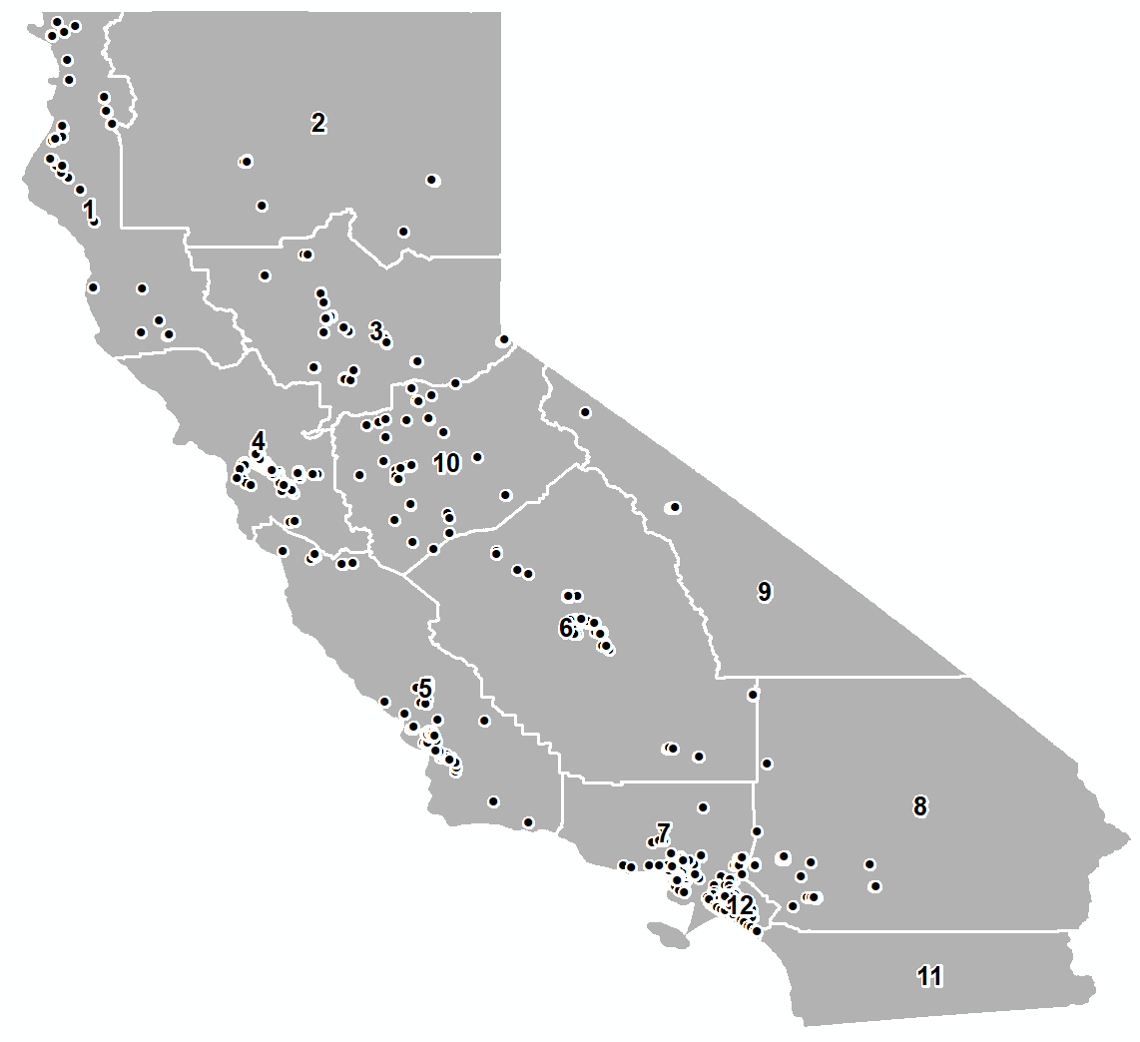

Figure 1 Location of counts