**Neural Networks And Deep Learning**

**Assignment 5**

**Kesavapatnam Sravya**

**700747122**

1. Save the model and use the saved model to predict on new text data (ex, “A lot of good things are happening. We are respected again throughout the world, and that's a great thing.@realDonaldTrump”)

2. Apply GridSearchCV on the source code provided in the class

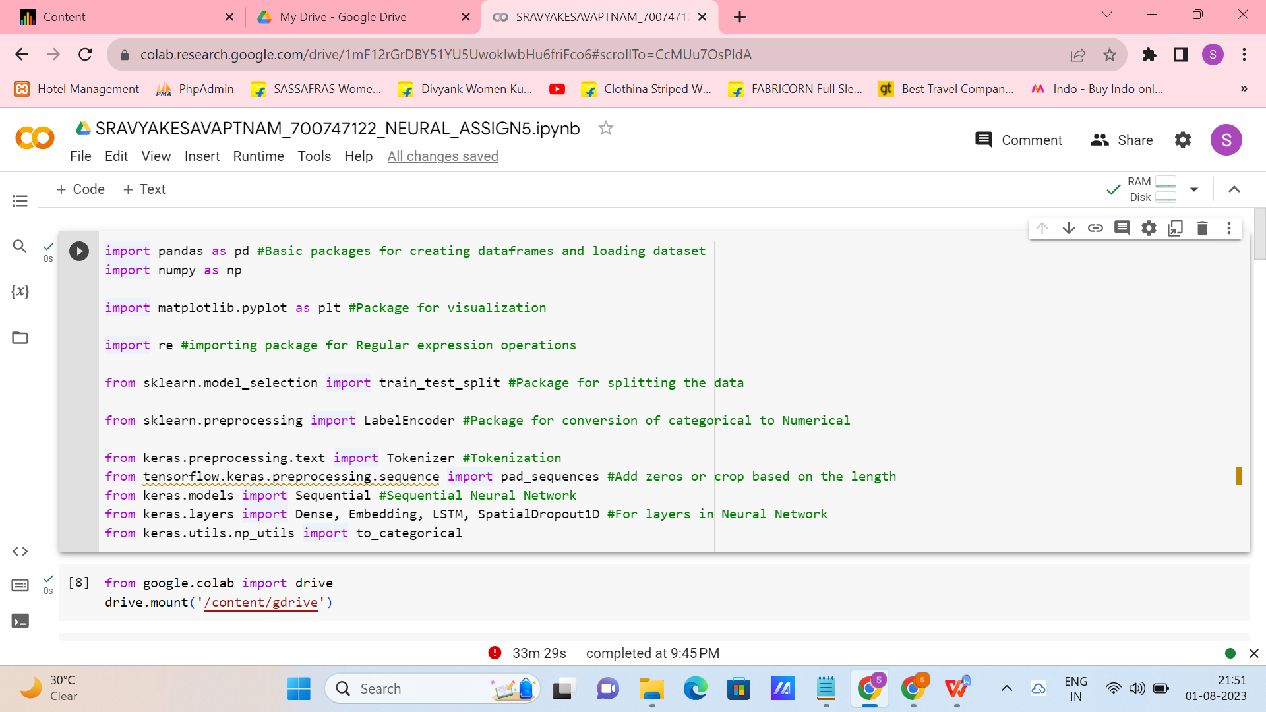

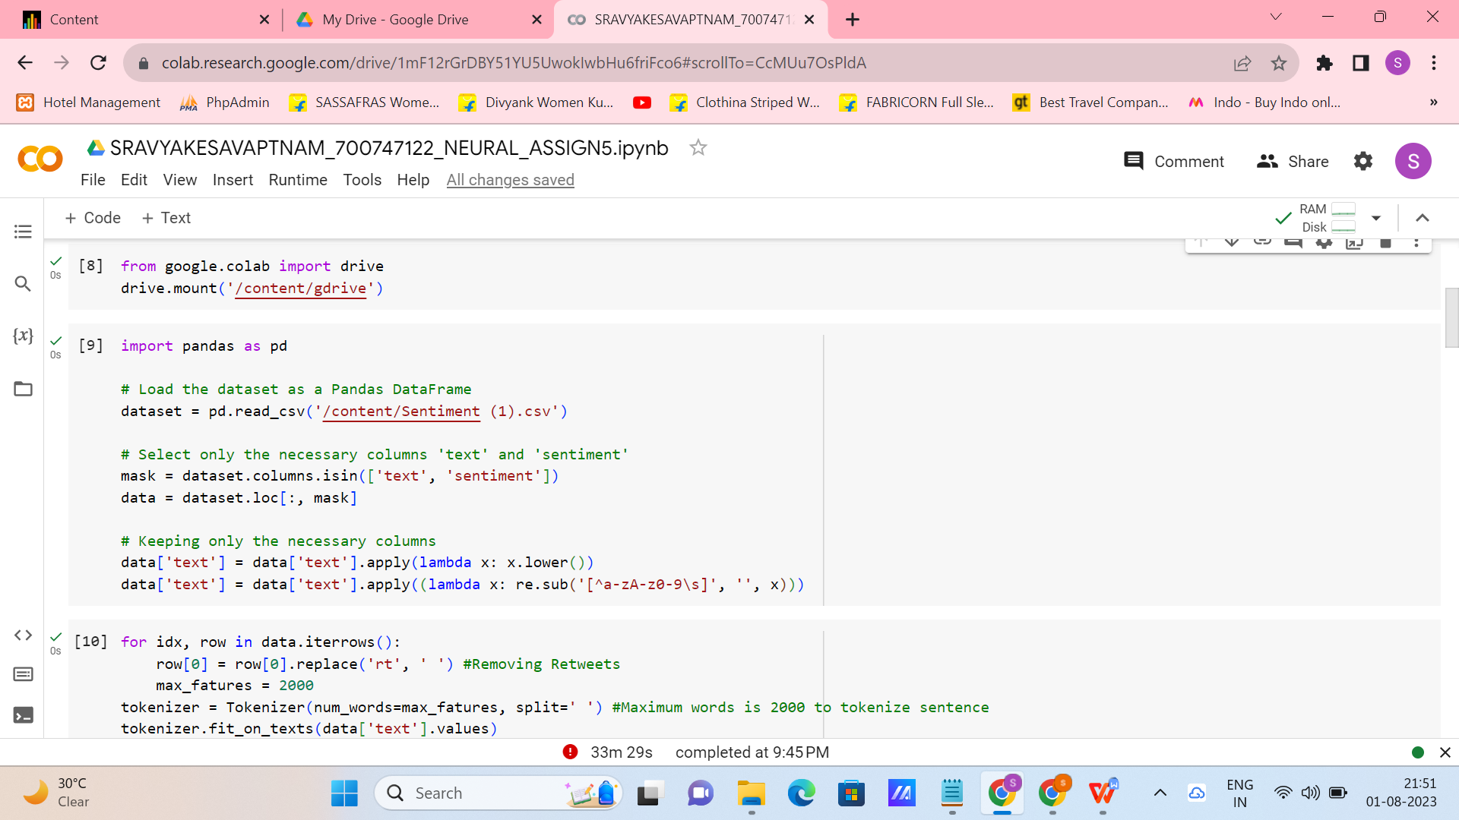

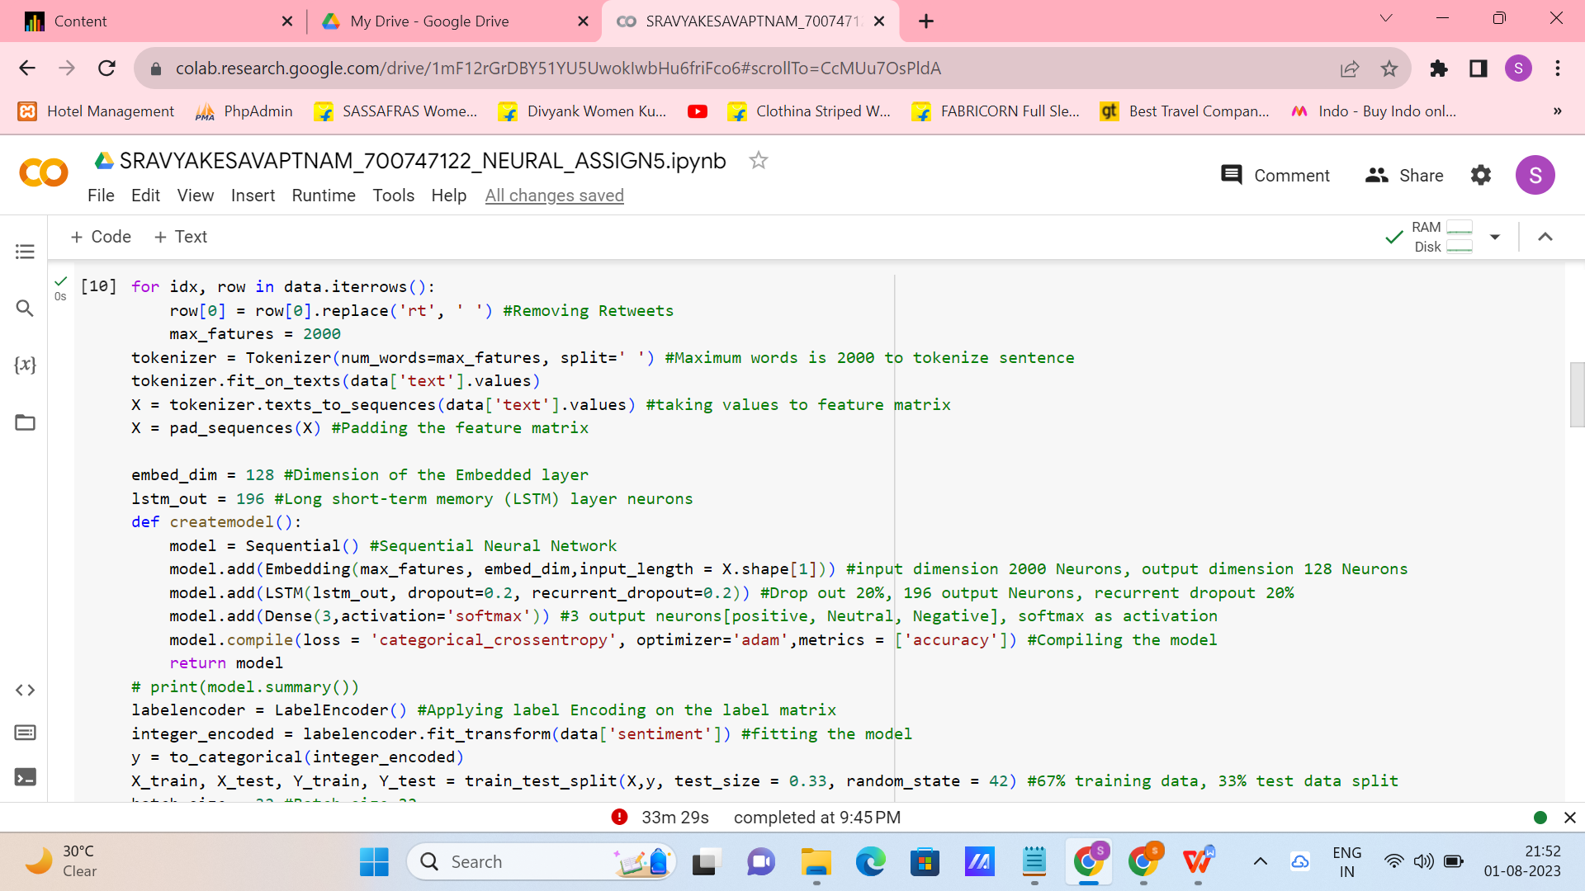

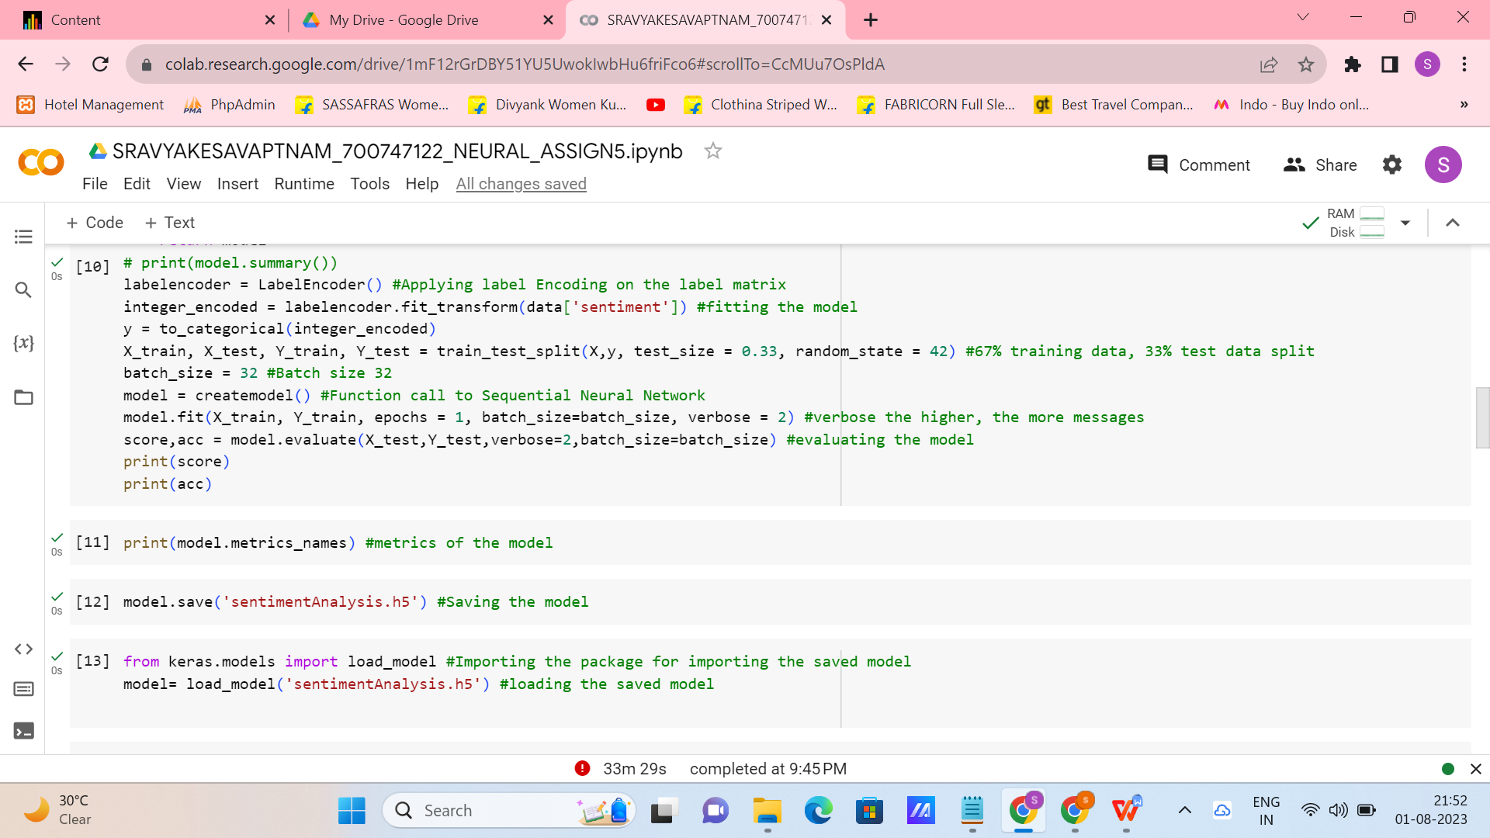

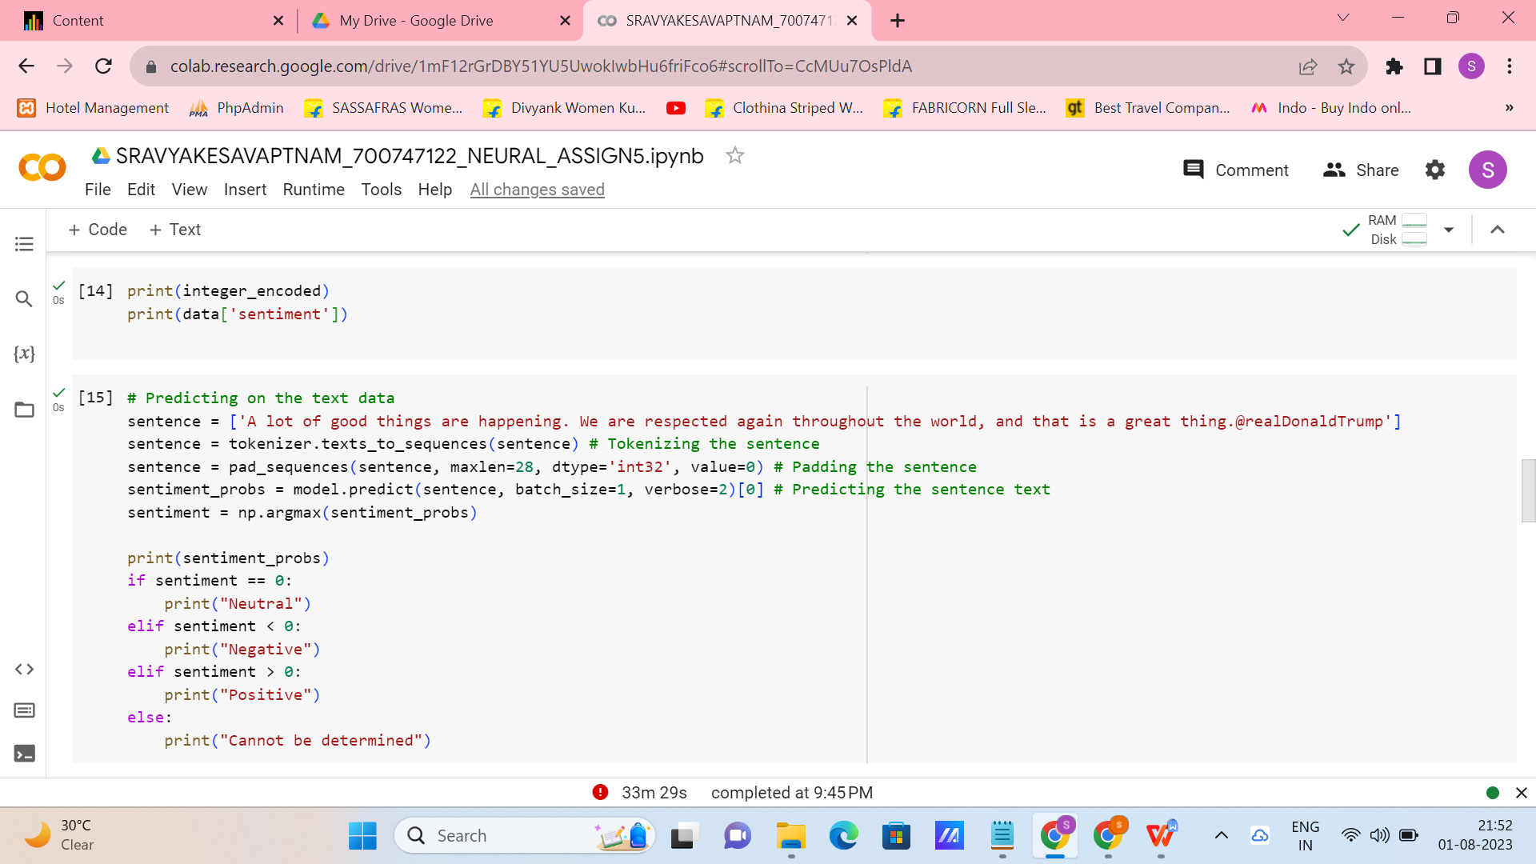

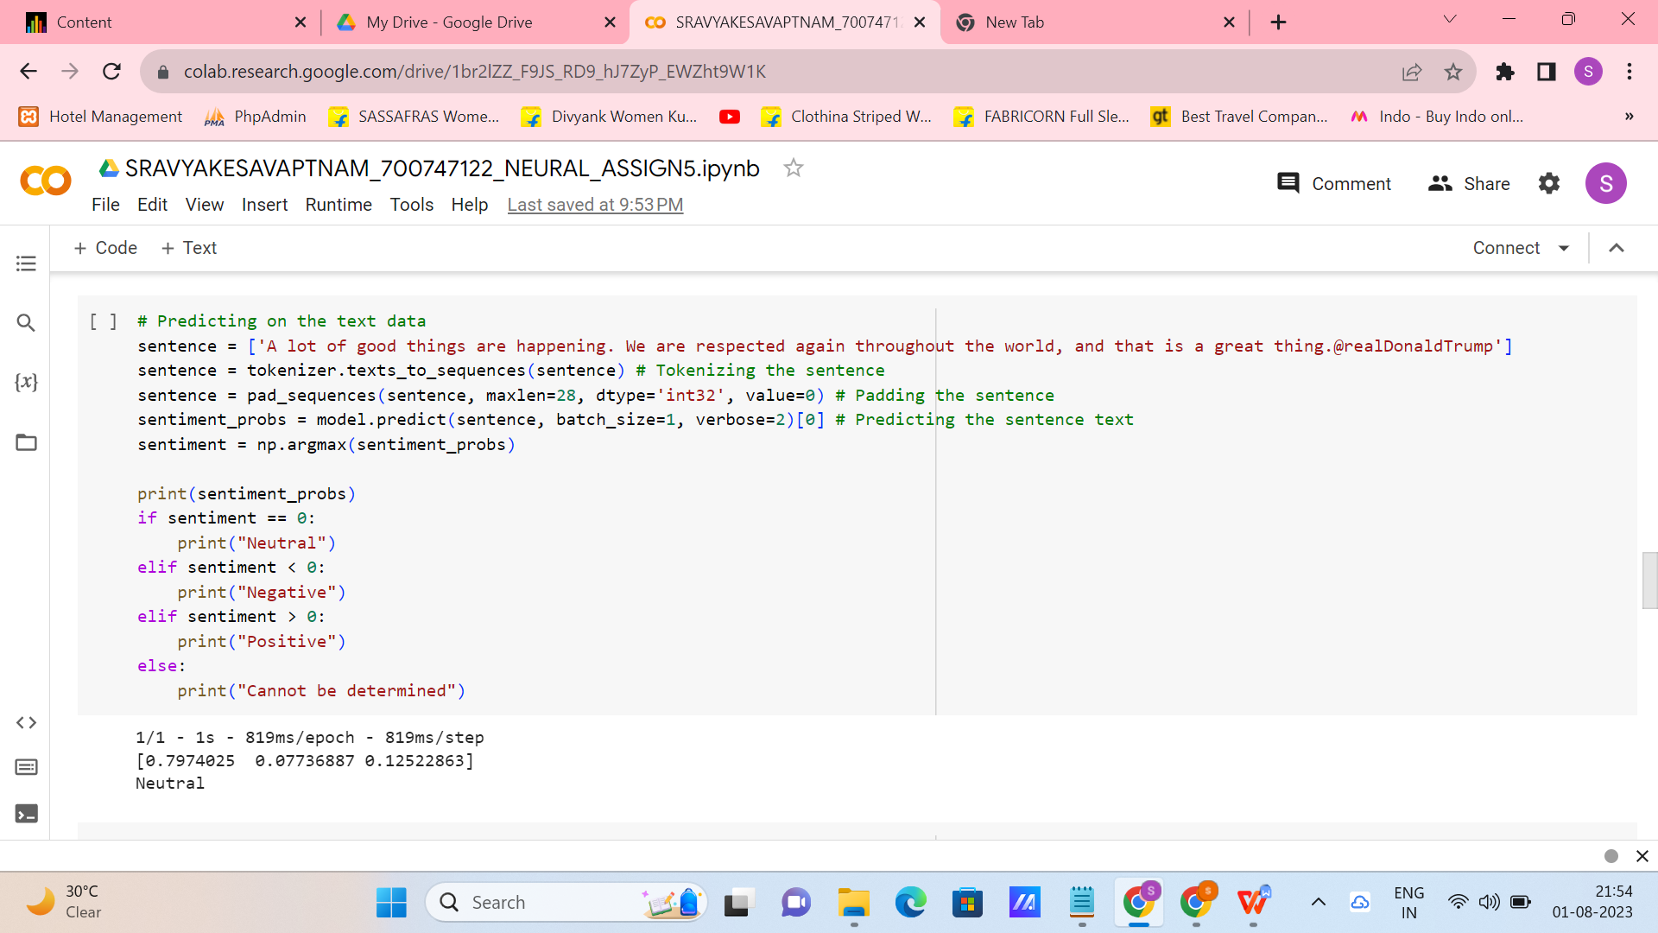

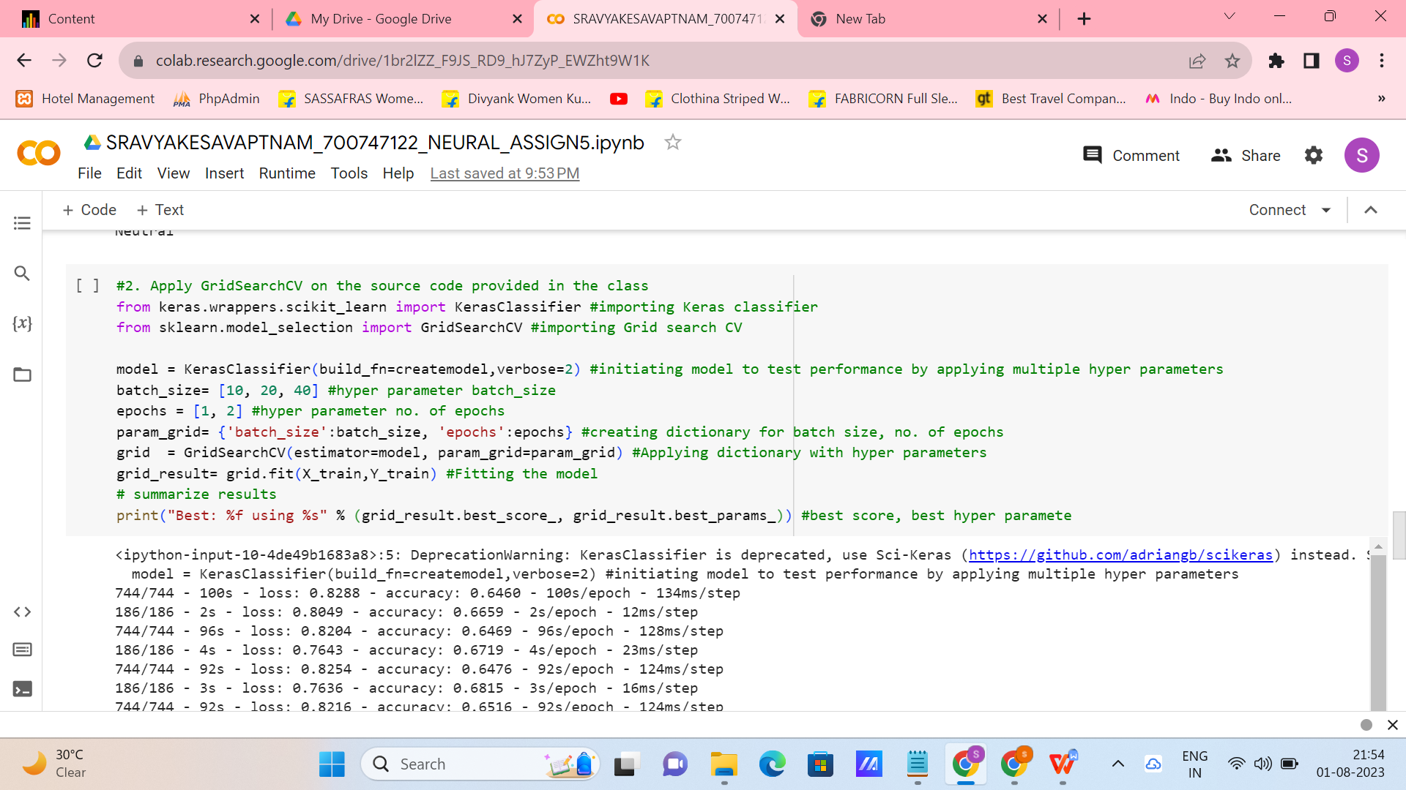

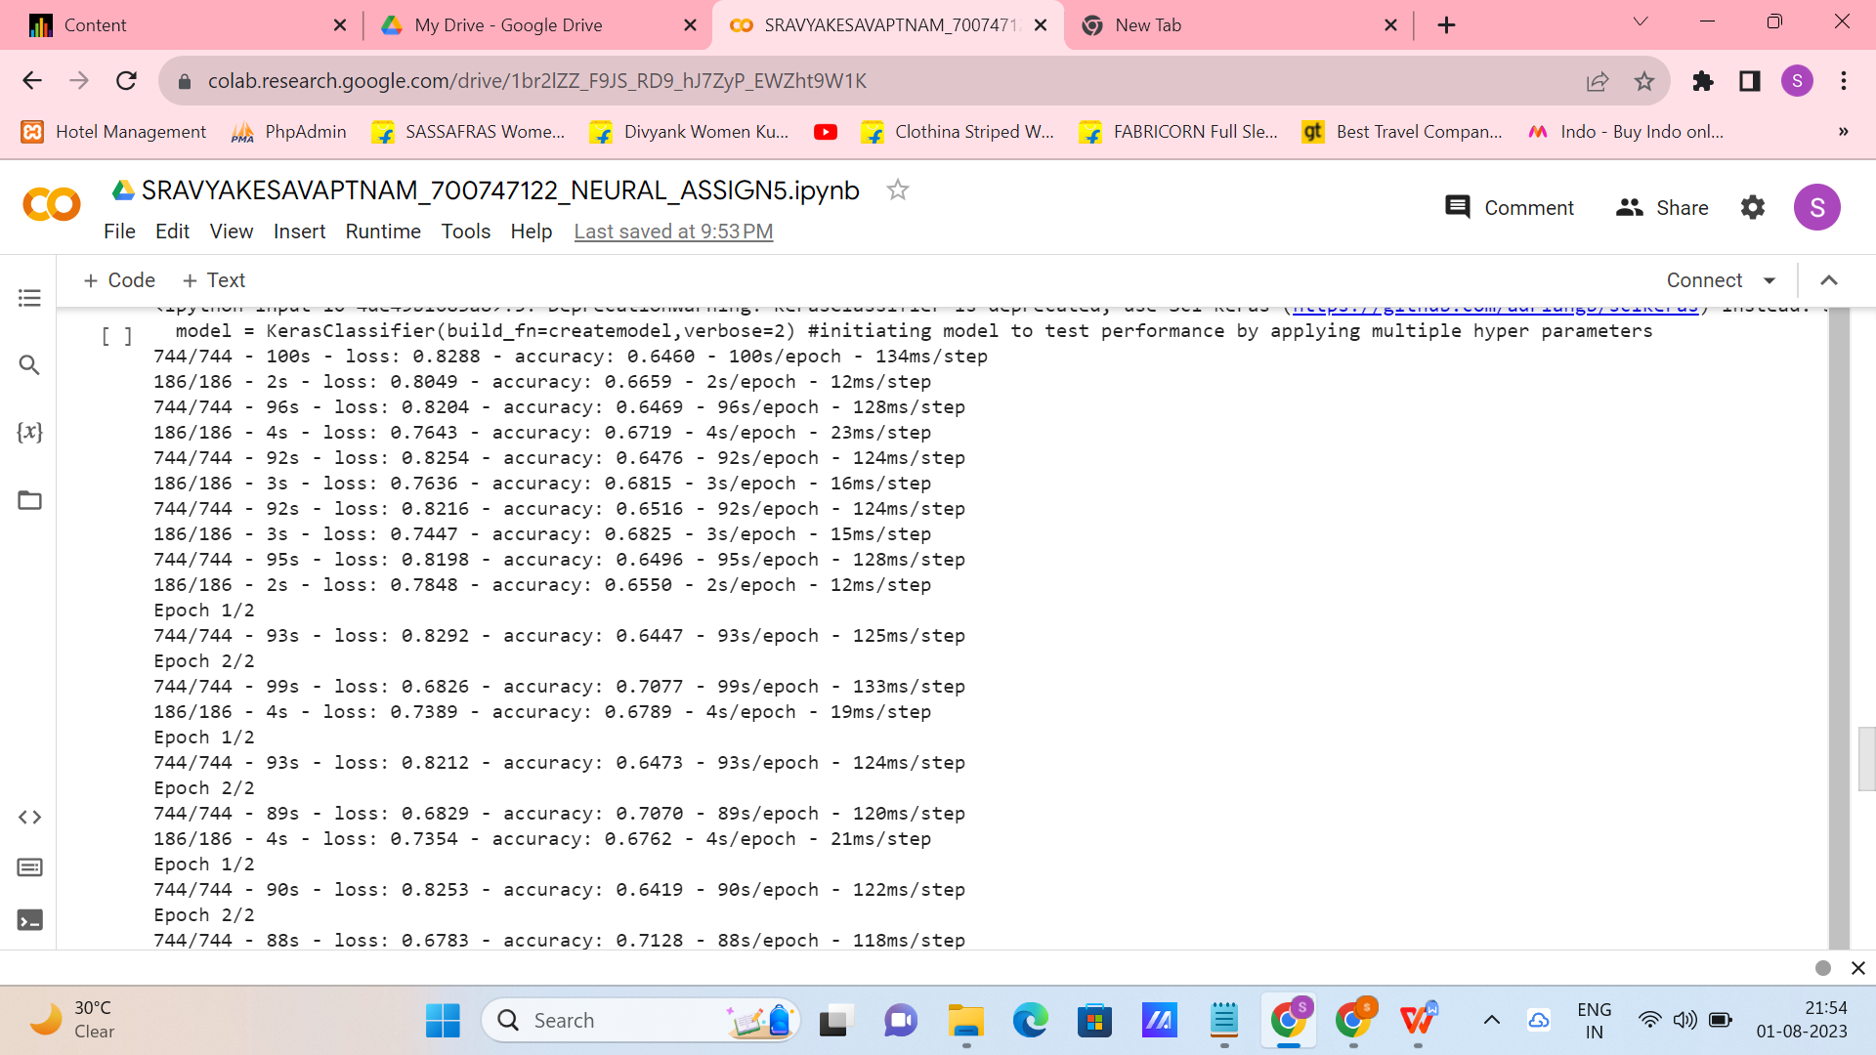

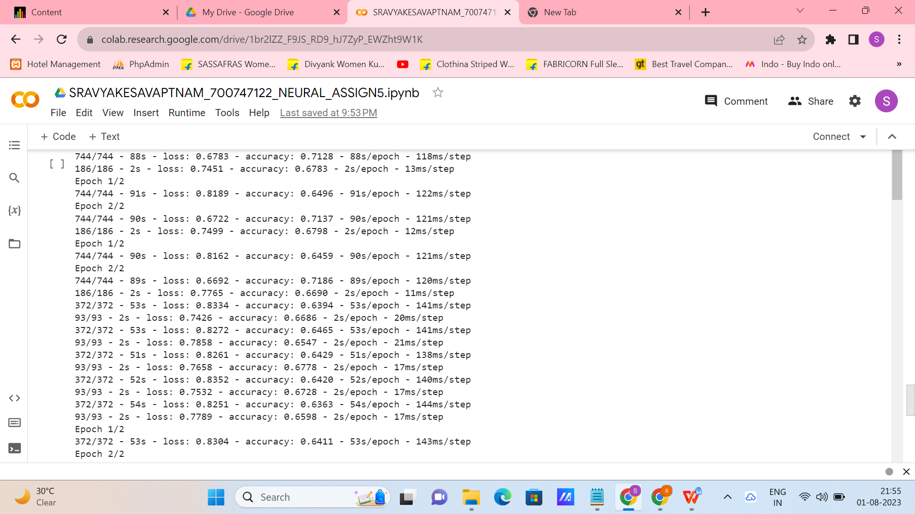

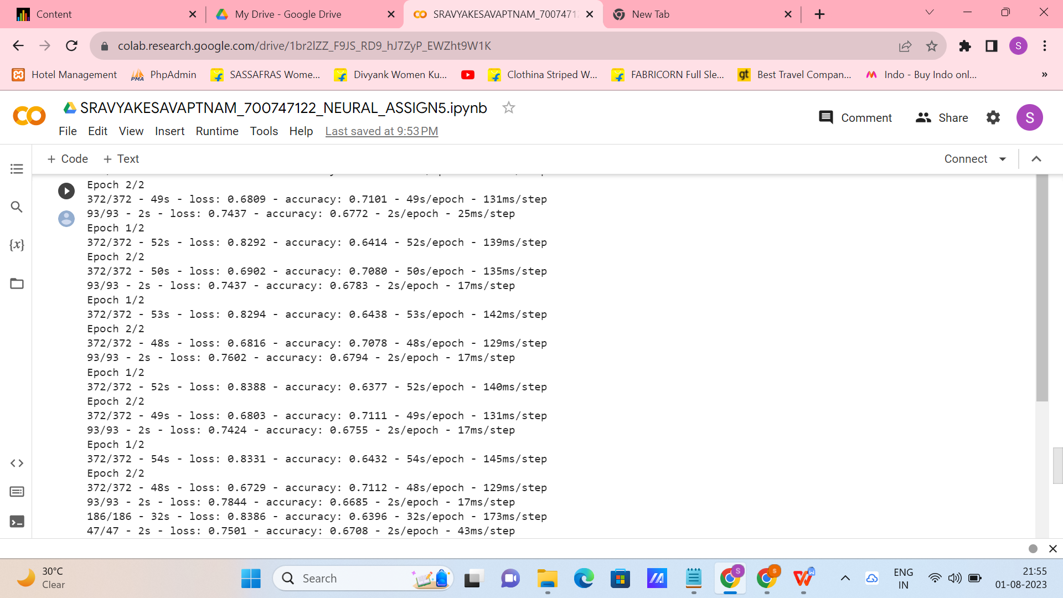

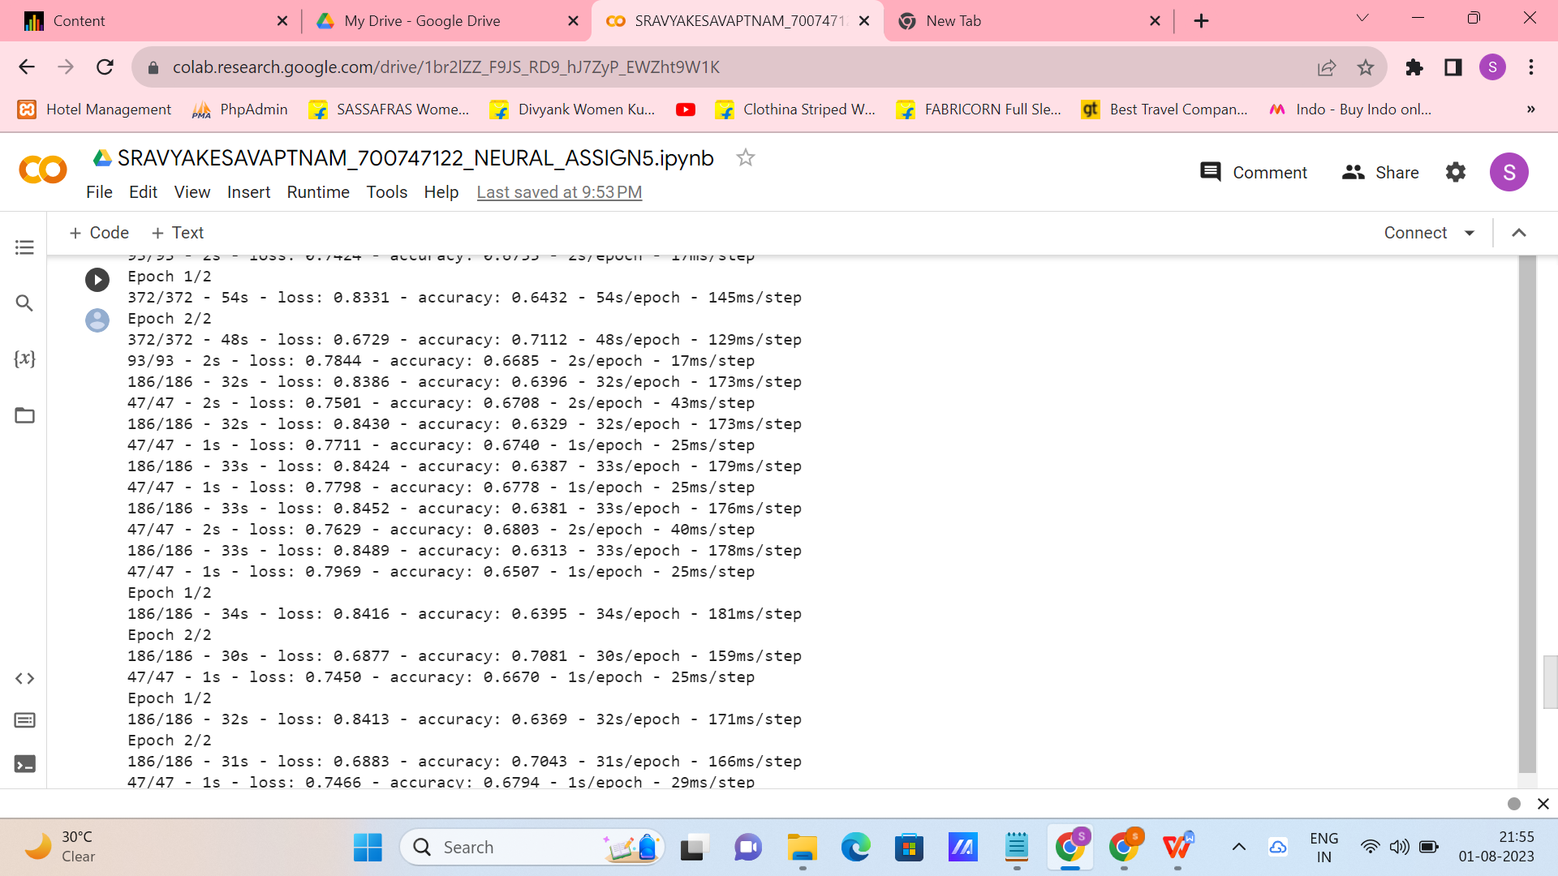

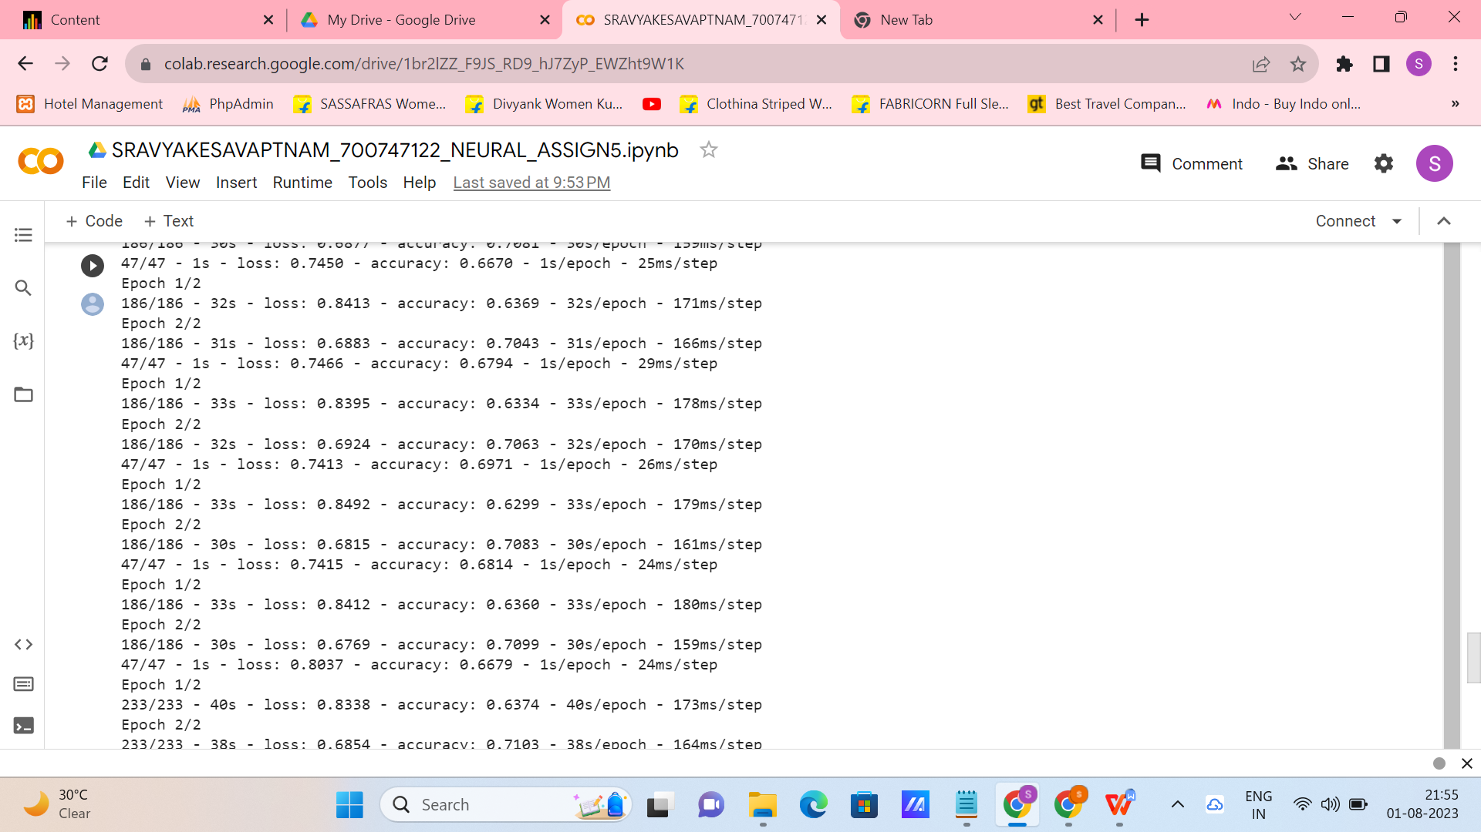

**GIT-HUB:**

**<https://github.com/srav200/NEURAL5_SRAVYAKESAVAPATNAM>**

**VIDEO LINK:**

**<https://github.com/srav200/NEURAL5_SRAVYAKESAVAPATNAM/blob/main/Kesavapatnam%20sravya.mp4>**