**NEURAL NETWORKS AND DEEP LEARNING**

**ASSIGNMENT-3**

**KESAVAPATNAM SRAVYA**

**700747122**

1. **Add one more hidden layer to autoencoder**

As per the given question imported necessary modules and has plotted the data without hidden layer first and then added hidden layer and repeated the process.

Visualized graphs in both cases using matplotlib. Here are the screenshots attached below.

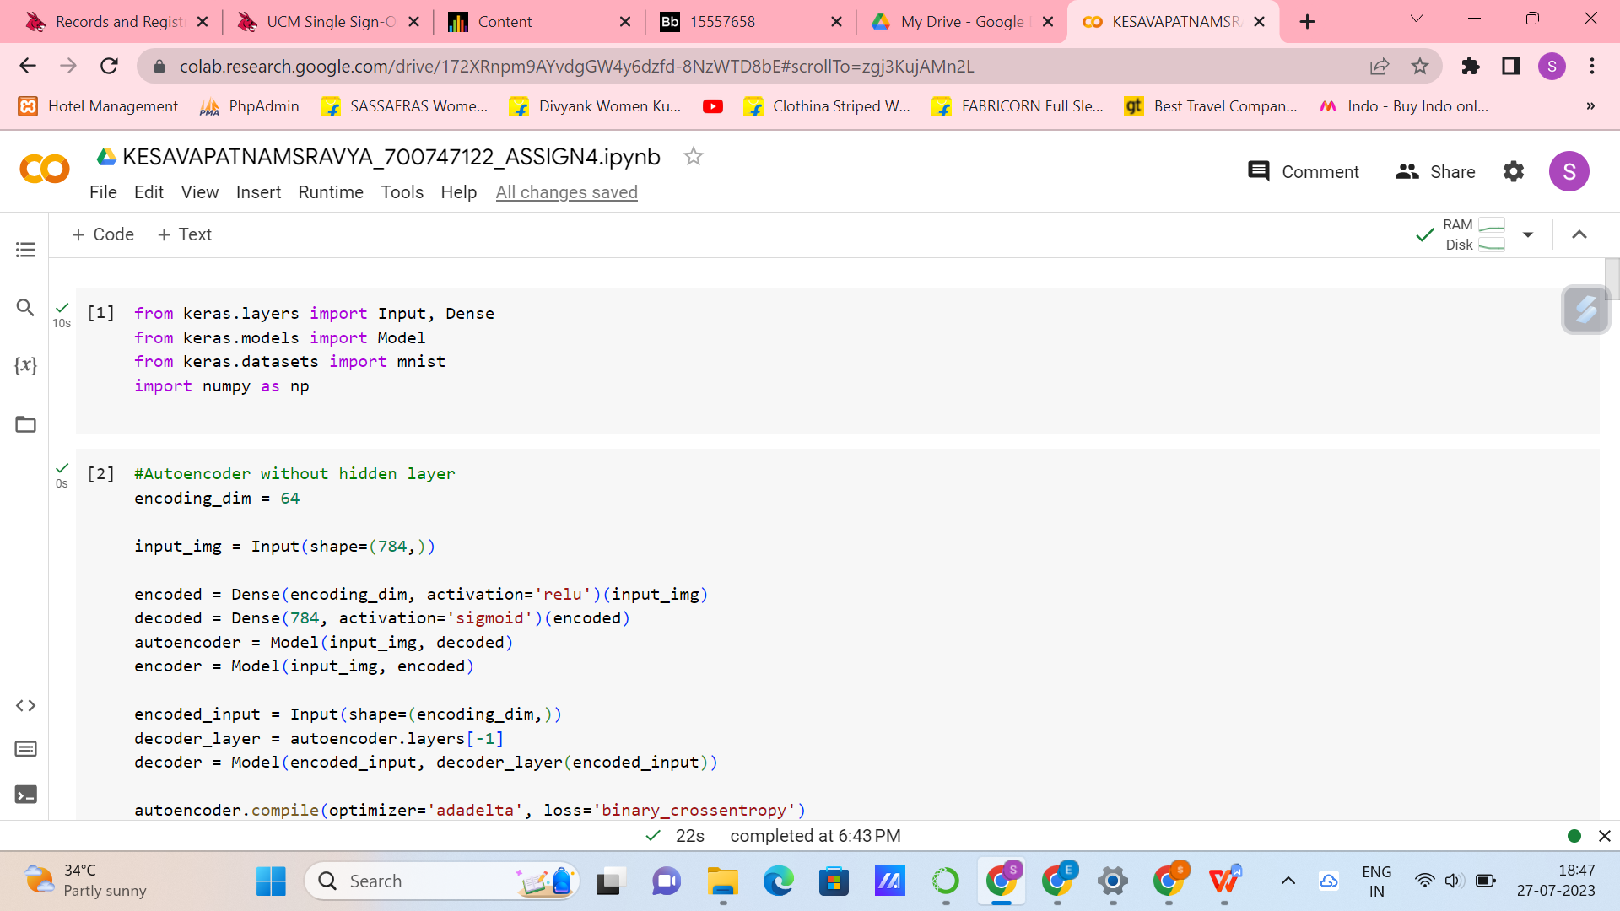

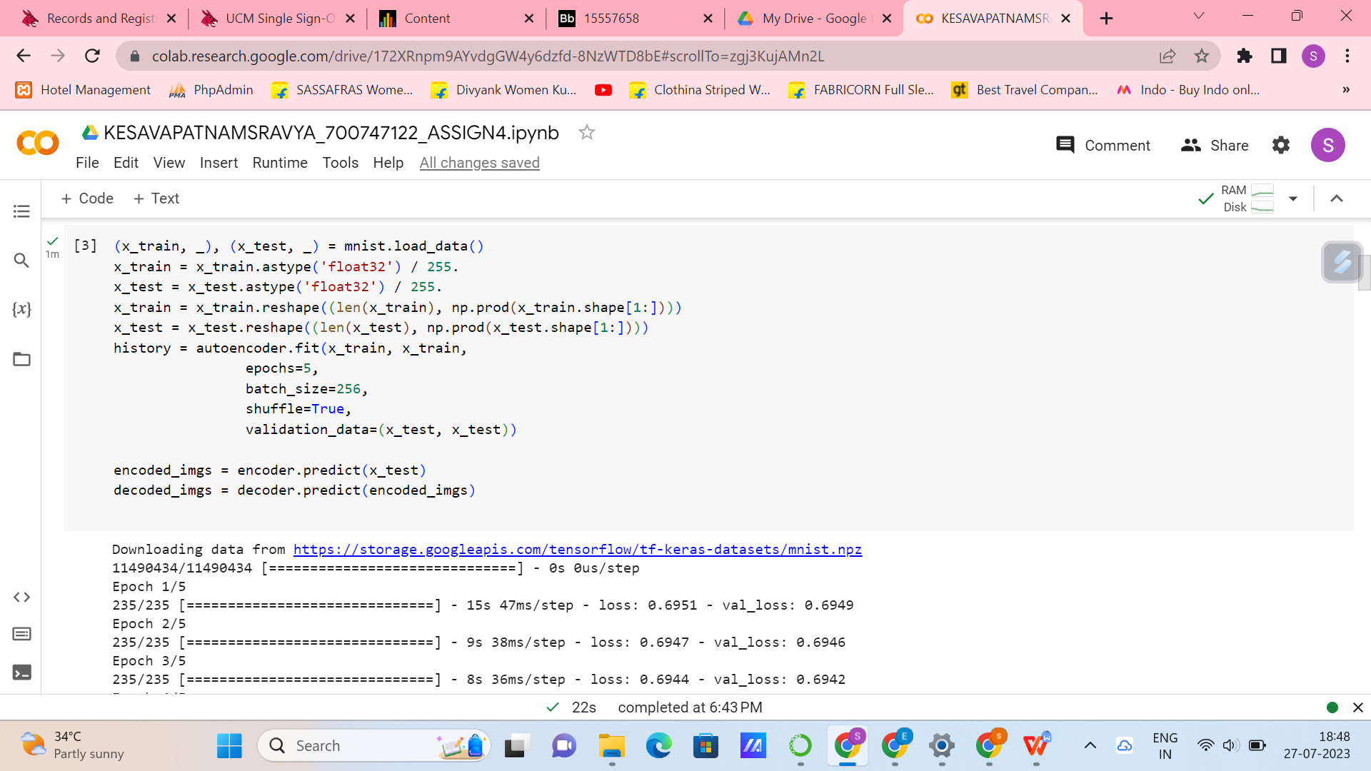

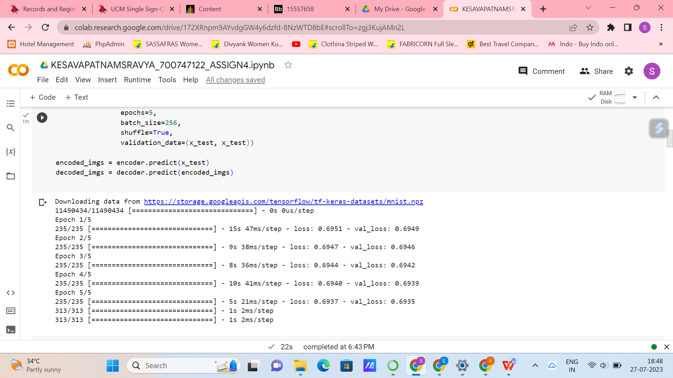

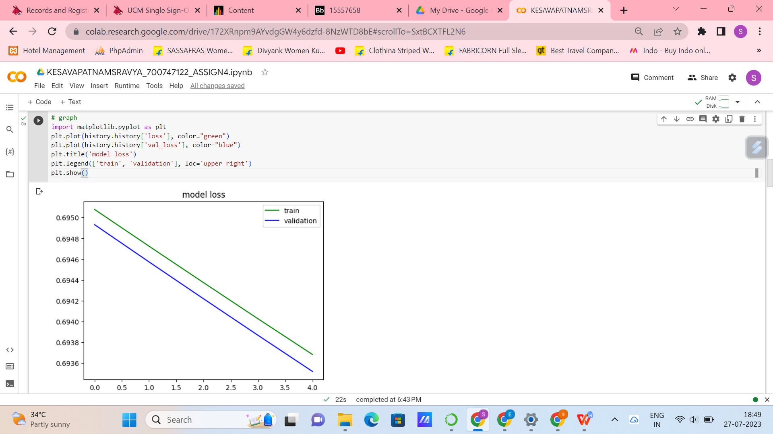

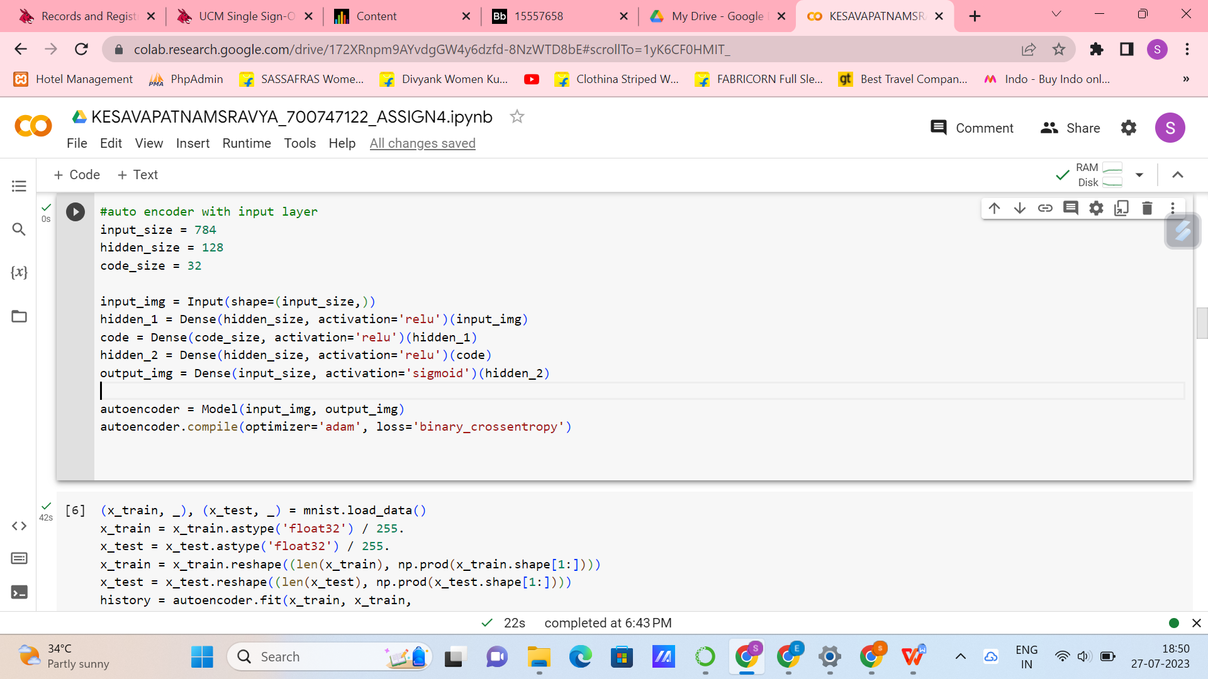

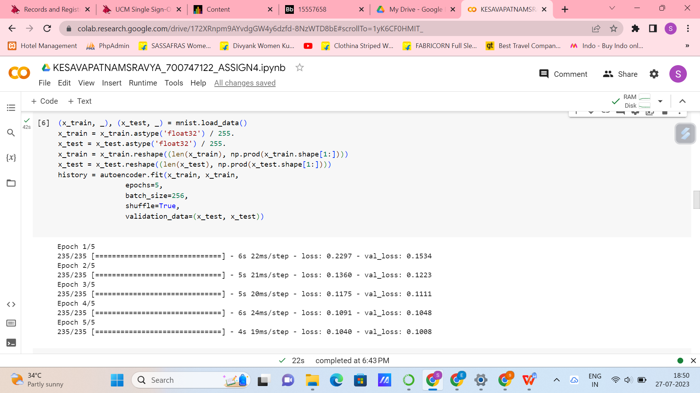

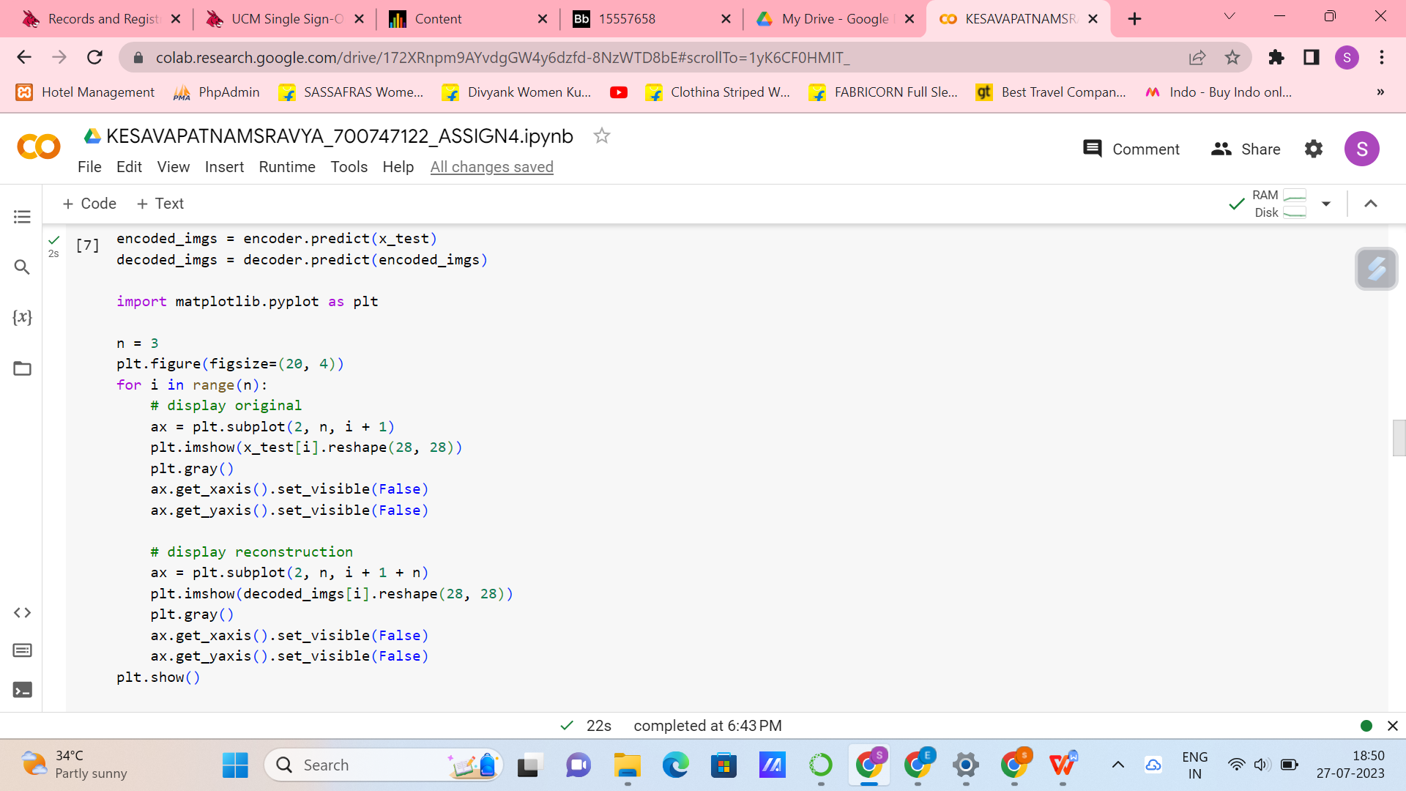

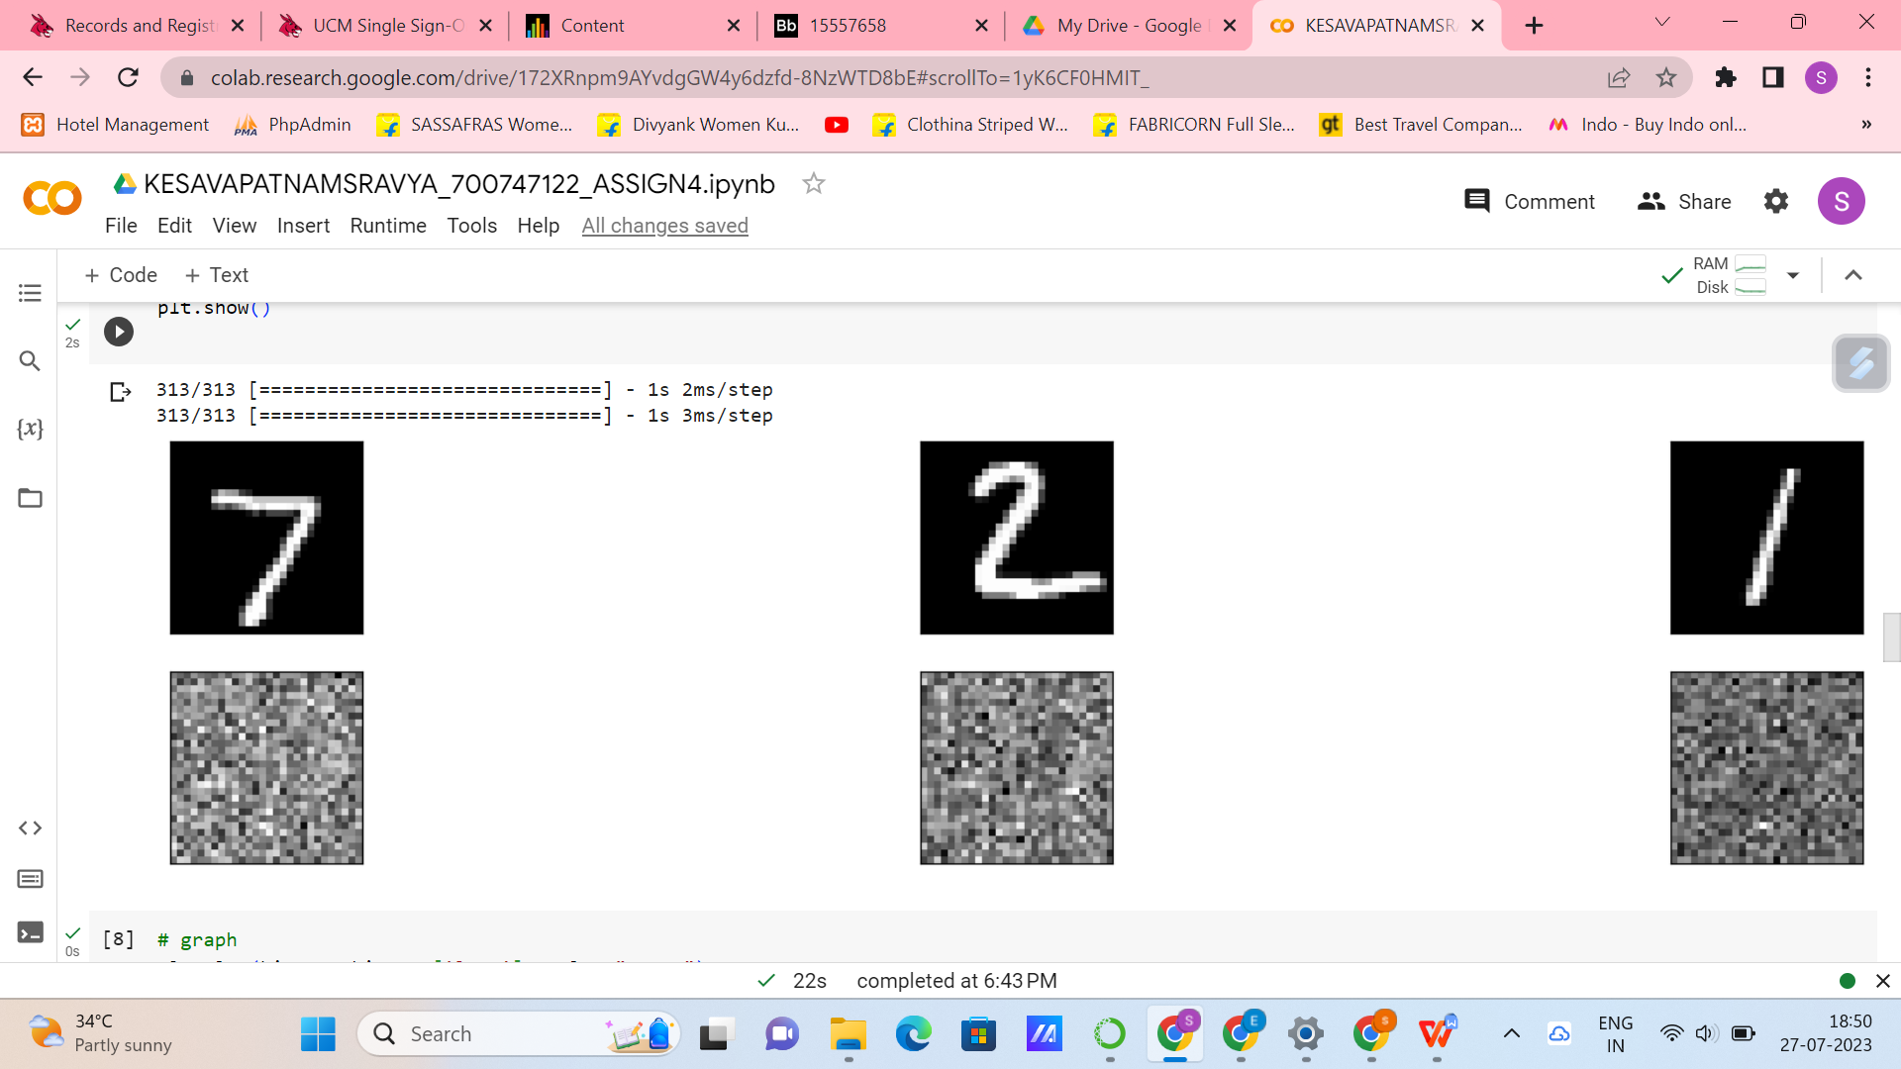

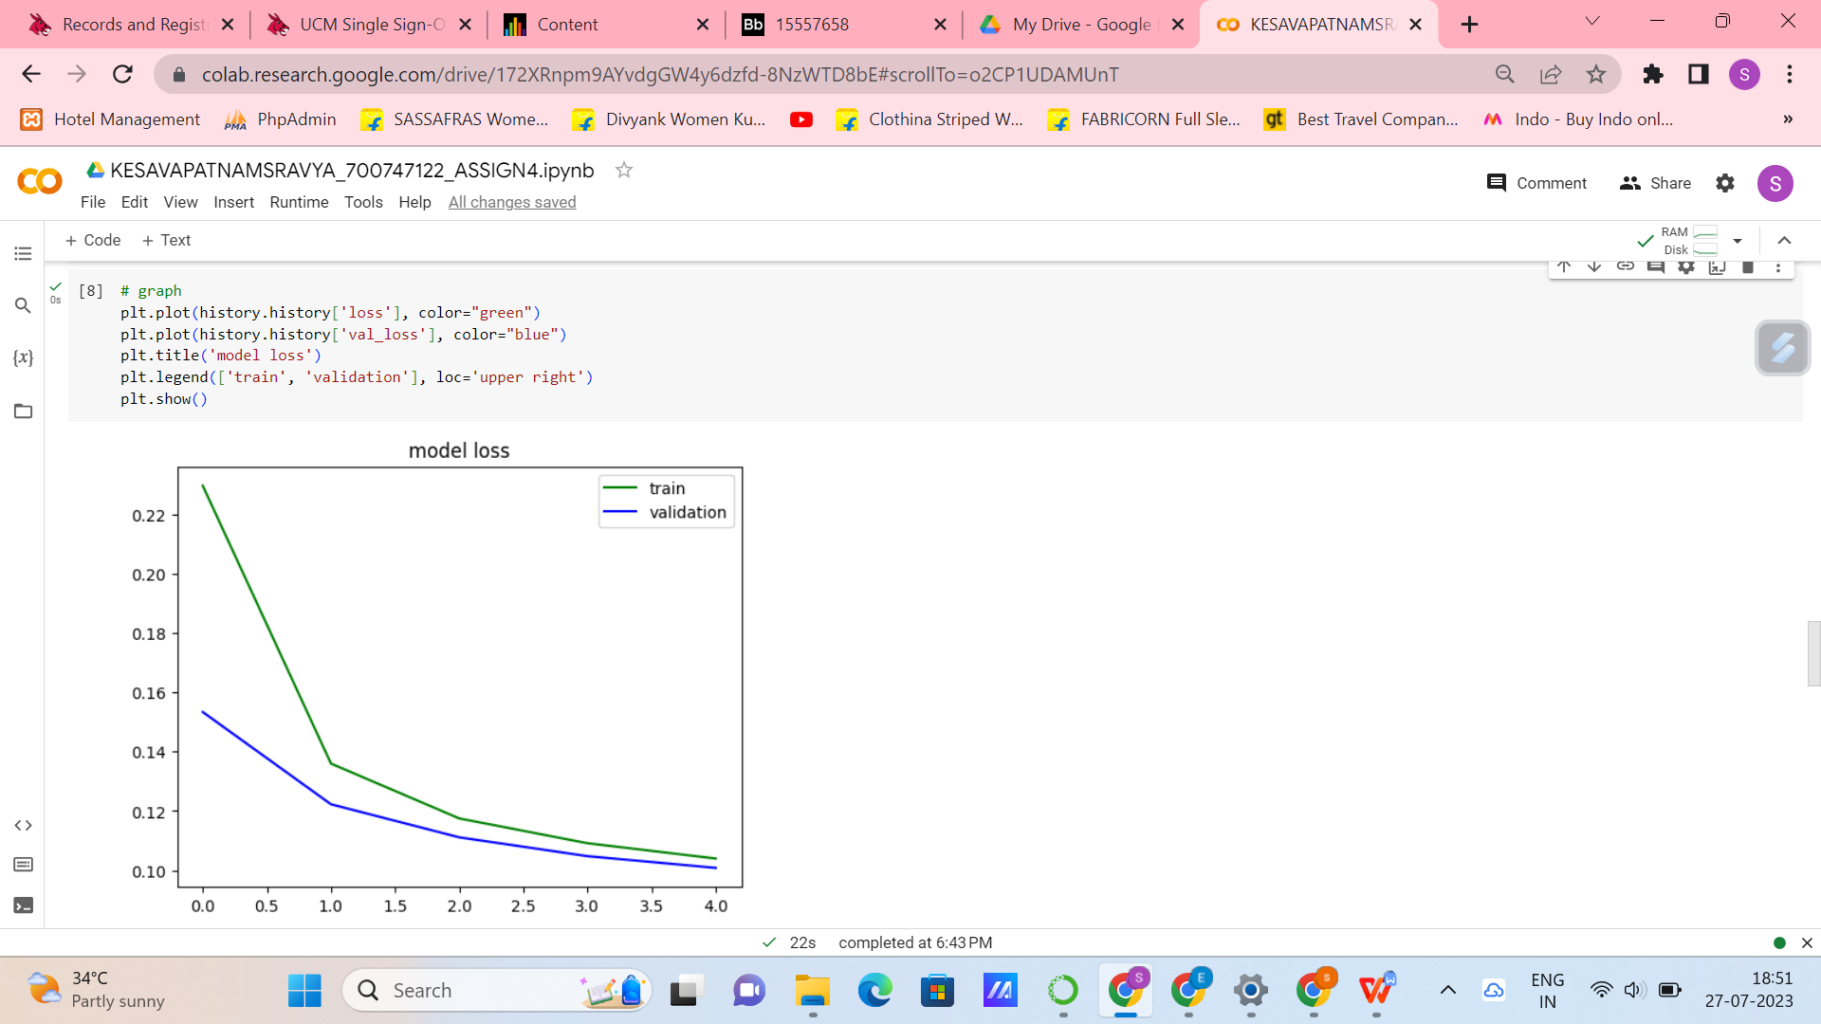

**2. Do the prediction on the test data and then visualize one of the reconstructed version of that test data. Also, visualize the same test data before reconstruction using Matplotlib**

**3. Repeat the question 2 on the denoisening autoencoder**

**4. plot loss and accuracy using the history object**

Predicted the test data and then visualized one of the reconstructed data. Repeated the same thing with denoisening auto encoder and plotted the graph for loss and accuracy using the history object. Here are the screenshots attached below.

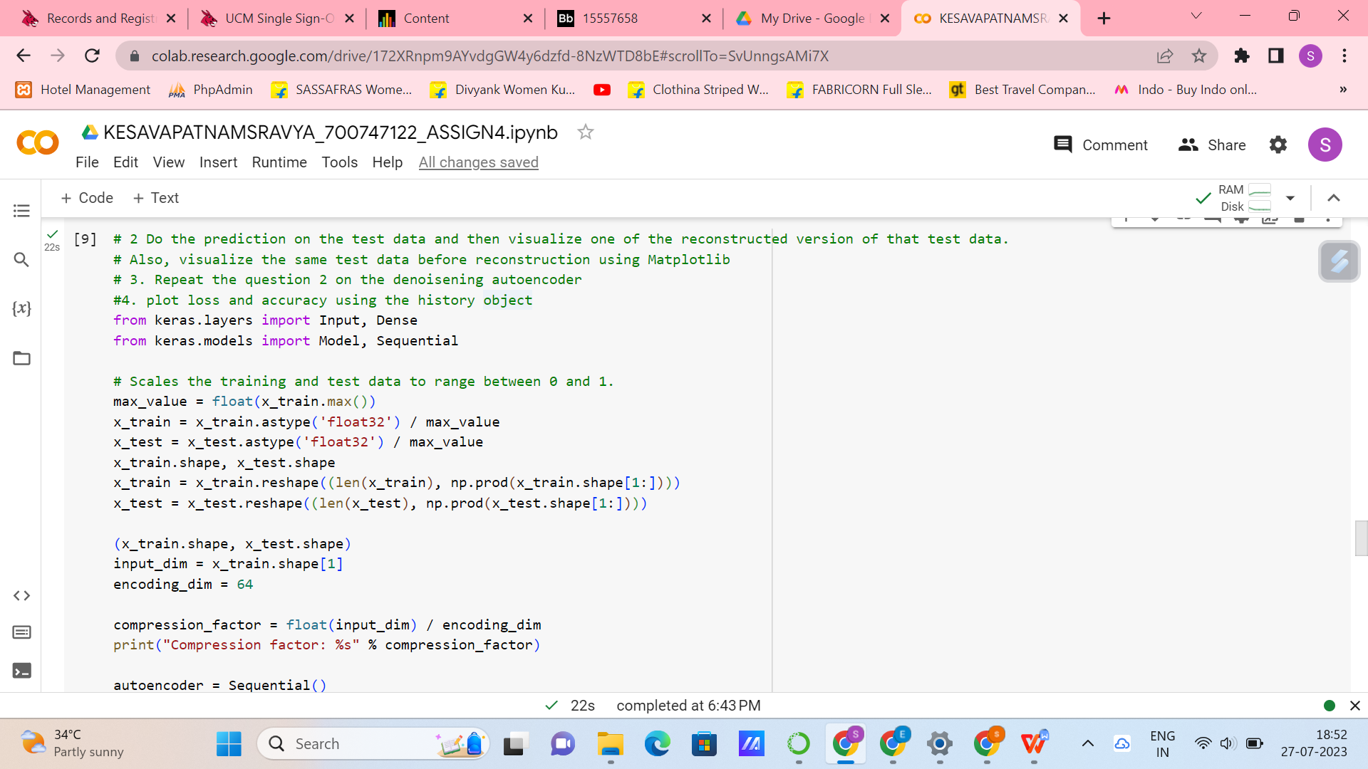

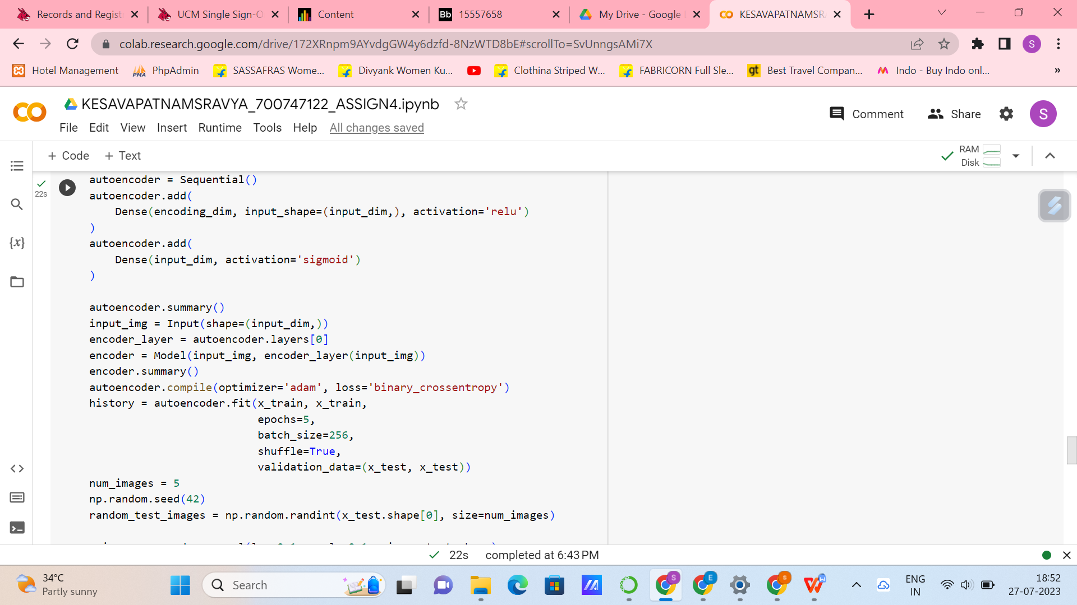

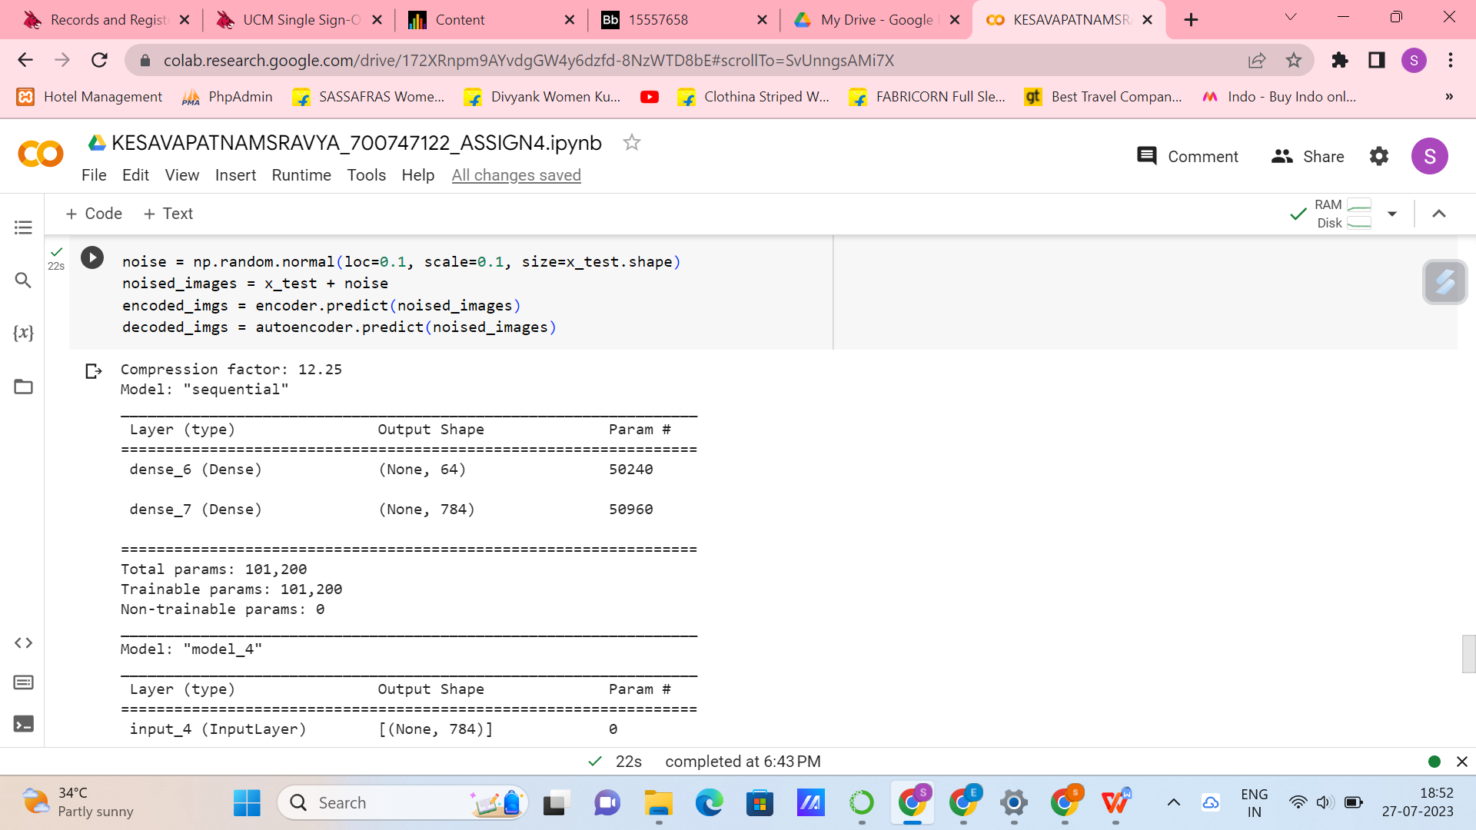

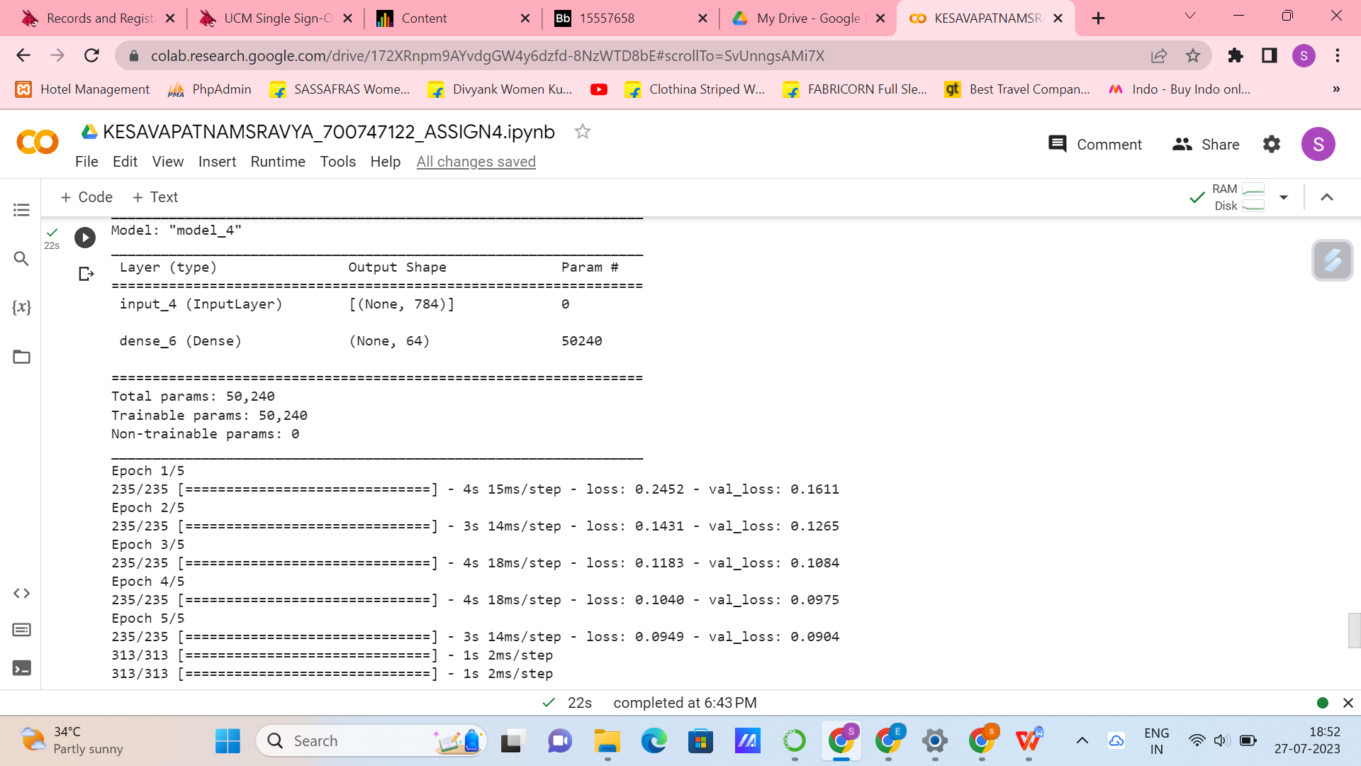

**GITHUB LINK:**

**<https://github.com/srav200/NEURALASSIGNMENT4_SRAVYA>**

**VIDEO LINK:**

**<https://github.com/srav200/NEURALASSIGNMENT4_SRAVYA/blob/main/kesavapatnamsravya_assign4_neural.mp4>**