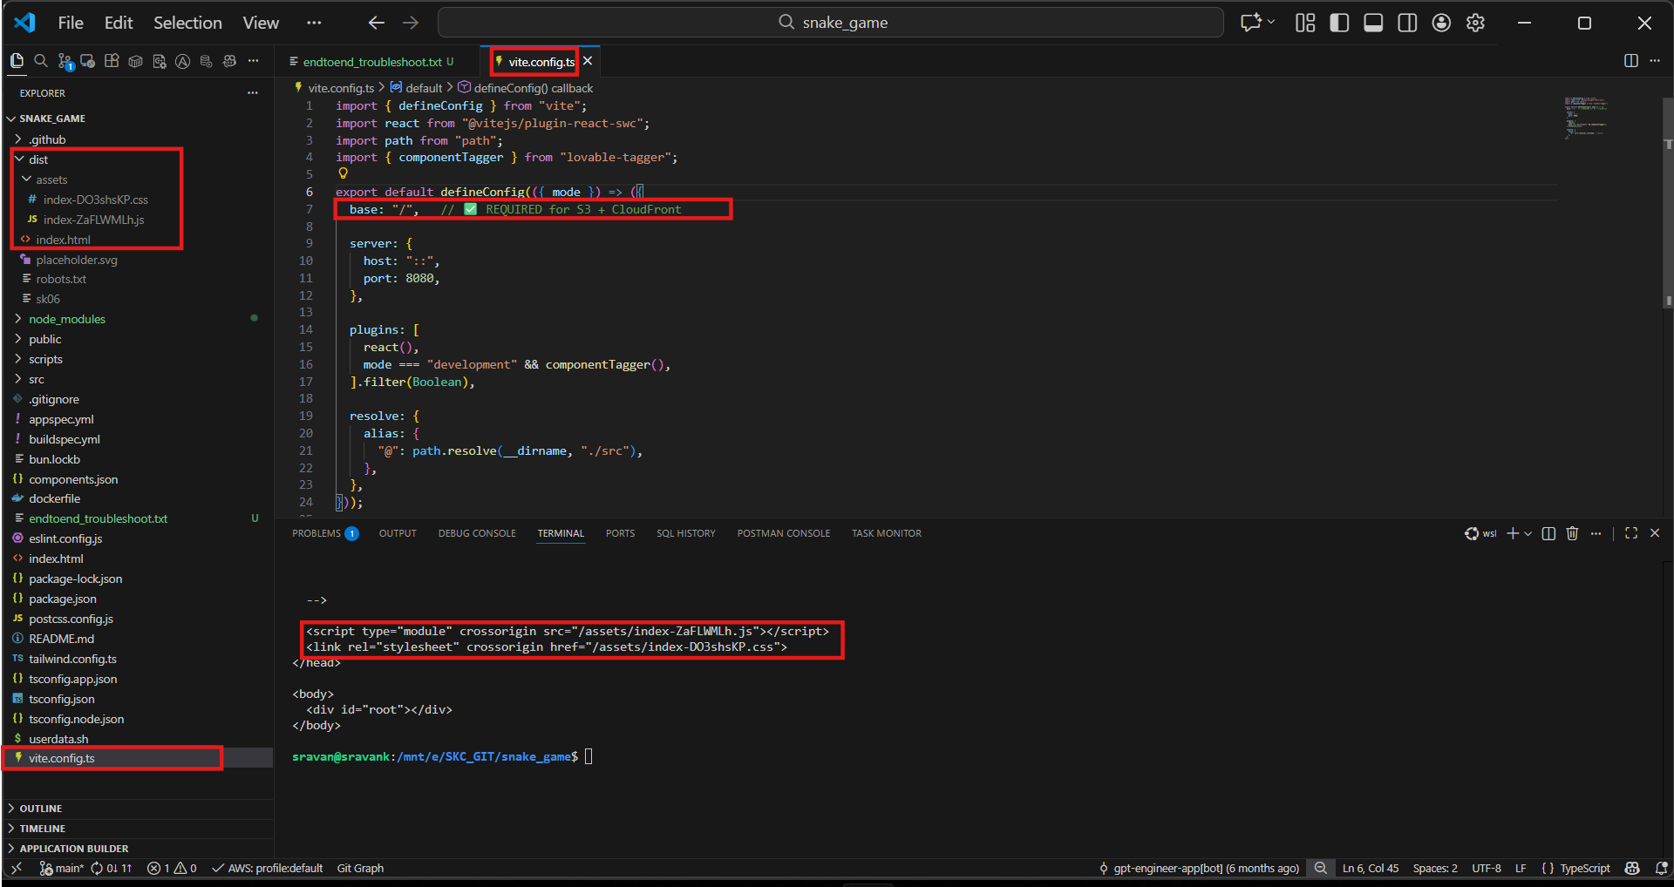

import { defineConfig } from "vite";
import react from "@vitejs/plugin-react-swc";
import path from "path";
import { componentTagger } from "lovable-tagger";

export default defineConfig(({ mode }) => ({
base: "/", // ✅ REQUIRED for S3 + CloudFront

server: {
host: "::",
port: 8080,
},

plugins: [
react(),
mode === "development" && componentTagger(),
].filter(Boolean),

resolve: {
alias: {
"@": path.resolve(__dirname, "./src"),
},
},
}));

