Active Directory Security Groups
Last reviewed: 2026-07-01. Source of truth: application code (ClientIQ / Banking Client 360).

Purpose
This is the operational registry of the Active Directory security groups that grant
access to the ClientIQ / Banking Client 360 application and control which
application role each user receives. It documents:
- the <PREFIX>_<ENV>_APP_ClientIQ_<RoleToken>_<Access> group naming convention;
- how each group's RoleToken resolves to a ClientIQ application role (and its
privilege level);
- how the same on-prem AD serves multiple deployment environments through the
SAML_ROLE_ENV scoping variable;
- the GEN access-only entitlement and the default-role safety net;
- the group registry itself (owners and data classifications require governance
sign-off; see [CONFIRM] markers).

Group membership is delivered to ClientIQ in the SAML role claim at login (SSO is
enabled in preprod and prod only; dev and test use local/mock auth). Role
assignment is driven entirely by a convention-based code mapper,
server/auth/adGroupRoleMap.ts, not by any database table. The resolved role
names are matched case-insensitively against rows in the SQL Server role table.

1. Group naming convention
Every ClientIQ security group follows this structure
(server/auth/adGroupRoleMap.ts:5-15):
<PREFIX>_<ENV>_APP_ClientIQ_<RoleToken>_<Access>
Segment | Values | Effect on the granted role
<PREFIX> | e.g. CTRL, IAM | None. Naming/ownership convention only.
<ENV> | DEV, TST, STG, PRD (also PRE for the preprod admin group, see §4) | Used only for environment scoping (§3). Ignored for role selection.
APP_ClientIQ | literal | Marks the group as a ClientIQ application group.
<RoleToken> | e.g. Teller, BranchManager, AppAdmin | The only segment that selects the application role (§2).
<Access> | RO, RW, MOD, ADM, EXEC | None. The suffix is descriptive; it does not change the granted role or its permissions.

Key point: only the RoleToken determines the ClientIQ role. The environment
segment and the access suffix are ignored when selecting a role
(adGroupRoleMap.ts:12-15). The RoleToken is captured by a case-insensitive,
end-anchored regex:
/_ClientIQ_([A-Za-z]+)_(?:RO|RW|MOD|ADM|EXEC)$/i // CLIENTIQ_GROUP_RE, adGroupRoleMap.ts:64
A group that does not match this pattern (for example, a non-ClientIQ AD group) is
ignored entirely.

2. RoleToken → application role mapping
The mapper resolves the captured RoleToken (lowercased) to a ClientIQ application
role name via AD_GROUP_TOKEN_TO_ROLE (adGroupRoleMap.ts:41-58). The role names on
the right must exist as rows in the SQL Server role table.
RoleToken (case-insensitive) | ClientIQ application role | Privilege level
AppAdmin, APPSVCS | System Admin | 4
BranchManager | Branch Manager | 3
BusinessBanker, AsstManager (assistantmanager) | BRS | 2
LoanOfficer | Loan Officer | 2
Risk | Risk Analyst | 1
Compliance | Compliance Officer | 1
Teller | Teller | 1
DataAnalyst | Teller | 1
GEN | (no role, access entitlement only, see §5) | n/a

Notes:
- DataAnalyst is not a distinct application role. Members of a DataAnalyst
group receive the Teller role (privilege 1); there is no "Data Analyst" role in
the role table (adGroupRoleMap.ts:57).
- BusinessBanker and AsstManager both resolve to the BRS role
("Business Relationship Specialist", privilege 2) (adGroupRoleMap.ts:48-49).
Dependency: a role row named exactly BRS must exist in the SQL Server role
table. BRS is not created by the seed script (scripts/seed.ts seeds separate
"Assistant Manager" and "Business Banker" roles), and no in-repo migration creates
it. If the BRS row is absent, the role does not resolve and affected users fall
back to the default role (§5).
- LoanOfficer, Risk, and Compliance each map to their own dedicated role;
privilege levels for Loan Officer (2), Risk Analyst (1), and Compliance Officer (1)
come from the RBAC seed (scripts/seed.ts).

If a group matches the ClientIQ naming pattern but its RoleToken is not in the map, it
is collected as unmatched for operator visibility and grants no role
(adGroupRoleMap.ts:157-159).

3. Environment scoping: SAML_ROLE_ENV
The bank runs one on-prem Active Directory. A single user is therefore typically a
member of the ClientIQ groups for every deployment environment (both STG and PRD,
for example). Without scoping, the preprod deployment would honor a user's PRD groups
and prod would honor their STG groups (adGroupRoleMap.ts:116-129).
To prevent this, each deployment sets the SAML_ROLE_ENV environment variable.
When set, only groups whose <ENV> segment matches the deployment's env are honored;
groups from other environments are skipped (collected as ignoredOtherEnv)
(adGroupRoleMap.ts:143-150). When unset, every environment's groups are honored
(backwards-compatible).
SAML_ROLE_ENV is normalized (trim + uppercase, with aliases) to one of
DEV/TST/STG/PRD (normalizeRoleEnv, adGroupRoleMap.ts:78-86):
SAML_ROLE_ENV input | Resolves to
DEV, Development | DEV
TST, Test | TST
STG, Stage, Staging, Pre, PreProd, Pre-Prod | STG
PRD, Prod, Production | PRD
unset / unrecognized | (unscoped: all environments honored)

Per-deployment values
SSO is enabled only in preprod and prod. The Azure DevOps pipeline sets
SAML_ROLE_ENV per stage via the SAMLRoleEnv pipeline variable
(→ $env:SAML_ROLE_ENV):
Environment | Deploy stage | SAML_ROLE_ENV | Honored group ENV segment
dev | Deploy_Dev | DEV (SSO off; local/mock auth) | DEV
test | Deploy_Test | TST (SSO off; local/mock auth) | TST
preprod | Deploy_Preprod | STG | CTRL_STG_APP_ClientIQ_*
prod | Deploy_Prod, Deploy_Prod2 | PRD | CTRL_PRD_APP_ClientIQ_*

Source: azure-pipelines.yml per-stage SAMLRoleEnv; preprod STG
(:181-182), prod PRD (:207-208, :233-234).
Consequence: a user who is a Teller in STG and a Branch Manager in PRD
resolves to Teller in preprod and Branch Manager in prod: the same AD
membership, different effective role per deployment.

Environment-scoping flow
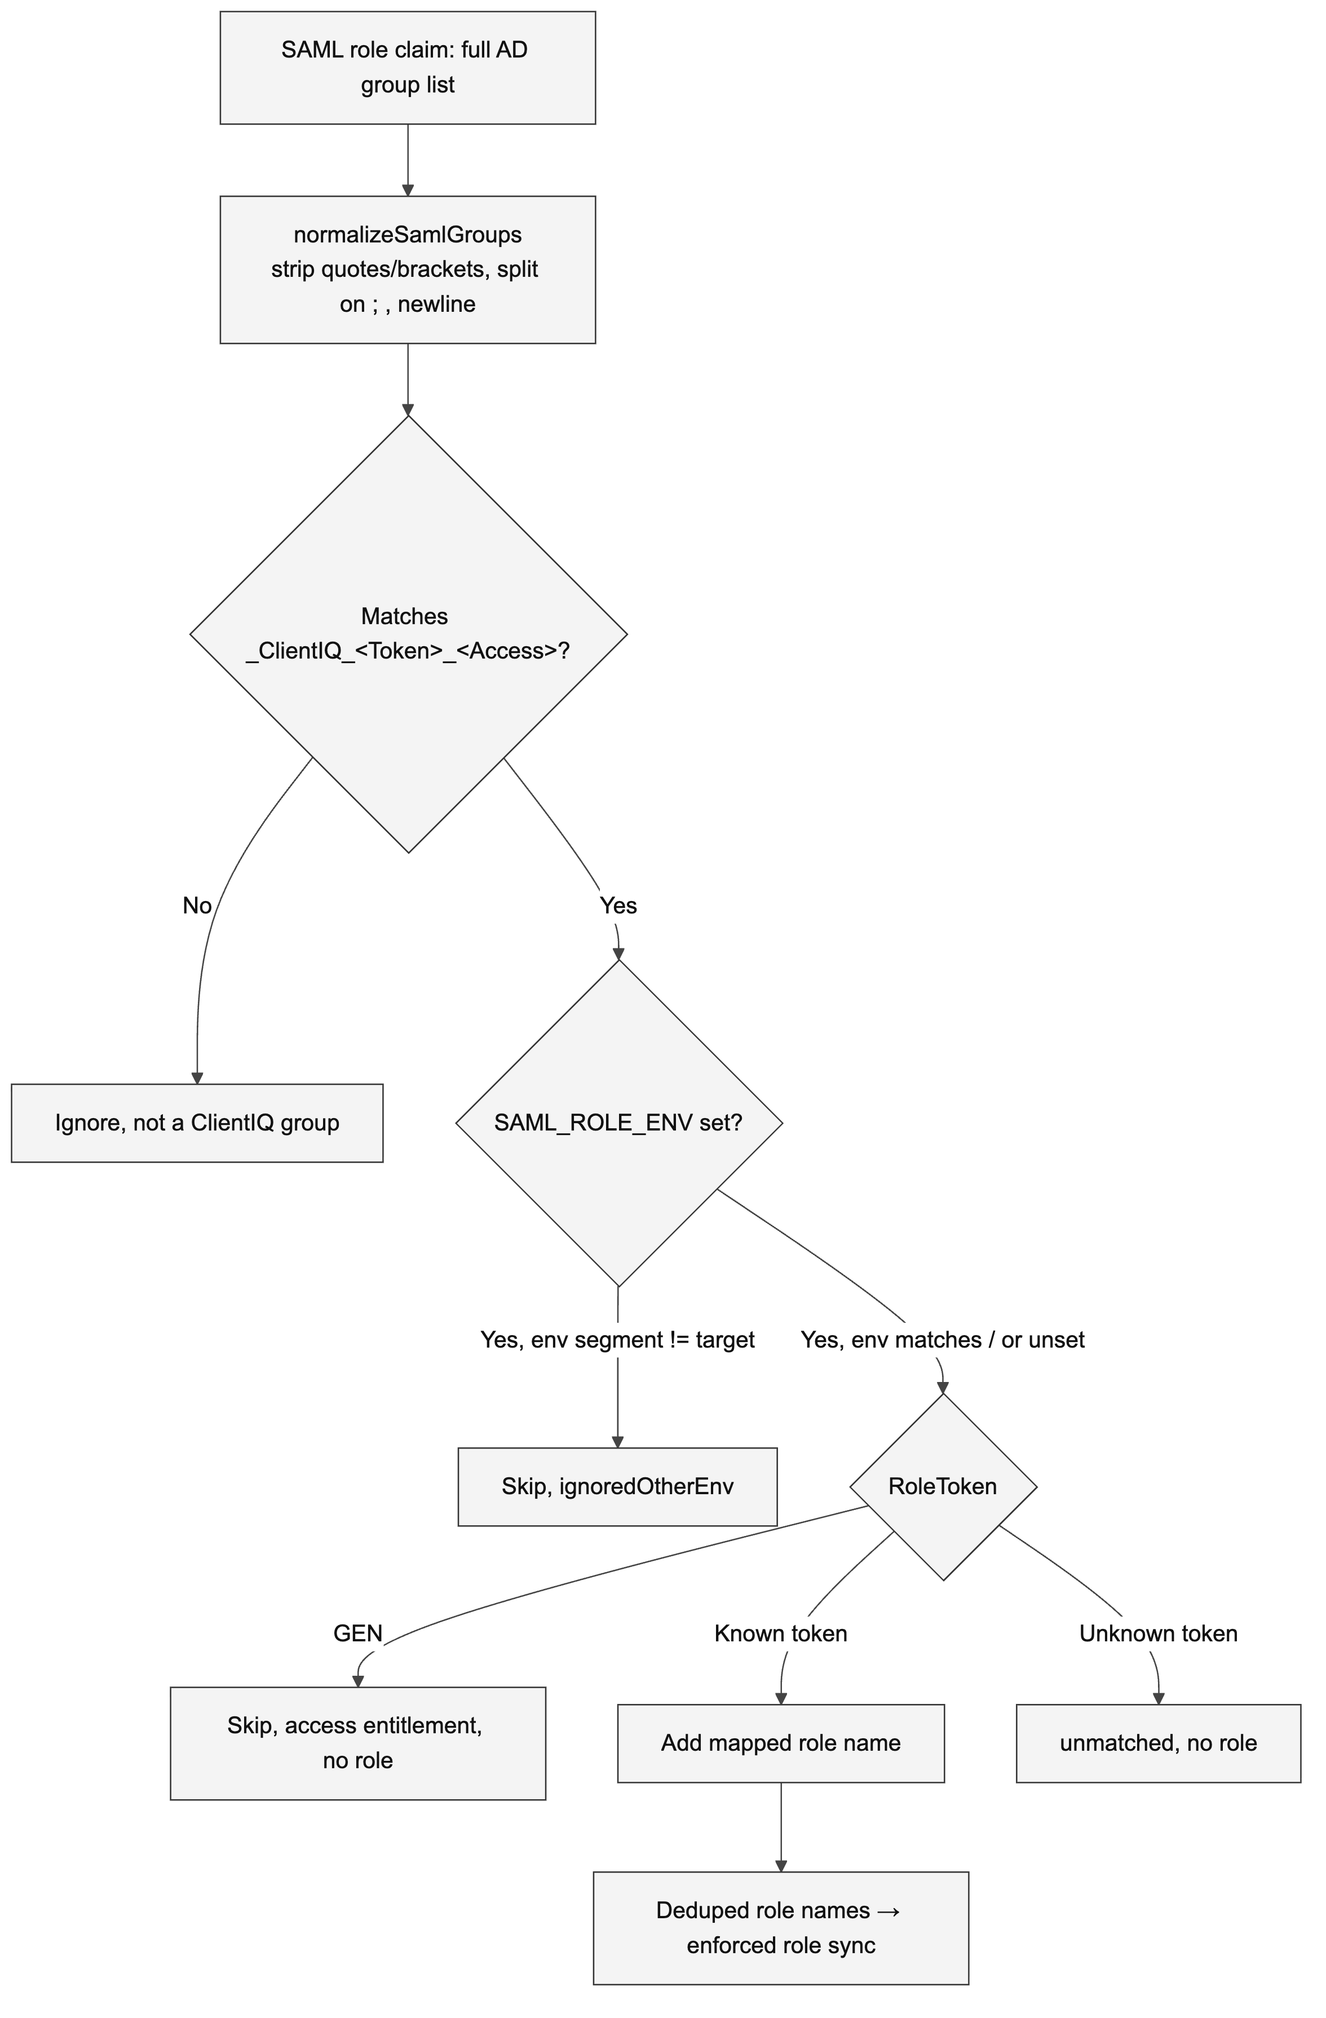

4. The administrative group: token differs by environment
The code comment (adGroupRoleMap.ts:27-39) documents that the admin group token
differs by environment, per the bank's IdP entitlement list:
- Preprod uses the APPSVCS token, in the form CTRL_PRE_..._APPSVCS_ADM.
- dev / test / stg / prod use the AppAdmin token.

The mapper accepts both tokens and maps each to the System Admin role
(privilege 4); appsvcs and appadmin are both keys in AD_GROUP_TOKEN_TO_ROLE
(adGroupRoleMap.ts:43-44). Because the environment segment is ignored for role
selection, both group-name forms resolve identically.
[CONFIRM] The preprod administrative group name is inconsistent between sources:
the legacy registry lists CTRL_STG_APP_ClientIQ_AppAdmin_ADM (STG + AppAdmin),
while the code comment describes CTRL_PRE_..._APPSVCS_ADM (PRE + APPSVCS) as the
preprod form. Confirm the exact preprod admin group name and its <ENV> segment with
the IAM/AD entitlement source of truth. Note: whichever form is registered, both the
APPSVCS and AppAdmin tokens resolve to the System Admin role, so role assignment
is unaffected; this is a registry-naming discrepancy, not a mapping error.If the preprod admin group uses the PRE env segment, verify it is honored under
SAML_ROLE_ENV=STG: the env normalizer maps the variable value PRE → STG, but
the group's own <ENV> segment is matched by GROUP_ENV_RE
(/^[A-Za-z]+_(DEV|TST|STG|PRD)_APP_/i, adGroupRoleMap.ts:67), which recognizes
only DEV/TST/STG/PRD. A group whose segment is literally PRE would not
match the target env STG and would be skipped as ignoredOtherEnv.

5. The GEN access entitlement and the default-role safety net

GEN: app access only, no role
The GEN token (e.g. IAM_<ENV>_APP_RSA_ClientIQ_GEN_EXEC) is the "may access the
app" entitlement. It is in ACCESS_ONLY_TOKENS (adGroupRoleMap.ts:60-61) and is
skipped during mapping (adGroupRoleMap.ts:152-153); it grants no application
role by itself. A user who holds only GEN/RSA access is authenticated but has no
AD-derived role, so they receive the configured default role rather than being blocked.

Default / fallback role
When a user's groups map to no ClientIQ role (or when the resolved role names are
absent from the role table), the enforced role sync applies the fallback role
SAML_DEFAULT_ROLE_NAME (default Branch Manager)
(server/routes/auth.ts:357; server/storage/sqlServerEmployee.ts:359).
A two-tier "never strand a user" guarantee ensures an authenticated RSA user is never
left role-less:
- In the sync: if AD groups yield no role, the fallback role is applied
(sqlServerEmployee.ts:367-372).
- Bulletproof ACS fallback: after permissions load, if the user still has zero
roles, ensureEmployeeHasDefaultRoleSqlServer() grants the default role
(server/routes/auth.ts:412-424; server/storage/sqlServerEmployee.ts:208-290).

The user is stranded on "Awaiting Role Assignment" only if even the fallback role
itself is missing from the role table (defaultRoleMissing,
server/routes/auth.ts:428-430): a genuine misconfiguration.

6. Pre-prod (STG) group registry
The pre-prod deployment runs with SAML_ROLE_ENV=STG and therefore honors only the
STG-segment ClientIQ groups below. The Resolved role and Privilege columns
are code-verifiable (server/auth/adGroupRoleMap.ts:41-58); the Owner and Data
classification columns are governance metadata that is not represented in the
codebase and must be confirmed (see the [CONFIRM] note at the end of this section).
AD security group | RoleToken | Resolved ClientIQ role | Privilege | Purpose
CTRL_STG_APP_ClientIQ_Teller_RO | Teller | Teller | 1 | Access for Tellers.
CTRL_STG_APP_ClientIQ_Risk_RO | Risk | Risk Analyst | 1 | Access for Risk users.
CTRL_STG_APP_ClientIQ_LoanOfficer_RW | LoanOfficer | Loan Officer | 2 | Access for Loan Officers.
CTRL_STG_APP_ClientIQ_DataAnalyst_RO | DataAnalyst | Teller | 1 | Access for Data Analysts. Maps onto Teller permissions; there is no separate Data Analyst role.
CTRL_STG_APP_ClientIQ_Compliance_RO | Compliance | Compliance Officer | 1 | Access for Compliance users.
CTRL_STG_APP_ClientIQ_BusinessBanker_RW | BusinessBanker | BRS | 2 | Access for Banking Relationship Specialists / Lending Specialists. Requires a BRS role row (§2).
CTRL_STG_APP_ClientIQ_BranchManager_MOD | BranchManager | Branch Manager | 3 | Access for Branch Managers and Operations Managers.
CTRL_STG_APP_ClientIQ_AppAdmin_ADM | AppAdmin | System Admin | 4 | Administrative access. See §4 re: the APPSVCS/PRE preprod naming discrepancy.
IAM_STG_APP_RSA_ClientIQ_GEN_EXEC | GEN | (none: access entitlement only) | n/a | RSA "may access the app" entitlement. Grants no role by itself; user receives the default role (§5).

Reminder: the access suffix (RO/RW/MOD/ADM/EXEC) is descriptive only and does
not change the granted role; the actual permission set comes from the resolved role's
privilege level and grants (see the RBAC documentation).
[CONFIRM] The group owner and data-classification for each group must be
confirmed with the IAM/AD governance team. These fields are outside the code's scope
and are not verifiable from source. The legacy registry recorded them as:
Data Classification Confidential for all groups; owners, Teller/LoanOfficer/
BusinessBanker/BranchManager: Operations Administration Manager; Risk: Risk
Manager; Compliance: Compliance Manager; DataAnalyst/AppAdmin: Application
Services Manager. Validate each against the current group owner of record.

7. Production (PRD) group registry
Production is a distinct HA deployment (two app servers, Deploy_Prod +
Deploy_Prod2) that runs with SAML_ROLE_ENV=PRD and therefore honors only the
PRD-segment groups. By the naming convention (§1) and the same RoleToken mapping
(§2), the production groups mirror the pre-prod set with a PRD env segment, for
example CTRL_PRD_APP_ClientIQ_BranchManager_MOD → Branch Manager
(adGroupRoleMap.ts:7) and IAM_PRD_APP_RSA_ClientIQ_GEN_EXEC → access-only.
The RoleToken → role mapping is identical to §2 (the mapper does not distinguish env
for role selection). The production admin group uses the AppAdmin token per the code
comment (§4).
[CONFIRM] The exact production (CTRL_PRD_* / IAM_PRD_*) group names, their
owners, and data classifications are not present in the codebase. Confirm the full
production group registry with the IAM/AD governance team. The application code
resolves any CTRL_PRD_APP_ClientIQ_<RoleToken>_<Access> group by its RoleToken per
the §2 mapping regardless of the exact registered name.

8. Operational reference
Concern | Detail | Source
Where mapping lives | Convention-based code mapper; no DB table on the login path | server/auth/adGroupRoleMap.ts
How groups arrive | SAML role claim (multi-valued array or delimited string), parsed by normalizeSamlGroups | adGroupRoleMap.ts:102-114
Which segment picks the role | RoleToken only; ENV + Access suffix ignored | adGroupRoleMap.ts:12-15, :64
Env scoping | SAML_ROLE_ENV (STG=preprod, PRD=prod); unset = all envs | adGroupRoleMap.ts:78-86, :143-150
Access-only token | GEN → no role → default role | adGroupRoleMap.ts:60-61, :152-153
Default role | SAML_DEFAULT_ROLE_NAME, default Branch Manager | server/routes/auth.ts:357, :412-430
Role names required in DB | System Admin, Branch Manager, BRS, Teller, Loan Officer, Risk Analyst, Compliance Officer | adGroupRoleMap.ts:22-25
Role reconciliation | AD-derived roles are re-synced (assigned/revoked) every login; admin-granted roles are never auto-revoked | server/storage/sqlServerEmployee.ts:355-468

For how resolved roles translate into permissions and how role sync reconciles
employee_role on each login, see the RBAC and SAML/AD documentation.

