ClientIQ / Banking Client 360: System Architecture
Last reviewed: 2026-07-01 · Source of truth: application code (ClientIQ / Banking Client 360).

Purpose & Overview
ClientIQ (also branded "Banking Client 360") is an on-premise customer-360 CRM for Farmers &
Merchants Bank (FMB). It gives bank staff a unified view of customers, households, accounts,
transactions, contacts, and notes, sourced from the Jack Henry core-banking data platform.
This is the single authoritative system-architecture document. It supersedes the earlier
"ClientIQ Architecture V2.2" overview and the retired enterprise-architecture blueprint, both of
which described aspirational or incorrect designs. Every statement here is grounded in the
application source code and infrastructure scripts in this repository, or explicitly flagged for
human confirmation where the fact lives outside the codebase.
Technology at a glance:
Layer | Technology
Web / proxy tier | IIS on Windows Server (TLS termination, reverse proxy to Node); see §3
Application runtime | Node.js + Express + TypeScript, run via tsx
Frontend | React 18 + Material-UI single-page app (Vite build)
Database | Microsoft SQL Server (only)
Authentication | RSA SecurID Access SAML 2.0 SSO (preprod & prod); local/mock auth (dev & test)
CI/CD | Azure DevOps pipeline; PowerShell-remoting deploy to a Windows Service

[CONFIRM] Document version and owner. package.json reports version 1.0.0; treat the
published doc version, owner, approvers, and distribution list as organizational metadata a human
must supply. Reconcile against any existing governance record.

1. Architectural Principles
- On-premise, Windows-native. The app runs as a Windows Service on Windows Server hosts under
C:\ClientIQ, fronted by IIS, backed by SQL Server. There is no cloud/container tier.
- Single database engine, SQL Server. All runtime data access targets Microsoft SQL Server.
The runtime connection manager (server/dbConnection.ts) is SQL-Server-only.
- Read-oriented CRM over core-banking data. ClientIQ is primarily a read/aggregate surface over
data groomed from Jack Henry views; the only substantial write surface is the Notes module and
RBAC/role administration.
- Defense in depth for access control. Enterprise SSO (SAML/RSA) for authentication; RBAC with
privilege-level inheritance plus limited ABAC for authorization; a unified audit-event stream.
- DTO boundary. Adapters map database rows to API DTOs and mask PII (e.g. tax id) before it
leaves the server.

2. Layered Component Architecture
ClientIQ is a layered TypeScript monorepo: a React SPA (client/), an Express API (server/), and
shared types/validation (shared/schema.ts). A single Node process serves both the API and the
compiled/served SPA on one port.
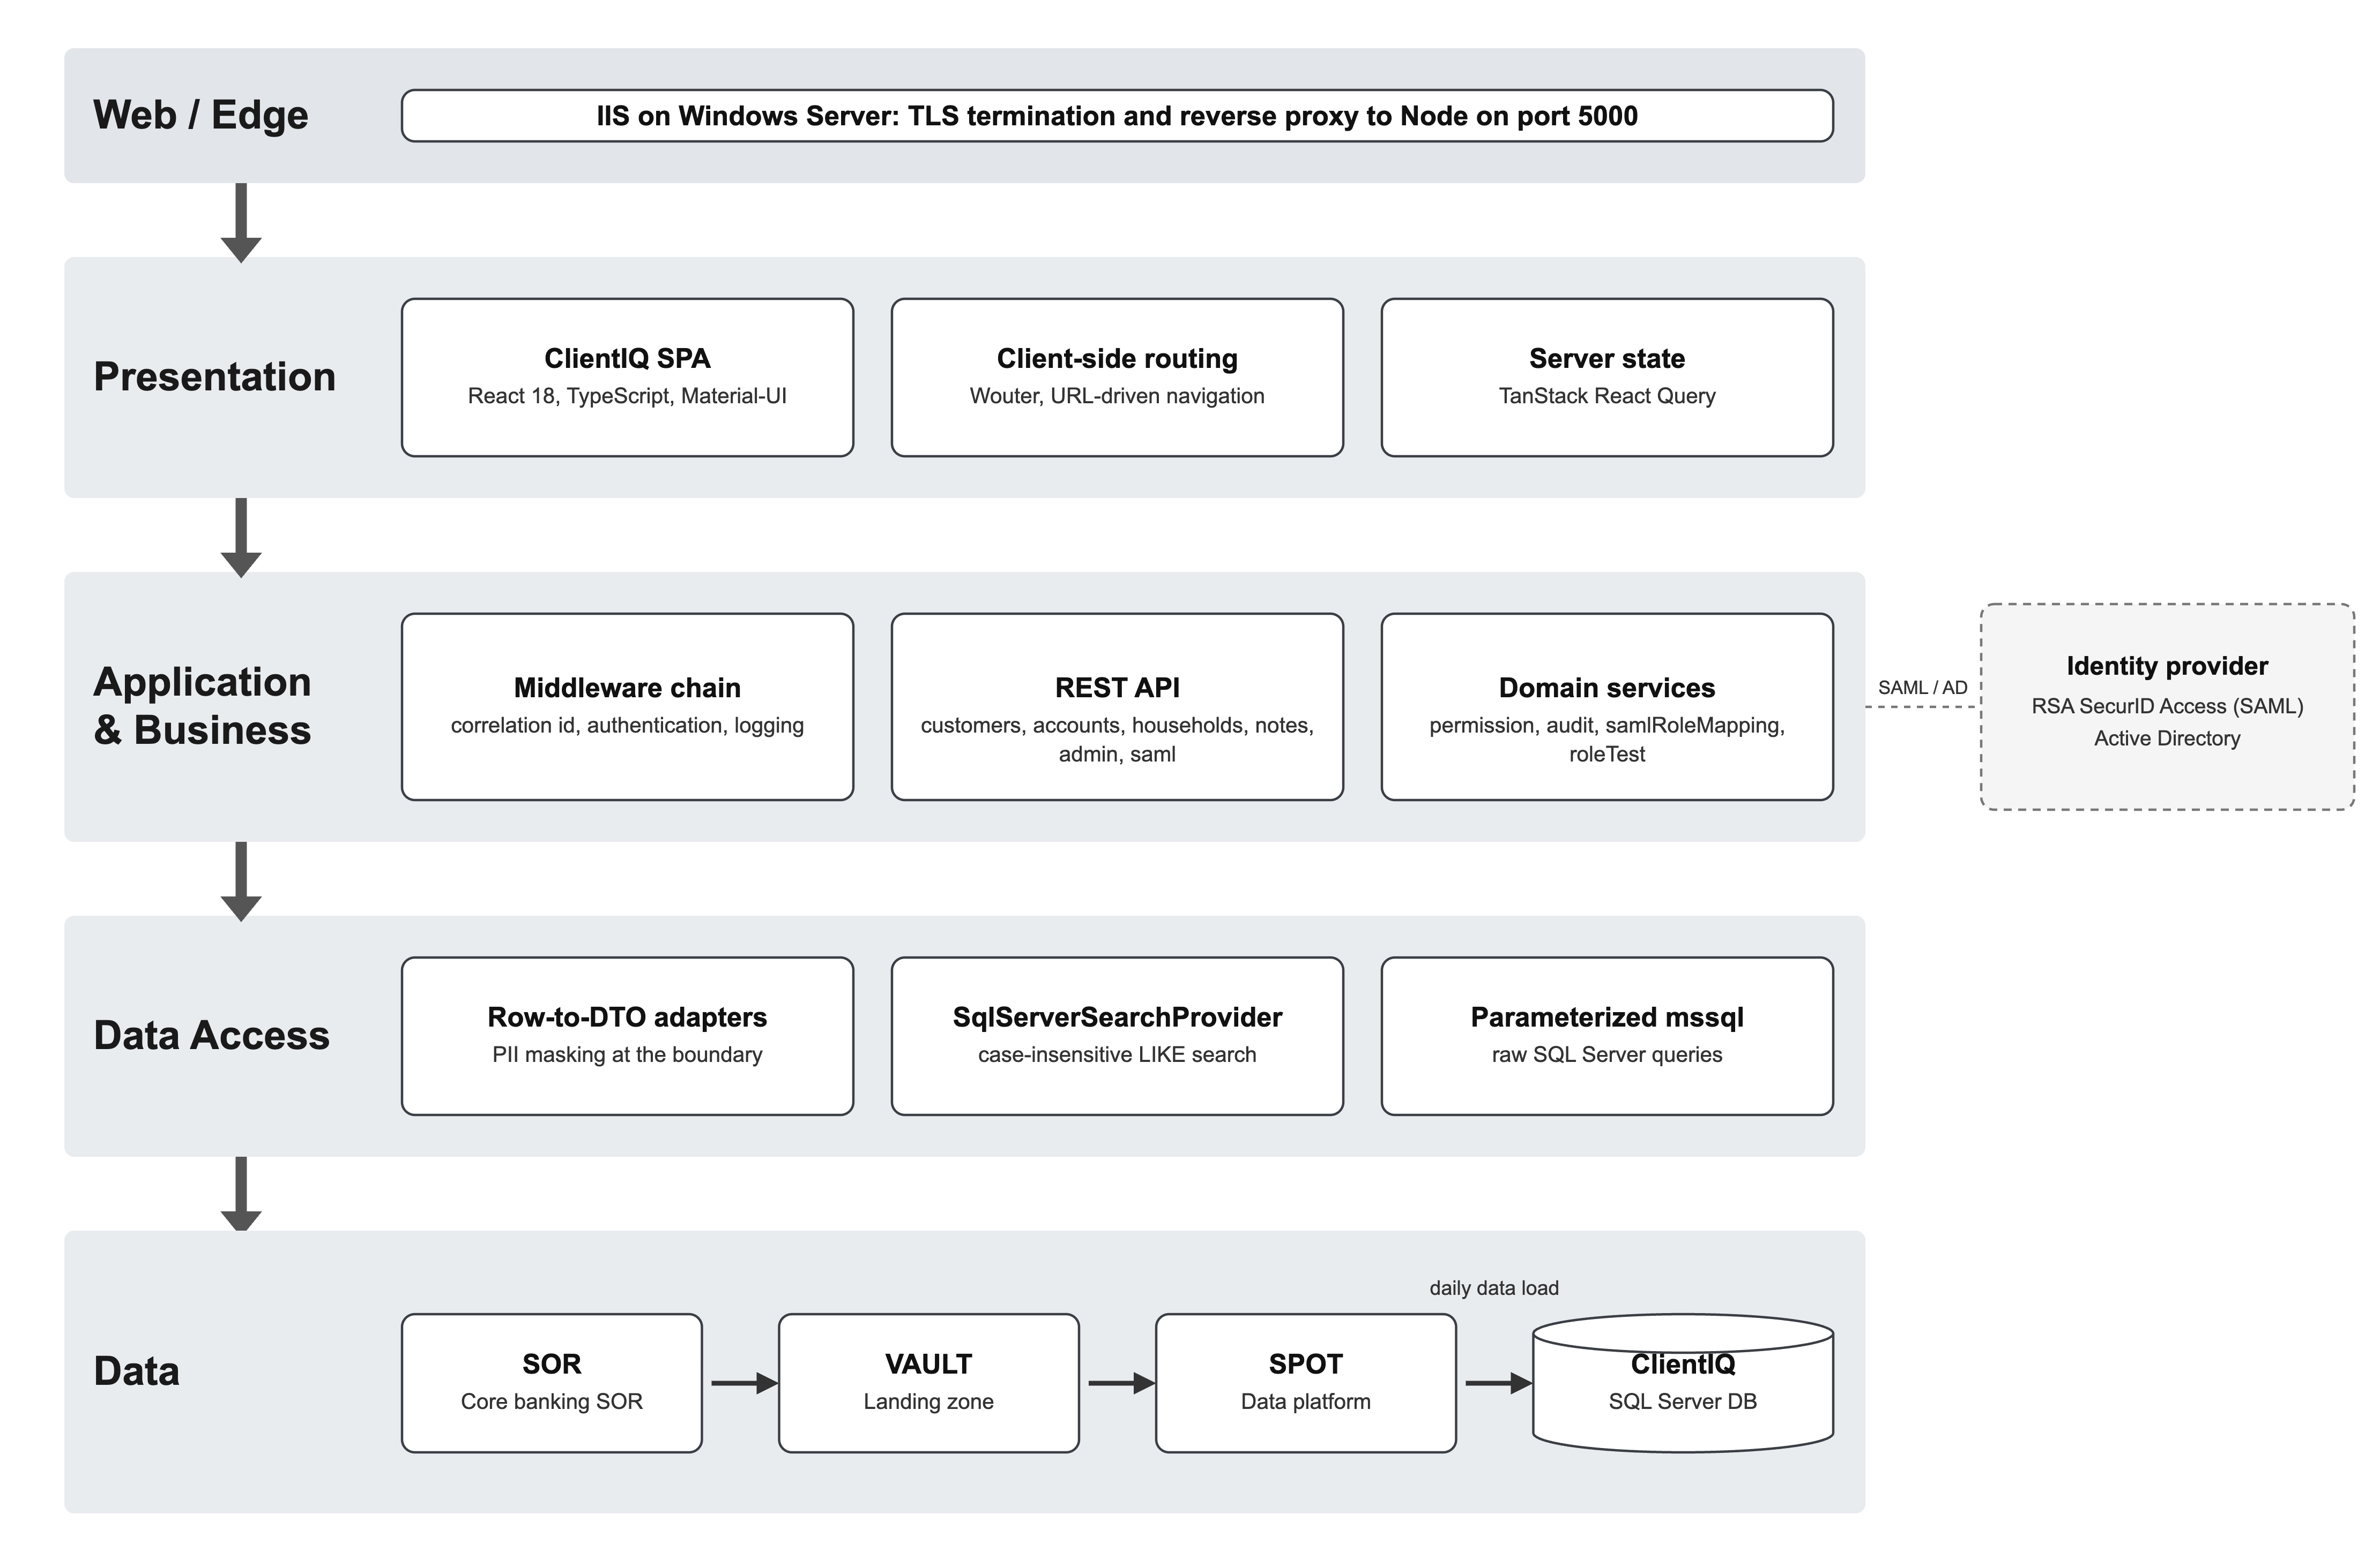

2.1 Presentation layer (client/)
- React 18 + TypeScript SPA, built with Vite. UI is predominantly Material-UI (MUI); the shell uses
a neutral gray theme while page bodies re-theme to the green/gold banking palette (#1b4d20).
- Routing is client-side via wouter; URL query params (customerId, householdId, accountId)
are the source of truth for the selected entity (client/src/lib/navigation.ts).
- Server state is managed by TanStack Query (client/src/lib/queryClient.ts), fetching with
credentials: include.
- Primary screens: the Client dashboard (/ciq/client), Accounts (/ciq/accounts), Household
(/ciq/household), and the admin User Management page (/admin/users).
- Global search box lives in the header (client/src/components/CustomerSearch.tsx), debounced
250 ms, calling GET /api/customers/search.
- The on-page tab strip in CustomerDashboard is commented out; navigation between
Client/Accounts/Household is via the left navbar + URL, not an on-screen tab bar.

2.2 API layer (server/routes.ts, server/routes/)
- Express REST endpoints. Routes are unversioned: there is no /api/v1 / /api/v2 prefix and
no X-API-Version header anywhere in the codebase. The surface is /api/customers,
/api/accounts, /api/households, /api/notes, /api/admin/*, /api/auth/*, and the SP
endpoints /saml/*.
- Request bodies validated with Zod schemas from shared/schema.ts.
- Middleware order (server/index.ts:13-67): correlationIdMiddleware → express.json /
urlencoded → authentication branch (SAML or dev-mock) → requestLoggerMiddleware. A JSON error
handler and the SPA-serving branch are registered inside the async bootstrap.

2.3 Business-logic & services layer
- Adapters (server/adapters/) map DB rows to API DTOs and enforce that DB column names never
leak to the frontend. customerAdapter masks the tax id to XXX-XX-<last4>.
- permissionService resolves a user's effective permissions and evaluates permission checks.
- auditService classifies and persists audit events to audit_event.
- roleTestService allows an admin to preview another role's permission set (disabled in
production).
- samlRoleMappingService provides admin CRUD over the saml_role_mapping table (see
§6.4; not on the login path).
- Search is provided through SearchProviderFactory, which returns a SqlServerSearchProvider
in production (see §5).

2.4 Data-access layer
- Production data access is via the mssql driver against SQL Server. server/dbConnection.ts
builds a single lazily-initialized connection pool (see §4.1).
- shared/schema.ts provides Drizzle-derived TypeScript types and Zod insert schemas used across
the app. These are a type-generation layer only; they are not a second runtime database
engine (see §4.2).
- The production RBAC and employee read/write path uses raw parameterized mssql queries in
server/storage/roleManagement/sqlServer.ts and server/storage/sqlServerEmployee.ts.

2.5 Integration surfaces
- Jack Henry data platform: the SQL Server database is groomed from Jack Henry views (see
§7).
- RSA SecurID Access (SAML IdP): enterprise SSO in preprod and prod (see
§6).

3. Deployment Topology
ClientIQ runs in four environments: dev, test, preprod, and prod. Each of dev, test, and
preprod runs a single application server and a single SQL Server database; prod is the
high-availability tier with a load-balanced app pair.
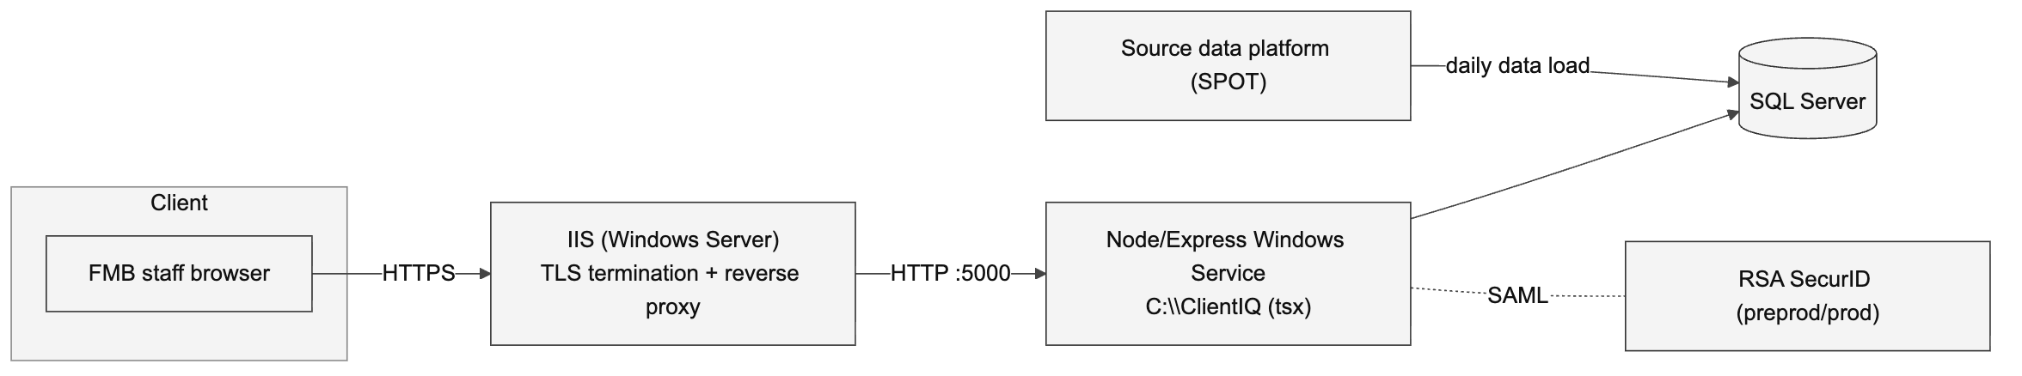

3.1 Environment / host matrix
Hostnames and cluster names below are from the ClientIQ logical diagram (2026-06-29).
Environment | App host(s) | App hostname | SQL Server host | Databases
Dev | CIQ-DEVAPP01 | dev-clientiq.fmb.com | Always On cluster HUB-SQL1TST-LIS | ClientIQ, RBR
Test | CIQ-TSTAPP01 | test-clientiq.fmb.com | PYT-TSTAPP01 | ClientIQDev, RBRDev
PreProd | CIQ-PREAPP01 | preprod-clientiq.fmb.com | DLK-SQL01 | ClientIQPreProd, RBRPreProd
Prod | Load-balanced CIQ-APP01, CIQ-APP02 | clientiq.fmb.com | Always On cluster CIQ-SQL01-LIS | ClientIQ, RBR

Notes:
- The database/host names above are as drawn on the logical diagram and are not derivable from the
application code. See the [CONFIRM] block below.
- Local developer runs use Start-Dev.ps1, which points at test SQL Server HUB-SQL1TST-LIS,
database ClientIQdev.

[CONFIRM] Real host FQDNs, cluster membership, load-balancer product/config for the prod app
pair (CIQ-APP01 / CIQ-APP02), IIS site bindings and ARR/reverse-proxy configuration, TLS
certificate owners and paths, and the exact prod database topology. None of these are defined in
the repository; validate with FMB infrastructure/ops.

3.2 Web / proxy tier: IIS
- The Node application listens on plain HTTP, port 5000, bound 0.0.0.0
(server/index.ts:98-102). A single un-firewalled port serves both the API and the client;
the code comment states all other ports are firewalled at the host/infra level.
- SAML callback/entity/entrypoint URLs are all https:// (portal.fmb.com,
<SAMLHost>/saml/acs), and the Node process has no TLS listener of its own. IIS terminates TLS
and reverse-proxies to the Node process on HTTP :5000.
- The IIS site configuration (bindings, certificates, ARR rewrite rules) is not stored in this
repository.

[CONFIRM] IIS binding specifics (site names, host headers, ports), the TLS certificate
(issuer, owner, path, renewal), and ARR/URL-Rewrite rules that forward clientiq.fmb.com traffic
to http://127.0.0.1:5000.

3.3 Application runtime: Windows Service via tsx
The application is installed to C:\ClientIQ and runs as a Windows Service on each app host. Logs
are written to C:\ClientIQ\logs\ (errors.log).
Runtime configuration note (dev/prod mismatch). The Azure DevOps deploy generates a
C:\ClientIQ\Start-Server.ps1 that launches the app with
npx tsx watch --clear-screen=false server/index.ts and NODE_ENV=development
(PipelineTemplates/start-script.yml). It runs TypeScript directly from source, not the
compiled dist/index.js, and not NODE_ENV=production. Consequences:The npm start "production" path (NODE_ENV=production node dist/index.js) exists in
package.json but is not what the pipeline deploys.
[CONFIRM] Whether the Windows Service definition (or a service wrapper env) overrides
NODE_ENV/SAML_ENABLED for preprod/prod at runtime. The service-to-script binding is configured
outside this repository.

3.4 CI/CD: Azure DevOps
CI/CD is an Azure DevOps pipeline (azure-pipelines.yml) with reusable templates under
PipelineTemplates/. Preprod and prod deploy from Azure DevOps branches, not from GitHub main.
Pushing to GitHub main deploys nowhere.
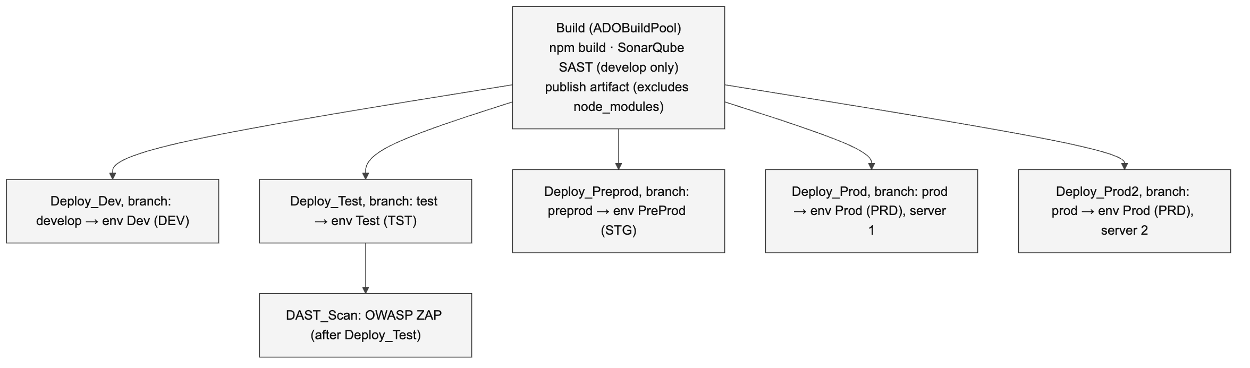
Branch | Stage | ADO environment | Variable group | SAMLRoleEnv → SAML_ROLE_ENV
develop | Deploy_Dev | Dev | VG-Dev | DEV
test | Deploy_Test (+ DAST_Scan) | Test | VG-Test | TST
preprod | Deploy_Preprod | PreProd | VG-Preprod | STG
prod | Deploy_Prod | Prod (server 1) | VG-Prod | PRD
prod | Deploy_Prod2 | Prod (server 2) | VG-Prod2 | PRD

Pipeline behavior:
- Build stage runs npm run build (Vite client build + esbuild server bundle). npm ci on the
build agent runs only when the commit message contains the literal string npm ci. The
published artifact excludes node_modules, PipelineTemplates/, azure-pipelines.yml, and
.git/. The private npm registry is the FMB Nexus proxy
(farmers-merchants-bank.repo.sonatype.app).
- SonarQube (SAST) runs on the develop branch only.
- OWASP ZAP (DAST) runs after the Test deploy (dast-scan.yml) and fails the build on any
high-severity finding.
- Deploy (deploy-nodejs.yml) uses PowerShell Remoting (New-PSSession -ComputerName) to each
target host: copy artifact to C:\ClientIQ → Stop-Service → optional npm ci on the target
(again, only if the commit message contains npm ci) → Start-Service. node_modules on the
target is refreshed only on that gated npm ci.
- Prod is deployed to two servers via two stages (Deploy_Prod, Deploy_Prod2), both gated on
the prod branch.

Pipeline gap (as written): prod is not listed in the trigger: block of
azure-pipelines.yml, yet two prod-conditioned deploy stages exist. A prod deploy therefore
comes from a manual/other trigger not declared in that file.
The four environments are dev, test, preprod, and prod as listed above; there is no separate
user-acceptance tier, no GitHub-main-driven promotion, no blue-green cutover, and no Docker,
Kubernetes, Helm, or GitHub Actions in this system. Deployment is the Azure DevOps +
PowerShell-remoting Windows-Service model described above.

4. Data Architecture

4.1 Connection management
- server/dbConnection.ts ("MS SQL Server only, on-prem deployment") builds an mssql
ConnectionPool from environment variables and exposes getDatabase() returning
{ type: 'mssql', pool }.
- Connection config (server/dbConnection.ts:22-39): user/password/server/database from
MSSQL_* (falling back to DB_*, then defaults localhost / ClientIQ); options
encrypt: true, trustServerCertificate: (NODE_ENV === 'development'), enableArithAbort: true,
30 s connect/request timeouts.
- Connection pool: max: 10, min: 0, idleTimeoutMillis: 30000. The pool is a lazily
initialized module-level singleton.

Connection-encryption reality (not the clean "TLS 1.3/TDE" picture): all deploy/start scripts
set MSSQL_ENCRYPT="false" and MSSQL_TRUST_SERVER_CERTIFICATE="true". The main pool hard-codes
encrypt: true but derives trustServerCertificate solely from NODE_ENV==='development' (and
the pipeline runs with NODE_ENV=development). The session-store connection honors the
MSSQL_ENCRYPT/MSSQL_TRUST_SERVER_CERTIFICATE vars instead. Net: DB-link encryption cannot be
confirmed as "TLS 1.3 enforced" from the repository.
[CONFIRM] SQL Server TDE (encryption at rest), enforced TLS for DB connections, backup
cadence/retention, and Always On availability-group configuration, all ops-layer facts not
present in the repository.

4.2 Schema and type-generation
- shared/schema.ts defines 35 tables used for TypeScript type inference ($inferSelect) and
Zod insert schemas consumed app-wide. This schema file is a type-generation and
validation layer; the physical production database is Microsoft SQL Server and is managed by
the SQL scripts described in §4.4 and by manual DDL.
The Drizzle Kit CLI (drizzle-kit, db:push) is a developer tool and is not applied to the
production SQL Server.
- ID convention: primary keys are BIGINT IDENTITY; foreign keys are BIGINT. Natural-key PKs
exist on sic_code and privilege_level. Junction tables use composite unique/primary keys.
Note: SQL Server returns BIGINT values as JavaScript strings, so numeric coercion is required at
API boundaries.

4.3 Core domain model
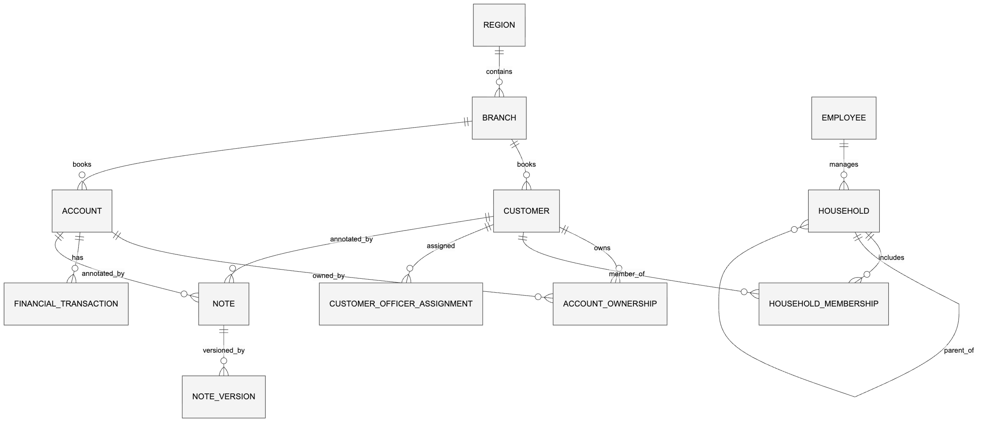
Key entities (from shared/schema.ts):
- customer: central entity. Supports individual and business/organization shapes. Selected
columns: customer_type (varchar, default "regular"), customer_status (default
"active"), tax_identifier (unique), full_name (generated, used for search),
jack_henry_cif_number, silverlake_customer_id, and flags is_employee / vip_customer /
is_deceased.
  - Name/type validation is a Zod discriminated union on customerType
(shared/schema.ts:907-929): individual / premium / regular require first + last name and
forbid business_name; business / trust require business_name and forbid first/last name.
There is no estate type and no CK_customer_name_type CHECK constraint; the only
DB-level CHECK in the schema is note.check_note_one_target.
- account: account_number (unique), type/subtype/status, balances, branch_id FK, and
core-banking identifiers (jack_henry_account_id, silverlake_account_structure).
- household / household_membership: households with a relationship-manager FK to
employee, B2B self-referencing parent/subsidiary hierarchy, and ownership-percentage on
membership rows.
- financial_transaction: account_id is nullable; the ETL now pivots joins on
account_number (denormalized onto the transaction row). Includes amount, transaction/posting
dates, category FK, running balances, source_system (default "jack_henry"), and a
dedup unique key on (account_id, source_system, source_transaction_id).
- employee: HR identity plus SAML/SSO fields: sso_subject (unique), email,
last_seen_saml_role (widened to NVARCHAR(MAX) in SQL Server, see
§4.4), last_login_at.
- Notes module: note (immutable identity + target reference), note_version (content +
full version history, one current version enforced), note_category (hierarchical),
note_audit_log. Supports soft delete, legal hold, visibility levels, and PST timestamp
formatting.
- RBAC tables: privilege_level, role, permission, role_permission, employee_role,
saml_role_mapping, plus audit/history tables (see §8).

4.4 Schema-change & infrastructure scripts
Production SQL Server schema is managed by idempotent scripts under scripts/ and
Insert Queries/Schema Changes/, not by Drizzle Kit. Notable scripts:
- scripts/create_audit_event_table.sql: creates dbo.audit_event and its 7 indexes.
- scripts/create_sessions_table.sql / scripts/fix_sessions_table.sql: the connect-mssql-v2
session store (see §6.5).
- scripts/create_performance_indexes.sql: post-load nonclustered indexes on
financial_transaction, account_ownership, account, and customer.
- scripts/ensure_branch_manager_role.sql: guarantees a Branch Manager role exists so SAML
auto-provisioned users always get a default role.
- scripts/ensure_rbac_provenance_columns.sql: adds employee_role.assigned_by (AD-derived vs
admin-assigned provenance) required by enforced role sync.
- scripts/widen_employee_last_seen_saml_role.sql: widens employee.last_seen_saml_role to
NVARCHAR(MAX) (IdPs can send the full multi-KB AD group list; the prior varchar(255) caused
SQL Server truncation errors that stranded SSO users).
- Insert Queries/Schema Changes/: adds and backfills the denormalized
financial_transaction.account_number and note.cif_number columns.

Note: scripts/validate-schema.js and drizzle.config.ts are developer-tooling artifacts of the
Drizzle type layer; they do not reflect the production SQL Server schema and should not be treated
as authoritative for it.

5. Search
Global search is a single unified box (GET /api/customers/search) returning results grouped into
Clients, Accounts, and Households.
- The search provider is selected at runtime by server/adapters/search/SearchProviderFactory.ts;
in production this resolves to SqlServerSearchProvider.
- Matching is a case-insensitive substring LIKE. The SQL Server query
(server/storage/sqlServerCustomerSearch.ts:37-108) builds a pattern %<query>% and applies
COLLATE Latin1_General_CI_AS LIKE @searchPattern across first_name, last_name,
business_name, full_name, tax_identifier, silverlake_customer_id, and
CONCAT(first_name, ' ', last_name).
- There is no relevance ranking and no full-text index; the search uses plain substring
matching, not CONTAINS / CONTAINSTABLE, and not fuzzy/phonetic scoring. (A header comment in
SqlServerSearchProvider.ts references full-text search, but the executed production path is the
LIKE query above.)
- Balance-bearing identifiers are stripped from a search row when the user lacks
account.view.balances.

6. Authentication & SSO (SAML / Active Directory)
Authentication mode is selected by SAML_ENABLED and NODE_ENV in server/index.ts:21-64:
Mode | Condition | Behavior
SAML SSO | SAML_ENABLED === 'true' | Session + Passport + SAML strategy + global authGate
Dev/mock auth | SAML_ENABLED off and NODE_ENV === 'development' | Injects req.employeeId = 1 (Sarah Johnson, System Admin)
No auth | SAML_ENABLED off and non-development | Logs a warning; no auth mounted

SSO is enabled in preprod and prod only. In dev and test, SAML_ENABLED=false and the app uses
the local/mock auth path.

6.1 Identity provider
- IdP is RSA SecurID Access, reached through the F&M Bank RSA portal (portal.fmb.com). SP =
ClientIQ.
- Library: @node-saml/passport-saml v5 (package.json). RSA signs the SAML Response
wrapper, not the assertion, so both wantAssertionsSigned and wantAuthnResponseSigned are
false (passport-saml still requires at least one signed element). audience validation and
validateInResponseTo are disabled to match the RSA IdP.
- Login is effectively IdP-initiated via the RSA portal tile: RSA only emits a SAMLResponse
when the user launches ClientIQ from the portal, so the app's sign-in page links to the portal
rather than auto-redirecting.

There is no local password store and no password hashing in the application. Authentication is
SSO-only; bcryptjs, although present in package.json, is not imported anywhere in server/.

6.2 Login flow (ACS)
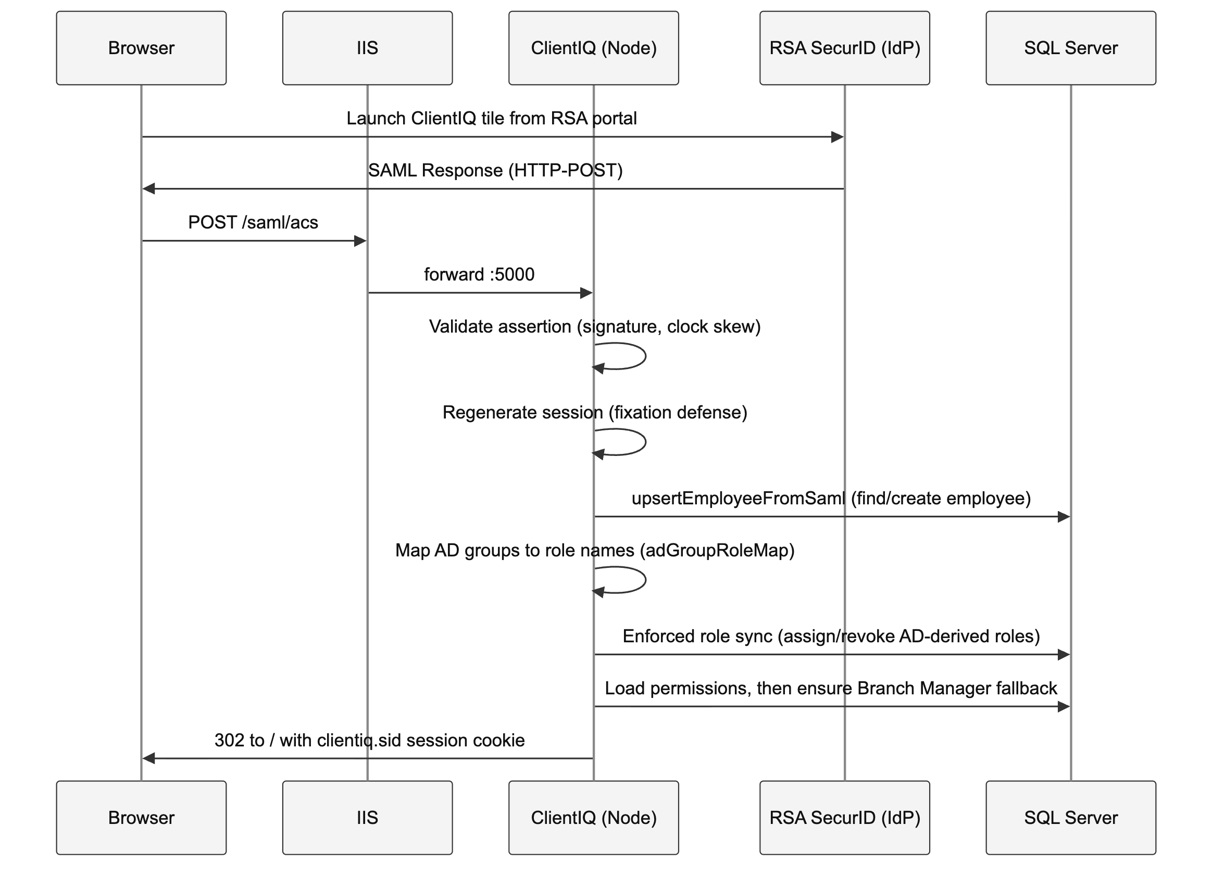
On a successful assertion (server/routes/auth.ts:264-476): the employee is found or auto-created
(auto-creation is safe because RSA already gates who can authenticate), AD-group-driven role sync
runs, the session is populated with roles + permissions, and a bulletproof default-role fallback
runs so an authenticated user is never stranded role-less.

6.3 AD-group → role mapping (code convention)
Role assignment on login is driven by a code-based naming convention
(server/auth/adGroupRoleMap.ts), not by a database mapping table. The AD group list arrives in the
SAML role claim.
- Group convention: <PREFIX>_<ENV>_APP_ClientIQ_<RoleToken>_<Access> (e.g.
CTRL_PRD_APP_ClientIQ_BranchManager_MOD). Only the RoleToken matters; the Access suffix
(RO/RW/MOD/ADM/EXEC) is ignored.
- Environment scoping via SAML_ROLE_ENV (DEV/TST/STG/PRD): because a single on-prem AD
carries every environment's ClientIQ groups, each deployment honors only groups whose env segment
matches its SAML_ROLE_ENV. Unset ⇒ all environments honored. This is why each ADO deploy stage
sets SAMLRoleEnv (dev=DEV, test=TST, preprod=STG, prod=PRD).
- Token → role mapping resolves role names against the role table case-insensitively. The
gen token grants app access but no role; it falls back to the default role.

Role-name dependency: the AD-group map references role names including System Admin,
Branch Manager, BRS, Teller, Loan Officer, Risk Analyst, Compliance Officer. The
BRS role (mapped from the businessbanker/assistantmanager AD tokens) is not created by
the seed or any in-repo migration.[CONFIRM] That a BRS role row exists in each SQL Server environment (or that the AD map
should instead resolve to the seeded Business Banker / Assistant Manager roles). If BRS is
absent, affected users fall back to Branch Manager.

6.4 Two role-mapping mechanisms
- AD-group convention (adGroupRoleMap.ts): the live login path.
- saml_role_mapping table: an admin-managed DB table (CRUD via /api/admin/saml-mappings,
gated by user_management.*). Its role-assignment logic (samlRoleMappingService.processSamlRole)
is not called on login and is dormant in the SQL Server path. It does not drive role
assignment.

6.5 Session store
- Sessions are SQL Server-backed via express-session + connect-mssql-v2
(server/auth/session.ts). The session table is dbo.sessions with columns
sid NVARCHAR(255) PK, session NVARCHAR(MAX), expires DATETIME
(scripts/create_sessions_table.sql). Expired rows are auto-removed every 15 minutes; there is
no cleanup stored procedure.
- Store TTL is 12 hours. The cookie maxAge is 1 hour idle with rolling refresh,
httpOnly, sameSite: 'lax', secure only in production. Cookie name is clientiq.sid.
- sameSite: 'lax' is deliberate: 'strict' would drop the cookie on the redirect chain following
the cross-site SAML HTTP-POST, causing a re-auth loop.

7. Data Pipeline (ETL)
ClientIQ is a read-mostly reporting database, loaded on a daily cadence from the bank's
core-banking data platform. The end-to-end lineage is SOR to VAULT to SPOT to ClientIQ:
- SOR is the core-banking system of record.
- Source records land in VAULT, the landing zone.
- Data then moves from VAULT into SPOT, the data platform that ClientIQ reads from.
- A daily data load populates the ClientIQ SQL Server database from SPOT.

Within the repository, the SPOT feed surfaces as the Jack Henry views (TheSpot, TheSpotPreProd,
and the TheVault landing view). There is no SSIS orchestration, no staging tables, and no
stored-procedure loader in the repository.
- The ETL is a set of hand-run SQL files under Insert Queries/ (plus
Insert Queries/Lookup Tables/ and Insert Queries/Schema Changes/), executed manually in
foreign-key dependency order against ClientIQPreProd.dbo.*.
- Load order (FK-driven): lookups first (branch, note_category, transaction_category) →
customer, employee → address, contact_info, account, customer_officer_assignment →
entity_address, account_ownership, household → household_membership, contact_history,
debit_card, financial_transaction. Every downstream join keys on jack_henry_cif_number,
account_number, officer_code, or branch_code.
- Loaders are largely idempotent via MERGE or NOT EXISTS guards; a few plain-INSERT loaders
(address.sql, contact_info.sql) are not guarded and will duplicate on re-run.
- financial_transaction.sql loads only the last 13 months of transactions and pivots joins on
account_number. Debit cards are loaded only for active checking/business-checking accounts.
- RBAC tables are not loaded by the ETL. SQL Server environments bootstrap RBAC separately via
ensure_branch_manager_role.sql, ensure_rbac_provenance_columns.sql, and
widen_employee_last_seen_saml_role.sql (see §4.4).

A separate faker-based seed (scripts/seed.ts) generates synthetic data for the developer/type
abstraction; it is not the production loader and should not be conflated with the SQL Server ETL.
[CONFIRM] Whether an out-of-repo SSIS/SQL-Agent job (or any scheduled orchestration) drives
these loads on a cadence in preprod/prod, and the actual refresh schedule. The repository shows
only manually executed SQL files; any automated schedule is not evidenced here.

8. Authorization (RBAC + ABAC)

8.1 Privilege levels and roles
- 5 privilege levels (0-4): Read-Only (0), Staff (1), Manager (2), Senior/Branch (3),
System Admin (4). Level 0 is defined but no seeded role uses it.
- 9 seeded roles (scripts/seed.ts:117-127): System Admin (4), Branch Manager (3), Assistant
Manager (2), Loan Officer (2), Business Banker (2), Teller (1), Customer Service Rep (1),
Risk Analyst (1), Compliance Officer (1).

8.2 Effective-permission model
A user's effective permissions are the union of:
- Privilege-level inheritance: every active permission whose min_privilege_level ≤ the
user's max privilege level is granted automatically.
- Explicit role_permission grants: only needed for level-1 roles (which cannot inherit the
level-2 permissions).

There are 11 seeded permissions (e.g. accounts.view, account.view.balances,
transaction.view, customer.view.*, household.view, users.view, users.assign_roles,
user_management.*). Only System Admin (level 4) can assign roles or manage SAML mappings; users
at level ≥3 (Branch Manager, System Admin) can view users.

8.3 Enforcement and gaps
- Server enforcement is via requirePermission middleware (server/middleware/permissions.ts) on
accounts, transactions, and admin routes. The React client mirrors these gates with
PermissionGuard / usePermissions, but the server is the real enforcement point.
- Not every route is permission-gated. The Notes surface (all CRUD) and the
deposit-summary / deposit-trend endpoints are authentication-only: there is no
requirePermission on them and no notes.* permission exists anywhere in schema, seed, or
DB. Any authenticated employee can read/write notes regardless of role.

8.4 ABAC
- The single seeded ABAC permission is transaction.view: viewing the transactions of a
customer who is themselves a bank employee (customer.isEmployee === true) is denied unless the
viewer's privilege level is ≥3.
- This restriction is evaluated by the Drizzle-path permissionService. In the SQL Server path,
permissionService.checkPermission returns { allowed: true } early when the Drizzle db handle
is null, and the SQL Server store's own checkPermission implements branch/region restrictions
instead of the employee-record restriction.

[CONFIRM] Whether the customer.isEmployee (level-3) ABAC control actually fires in the SQL
Server production path. The two ABAC implementations diverge (employee-record vs branch/region),
and the employee-record control may not be enforced unless the SQL Server permission.conditions
data encodes it. Validate against the live SQL Server permission data.

8.5 Role sync & provenance
On each SSO login, enforced sync reconciles AD-derived roles:
- Rows with employee_role.assigned_by IS NULL are AD/system-derived and may be revoked when
the corresponding AD group is no longer present.
- Rows with assigned_by IS NOT NULL are admin-assigned and are never auto-revoked.
- A guaranteed Branch Manager fallback (configurable via SAML_DEFAULT_ROLE_NAME) ensures an
authenticated user is never left role-less unless that role is missing from the role table.

8.6 Not implemented
- The role_change_request approval workflow table exists but has no implementing code.
- role_audit_log has no writer; auditing is done via audit_event, employee_role_history,
and permission_denial_log instead.
- updateUserStatus / employee_status_history writes and the SQL Server getUserById are
unimplemented placeholders.

9. Audit & Observability

9.1 Audit-event stream
- The unified audit table is audit_event (scripts/create_audit_event_table.sql;
shared/schema.ts:854-887), with columns event_id, event_type, category, severity,
correlation_id (uniqueidentifier), employee_id, session_id, ip_address, user_agent, action,
outcome, resource_type/resource_id/resource_name, metadata (JSON), source
(server/client), module, occurred_at, created_at. There is no audit_log or
event_store table.
- server/services/auditService.ts classifies and persists events; shared/auditEvents.ts defines
the taxonomy, categories (authentication, authorization, pii_access, financial_data,
data_modification, admin_action, navigation, search, error) and severities
(critical/high/medium/low).
- Every requirePermission grant and deny emits an authorization audit event; permission denials
also write permission_denial_log.
- Route-level audit middleware (server/middleware/routeAudit.ts) records customer/account/PII
access independently of the RBAC events; correlation IDs are attached per request.

9.2 Logging & health
- Application logging is a custom structured logger (server/services/logger.ts), not Winston.
Default level is debug in development and info otherwise; overridable via LOG_LEVEL.
Deployed stderr is redirected to C:\ClientIQ\logs\errors.log.
- The process forces TZ=America/Los_Angeles (PST) at startup.
- There is no /health route handler in the application. /health appears only as an
authGate allowlist entry; no endpoint currently responds there.

[CONFIRM] Monitoring/alerting, SLA targets, and whether an external health probe is expected
(and if a /health endpoint should be added). These are ops concerns not defined in the
repository.

9.3 PII protection
- Implemented masking: the customer tax id is masked to XXX-XX-<last4> in customerAdapter
before leaving the server; account numbers are masked to the last 5 digits in the UI
(AccountList).

[CONFIRM] SQL Server TDE, TLS 1.3 enforcement, HSM/tokenization, PCI DSS posture, GLBA/Reg
retention schedules, and the 7-year retention claims. These are compliance/ops assertions that
cannot be verified from the codebase.

10. Technology Stack (verified against package.json)
Versions below are read from the live package.json (semver ranges shown as pinned baselines).
Frontend:
Component | Technology | Version
UI framework | React | 18.3.1
Language | TypeScript | 5.6.3
Build tool | Vite | 5.4.19
UI library | Material-UI (MUI) | 7.3.2
Styling | Tailwind CSS | 4.1.3
Server state | TanStack React Query | 5.60.5
Routing | Wouter | 3.3.5
Forms | React Hook Form | 7.55.0
Validation | Zod | 3.24.2
Dates | date-fns | 3.6.0
Charts | Recharts | 2.15.2

Backend:
Component | Technology | Version
Runtime | Node.js | see [CONFIRM] below
Framework | Express | 5.2.1
Language | TypeScript | 5.6.3
SQL Server driver | mssql | 12.0.0
SAML SSO | @node-saml/passport-saml | 5.1.0
Passport | passport | 0.7.0
Session store | connect-mssql-v2 | 6.0.0
Type/schema layer | drizzle-orm / drizzle-kit | 0.39.3 / 0.30.4
TS execution | tsx | 4.19.1
Server bundler | esbuild | 0.25.0

Build scripts (package.json): dev = NODE_ENV=development tsx server/index.ts; build =
vite build && esbuild server/index.ts ... --outdir=dist; start =
NODE_ENV=production node dist/index.js; check = tsc; db:push = drizzle-kit push.
[CONFIRM] The target Node.js runtime version. package.json does not pin an engines.node
value; the ADO build agent's NodeTool version (declared in pipeline variables) is the effective
version; confirm with FMB ops.

11. Known Divergences & Caveats
- Deployed runtime runs from TypeScript source with NODE_ENV=development (tsx watch), so it
uses the Vite dev-middleware path and the dev/mock-auth branch unless SAML_ENABLED=true
(§3.3).
- Two independent dialect/vendor switches in the type/search layers (DATABASE_DIALECT in
dbConfig, DB_VENDOR in SearchProviderFactory) both default to a non-SQL-Server value when
unset; production deploy scripts set DATABASE_DIALECT=sqlserver and DB_VENDOR=mssql. The
runtime data pool is hard-wired to SQL Server regardless.
- Dead deploy-time environment variables: HOST, MSSQL_PORT, SAML_ENTITY_ID, and
SAML_IDP_INITIATED_URL are set by the start scripts but never read by application code (the app
binds 0.0.0.0 in code and uses SAML_ISSUER rather than SAML_ENTITY_ID).
- Plaintext secrets in the repo: Start-Dev.ps1 contains a hard-coded MSSQL password and a
hard-coded SESSION_SECRET.
- prod is missing from the pipeline trigger: block despite having two prod deploy stages
(§3.4).

12. Confirmation Checklist (human input required)
# | Item to confirm | Owner
1 | Document version, owner, approvers, distribution | Doc owner
2 | Host FQDNs, prod LB product/config, DB cluster topology | FMB infrastructure
3 | IIS bindings, TLS cert (issuer/owner/path/renewal), ARR rules | FMB infrastructure
4 | Whether the Windows Service overrides NODE_ENV/SAML_ENABLED in preprod/prod | FMB ops
5 | SQL Server TDE, DB-connection TLS, backup cadence/retention, Always On config | FMB DBA
6 | Existence of BRS role rows in each SQL Server environment | RBAC/AD owner
7 | Whether the employee-record ABAC control fires in SQL Server prod | Engineering
8 | Any out-of-repo SSIS/scheduled ETL job and its cadence | Data engineering
9 | Monitoring/alerting, SLAs, health-probe expectations | FMB ops
10 | Compliance posture (PCI/GLBA), retention schedules | Compliance
11 | Target Node.js runtime version | FMB ops

