Database ERD: ClientIQ / Banking Client 360
Last reviewed: 2026-07-01 · Source of truth: application code (ClientIQ / Banking Client 360).

Purpose
This document is the entity-relationship reference for the ClientIQ (Banking Client 360) data model. It is regenerated directly from shared/schema.ts, which is the single authoritative definition of the schema. It covers all 40 tables, grouped by domain, with the foreign keys, cardinalities, and constraints that actually exist in the code, nothing aspirational.

Database engine
Microsoft SQL Server 2019+ is the only production database engine, in every environment.
The schema in shared/schema.ts is authored using Drizzle's *-core table builder for TypeScript type generation only. Those table objects and drizzle.config.ts are a type/tooling abstraction; they are not a runtime target and are never applied to production. Production DDL is managed by standalone idempotent SQL Server scripts (see Change Management). The production database uses the dbo schema.
Column names in this document use the physical (snake_case) names as they exist in SQL Server; the TypeScript property names in shared/schema.ts are camelCase equivalents.

Table inventory (40 tables)
Domain | Tables | Count
Core Banking | region, branch, employee, address, contact_info, customer, household, account, debit_card_limit_profile, debit_card | 10
Relationship / Junction | entity_address, entity_contact, household_membership, account_ownership, employee_branch, customer_officer_assignment, customer_sic_code, account_sic_code | 8
Reference / Lookup | sic_code, transaction_category | 2
Financial Transactions | financial_transaction | 1
Dashboard / Activity | online_banking_user, online_banking_login_event, contact_history | 3
Notes | note_category, note, note_version, note_audit_log | 4
RBAC / Roles | privilege_level, role, permission, role_permission, employee_role, saml_role_mapping, role_audit_log, permission_denial_log | 8
User Management | employee_status_history, employee_role_history, role_change_request | 3
Audit | audit_event | 1
Total |  | 40

Primary keys are bigint IDENTITY columns unless noted. Because these are 64-bit integers, they are returned to the Node/Express layer as JavaScript strings; coerce with Number() / z.coerce.number() at every boundary.

Core Banking domain
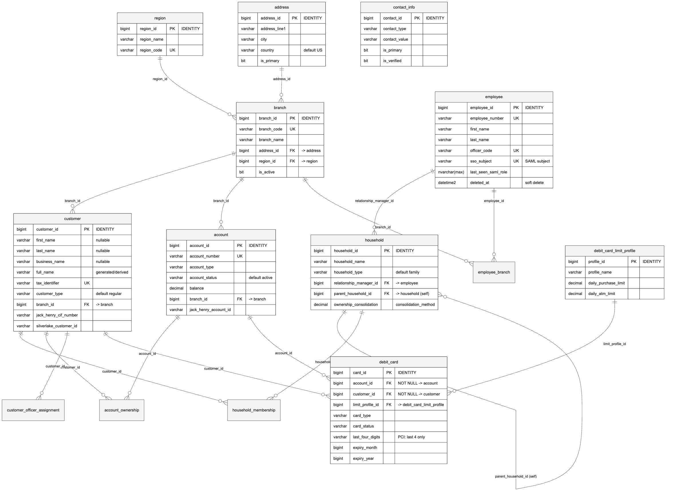
Per-table notes:
- region (schema.ts:24): Geographic region lookup. region_code is unique.
- branch (schema.ts:32): Physical branches. FKs: address_id → address, region_id → region.
- employee (schema.ts:45): Bank staff and system users. Carries the SAML SSO fields sso_subject (unique), email, and last_seen_saml_role (the raw claim last observed at login). Soft-deleted via deleted_at. modified_by is a plain bigint (no FK constraint in the schema).
- address (schema.ts:68): Standalone address records; linked to entities polymorphically through entity_address.
- contact_info (schema.ts:84): Standalone contact records (phone/email/etc.); linked polymorphically through entity_contact.
- customer (schema.ts:100): Individuals and businesses in one table. Individual name fields and business_name are all nullable; the applicable set is enforced by the Zod insertCustomerSchema discriminated union on customer_type (schema.ts:907), not by a DB check constraint. Only FK is branch_id → branch. full_name is a derived column (see Derived columns).
- household (schema.ts:165): Supports B2B hierarchies via self-referencing parent_household_id. FK relationship_manager_id → employee.
- account (schema.ts:188): Deposit/loan accounts. account_number is unique. Its only FK is branch_id → branch. There is no sic_code column or FK on account; account↔SIC classification is modeled via the account_sic_code junction (see below).
- debit_card_limit_profile (schema.ts:453): Reusable card-limit templates.
- debit_card (schema.ts:466): Read-only card display from core banking; stores only last_four_digits, card_brand, and token references (PCI-DSS). FKs: account_id → account (NOT NULL), customer_id → customer (NOT NULL, ties the card to a valid account owner), and limit_profile_id → debit_card_limit_profile (nullable). Card account-type and owner-validation rules are enforced by SQL Server triggers whose DDL is external to shared/schema.ts.

[CONFIRM] Location and current text of the SQL Server trigger(s) that enforce the debit-card business rules (account_type IN ('checking','business_checking') and cardholder-is-account-owner). The rules are documented in a code comment (schema.ts:431-450) but the trigger DDL is not present in shared/schema.ts or the reviewed scripts/ files.

Relationship / junction domain
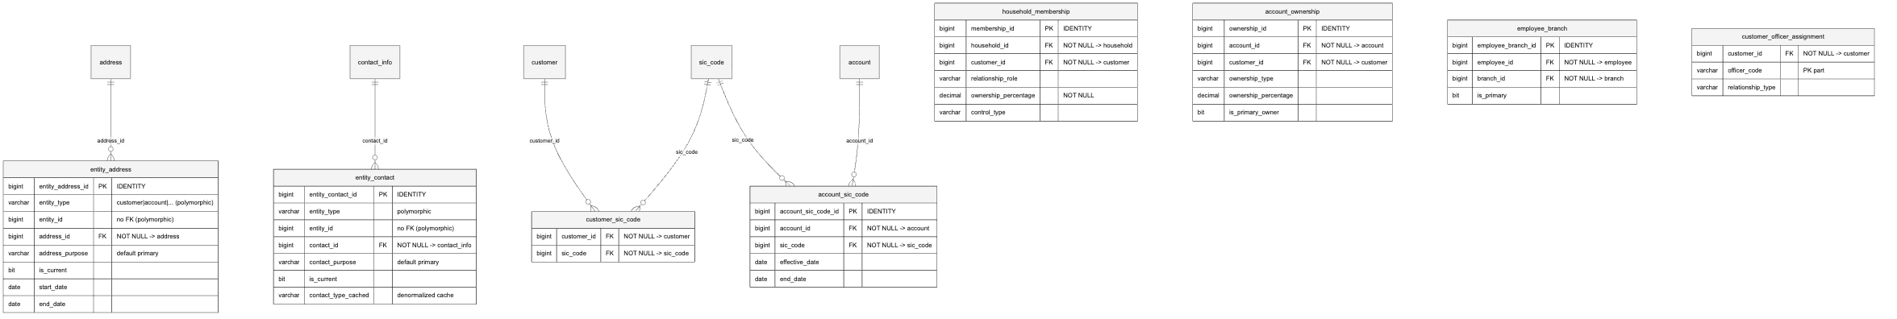
Per-table notes:
- entity_address (schema.ts:222): Polymorphic M:N between any entity and address. entity_id deliberately has no FK (polymorphic, discriminated by entity_type). address_purpose defaults to primary; effective range via start_date / end_date.
- entity_contact (schema.ts:235): Polymorphic M:N between any entity and contact_info. entity_id has no FK by design. Carries a denormalized contact_type_cached column (schema.ts:246).
- household_membership (schema.ts:249): M:N customer↔household with role, ownership_percentage (NOT NULL) and control_type for B2B modeling.
- account_ownership (schema.ts:271): M:N account↔customer with ownership type, percentage, and signing/transaction authority flags.
- employee_branch (schema.ts:288): M:N employee↔branch. Unique key unq_employee_branch (employee_id, branch_id).
- customer_officer_assignment (schema.ts:306): Composite unique key pk_customer_officer (customer_id, officer_code). Links customers to servicing officers by officer_code string (note: officer_code is not a declared FK to employee.officer_code, though employee.officer_code is unique).
- customer_sic_code (schema.ts:335): M:N customer↔SIC. Composite unique key pk_customer_sic (customer_id, sic_code).
- account_sic_code (schema.ts:348): M:N account↔SIC with effective dating. Unique key unq_account_sic (account_id, sic_code). This is how accounts are classified by industry; there is no sic_code FK on account itself.

Reference / lookup and Financial Transactions domain
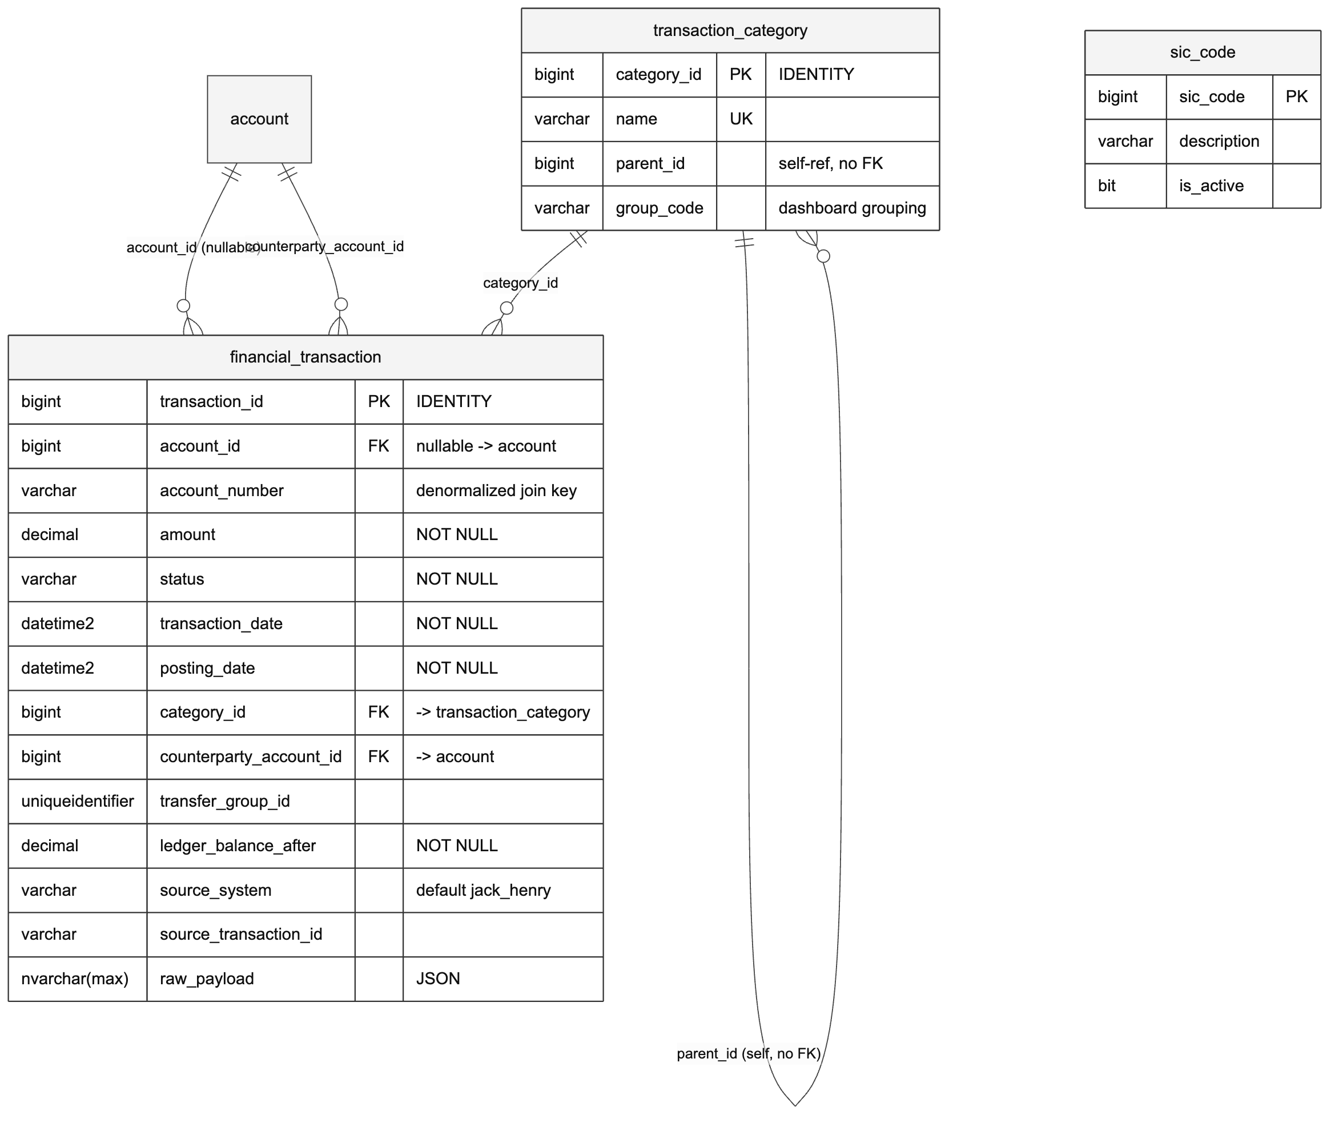
Per-table notes:
- sic_code (schema.ts:324): Standard Industrial Classification lookup. The sic_code numeric value is itself the primary key.
- transaction_category (schema.ts:370): Category lookup. name is unique. parent_id is a self-reference but declared without a FK constraint. group_code drives dashboard activity grouping (e.g. direct_deposit, atm, billpay, zelle, wire, ach).
- financial_transaction (schema.ts:380): Ledger of transactions. Its foreign keys are exactly: account_id → account (nullable), category_id → transaction_category, and counterparty_account_id → account. related_transaction_id is a plain bigint with no FK.
  - There is no debit_card_id column or FK on this table, and no debit_card → financial_transaction relationship exists in the schema. (A stale code comment at schema.ts:448 claims such a linkage; the table definition contradicts it.)
  - account_id is nullable because the ETL no longer guarantees it (schema.ts:382-384). The denormalized account_number (varchar(50), schema.ts:404) is the current join/filter source of truth for Operations queries.
  - Deduplication unique key: unq_account_source_txn (account_id, source_system, source_transaction_id) (schema.ts:424).

[CONFIRM] A card↔transaction linkage does not exist in the current schema. If the business requires attributing transactions to a specific debit_card, treat it as a known data-model gap to be scoped, not as existing behavior.

Dashboard / activity domain
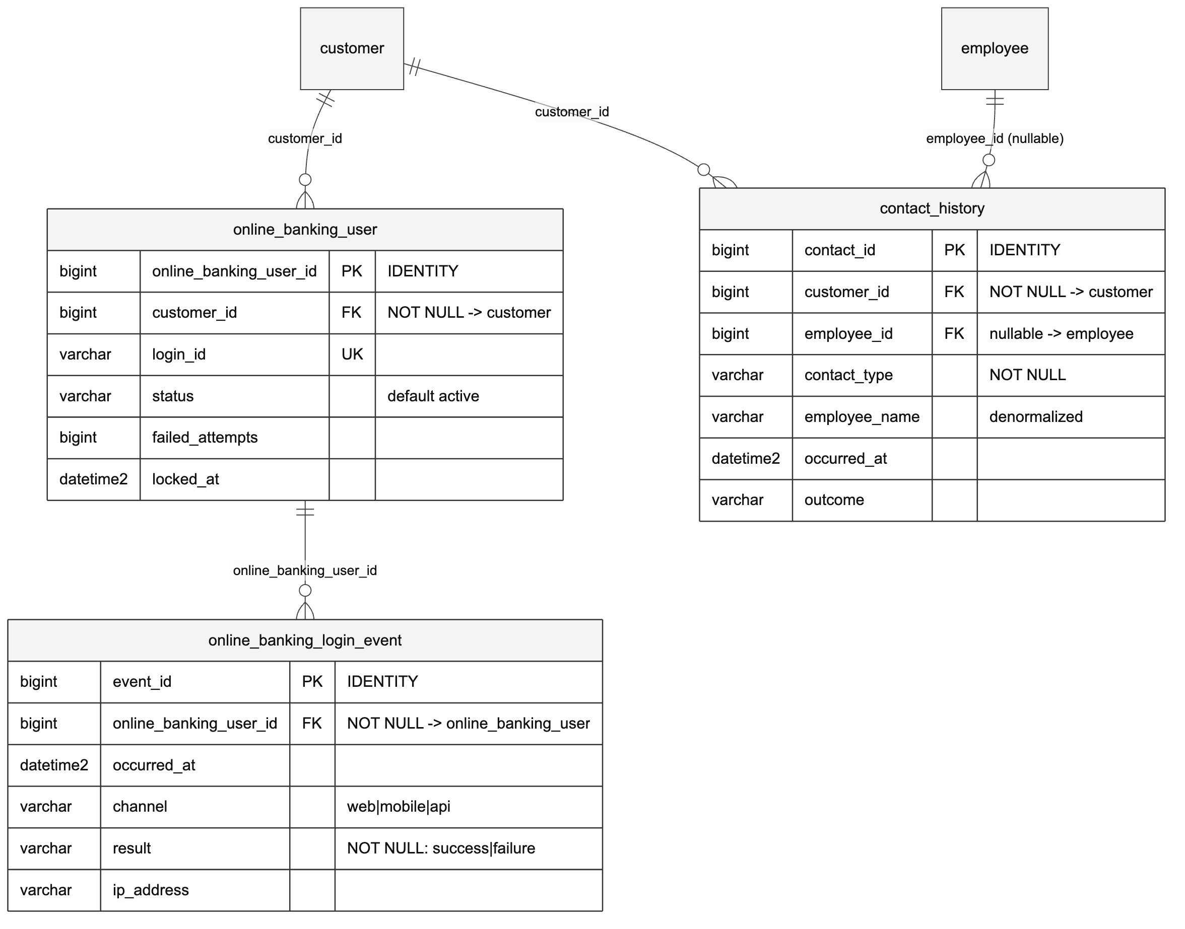
Per-table notes:
- online_banking_user (schema.ts:495): Online-banking credential/status per customer. login_id is unique; tracks failed_attempts and locked_at.
- online_banking_login_event (schema.ts:512): Login event log. result is NOT NULL (success/failure); indexed by idx_login_event_result (result, occurred_at).
- contact_history (schema.ts:527): Recent customer interactions for the dashboard. customer_id is NOT NULL; employee_id is a nullable FK. Carries a denormalized employee_name column (schema.ts:533).

Notes domain
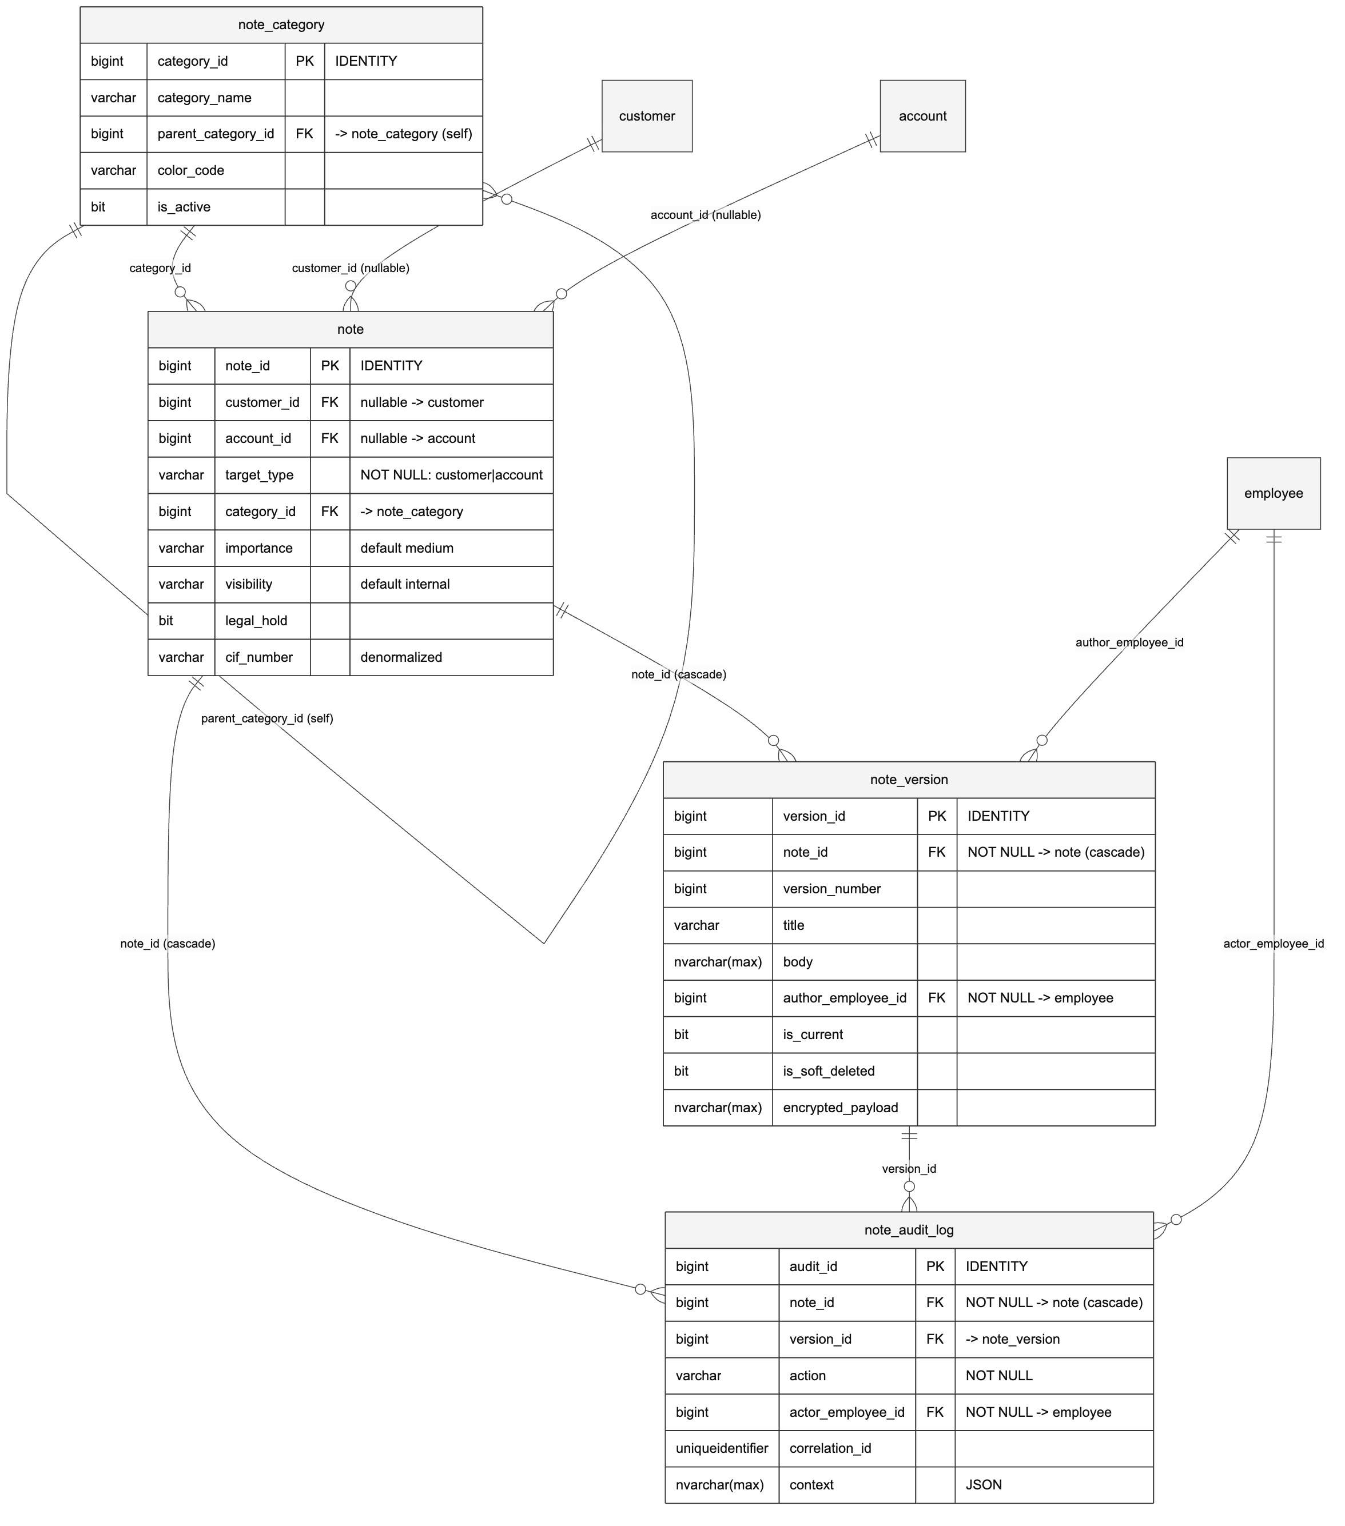
Per-table notes:
- note_category (schema.ts:559): Hierarchical categories via self-referencing parent_category_id.
- note (schema.ts:575): Immutable note identity and target. Both customer_id and account_id are nullable FKs; a table CHECK constraint check_note_one_target (schema.ts:598-601) enforces that exactly one of them is set. legal_hold prevents deletion; cif_number is denormalized for Operations queries.
- note_version (schema.ts:605): Versioned content with soft deletes. FK note_id → note with ON DELETE CASCADE; author_employee_id → employee (NOT NULL); deleted_by_employee_id → employee. Unique constraint uq_note_current_version (note_id, is_current) with NULLS NOT DISTINCT enforces one current version per note. encrypted_payload holds confidential note bodies.
- note_audit_log (schema.ts:630): All note operations (create, update, delete, restore, view). FKs note_id → note (cascade), version_id → note_version, actor_employee_id → employee (NOT NULL).

RBAC / roles domain
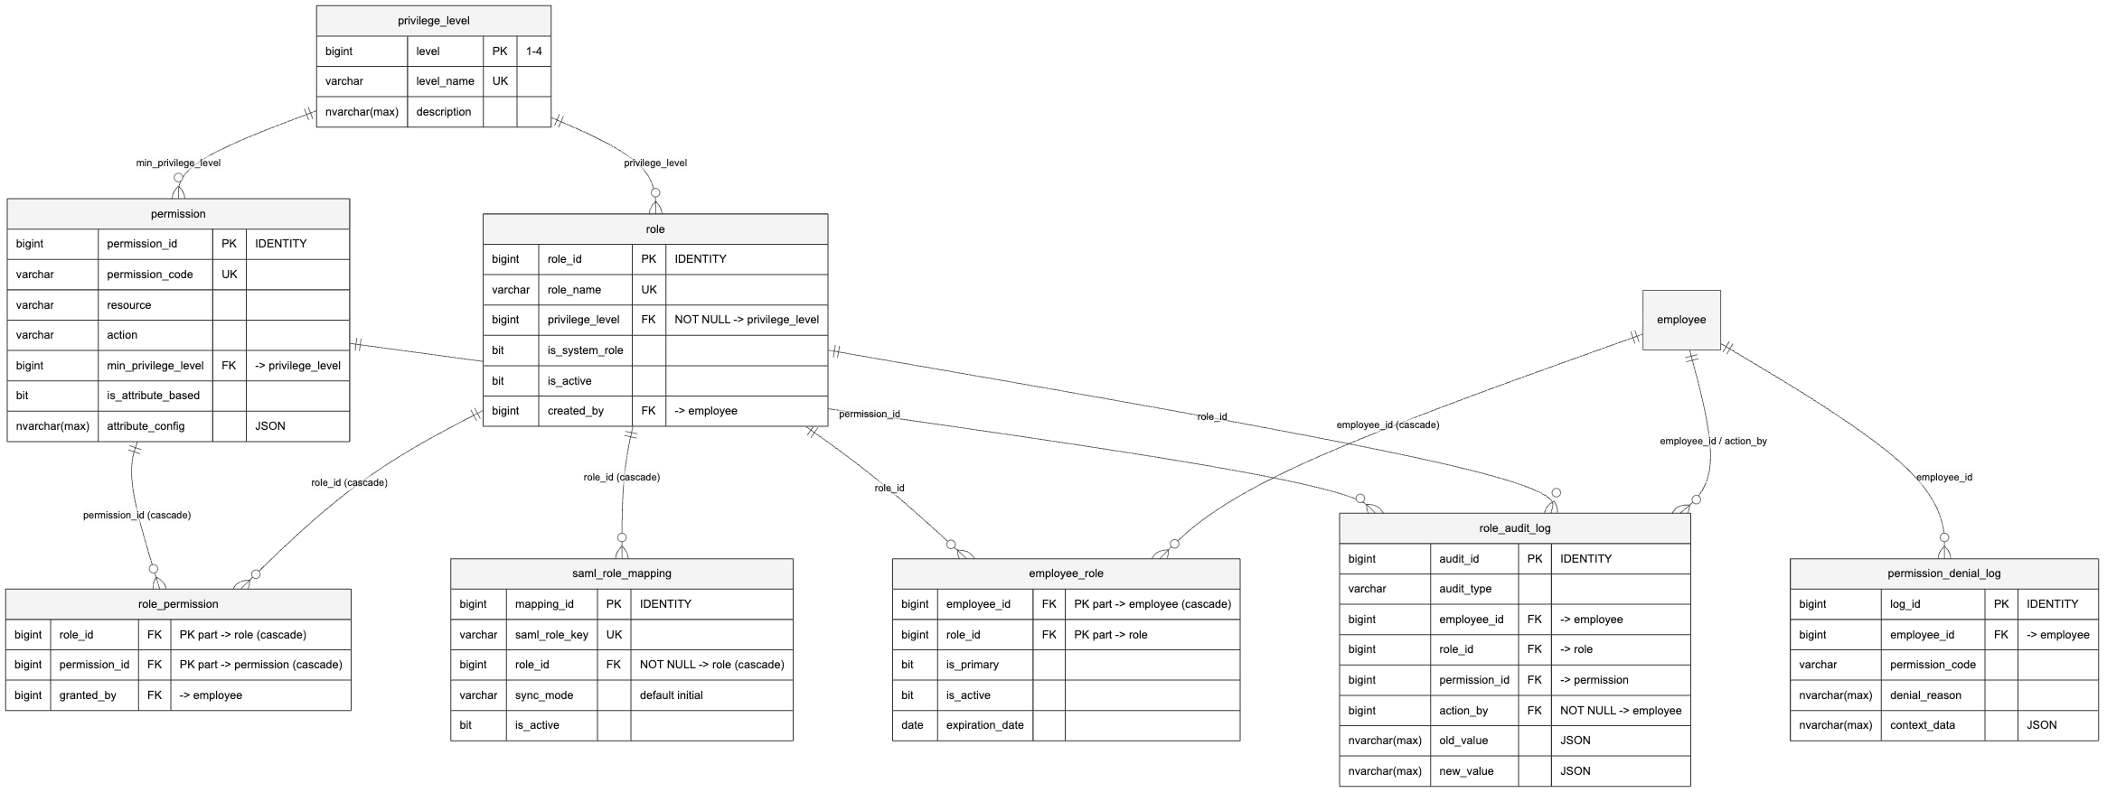
Per-table notes:
- privilege_level (schema.ts:654): Levels 1 to 4; level is the PK, level_name is unique.
- role (schema.ts:662): Named roles. role_name unique; privilege_level → privilege_level (NOT NULL); created_by → employee.
- permission (schema.ts:678): Resource/action permissions. permission_code unique; unique key uq_permission_resource_action (resource, action). Supports attribute-based access via is_attribute_based + attribute_config (nvarchar(max) JSON). min_privilege_level → privilege_level.
- role_permission (schema.ts:697): M:N role↔permission. Composite PK (role_id, permission_id); both FKs cascade on delete. granted_by → employee.
- employee_role (schema.ts:709): M:N employee↔role. Composite PK (employee_id, role_id); employee_id → employee cascades; assigned_by → employee. Supports effective/expiration dating and is_primary.
- saml_role_mapping (schema.ts:728): Maps a SAML role key to a role. saml_role_key unique; role_id → role cascades; sync_mode defaults to initial. (Note: this is the persisted SSO→role mapping table; AD-group-name-convention resolution is additionally handled in application code, scoped by SAML_ROLE_ENV.)
- role_audit_log (schema.ts:744): Compliance log of role/permission changes. action_by → employee is NOT NULL; employee_id, role_id, permission_id are nullable FKs.
- permission_denial_log (schema.ts:765): Records denied authorization attempts; employee_id → employee (nullable).

User Management domain
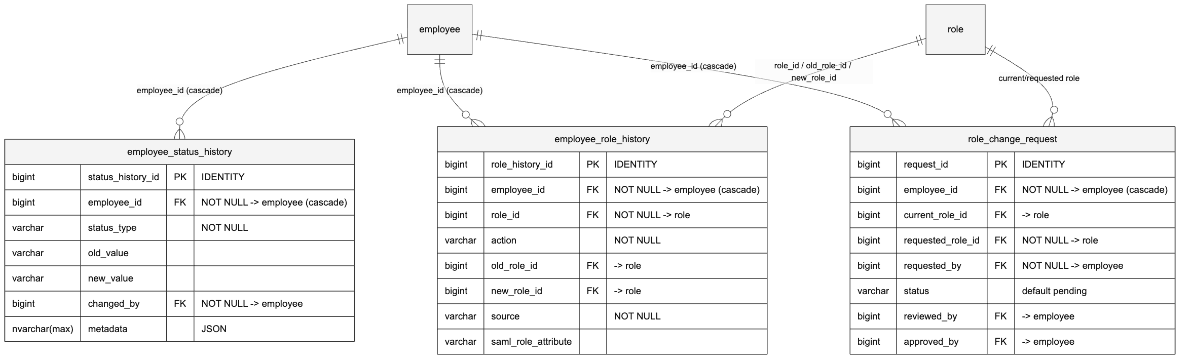
Per-table notes:
- employee_status_history (schema.ts:785): Audit trail of employee status changes. employee_id → employee cascades; changed_by → employee (NOT NULL).
- employee_role_history (schema.ts:802): Audit trail of role assignments. employee_id → employee cascades; role_id, old_role_id, new_role_id all reference role; assigned_by → employee. source (NOT NULL) records the origin (e.g. manual vs SAML); saml_role_attribute captures the raw claim when applicable.
- role_change_request (schema.ts:825): Approval workflow for role changes. employee_id → employee cascades; current_role_id/requested_role_id → role (requested is NOT NULL); requested_by, reviewed_by, approved_by all reference employee. status defaults to pending.

Audit domain
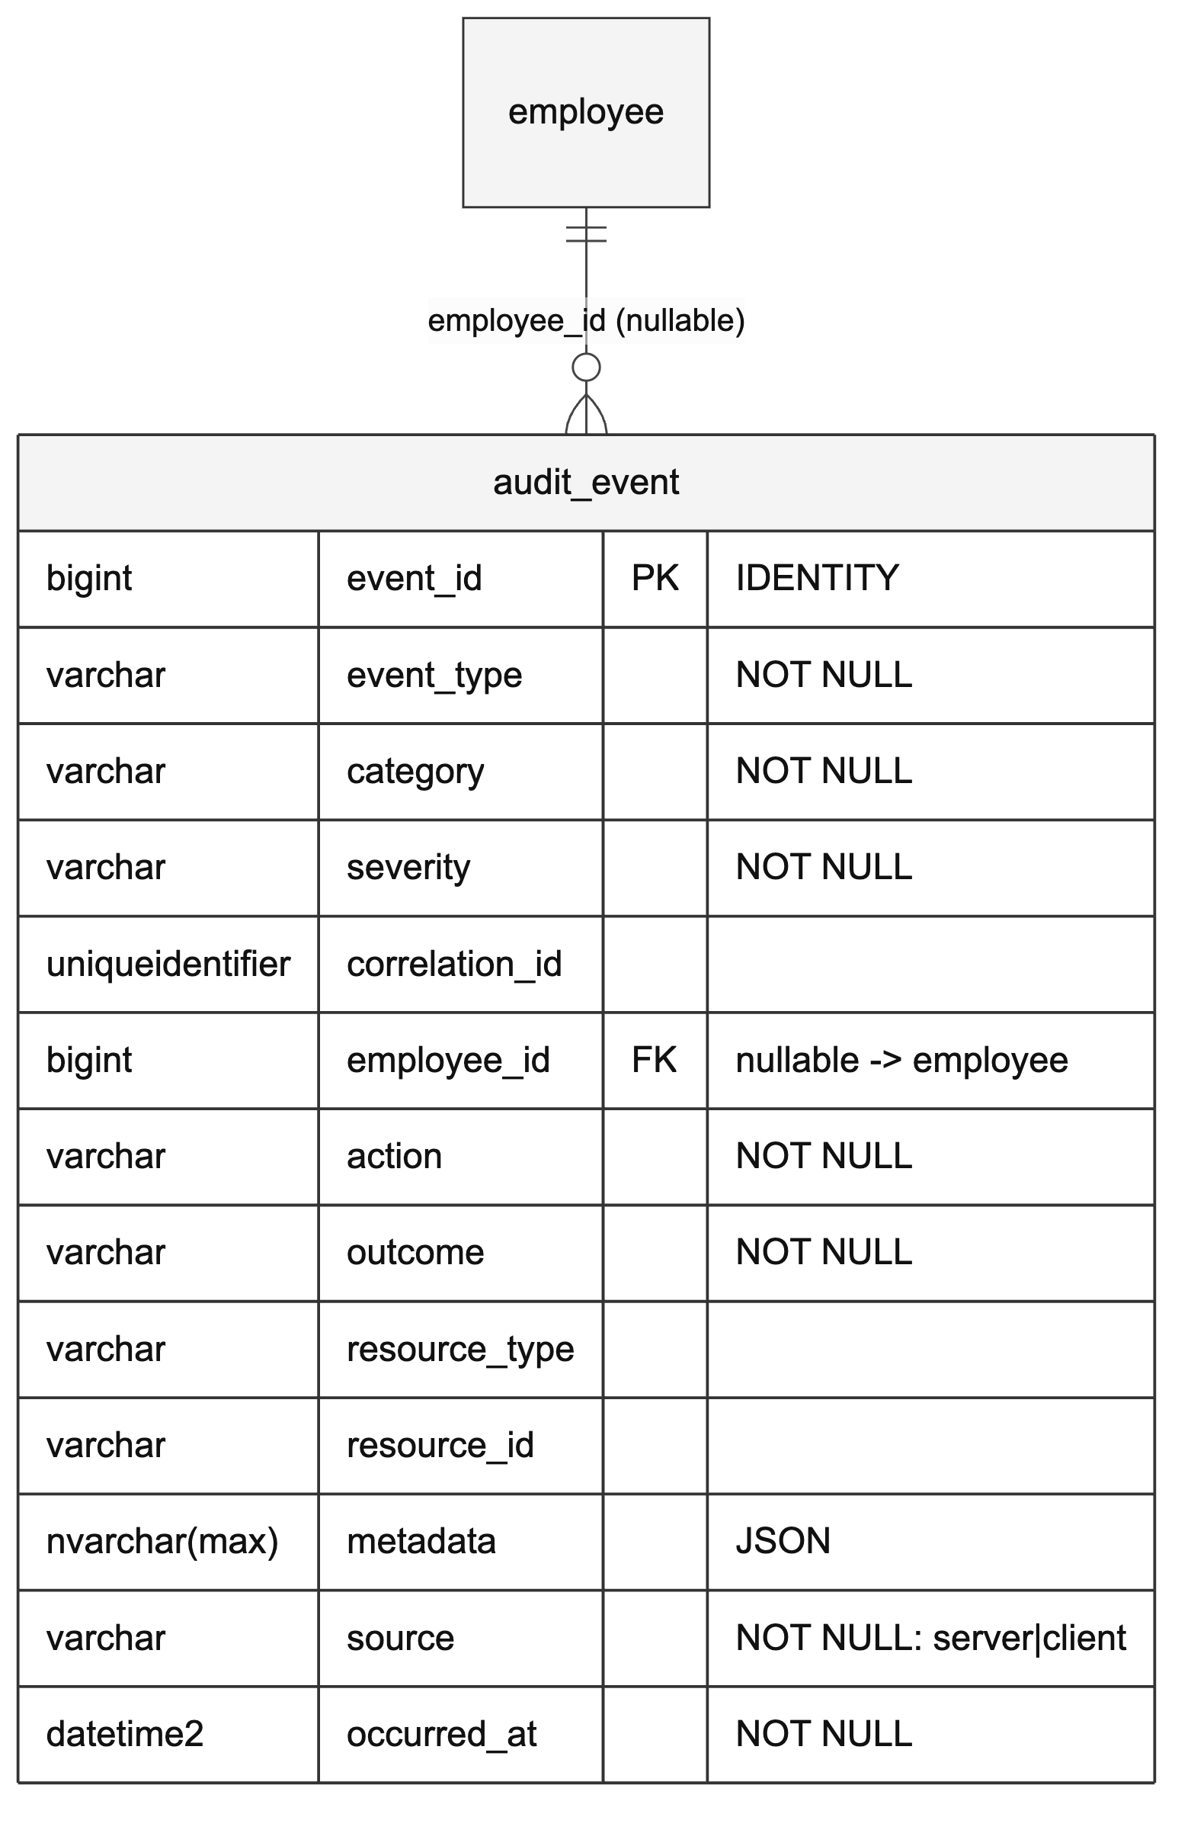
Per-table notes:
- audit_event (schema.ts:854): Cross-cutting application audit log for security/compliance events. Only FK is employee_id → employee (nullable, since some events have no authenticated actor). source is either server or client. Heavily indexed for reporting (see below).

Derived and denormalized columns
The model uses several derived/denormalized columns to support search and dashboard read paths:
Table.column | Nature | Notes
customer.full_name | Generated / derived | Omitted from inserts by the Zod insertCustomerSchema as a "Generated column, not manually inserted" (schema.ts:114,902). Used as the unified search target.
financial_transaction.account_number | Denormalized from account | Current join/filter source of truth for Operations (schema.ts:404).
entity_contact.contact_type_cached | Denormalized cache | Cache of the linked contact_info.contact_type (schema.ts:246).
contact_history.employee_name | Denormalized | For display without a join (schema.ts:533).
note.cif_number | Denormalized Jack Henry CIF | For Operations queries (schema.ts:586).
note_version.author_employee_name | Denormalized | Author display name (schema.ts:612).
note_audit_log.actor_employee_name | Denormalized | Actor display name (schema.ts:636).

[CONFIRM] The exact SQL Server mechanism that maintains customer.full_name (persisted computed column vs. trigger vs. application-populated). shared/schema.ts only marks it as a derived column; the production DDL for this column was not located in the reviewed files.

Explicit constraints
The only explicit CHECK constraint declared in shared/schema.ts:
Constraint | Table | Rule | Location
check_note_one_target | note | Exactly one of customer_id / account_id is non-null | schema.ts:598-601

Other business rules commonly assumed to be DB constraints are actually enforced elsewhere:
Rule | Enforced by | Location
Individual-vs-business required name fields | Zod discriminated union on customer_type | insertCustomerSchema, schema.ts:907-929
Debit-card expiry month 1-12, year ≥ current year | Zod validation | insertDebitCardSchema, schema.ts:1117-1124
Debit-card allowed account type; cardholder is a valid account owner | SQL Server trigger(s) | External DDL (see the [CONFIRM] under Core Banking)

Notable UNIQUE constraints (from shared/schema.ts): region.region_code, branch.branch_code, employee.employee_number, employee.officer_code, employee.sso_subject, customer.tax_identifier, account.account_number, transaction_category.name, online_banking_user.login_id, role.role_name, permission.permission_code, saml_role_mapping.saml_role_key, plus the composite keys unq_employee_branch, pk_customer_officer, pk_customer_sic, unq_account_sic, uq_permission_resource_action, unq_account_source_txn, and uq_note_current_version (nulls-not-distinct).

Index strategy
All production indexes are B-tree nonclustered indexes on SQL Server. Representative indexes declared in shared/schema.ts and in the production performance script (scripts/create_performance_indexes.sql):
Purpose | Index | Columns | Source
Customer name lookup | IX_customer_name | (last_name, first_name) | scripts/create_performance_indexes.sql:52-53
Customer by CIF | IX_customer_cif | jack_henry_cif_number | scripts/create_performance_indexes.sql:46-47
Customer full-name search target | idx_customer_full_name | full_name | schema.ts:157
Account by type + status | IX_account_type_status | (account_type, account_status) | scripts/create_performance_indexes.sql:36-37
Account ownership by customer | IX_account_ownership_customer | customer_id | scripts/create_performance_indexes.sql:26-27
Transaction primary query | idx_transaction_account_posting | (account_id, posting_date, transaction_id) | schema.ts:409
Transaction by account_number (Operations) | idx_transaction_account_number | account_number | schema.ts:422
Transaction dedup | unq_account_source_txn (unique) | (account_id, source_system, source_transaction_id) | schema.ts:424
Audit event reporting | idx_audit_event_occurred_at, idx_audit_event_employee_occurred, etc. | various | schema.ts:880-887

There is no index on debit_card_id in financial_transaction; that column does not exist.

Customer search
Customer/household search runs through server/adapters/search/SqlServerSearchProvider.ts, which is the production path:
- Exact / substring matches (name, government ID, Silverlake ID, Jack Henry CIF) use a case-insensitive LIKE substring match with an explicit COLLATE SQL_Latin1_General_CP1_CI_AS (SqlServerSearchProvider.ts:224,274,306,338). This is not full-text/CONTAINS(), and not phonetic.
- Fuzzy name matching uses STRING_SIMILARITY(full_name, @query) on SQL Server 2022+ (version 16+), falling back to SOUNDEX/DIFFERENCE on SQL Server 2019 and earlier (SqlServerSearchProvider.ts:114-129,157,194). The provider detects the engine version at runtime and chooses the strategy accordingly.

There is no full-text catalog and no fuzzy-search index maintained in the production database; fuzzy matching is computed at query time over full_name.

Change management
There is no numbered Drizzle migration workflow in production. The repo contains no migrations/ or drizzle/ directory and no ordered migration files. Production SQL Server schema is applied via standalone idempotent SQL scripts, for example:
- scripts/create_audit_event_table.sql
- scripts/create_sessions_table.sql
- scripts/create_performance_indexes.sql
- scripts/ensure_rbac_provenance_columns.sql
- scripts/widen_employee_last_seen_saml_role.sql
- additional DDL under Insert Queries/Schema Changes/*.sql (e.g. financial_transaction_add_account_number.sql)

These scripts guard every object with existence checks (IF NOT EXISTS ...) so they can be re-run safely across the four environments (dev, test, preprod, prod).
[CONFIRM] The authoritative ordering/runbook for applying the scripts/ and Insert Queries/Schema Changes/ DDL to a fresh SQL Server database, and which scripts are baseline vs. incremental.

Performance monitoring
Recommended SQL Server monitoring for the largest tables (financial_transaction, audit_event, note_audit_log, contact_history):
-- Index fragmentation / physical stats (run in the ClientIQ database)
SELECT
OBJECT_NAME(ips.object_id) AS table_name,
i.name AS index_name,
ips.avg_fragmentation_in_percent,
ips.page_count
FROM sys.dm_db_index_physical_stats(DB_ID(), NULL, NULL, NULL, 'LIMITED') ips
JOIN sys.indexes i
ON ips.object_id = i.object_id AND ips.index_id = i.index_id
WHERE ips.page_count > 1000
ORDER BY ips.avg_fragmentation_in_percent DESC;
-- Row counts / space by table
SELECT
t.name AS table_name,
SUM(p.rows) AS row_count,
SUM(a.total_pages) * 8 / 1024 AS total_mb
FROM sys.tables t
JOIN sys.partitions p ON t.object_id = p.object_id AND p.index_id IN (0, 1)
JOIN sys.allocation_units a ON p.partition_id = a.container_id
GROUP BY t.name
ORDER BY total_mb DESC;

Growth projections
[CONFIRM] Expected row-count and growth-rate projections per table (e.g. for customer, financial_transaction, contact_history, audit_event). These are capacity-planning inputs that are not derivable from code and must be supplied and dated by the data/operations owner. Treat any prior figures as illustrative only until confirmed.

Summary statistics
Metrics recomputed against the current shared/schema.ts (40-table schema):
Metric | Value | Basis
Total tables | 40 | Count of table definitions in shared/schema.ts
Junction / association tables | 8 | entity_address, entity_contact, household_membership, account_ownership, employee_branch, customer_officer_assignment, customer_sic_code, account_sic_code
Reference / lookup tables | 2 | sic_code, transaction_category
Explicit CHECK constraints | 1 | check_note_one_target (note)
Self-referencing tables | 3 | household (FK), note_category (FK), transaction_category (no FK)
Polymorphic (no-FK) links | 2 | entity_address.entity_id, entity_contact.entity_id
Database engine | SQL Server 2019+ | Production, all environments

[CONFIRM] Documentation version. package.json reports application version 1.0.0; a separate doc-version has not been established for this ERD.

