Environment Variables Reference
Last reviewed: 2026-07-01 · Source of truth: application code (ClientIQ / Banking Client 360).

Purpose
This document is the authoritative reference for every environment variable the ClientIQ (Banking Client 360) application actually reads at runtime, plus the variables that deploy scripts set but the code never consumes. It is rebuilt directly from process.env.* reads in the codebase; it does not describe an idealized configuration surface.
Key facts to keep in mind while reading:
- SQL Server is the only database engine in every environment (dev, test, preprod, prod). There is no other production data store.
- The app does not use a .env file. There is no dotenv dependency and no .env loader anywhere in the code. Configuration is delivered by PowerShell scripts that export process environment variables before launching the Node process (see Where configuration comes from).
- SSO is per-environment. SAML is enabled only in preprod and prod. In dev and test, SAML_ENABLED=false and the app uses the local/mock authentication path.
- A large set of variables in the prior guide were never read by the code. Those have been removed here or explicitly marked as dead (set-but-unread). See Set-but-unread (dead) variables and Variables removed from this reference.

Where configuration comes from
There is no dotenv loading. Environment variables reach the Node process through PowerShell scripts that set $env:* before invoking the app:
Context | Script | How it is produced
Local / dev | Start-Dev.ps1 (repo root) | Static, hard-coded values. SAML_ENABLED=false. Contains committed plaintext secrets (see the security note below).
Parameterized dev-style server | Start-Server.ps1 (repo root) | Same variable set as Start-Dev.ps1, but sourced from mandatory parameters ($DBServer, $DBName, $DBUser, $DBPassword, $SessionSecret). SAML_ENABLED=false.
Each deployed server (dev/test/preprod/prod) | Generated C:\ClientIQ\Start-Server.ps1 on the target host | Written remotely by the Azure DevOps pipeline template PipelineTemplates/start-script.yml. Substitutes ADO pipeline / variable-group tokens ($(DBServer), $(SAMLEnabled), $(SessionSecret), $(SAMLRoleEnv), …) into the exported env vars. This is the only script that emits the full SAML block.

Secrets for the deployed servers are supplied by Azure DevOps variable groups ($(SessionSecret), $(DBPassword), etc.), not files on disk.
[CONFIRM] File-system ACLs / permissions on C:\ClientIQ\Start-Server.ps1 on each host, the owner of the ADO variable groups (VG-Dev, VG-Test, VG-Preprod, VG-Prod, VG-Prod2), and the secret-rotation cadence/policy are governance items not derivable from the repo.
Security note (fact, not speculation): Start-Dev.ps1 commits a plaintext MSSQL_PASSWORD (line 16) and a plaintext SESSION_SECRET (line 23). These should be rotated and removed from version control.

Quick reference
Category | Variable | Required | Notes
Runtime | NODE_ENV | Effectively required | Master mode switch (auth path, cookie security, log level, dev routes). Code uses 'development' / 'production'.
Runtime | PORT | Optional | HTTP listen port. Default 5000.
Runtime | ROLE_TESTING_ENABLED | Optional | Role-testing/impersonation feature. Enabled unless exactly 'false'.
Runtime | TZ | Set by app | Forced to America/Los_Angeles at startup. Not an operator input.
Database | DATABASE_DIALECT | Optional (deploy sets sqlserver) | Dialect selector for DB config resolution.
Database | DB_VENDOR | Optional (deploy sets mssql) | Selects the SQL Server search provider.
Database | MSSQL_SERVER / DB_SERVER | Optional (chain default localhost) | SQL Server host.
Database | MSSQL_DATABASE / DB_NAME | Optional (chain default ClientIQ) | Database name.
Database | MSSQL_USER / DB_USER | Required in prod | SQL Server login.
Database | MSSQL_PASSWORD / DB_PASSWORD | Required in prod | SQL Server password.
Database | MSSQL_ENCRYPT | Optional | Session-store connection TLS only.
Database | MSSQL_TRUST_SERVER_CERTIFICATE | Optional | Session-store connection trust only.
Database | DATABASE_URL | CLI-only | Required only for the drizzle-kit schema CLI, not the running server.
Session | SESSION_SECRET | Required when SAML enabled | express-session signing secret.
SAML / auth | SAML_ENABLED | Optional (default off) | Master SSO gate; exact string 'true' enables SAML.
SAML / auth | SAML_ENTRYPOINT | Required when SAML enabled | IdP SSO entry-point URL.
SAML / auth | SAML_CALLBACK_URL | Required when SAML enabled | SAML ACS callback (/saml/acs).
SAML / auth | SAML_CERT | Required when SAML enabled | IdP signing cert (inline PEM or file path).
SAML / auth | SAML_ISSUER | Optional | SP issuer; defaults to ClientIQ-Production.
SAML / auth | SAML_ROLE_ENV | Optional | Scopes AD-group→role mapping to one environment.
SAML / auth | SAML_DEFAULT_ROLE_NAME | Optional | Fallback role; default Branch Manager.
SAML / auth | RSA_PORTAL_URL | Optional | Explicit IdP portal URL for logout; else derived from SAML_ENTRYPOINT.
Logging | LOG_LEVEL | Optional | Threshold; default debug in dev, info otherwise.

Runtime / application settings

NODE_ENV
- Required: effectively required for correct behavior (technically optional).
- Values used in code: 'development', 'production'.
- Default: none. When undefined it is treated as non-dev/non-prod: isDev is false in server/services/loggerConfig.ts:6, so the log level defaults to info; server/services/logger.ts:237 reports a 'development' fallback string.
- Where read: server/index.ts:56, :88; server/auth/session.ts:17, :41; server/dbConnection.ts:29; server/middleware/authGate.ts:7; server/routes.ts:294, :1799, :1866, :1929; server/services/logger.ts:237; server/services/loggerConfig.ts:6; server/services/roleTestService.ts:20.

NODE_ENV gates a wide range of behavior: mock-auth vs SAML selection, the secure-cookie flag, dev-only debug routes, the default log level, main-pool certificate trust, and role-testing production guards.
$env:NODE_ENV = "development"
Deployment reality, read this. The pipeline-generated C:\ClientIQ\Start-Server.ps1 writes NODE_ENV=development for all environments, including prod (PipelineTemplates/start-script.yml). Consequences of running with NODE_ENV=development: the session cookie secure flag is false (server/auth/session.ts:41), the main data pool sets trustServerCertificate: true (server/dbConnection.ts:29), dev-only debug branches in server/routes.ts activate, and the default log level is debug.[CONFIRM] Whether prod overrides NODE_ENV to production at the Windows-service level is not visible in the repo. A human must confirm the effective NODE_ENV on the preprod and prod hosts; if it is not overridden, the security implications above apply in production.

PORT
- Required: optional.
- Default: '5000'.
- Where read: server/index.ts:98 (parseInt(process.env.PORT || '5000', 10)).

The single un-firewalled port 5000 serves both the API and the client. The listen host is hard-coded to 0.0.0.0 in code and is not configurable (see HOST under Set-but-unread (dead) variables).

ROLE_TESTING_ENABLED
- Required: optional.
- Default: none (unset means enabled).
- Where read: server/services/roleTestService.ts:14.

Enables the role-testing / impersonation feature. It is enabled unless the value is exactly 'false'. Note that role testing is additionally blocked at runtime when NODE_ENV === 'production' (server/services/roleTestService.ts:20), regardless of this flag.

TZ
- Required: N/A. Set by the application, not by the operator.
- Where set/read: server/utils/timezone.ts:13, :20 (assigned), :23 (logged).

The app forces process.env.TZ = 'America/Los_Angeles' at module load and again in initializeServerTimezone() at startup. Any TZ supplied by the environment is overwritten. This is documented only so operators understand why the process timezone is fixed to Pacific Time; it is not a tunable knob.

Database configuration
SQL Server is the only production engine. All deploy scripts set DATABASE_DIALECT=sqlserver and DB_VENDOR=mssql. The connection variables below configure the mssql driver.

Connection variables (with fallback chain)
Every MSSQL_* connection variable falls back to a legacy DB_* equivalent, and some have a final literal default. Both the main data pool (server/dbConnection.ts:23-26) and the session store (server/auth/session.ts:8-11) use the same chain.
Variable | Fallback | Final default | Required | Where read
MSSQL_SERVER | DB_SERVER | 'localhost' | Optional | session.ts:10; dbConnection.ts:25
MSSQL_DATABASE | DB_NAME | 'ClientIQ' | Optional | session.ts:11; dbConnection.ts:26
MSSQL_USER | DB_USER | none | Required (prod) | session.ts:8; dbConnection.ts:23
MSSQL_PASSWORD | DB_PASSWORD | none | Required (prod) | session.ts:9; dbConnection.ts:24

- DB_USER, DB_PASSWORD, DB_SERVER, DB_NAME are legacy/fallback variables, used only when the corresponding MSSQL_* variable is unset. Deploy scripts set the MSSQL_* names, so the DB_* names are typically inactive.

DB_VENDOR
- Required: optional (deploy sets mssql).
- Where read: server/adapters/search/SearchProviderFactory.ts:25 (.toLowerCase()).

Selects the search provider. When set to mssql the SQL Server search provider is used. If unset, the factory attempts to detect a vendor and falls back to a non-production path; deploy scripts always set it to mssql, so the SQL Server provider is always selected in practice.
Search implementation note: ClientIQ search is a case-insensitive LIKE substring match. It is not full-text, phonetic, or any specialized index feature.

DATABASE_DIALECT
- Required: optional (deploy sets sqlserver).
- Where read: server/dbConfig.ts:13 (.toLowerCase()).

Explicit dialect selector for DB config resolution. Deploy scripts set sqlserver.

TLS variables: session store only
These two variables affect only the session-store connection (server/auth/session.ts:15-16). The main data pool ignores them.
Variable | Effect (session store) | Default | Where read
MSSQL_ENCRYPT | TLS encrypt enabled unless the value is exactly 'false' | unset → encrypt true | session.ts:15
MSSQL_TRUST_SERVER_CERTIFICATE | Trust self-signed cert when 'true' or NODE_ENV==='development' | unset → false unless dev | session.ts:16

- Main data pool divergence: the main pool hard-codes encrypt: true (server/dbConnection.ts:28) and derives trustServerCertificate solely from NODE_ENV === 'development' (server/dbConnection.ts:29). It reads neither MSSQL_ENCRYPT nor MSSQL_TRUST_SERVER_CERTIFICATE. Setting MSSQL_ENCRYPT=false (as all Start scripts do) changes only the session connection, not the main pool.

DATABASE_URL: CLI only, not the server runtime
- Required: only for the drizzle-kit schema CLI (throws if unset). Optional (and unused on the SQL Server path) at server runtime.
- Where read: drizzle.config.ts:3 (throws "DATABASE_URL, ensure the database is provisioned" if missing), :12; server/dbConfig.ts:12 (defaults to ''); server/adapters/search/SearchProviderFactory.ts:34 (defaults to '').

DATABASE_URL belongs to the legacy schema-tooling abstraction, not the running application. It is required only when running the drizzle-kit command-line tool (npm run db:push); the SQL Server application server does not need it and defaults it to an empty string.

Connection pool sizing (not configurable)
Pool sizes are hard-coded and cannot be tuned via environment variables:
- Main data pool: max: 10, min: 0, idleTimeoutMillis: 30000 (server/dbConnection.ts:34-37).
- Session store pool: max: 10, min: 0, idleTimeoutMillis: 30000 (server/auth/session.ts:20-24).

Example (deployed server, PowerShell)
$env:DATABASE_DIALECT = "sqlserver"
$env:DB_VENDOR = "mssql"
$env:MSSQL_SERVER = "<sql-host>" # confirm real host
$env:MSSQL_DATABASE = "ClientIQ"
$env:MSSQL_USER = "<sql-login>"
$env:MSSQL_PASSWORD = "<from ADO variable group>"
$env:MSSQL_ENCRYPT = "false" # session store only
$env:MSSQL_TRUST_SERVER_CERTIFICATE = "true" # session store only
[CONFIRM] Real SQL Server hostnames/instances and service-account logins per environment are not in the repo. Start-Dev.ps1 references HUB-SQL1TST-LIS / ClientIQdev for local dev only.

Session configuration

SESSION_SECRET
- Required: required when SAML is enabled (the session middleware is mounted only on the SAML path).
- Default: none. Read with a non-null assertion (process.env.SESSION_SECRET!), so an undefined value would break session signing.
- Where read: server/auth/session.ts:34.

# Generate a strong secret
node -e "console.log(require('crypto').randomBytes(32).toString('hex'))"
$env:SESSION_SECRET = "<generated value>"

Session cookie / TTL settings: hard-coded, not env-configurable
The following are fixed in server/auth/session.ts and are not environment variables:
- Cookie name: clientiq.sid (:45).
- Cookie maxAge: 60 * 60 * 1000 = 1 hour idle, with rolling: true refreshing on activity (:37, :39).
- Cookie secure: derived from NODE_ENV === 'production' (:41).
- Cookie httpOnly: true, sameSite: 'lax', path: '/' (:40-43).
- Session-store TTL (server side): 12 * 60 * 60 seconds = 12 hours, with auto-remove of expired sessions every 15 minutes (:30-33).

SAML / authentication configuration
SAML SSO integrates with RSA SecurID Access via the F&M Bank portal. SSO is enabled only in preprod and prod. In dev and test, SAML_ENABLED=false and the app uses the local/mock auth path (dev injects a fixed test user).
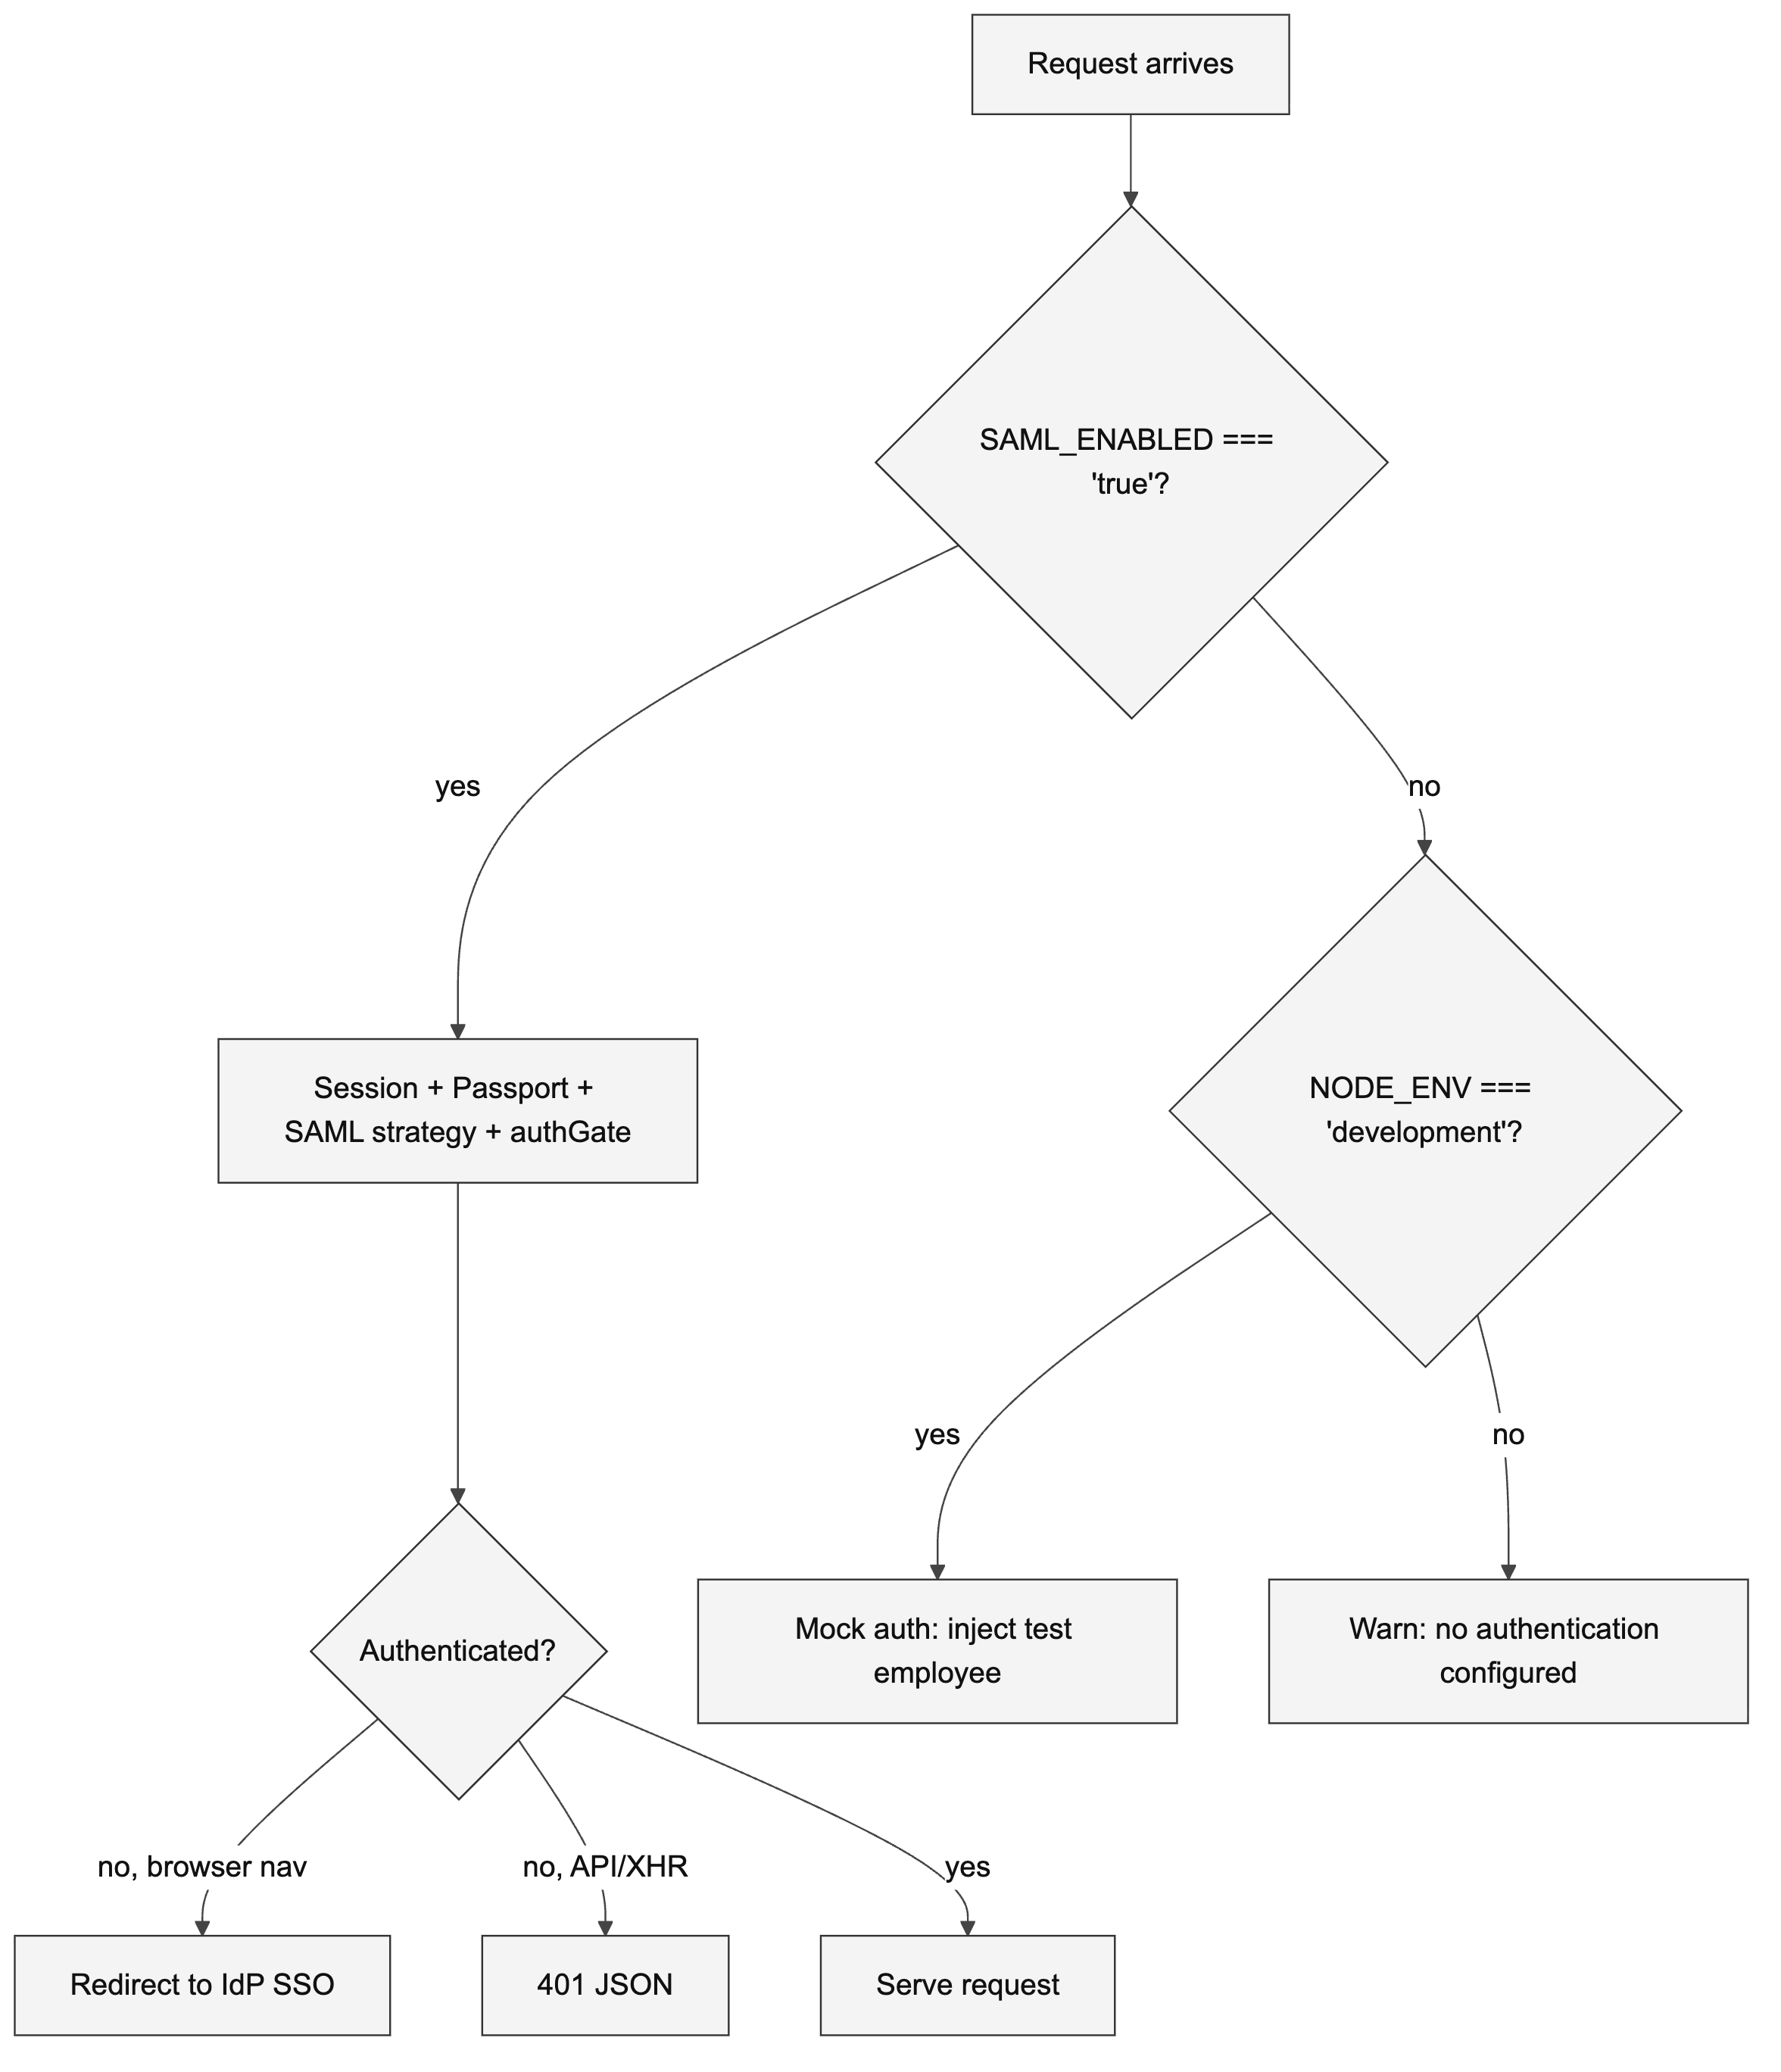

SAML_ENABLED
- Required: optional (default off). This is the master gate for all SSO.
- Values: must be the exact string 'true' to enable SAML. Any other value (including unset) leaves SAML off.
- Behavior when off: in dev (NODE_ENV==='development') the app falls back to mock auth; in non-dev it logs a "no authentication configured" warning and mounts no auth (server/index.ts:63).
- Where read: server/index.ts:21; server/middleware/authGate.ts:6; server/routes/auth.ts:19.
- Set by: Start-Dev.ps1 / Start-Server.ps1 set false; the ADO deploy sets it via $(SAMLEnabled).

SAML_ENTRYPOINT
- Required: required when SAML is enabled.
- Default: none in the real strategy config (server/auth/samlStrategy.ts:130 uses it non-null). A '<missing>' string appears only in the startup log at :116.
- Where read: server/auth/samlStrategy.ts:116, :130; server/routes/auth.ts:20 (gates isSamlConfigured()), :47 (derives the portal origin for logout).

SAML_CALLBACK_URL
- Required: required when SAML is enabled.
- Default: none in config (server/auth/samlStrategy.ts:129, non-null). '<missing>' appears only in the startup log at :117.
- Purpose: SAML ACS callback URL (/saml/acs).

SAML_CERT
- Required: required when SAML is enabled.
- Dual behavior: if the value contains BEGIN CERTIFICATE it is treated as an inline PEM; otherwise it is treated as a file path and read from disk (server/auth/samlStrategy.ts:16).
- Default: none in the loader; '<missing>' appears only in the startup log at :121.
- Deploy value: the generated start script sets SAML_CERT=./saml_cert.pem (a file path relative to C:\ClientIQ).

[CONFIRM] The owner, source, and rotation process for the IdP signing certificate at C:\ClientIQ\saml_cert.pem are not in the repo.

SAML_ISSUER
- Required: optional.
- Default: 'ClientIQ-Production' (the strategy config falls back to this when unset, server/auth/samlStrategy.ts:128). '<missing>' appears only in the log at :118.
- Purpose: SP issuer / entity identifier sent to the IdP. Deploy scripts set it explicitly.

SAML_ROLE_ENV
- Required: optional.
- Default: none. When unset, AD groups from all environments are honored (the log shows '<unset, AD groups from all environments honored>').
- Values: DEV, TST, STG, PRD (trimmed via .trim()).
- Where read: server/auth/samlStrategy.ts:109, :122; server/routes/auth.ts:362.

Scopes the AD-group-name-convention → role mapping to a single environment. Set per ADO stage via the SAMLRoleEnv pipeline variable → $env:SAML_ROLE_ENV:
Stage | Branch | Variable group | SAML_ROLE_ENV | file:line
Deploy_Dev | develop | VG-Dev | DEV | azure-pipelines.yml:110-111
Deploy_Test | test | VG-Test | TST | azure-pipelines.yml:135-136
Deploy_Preprod | preprod | VG-Preprod | STG | azure-pipelines.yml:181-182
Deploy_Prod | prod | VG-Prod | PRD | azure-pipelines.yml:207-208
Deploy_Prod2 | prod | VG-Prod2 | PRD | azure-pipelines.yml:233-234

SAML_DEFAULT_ROLE_NAME
- Required: optional.
- Default: 'Branch Manager' (trimmed via .trim()).
- Where read: server/auth/samlStrategy.ts:123; server/routes/auth.ts:357, :416. Also referenced (not read) in error messages at server/storage/sqlServerEmployee.ts:204, :266.

Fallback role assigned when no AD-group role matches.

RSA_PORTAL_URL
- Required: optional.
- Default: none. When unset, the logout portal origin is derived from SAML_ENTRYPOINT.
- Where read: server/routes/auth.ts:39.

Explicit RSA / IdP portal URL used to build the IdP-initiated logout link.

SAML example (deployed preprod/prod, PowerShell)
$env:SAML_ENABLED = "true"
$env:SAML_ENTRYPOINT = "https://<idp-portal>/IdPServlet?idp_id=<issuer>"
$env:SAML_ISSUER = "<sp-entity-id>"
$env:SAML_CALLBACK_URL = "https://<app-host>/saml/acs"
$env:SAML_CERT = "./saml_cert.pem"
$env:SAML_ROLE_ENV = "PRD" # DEV | TST | STG | PRD
$env:SAML_DEFAULT_ROLE_NAME = "Branch Manager"
[CONFIRM] The real IdP entry-point / portal host, the SP entity ID, the application FQDN used in SAML_CALLBACK_URL, and the IIS site bindings / TLS certificate that terminate HTTPS in front of the Node process on port 5000 are not in the repo. IIS (not the Node process) terminates TLS and reverse-proxies to HTTP :5000; the SAML URLs are all https:// while the app listens on plain HTTP.

Attribute mapping is code-level, not configurable
There are no SAML_ATTR_* environment variables. SAML claim mapping is a hard-coded constant ATTRIBUTE_MAP in server/auth/samlStrategy.ts:95-103 (using http://schemas.xmlsoap.org/... claim URLs), and the verify callback primarily resolves short NameFormat=basic attribute names. Attribute mapping cannot be changed through the environment.

Logging configuration

LOG_LEVEL
- Required: optional.
- Default: debug in development (NODE_ENV !== 'production'), info otherwise (isDev ? 'debug' : 'info').
- Where read: server/services/loggerConfig.ts:7 (exported), consumed in server/services/logger.ts:140.

Overrides the logger threshold. The application uses a custom console/structured logger; it does not use the Node debug module, and there is no LOG_FORMAT or DEBUG variable.

Set-but-unread (dead) variables
These are exported by Start scripts or pipeline templates but are never read by any process.env.* reference in the codebase (verified by recursive grep). Documented so operators do not assume they have an effect.
Variable | Set where | Intended purpose | Actual effect
HOST | Start-Dev.ps1:7; Start-Server.ps1:25; PipelineTemplates/start-script.yml:16 | Listen host | None: the server hard-codes host: "0.0.0.0" in its listen block (server/index.ts); HOST is never read.
MSSQL_PORT | Start-Dev.ps1:17; Start-Server.ps1:34; PipelineTemplates/start-script.yml:26 | SQL Server port | None: no process.env.MSSQL_PORT in code; the mssql pool uses the default port.
SAML_ENTITY_ID | PipelineTemplates/start-script.yml:32 | SP entity id | None: the strategy uses SAML_ISSUER instead. (The literal value also has a stray trailing ).)
SAML_IDP_INITIATED_URL | PipelineTemplates/start-script.yml:36 | IdP-initiated login URL | None: logout origin derives from RSA_PORTAL_URL / SAML_ENTRYPOINT.

Variables removed from this reference
The prior guide documented a number of variables that the code has never read. They are listed here so anyone migrating from the old document knows they are non-functional and should not be set with any expectation of effect.
Removed variable(s) | Reason
DB_POOL_MIN, DB_POOL_MAX, DB_POOL_IDLE_TIMEOUT | Not read. Pool sizes are hard-coded (server/dbConnection.ts:34-37; server/auth/session.ts:20-24).
SESSION_TIMEOUT, SESSION_COOKIE_NAME, SESSION_COOKIE_SECURE | Not read. Cookie name/maxAge/secure are hard-coded in server/auth/session.ts.
LOG_FORMAT, DEBUG | Not read. Only LOG_LEVEL controls logging.
CORS_ORIGIN, RATE_LIMIT_WINDOW_MS, RATE_LIMIT_MAX_REQUESTS | Not read anywhere.
ENABLE_AUDIT_LOGGING, ENABLE_PERFORMANCE_MONITORING | Not read. The only real runtime feature flag is ROLE_TESTING_ENABLED.
SAML_LOGOUT_URL, SAML_LOGOUT_CALLBACK_URL, SAML_DECRYPT_KEY, SAML_SIGNATURE_ALGORITHM, SAML_DIGEST_ALGORITHM, SAML_CLOCK_SKEW_MS | Not read. Logout portal is controlled by RSA_PORTAL_URL; signature/digest/clock-skew are not env-configurable.
SAML_ATTR_EMPLOYEE_ID, SAML_ATTR_EMPLOYEE_NUMBER, SAML_ATTR_FIRST_NAME, SAML_ATTR_LAST_NAME, SAML_ATTR_EMAIL, SAML_ATTR_DEPARTMENT, SAML_ATTR_ROLE | Not read. Attribute mapping is the hard-coded ATTRIBUTE_MAP in server/auth/samlStrategy.ts:95-103.

Startup behavior when required variables are missing
There is no config-validation gate in the application. The prior guide's [Config] Validating environment configuration... / [Config] ERROR: Missing required environment variables startup sequence does not exist (repo-wide grep for those strings returns nothing).
Instead, missing required variables fail at the point of use:
- Missing SESSION_SECRET: read with a non-null assertion at server/auth/session.ts:34; session signing breaks.
- Missing SAML_ENTRYPOINT / SAML_CALLBACK_URL: read non-null during SAML strategy construction (server/auth/samlStrategy.ts:129-130); the strategy fails to build.

Security best practices
- Deliver secrets through Azure DevOps variable groups ($(SessionSecret), $(DBPassword)), not files checked into the repo.
- Remove and rotate the plaintext MSSQL_PASSWORD (Start-Dev.ps1:16) and SESSION_SECRET (Start-Dev.ps1:23) currently committed to version control.
- Use a strong, random SESSION_SECRET (≥ 32 bytes) and a distinct value per environment.
- Restrict file-system permissions on the generated C:\ClientIQ\Start-Server.ps1 and C:\ClientIQ\saml_cert.pem.

[CONFIRM] Secret-rotation cadence, secret-management ownership, and the reconciliation plan for the committed plaintext secrets in Start-Dev.ps1 are governance decisions that require a human owner. The listed rotation frequency is not derivable from code.

Source references
Concern | File(s)
Runtime / port / auth branch | server/index.ts
Session store + cookie | server/auth/session.ts
Main data pool | server/dbConnection.ts
SAML strategy + attribute map | server/auth/samlStrategy.ts
Auth routes / logout / role env | server/routes/auth.ts
Search provider selection | server/adapters/search/SearchProviderFactory.ts
DB config resolution | server/dbConfig.ts
Logger threshold | server/services/loggerConfig.ts, server/services/logger.ts
Role testing | server/services/roleTestService.ts
Timezone | server/utils/timezone.ts
Deploy env wiring | Start-Dev.ps1, Start-Server.ps1, PipelineTemplates/start-script.yml, azure-pipelines.yml
Schema CLI (DATABASE_URL) | drizzle.config.ts

[CONFIRM] Document version and owner. Using the application package.json version 1.0.0 as a placeholder; the doc version and its maintainer must be confirmed by a human.

