Algorithms and structures programming

Sravan kumar reddy chethireddy

19720cs

Python program:

def twosum(numlist: list, target: int):

    indices = []

    for i in range(len(numlist)):

        for j in range(i+1, len(numlist)):

            if numlist[i] + numlist[j] == target:

                indices.append(i)

                indices.append(j)

                print(indices)

                return indices  # Return the indices as soon as they're found

    print("Match not found")  # If no match was found, print a message

    return indices  # Return an empty list if no match was found

twosum([2,7,11,15])

Flowchart:-

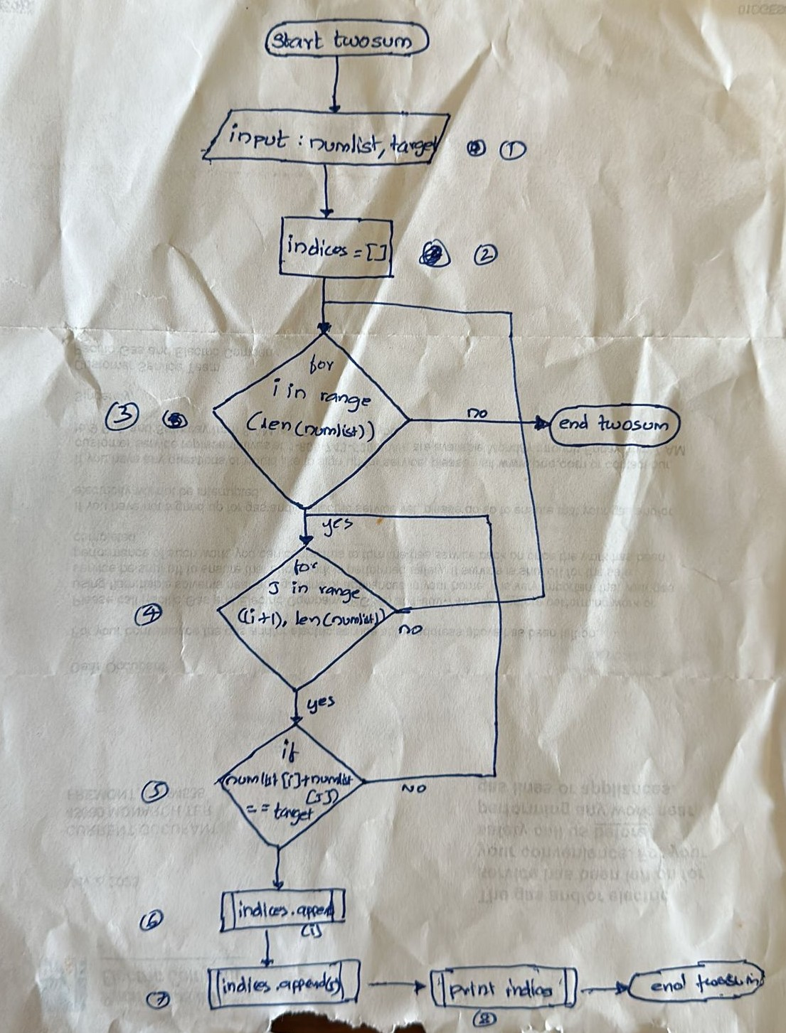

Trace table-:

|  |  |  |  |  |  |  |  |
| --- | --- | --- | --- | --- | --- | --- | --- |
| step | numlist | target | indices | i | j | numlist[i]+numlist[j]=target | screen |
| 1 | [2,7,11,15] | 9 |  |  |  |  |  |
| 2 |  |  | [] |  |  |  |  |
| 3 |  |  |  | 0 |  |  |  |
| 4 |  |  |  |  | 1 |  |  |
| 5 |  |  |  |  |  | True |  |
| 6 |  |  | [0] |  |  |  |  |
| 7 |  |  | [0,1] |  |  |  |  |
| 8 |  |  |  |  |  |  | [0,1] |

Testing:-

