1. Create on Bash script to check if a directory is available or not

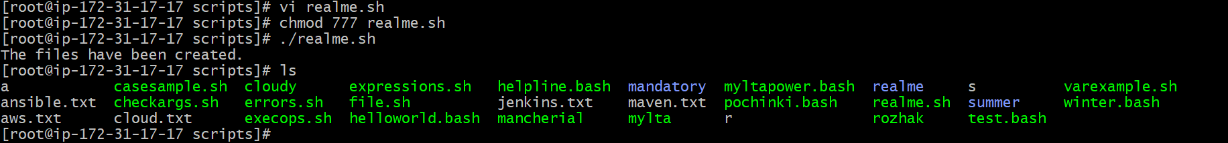

1. Create a bash script which will create multiple files

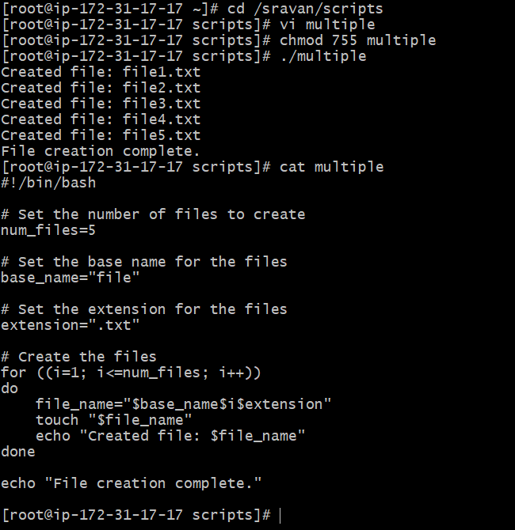

3) Create a bash script to take backup of a directory.

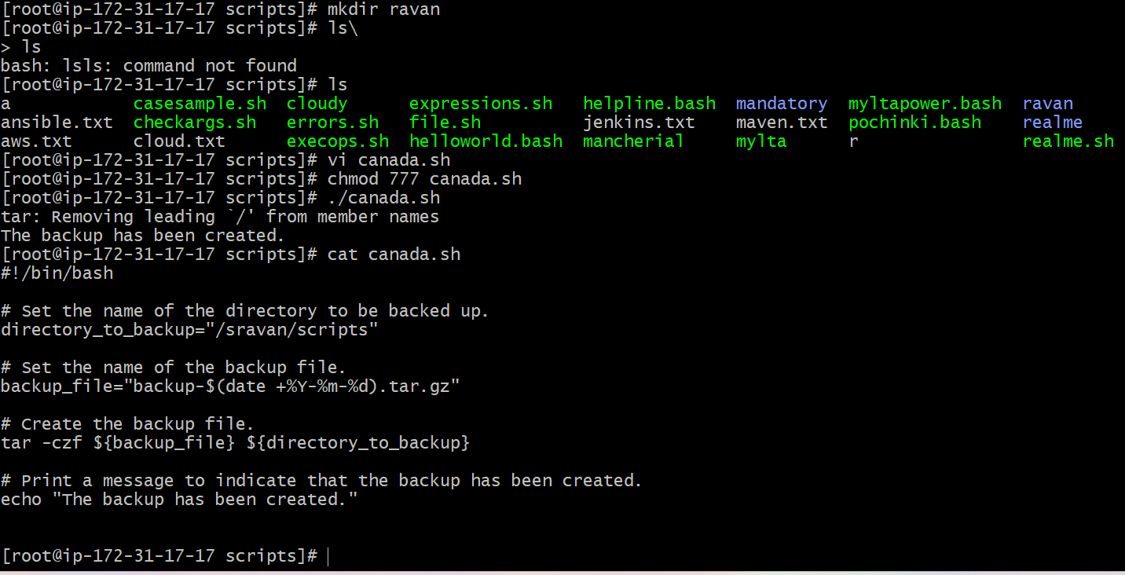

4)Create a bash script to install nginx in ec2 server.

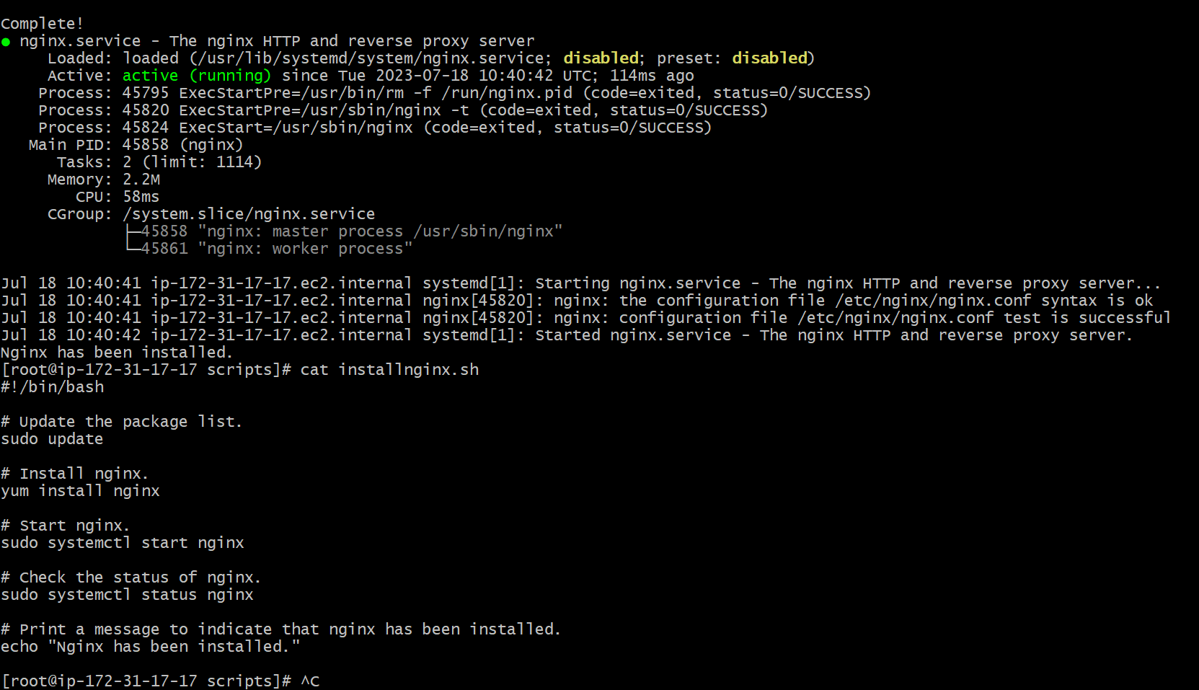

6) Create a bash script to check list if nginx service is running or not,if not running

then script should start the service.

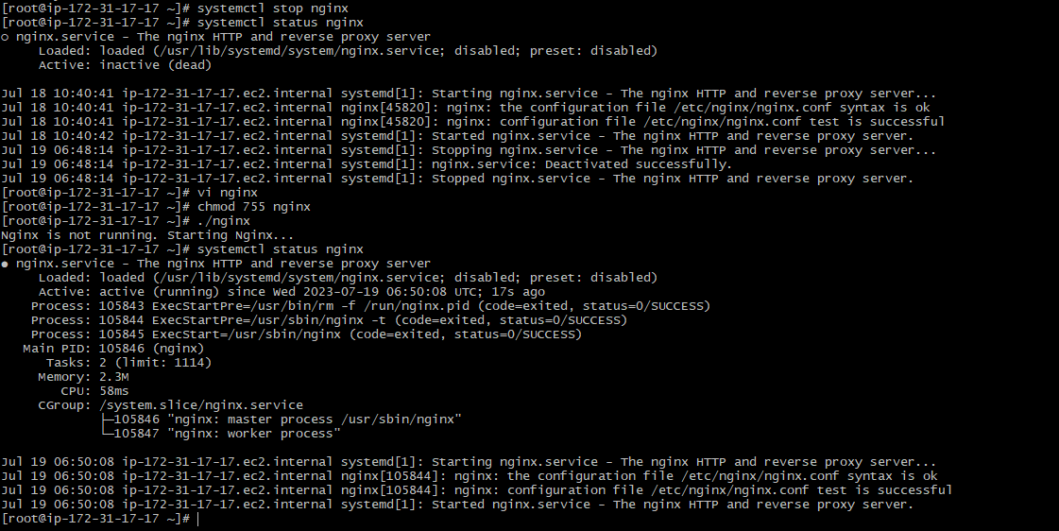

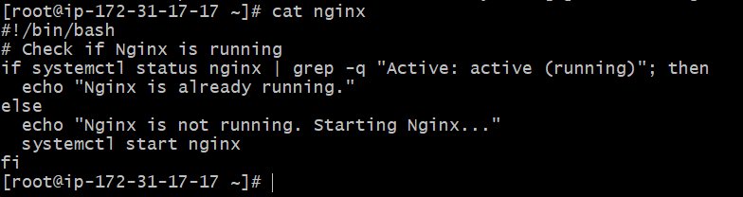

7) Create a bash script for calculator.

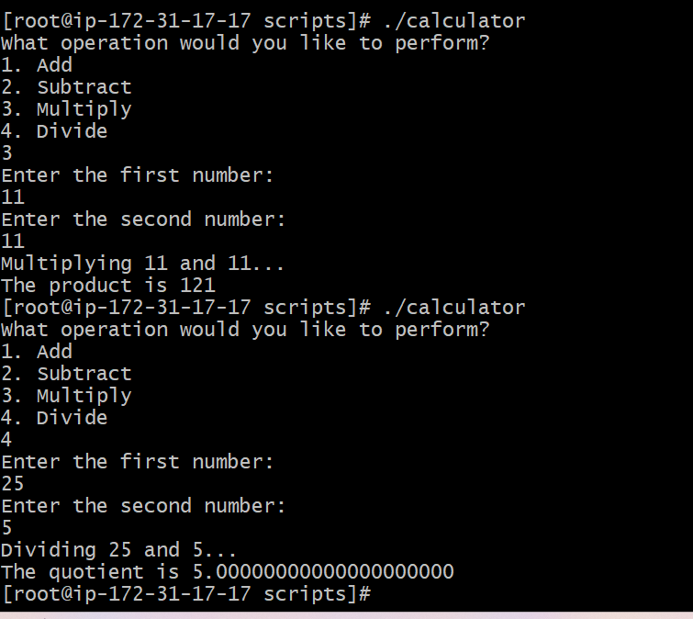

8) Create a bash script to check if directory is avaialble or not,if not then create a directory.

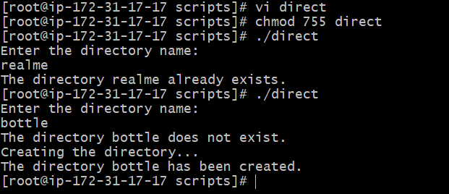

9) Create bash script to delete last 3 lines for a file.

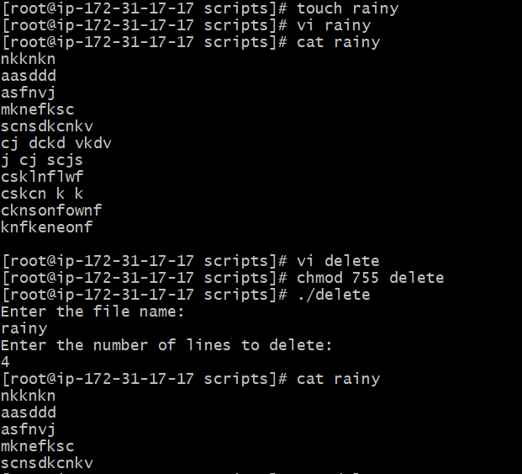

Crontab

1. April 5th Midnight

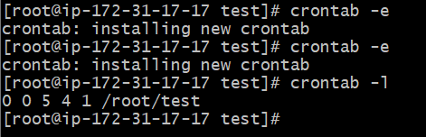

2) 5 th of Every November,Jan,June if it is a Thursday.

3) At 05 and 27th minutes of 9,10,11 hours everyday.

4) 15th second of 34 min. of 9th hour on 15th Aug.

5) Every midnight

6) Every Weekend ( Saturday night 11.59 )

7) After every reboot