Three Adress Code-
Code-
#include <stdio.h>
#include <string.h>

int main()
{
char result[20], op1[20], op2[20], oper;
char tac[100];
int i = 0;

printf("Enter Three Address Code:\n");
printf("Enter each statement on a separate line.\n");
printf("Enter END to finish.\n");

while (1)
{
fgets(tac, sizeof(tac), stdin);

if (strncmp(tac, "END", 3) == 0)
break;

/* Arithmetic instruction */
if (sscanf(tac, "%19s = %19s %c %19s",
result, op1, &oper, op2) == 4)
{
printf("\nTarget Code:\n");

printf("MOV R%d, %s\n", i, op1);

switch (oper)
{
case '+':
printf("ADD R%d, %s\n", i, op2);
break;

case '-':
printf("SUB R%d, %s\n", i, op2);
break;

case '*':
printf("MUL R%d, %s\n", i, op2);
break;

case '/':
printf("DIV R%d, %s\n", i, op2);
break;

default:
printf("Invalid operator\n");
return 1;
}

printf("MOV %s, R%d\n", result, i);
}

/* Simple assignment instruction */
else if (sscanf(tac, "%19s = %19s", result, op1) == 2)
{
printf("MOV %s, %s\n", result, op1);
}
else
{
printf("Invalid Three Address Code\n");
}

i++;
}

return 0;
}

Input-

t1 = b + c
a = t1
END

Output-

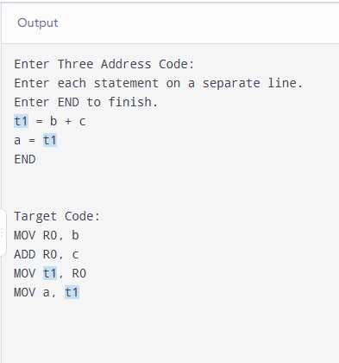
Algorithm-

- Start.
- Declare variables for the result, operands, operator, input statement, and register number.
- Read Three Address Code statements one by one.
- If the statement is END, stop reading.
- Check whether the statement is an arithmetic instruction.
- If it is an arithmetic instruction:
  - Move the first operand into a register.
  - Perform the specified operation (+, -, *, /).
  - Move the result from the register to the destination variable.
- If it is a simple assignment, generate a MOV instruction.
- If the statement is invalid, display an error message.
- Increment the register counter.
- Repeat until END is entered.
- Stop.

Pseudocode-

BEGIN
Initialize register number i = 0

REPEAT
Read Three Address Code statement

IF statement starts with "END" THEN
EXIT LOOP
END IF

IF statement is an arithmetic instruction THEN
Extract result, operand1, operator, operand2

Print MOV R[i], operand1

IF operator = '+' THEN
Print ADD R[i], operand2
ELSE IF operator = '-' THEN
Print SUB R[i], operand2
ELSE IF operator = '*' THEN
Print MUL R[i], operand2
ELSE IF operator = '/' THEN
Print DIV R[i], operand2
ELSE
Print "Invalid operator"
STOP
END IF

Print MOV result, R[i]

ELSE IF statement is a simple assignment THEN
Extract result and operand1
Print MOV result, operand1

ELSE
Print "Invalid Three Address Code"
END IF

Increment i

UNTIL END is entered

END

