Eliminate dead code-

Code-
#include <stdio.h>
#include <string.h>
#include <ctype.h>

#define MAX 100
#define LEN 100

int main()
{
char code[MAX][LEN];
char lhs[MAX][LEN];
char rhs[MAX][LEN];
int live[MAX] = {0};
int n = 0, i, j;
char line[LEN];

printf("Enter Three Address Code statements.\n");
printf("Enter END to finish:\n");

while (n < MAX && fgets(line, sizeof(line), stdin))
{
line[strcspn(line, "\n")] = '\0';

if (strcmp(line, "END") == 0)
break;

if (strlen(line) == 0)
continue;

strcpy(code[n], line);

char *equal = strchr(line, '=');

if (equal != NULL)
{
*equal = '\0';

sscanf(line, "%99s", lhs[n]);
strcpy(rhs[n], equal + 1);
}
else
{
lhs[n][0] = '\0';
rhs[n][0] = '\0';
}

n++;
}

/*
Variables assigned to final program outputs
are considered live.
*/
for (i = n - 1; i >= 0; i--)
{
if (lhs[i][0] == '\0')
{
live[i] = 1;
continue;
}

int needed = 0;

for (j = i + 1; j < n; j++)
{
if (live[j] && strcmp(lhs[i], lhs[j]) == 0)
{
needed = 1;
break;
}
}

/*
Keep a statement if its result is used
by a live statement.
*/
if (needed)
{
live[i] = 1;
}

/*
Statements with externally visible
destinations are preserved.
*/
if (strcmp(lhs[i], "x") == 0 ||
strcmp(lhs[i], "y") == 0)
{
live[i] = 1;
}

/*
Mark earlier definitions of variables
used by this live statement.
*/
if (live[i])
{
char *p = rhs[i];

while (*p)
{
if (isalpha((unsigned char)*p) || *p == '_')
{
char var[LEN];
int k = 0;

while (isalnum((unsigned char)*p) ||
*p == '_')
{
var[k++] = *p++;
}

var[k] = '\0';

for (j = i - 1; j >= 0; j--)
{
if (strcmp(lhs[j], var) == 0)
{
live[j] = 1;
break;
}
}
}
else
{
p++;
}
}
}
}

printf("\nOptimized Three Address Code:\n");

for (i = 0; i < n; i++)
{
if (live[i])
printf("%s\n", code[i]);
}

return 0;
}

Input-
t1 = a + b
t2 = c * d
t3 = t1 + 10
x = t3
y = 20
END

Output-
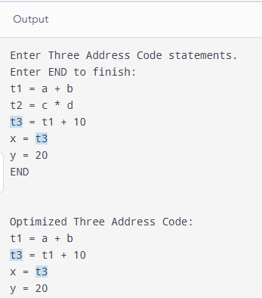
Algorithm: Dead Code Elimination
1. Start.
2. Read Three Address Code statements until END is entered.
3. Store each statement, its left-hand side (LHS), and right-hand side (RHS).
4. Traverse the statements in reverse order.
5. Mark statements whose results are needed or assigned to output variables (x or y) as live.
6. Identify variables used by each live statement and mark their earlier definitions as live.
7. Print only the live statements as optimized Three Address Code.
8. Stop.

Pseudocode-
BEGIN
Read TAC statements until END

Mark all statements as not live

FOR each statement in reverse order
IF statement assigns to x or y
Mark statement as live
END IF
IF its result is needed by a live statement
Mark statement as live
END IF

IF statement is live
Mark earlier definitions of its RHS variables as live
END IF
END FOR

FOR each statement in original order
IF statement is live
Print statement
END IF
END FOR
END

