PROJECT DOCUMENTATION
SMART LEARNING MANAGEMENT SYSTEM (SLMS)
A Comprehensive Project Documentation
Department of Artificial Intelligence and Data Science
Academic Year 2026
Faculty Mentor: Dr. Melinda
TEAM MEMBERS
S. No. | Name | Roll No.
1 | I. Tanusri | 2510080020
2 | M. Deekshitha | 2510080059
3 | G. Arshitha | 2510080063
4 | S. SravanaLakshmi | 2510080065

K L University
Project-Based Learning Documentation

DECLARATION
We hereby present this project documentation for the Smart Learning Management System (SLMS), prepared as part of the Project-Based Learning activities of the Department of Artificial Intelligence and Data Science. The documentation describes the project objectives, requirements, technology stack, architecture, design, implementation approach, features, testing, deployment considerations, challenges, future enhancements, and overall conclusion.
The technical descriptions and demonstrated outcomes in this document are based on the project material supplied for Review 4. Where a capability is identified as future scope rather than an implemented feature, it is described accordingly. The document is intended to provide a structured record of the project and its demonstrated functionality.

ACKNOWLEDGEMENT
We express our sincere gratitude to our faculty mentor, Dr. Melinda, for guidance and academic support throughout the development and review of the Smart Learning Management System. The project provided an opportunity to connect classroom concepts with practical software development activities.
We also acknowledge the support of the Department of Artificial Intelligence and Data Science and the academic environment that enabled the team to work through requirements, interface design, backend/API integration, database operations, testing, and refinement. The collaborative nature of the project helped the team understand the importance of modular design, clear responsibilities, systematic testing, and documentation.
Finally, we thank our teammates for their coordination and contribution to the project activities. The final documentation consolidates the project material into a single technical reference for academic evaluation and future enhancement.

ABSTRACT
The Smart Learning Management System (SLMS) is a centralized web-based learning platform designed to organize learning-related user interactions, records, application workflows, and result interpretation within a single environment. The project addresses the need for a structured digital platform in which users can access the application, work with records, perform search and filtering operations, communicate with backend services through APIs, and view dashboard-style outputs.
The system follows a layered architecture in which the user interacts with a frontend interface, the frontend communicates with RESTful backend/API logic, and the backend works with structured database storage. The project development approach progresses from requirement analysis and UI/UX design to frontend development, backend and API integration, database integration, testing, refinement, and demonstration.
The Review 4 implementation demonstrates core user and record-management workflows, CRUD operations, API communication, search and filtering, database operations, and dashboard outputs. The demonstrated functional test set contains five core cases: login, add record, update record, delete record, and API request. All five cases were successful in the supplied review material. The project is designed for further extension through richer learning and assessment features, analytics and personalized recommendations, notifications, stronger role-based security, and cloud deployment.
Keywords: Smart Learning Management System, Learning Platform, CRUD, REST API, Database Integration, Search and Filtering, Dashboard, Web Application.

TABLE OF CONTENTS
Chapter | Title | Contents
1 | Introduction | 1.1 Background, 1.2 Problem Statement, 1.3 Scope, 1.4 Objectives, 1.5 Importance, 1.6 Target Users
2 | System Requirements | 2.1 Hardware, 2.2 Software, 2.3 Development Environment
3 | Technology Stack | 3.1 Frontend, 3.2 Backend, 3.3 Database, 3.4 APIs, 3.5 Development Tools
4 | System Architecture | 4.1 High-Level Architecture, 4.2 Layers, 4.3 Data Flow, 4.4 Deployment Considerations
5 | System Design | 5.1 Design Principles, 5.2 Database Schema, 5.3 Module Design, 5.4 Interface Design
6 | Implementation | 6.1 Module-wise Implementation, 6.2 Frontend Logic, 6.3 API Integration, 6.4 Database Operations
7 | Features | 7.1 Main Features, 7.2 User Workflows, 7.3 Technical Description
8 | Testing | 8.1 Testing Approach, 8.2 Functional Tests, 8.3 Integration Tests, 8.4 Results
9 | Deployment | 9.1 Deployment Approach, 9.2 Environment Configuration, 9.3 Hosting Considerations
10 | Challenges & Limitations | 10.1 Development Issues, 10.2 Solutions, 10.3 Current Limitations
11 | Future Enhancements | 11.1 Planned Features, 11.2 Analytics, 11.3 Security, 11.4 Cloud
12 | Conclusion | 12.1 Summary, 12.2 Achievements, 12.3 Skills Learned
13 | References | Technical documentation and supporting references
14 | Appendices | Screens, diagrams, sample workflows, setup guide, user guide

CHAPTER - 1 INTRODUCTION

1.1 Background of the Project
Digital learning environments have become important for organizing educational activities, user interactions, records, and performance information. A learning management system provides a structured environment in which users can access application functions through a common interface rather than handling individual activities through disconnected mechanisms.
The Smart Learning Management System (SLMS) presented in this project is designed as a centralized learning platform. The project material identifies user management, interactive learning, data management, analytics/results, and scalability as central objectives. The platform therefore brings together the user-facing interface, application logic, API communication, structured data storage, and dashboard-style outputs in a single workflow.
The project follows a practical software development sequence. Requirement analysis establishes what the application should support. UI/UX design organizes the user interaction. Frontend development provides the visible interface. Backend and API integration connects interface actions to application logic. Database integration provides structured storage. Testing and refinement are used to verify the demonstrated workflows before the project is presented.
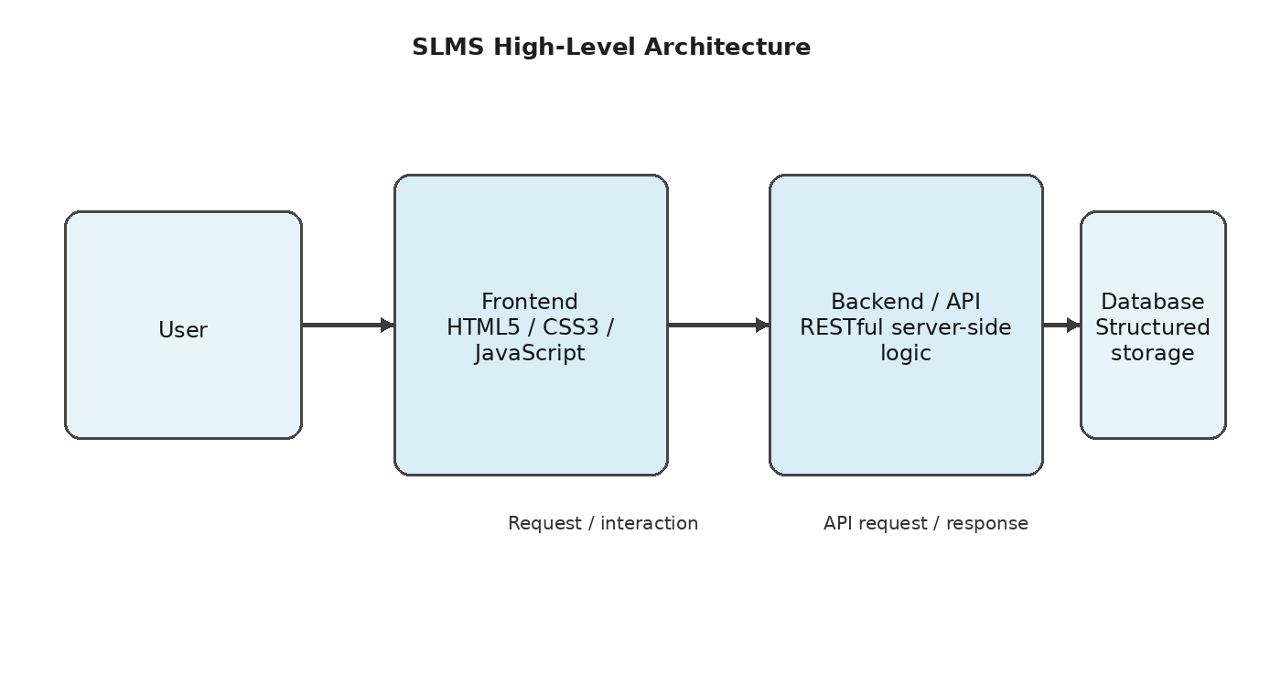
Figure 1.1: High-level architecture of the Smart Learning Management System.

1.2 Problem Statement
Learning-related application activities can become difficult to manage when user access, records, data operations, and results are separated across multiple tools or interfaces. A centralized system can reduce this fragmentation by providing a common application environment for user interaction, record operations, search, filtering, and result presentation.
The problem addressed by SLMS is therefore the organization of core learning-management workflows into a single structured platform. The system must provide a usable interface, support data operations, communicate with backend services, and present meaningful outputs while keeping the architecture clear enough for future extension.

1.3 Scope of the Project
- Centralized access to the learning application through a user-facing interface.
- User management and login workflow.
- Creation, reading, updating, and deletion of application records.
- Search and filtering for practical data access.
- RESTful API communication between application layers.
- Structured database operations.
- Dashboard-style presentation of application results.
- Testing of core workflows and identification of future enhancement areas.

1.4 Objectives
- To provide a centralized learning management environment.
- To support user management and controlled application access.
- To provide interactive learning-oriented application workflows.
- To organize and manage application data systematically.
- To support analytics and result-oriented dashboard outputs.
- To provide a scalable structure that can be enhanced with additional learning features.

1.5 Importance of the Application
The importance of SLMS lies in the integration of multiple software responsibilities into a coherent learning workflow. From a user perspective, a centralized platform reduces the need to move between disconnected interfaces. From a development perspective, separating the frontend, backend/API, and database layers makes the system easier to understand, test, maintain, and extend.
The project also demonstrates practical software engineering concepts. CRUD operations illustrate data lifecycle management. API communication demonstrates separation between interface and server-side logic. Search and filtering demonstrate practical data retrieval. Dashboard outputs demonstrate the importance of presenting processed results in a form that users can interpret.

1.6 Target Users / Audience
The primary audience for the platform is learners and users who interact with learning-management workflows through a web application. The system can also support academic staff or administrators in future versions, especially where stronger role-based access and richer analytics are introduced.
For academic evaluation, the project also serves as a demonstration of frontend development, backend/API communication, database integration, CRUD operations, testing, and system documentation.

CHAPTER - 2 SYSTEM REQUIREMENTS

2.1 Hardware Requirements
The supplied project material does not specify a mandatory hardware configuration. Since the demonstrated system is a web application using standard development and browser tools, a normal development computer capable of running an IDE, a browser, a local server, and project files is appropriate for development and demonstration.
Component | Recommended working level | Purpose
Processor | Modern multi-core processor | Development, local server and browser execution
RAM | 8 GB or above | IDE, browser and server multitasking
Storage | SSD preferred | Project files, tools and repository
Display | Standard HD/Full HD | Interface development and demonstration
Network | Stable internet | Git/GitHub synchronization and online resources

2.2 End-User Requirements
The end user primarily requires a modern web browser and a device capable of running JavaScript-based web interfaces. The project material emphasizes a browser-based workflow rather than a specialized client application. This supports access from common desktop or laptop environments.

2.3 Software Requirements
Software / Environment | Role in the project
HTML5 | Frontend page structure
CSS3 | Frontend presentation and styling
JavaScript | Frontend interaction and application behavior
RESTful API | Communication between application layers
Structured database | Persistent application data storage
VS Code / IDE | Development and source editing
Web Browser | Execution and interface testing
Local Server | Local application execution
Git / GitHub | Version control and project management

The PPT identifies HTML5, CSS3, JavaScript, RESTful server-side logic, structured database storage, HTTP/REST APIs, VS Code or an IDE, browser, local server, and Git/GitHub as part of the development environment. The documentation therefore retains these terms rather than introducing a framework that was not stated in the supplied project material.

2.4 Functional Requirements
- User should be able to access the login workflow.
- User should be able to work with application records.
- System should support add, update and delete operations.
- System should support search and filtering.
- Frontend should communicate with backend/API services.
- Database should store and retrieve structured records.
- Application should present results through dashboard-style outputs.

2.5 Non-Functional Requirements
The project material provides simple measurable indicators for the demonstrated build. Typical application interaction is targeted below 1.5 seconds, common database CRUD operations are targeted below 1 second, and standard API requests are targeted below 1.5 seconds. These figures are presented as demonstrated-build targets rather than a full production benchmark.
Requirement | Project interpretation
Usability | Clear user workflow from login to output
Performance | Typical interaction target below 1.5 seconds
Database responsiveness | Common CRUD target below 1 second
API responsiveness | Standard request target below 1.5 seconds
Reliability | Core demonstrated test cases should complete successfully
Maintainability | Separated frontend, backend/API and database responsibilities
Scalability | Architecture should permit future learning and analytics features

CHAPTER - 3 TECHNOLOGY STACK

3.1 Front-End Technologies
HTML5 provides the structural foundation for the user interface. It defines page-level elements, forms, content areas, navigation elements, and other semantic components required by the application.
CSS3 is used for presentation and interface styling. In an SLMS, styling is important because learning workflows should be readable and visually organized. Clear grouping of forms, navigation, records, and dashboard outputs helps users understand the application state.
JavaScript provides the interactive behavior of the frontend. It can process user actions, validate inputs, initiate API requests, update displayed content, and support dynamic workflows. The project material identifies JavaScript as part of the frontend stack and focuses on application capabilities such as validation, CRUD, search, filtering, and dashboard presentation.

3.2 Backend and Server-Side Logic
The backend is represented in the supplied PPT as RESTful server-side logic. Its responsibility is to receive requests from the frontend, apply application rules, communicate with the database, and return responses. Keeping this responsibility separate from the frontend improves maintainability because interface changes can be made without redesigning the entire data layer.

3.3 Database Layer
The database layer provides structured storage for application records. The project material does not name a specific database product in the Review 4 PPT, so this documentation refers to it as the structured database layer rather than introducing an unsupported database technology.
Database operations form an important part of the project because the functional results explicitly include database operations and CRUD workflows. Add operations create records, read operations retrieve information, update operations modify existing records, and delete operations remove records according to the application's rules.

3.4 APIs and Communication
The application uses HTTP/REST communication as the interface between the frontend and backend. REST-style APIs provide a structured way to expose application operations. The project testing material specifically includes an API Request test case whose expected and actual results are both described as correct.
Operation | Typical REST meaning | SLMS relevance
GET | Retrieve data | Read records / search
POST | Create data | Add records
PUT / PATCH | Modify data | Update records
DELETE | Remove data | Delete records

3.5 Development Tools
The development environment identified by the project includes a code editor or IDE, a browser, a local server, and Git/GitHub. These tools support the complete development cycle: writing source files, running the application locally, inspecting the interface, testing workflows, and maintaining project versions.

3.6 Version Control
Git and GitHub provide version control and project collaboration support. A repository makes it possible to maintain source files and track project changes. For an academic project, version control also provides a record of development progress and helps preserve stable versions while features are refined.

3.7 Technology Integration
The value of the technology stack comes from integration rather than from any single technology. HTML5, CSS3, and JavaScript provide the user interface. RESTful server-side logic provides application processing and communication. The structured database stores application information. HTTP/REST connects the layers, while the development environment and Git/GitHub support implementation and maintenance.

CHAPTER - 4 SYSTEM ARCHITECTURE

4.1 High-Level Architecture
The architecture of the SLMS follows a layered flow: User → Frontend → API/Backend → Database → Response. This structure separates presentation, application processing, and data storage. The user interacts with the frontend, the frontend sends requests through the API/backend layer, and the backend accesses structured database storage before returning a response.
Figure 4.1: SLMS high-level layered architecture.

4.2 Frontend Layer
The frontend is the presentation layer of the system. It contains the screens and interactive elements through which users access login, home, main application, forms, and dashboard/output areas. Its responsibility is to collect user actions, display system responses, and provide a coherent interaction flow.

4.3 Backend / API Layer
The backend/API layer acts as the processing boundary between the user interface and persistent data. It receives requests, determines the required operation, communicates with the database, and prepares a response for the frontend. This separation also creates a clear location for validation and application rules.

4.4 Database Layer
The database layer provides persistent structured storage. The architecture treats database access as a separate responsibility, allowing the application to perform CRUD and search-related operations without coupling storage details directly to the visible interface.

4.5 Response Flow
After an operation is processed, the result travels back through the API/backend layer to the frontend. The frontend then presents the result to the user, either through an updated record list, confirmation, filtered results, or dashboard-style output.
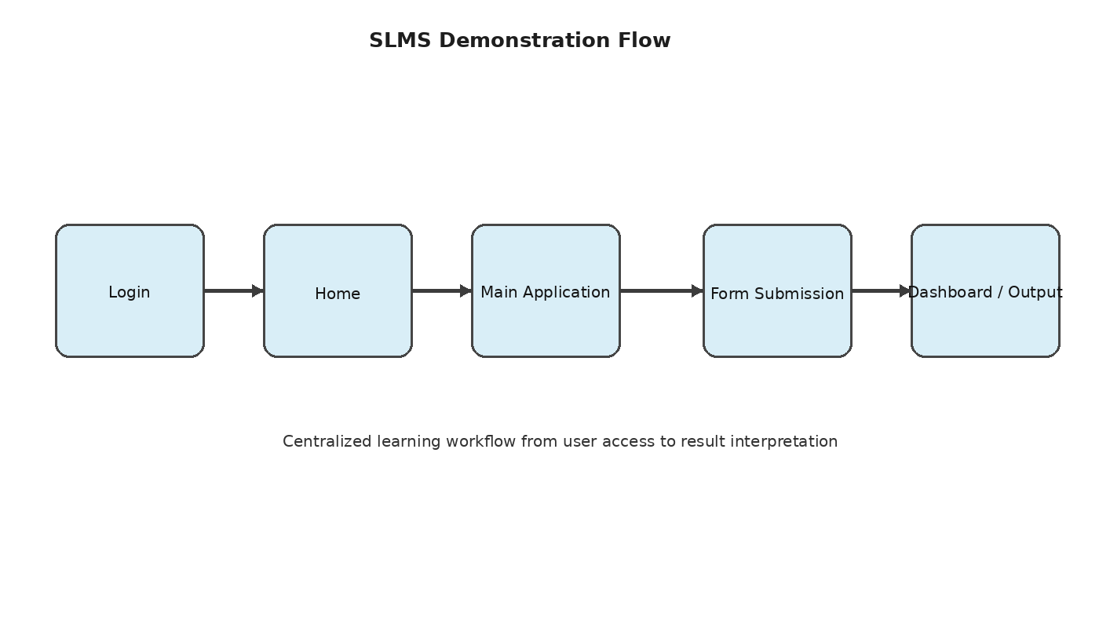
Figure 4.2: Demonstrated application workflow from login to dashboard/output.

4.6 Deployment Architecture
The Review 4 material identifies a local development environment consisting of an IDE, browser, local server, and Git/GitHub. It does not document a specific production hosting provider. Therefore, the present documentation treats local execution as the demonstrated environment and cloud deployment as future scope.

4.7 Architectural Benefits
- Clear separation of responsibilities between presentation, processing, and storage.
- Independent refinement of frontend and backend logic.
- Centralized API boundary for application communication.
- Structured data management through a dedicated database layer.
- Improved maintainability and a clear path for future scalability.

CHAPTER - 5 SYSTEM DESIGN

5.1 Design Principles
The SLMS design is based on modularity, separation of responsibilities, usability, and extensibility. Modularity means that user management, records, search, API communication, database operations, and dashboard outputs can be considered as distinct responsibilities. Separation of responsibilities prevents the interface from becoming responsible for storage or server-side processing.
The design also follows a workflow-oriented approach. Instead of presenting unrelated functions, the interface is organized around a sequence that begins with access and continues through application interaction, form submission, and result interpretation.

5.2 Module Design
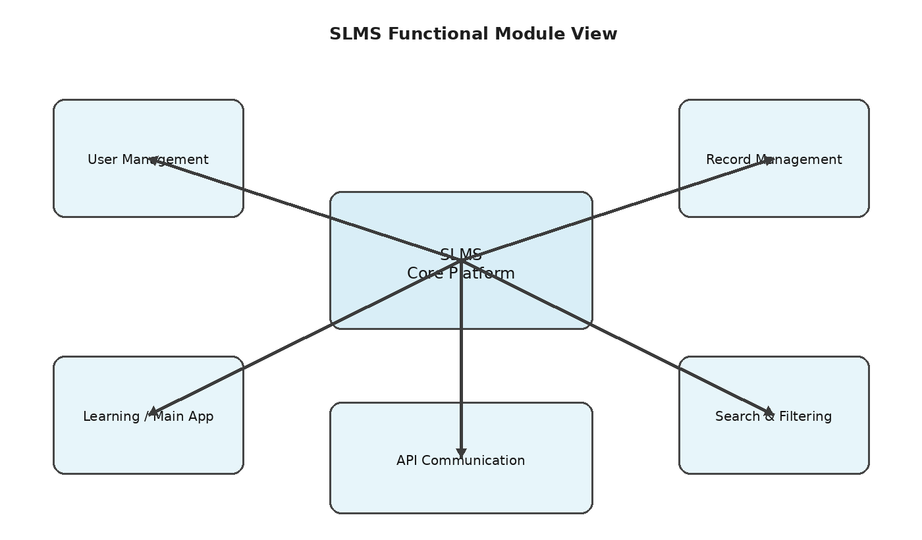
Figure 5.1: Functional module view of the SLMS.
The module view groups the project capabilities around a central application platform. User management provides access, learning/main application functions provide the primary workflow, record management supports CRUD, search and filtering improve information retrieval, and API communication connects these operations to the backend layer.

5.3 Database Design
The supplied Review 4 PPT identifies structured database storage and database operations but does not provide a complete ER diagram or named table schema. Accordingly, the design is described at the logical level rather than inventing table names or attributes that were not supplied.
Logical data responsibility | Purpose
User information | Supports login and user management
Application records | Stores records used by the main workflow
Searchable attributes | Supports search and filtering
Result information | Supports dashboard and output presentation

5.4 CRUD Design
CRUD is central to the demonstrated system. Create adds a record, Read retrieves information, Update modifies an existing record, and Delete removes a record. The testing material explicitly demonstrates add, update, and delete operations as successful test cases.

5.5 Interface Design
The PPT identifies five major screen areas: Login, Home, Main App, Form, and Dashboard. These screens form the visible sequence through which users interact with the application.
Screen / Area | Primary purpose
Login | User access
Home | Entry point and navigation
Main Application | Primary learning/application workflow
Form | Input and record submission
Dashboard / Output | Result interpretation and summary

5.6 Navigation Design
The navigation is designed to minimize unnecessary steps. A typical user journey begins at Login, continues to Home, moves to the Main Application, uses a Form to submit or modify information, and finishes at Dashboard/Output where the system response can be interpreted.

5.7 Data Flow Design
Data enters the system through user interaction with the frontend. The frontend formats the operation as an API request. The backend processes the request and communicates with the structured database. The database returns the relevant result, after which the backend prepares the API response and the frontend updates the visible application state.

5.8 Design for Maintainability
A maintainable design should make it possible to modify one layer without requiring unnecessary changes in the others. For example, presentation changes should remain primarily within the frontend, while storage changes should remain within the database layer. The API boundary provides a stable communication point between them.

CHAPTER - 6 IMPLEMENTATION

6.1 Module-wise Implementation
Implementation follows the development sequence presented in the Review 4 material: requirement analysis, UI/UX design, frontend development, backend and API integration, database integration, testing and refinement. This sequence is important because each stage provides an input to the next stage.
The implementation begins with identifying the user and record workflows. The interface is then organized around the screens required for those workflows. Once the interface is available, API communication connects user actions to server-side logic. Database integration then provides persistence, after which functional tests are used to validate the complete workflow.

6.2 User Management Implementation
User management forms the entry point of the application. The login workflow is one of the core test cases and is expected to result in successful login. In the demonstrated test set, the login case passed.

6.3 Record Management Implementation
Record management implements the data lifecycle through add, update, and delete operations. These operations provide the practical foundation for managing application information. Each operation requires coordination between the form/interface, API request, server-side processing, and database update.

6.4 Search and Filtering Implementation
Search and filtering are included in the functional capabilities identified by the project. Search allows a user to locate relevant records, while filtering narrows displayed information according to available criteria. Together they improve the usability of a record-oriented learning application.

6.5 API Integration
API integration connects frontend actions to backend processing. A request is generated when the user performs an operation, the backend receives and processes it, and the resulting response is returned to the interface. The API Request test case in the supplied PPT confirms the demonstrated request-response workflow.

6.6 Database Operations
Database integration provides persistent storage for records. The implementation must maintain consistency between what the user sees and what is stored. Add, update, and delete actions therefore form a complete lifecycle: a new record is stored, its information can be modified, and it can later be removed.

6.7 Dashboard and Output Implementation
Dashboard-style output provides a summary view of application results. The project material identifies reports/dashboard capabilities as functional results. This layer is important because raw records and API responses are not always the most useful form for interpretation.

6.8 Validation and Refinement
Testing and refinement are integrated into the development approach rather than treated as an isolated final step. The team verifies core workflows, observes the results, and refines the application before demonstration. This iterative approach supports more reliable implementation.

6.9 Demonstration Sequence
The supplied project material proposes a clear demonstration sequence: Login → Home → Main Application → Form Submission → Dashboard/Output. This sequence is suitable for showing the complete path from user access to result interpretation.
Figure 6.1: Implementation and demonstration sequence.

6.10 Implementation Summary
Implementation area | Demonstrated capability
User access | Login workflow
Records | CRUD operations
Information retrieval | Search and filtering
Communication | HTTP/REST API
Storage | Structured database operations
Presentation | Dashboard-style outputs

The implementation therefore covers the major layers required for a functional learning-management prototype while leaving room for deeper learning, analytics, security, and deployment capabilities in future iterations.

CHAPTER - 7 FEATURES

7.1 List of Main Features
- User management and login.
- Centralized learning/application workflow.
- Interactive form-based operations.
- Record creation, update, and deletion.
- Search and filtering.
- API-based frontend/backend communication.
- Structured database operations.
- Reports and dashboard-style output.

7.2 Login Feature
The Login feature provides the entry point into the application. It is designed to establish user access before the user proceeds to the main learning workflow. The demonstrated test case expects a successful login and records a PASS status.

7.3 Home and Main Application
The Home area provides a transition from authentication to the main application. The Main Application area contains the primary interactive workflow. Together they establish a clear user journey and reduce ambiguity about where the user should continue after login.

7.4 Form Submission
Forms provide a structured mechanism for entering information. A form operation can result in a create or update action depending on the workflow. Form submission is also a natural point for validation before information is sent through the API.

7.5 CRUD Feature
CRUD functionality provides the basic record lifecycle. The Add Record test confirms creation, the Update Record test confirms modification, and the Delete Record test confirms removal. These operations are central to practical data management.

7.6 Search and Filtering
Search and filtering help users locate relevant records without manually inspecting all available data. In a learning-management context, these capabilities can support organized access to records and make the application more practical as the volume of data increases.

7.7 API Communication
API communication provides the link between the interface and server-side processing. The system uses HTTP/REST principles to structure this communication. A correct API response is explicitly included in the demonstrated testing set.

7.8 Dashboard and Reports
Dashboard-style outputs present application results in a form that supports interpretation. Rather than leaving users with raw data, the system provides a summarized view of results. This capability is identified in the PPT as part of the functional results and supports the project's analytics-oriented objective.

7.9 Feature Summary
Feature | User value | Technical role
Login | Controlled entry | User access workflow
CRUD | Manage records | Database lifecycle
Search/filter | Find relevant data | Information retrieval
API | Connect application layers | Request/response
Dashboard | Interpret results | Presentation/summary

CHAPTER - 8 TESTING

8.1 Testing Approach
Testing is a major part of the project development cycle. The supplied Review 4 material presents a focused functional test set covering login, record creation, record update, record deletion, and API request handling. The purpose of the test set is to verify that the demonstrated core workflows produce the expected outcomes.
Testing is interpreted at the functional level for this documentation. The project material does not provide a full automated testing framework, browser matrix, load-testing report, or production benchmark. Therefore, the documentation records the demonstrated test results without claiming broader test coverage.

8.2 Test Cases and Results
Test Case | Expected Result | Actual Result | Status
Login | Successful login | Successful | PASS
Add Record | Record added | Added | PASS
Update Record | Record updated | Updated | PASS
Delete Record | Record deleted | Deleted | PASS
API Request | Correct response | Correct response | PASS

The supplied test summary reports five core functional cases executed, five successful, and zero failed in the demonstrated test set.

8.3 Testing of Login
The login test verifies that the user access workflow completes successfully. The expected result is a successful login, and the actual result recorded in the project material is also successful. The test therefore receives a PASS status.

8.4 Testing of CRUD Operations
The Add Record test checks whether a record can be created. The Update Record test checks whether an existing record can be modified. The Delete Record test checks whether a record can be removed. All three cases passed in the supplied test set.

8.5 API Testing
The API Request test checks request-response correctness. The expected result is a correct response and the actual result is also recorded as correct. This confirms the demonstrated API communication workflow.

8.6 Testing Summary
Metric | Demonstrated value
Core test cases | 5
Successful cases | 5
Failed cases | 0
Observed error rate in test set | 0%

8.7 Performance Indicators
Indicator | Value / target
Typical application interaction | < 1.5 s
Database response for common CRUD | < 1 s
Standard API response | < 1.5 s

These performance values are documented as the simple measurable indicators supplied with the Review 4 build. They should not be interpreted as a comprehensive load or stress benchmark.

8.8 Testing Conclusion
The demonstrated functional test set confirms that the principal user and record-management workflows operate as expected in the reviewed build. All five listed cases passed. Additional automated, security, usability, load, and regression testing would be appropriate for a production-ready system and can be incorporated as future development expands the platform.

CHAPTER - 9 DEPLOYMENT

9.1 Deployment Approach
The supplied project material identifies a local development environment consisting of a browser, local server, development editor/IDE, and Git/GitHub. A complete production hosting procedure is not included in the Review 4 PPT. Therefore, this chapter documents the demonstrated local deployment context and describes production deployment as a future consideration.

9.2 Local Execution
- Open the project source in the selected development environment.
- Ensure the required frontend and backend components are available.
- Start the local server according to the project implementation.
- Open the application in a modern web browser.
- Perform the login and core workflow demonstration.
- Verify record operations and dashboard/output behavior.

9.3 Environment Configuration
A web application requires the frontend, backend/API, database, and communication settings to agree on their operating environment. In a local development setup, these components are normally configured so that the frontend can reach the backend/API and the backend can reach the structured database.
The project PPT does not provide exact environment variable names, ports, deployment provider names, or server configuration files. Those details are therefore intentionally not invented in this documentation.

9.4 Hosting Considerations
For future production deployment, the frontend and backend can be hosted in environments capable of serving web assets and running server-side API logic. The database would be hosted in a persistent managed or self-managed environment. HTTPS, secure configuration, monitoring, backups, and access control would become important deployment concerns.

9.5 Version-Controlled Deployment
Git/GitHub provide a natural source-control foundation for deployment. The repository can preserve stable versions of the application while new features are developed. A future continuous integration and deployment pipeline could automatically validate the project before releasing a new version.

9.6 Deployment Summary
Area | Current documentation status
Local development | Supported by the supplied project environment
Browser execution | Part of demonstrated environment
Git/GitHub | Identified in technology stack
Production hosting provider | Not specified in Review 4 PPT
Cloud deployment | Future scope

CHAPTER - 10 CHALLENGES & LIMITATIONS

10.1 Development Challenges
Integrating multiple application layers is a common challenge in a system such as SLMS. The frontend must communicate correctly with the API, the API must process requests consistently, and database operations must preserve the expected state. A problem in any layer can affect the visible result.
Another challenge is maintaining a simple user workflow while supporting multiple capabilities. Login, forms, CRUD, search, filtering, and dashboard outputs need to fit into a coherent navigation sequence rather than appearing as unrelated functions.

10.2 Integration Challenges
API integration requires consistent request and response handling. Data sent by the frontend must match what the backend expects, while the returned result must be interpreted correctly by the frontend. Database integration introduces an additional dependency because the API must translate application operations into persistent data operations.

10.3 Testing Challenges
The Review 4 testing set focuses on five core functional cases. This provides useful validation of the main workflow, but it is smaller than the test coverage expected for a complete production application. Future versions can expand testing to include invalid input, authentication edge cases, concurrent operations, browser compatibility, security, and performance under load.

10.4 Usability Considerations
A learning platform must be easy to understand because users should focus on learning tasks rather than on navigating a complicated interface. The separation into Login, Home, Main Application, Form, and Dashboard/Output areas provides a foundation for clear navigation. Further usability evaluation with multiple users would strengthen the design.

10.5 Current Limitations
- The Review 4 material does not document a complete production deployment.
- The supplied material does not provide a detailed database schema or ER diagram.
- The demonstrated test set contains five core functional cases.
- Advanced analytics and personalized recommendations are listed as future scope.
- Notifications and stronger role-based security are listed as future scope.
- Cloud deployment is listed as future scope.

10.6 Limitations and Academic Interpretation
These limitations do not invalidate the demonstrated prototype. Instead, they define the boundary of what has been demonstrated in the supplied project material. A clear distinction between implemented capabilities and future enhancements makes the documentation more accurate and provides a practical roadmap for further work.

10.7 Solutions and Refinement Strategy
The development approach uses testing and refinement as a final validation stage after frontend, backend/API, and database integration. When an operation does not produce the expected result, the relevant layer can be inspected independently. This layered approach reduces the difficulty of diagnosing integration issues.
For future iterations, a broader automated test suite, stronger validation, structured logging, security review, and performance testing would improve reliability. These additions would also make the platform better suited to larger user populations and real deployment.

CHAPTER - 11 FUTURE ENHANCEMENTS

11.1 Planned Features
The Review 4 material explicitly identifies several future enhancements. The first is the addition of more learning and assessment features. Such features could extend the current centralized workflow into a broader learning environment.
A second direction is richer analytics and personalized recommendations. The existing dashboard-oriented approach provides a foundation for presenting results, while future analytics could use user activity and learning outcomes to provide more meaningful summaries.

11.2 Notifications
Notifications are identified as a future enhancement. A notification layer could inform users about learning activities, updates, or important application events. Its implementation would require a clear event model and appropriate delivery mechanism.

11.3 Stronger Role-Based Security
The supplied PPT identifies stronger role-based security as future scope. Role-based access can distinguish permissions for different categories of users. For example, future versions could provide different capabilities to learners, instructors, and administrators. The exact roles and permissions are not defined in the Review 4 material and therefore are left for future requirements analysis.

11.4 Cloud Deployment
Cloud deployment is also identified as a future enhancement. Moving the system from a local development environment to cloud infrastructure could improve accessibility and support scaling. Such a transition would require production configuration, secure secrets management, database hosting, monitoring, backups, and deployment automation.

11.5 Analytics and Personalization
The project objective includes analytics/results, and future scope identifies richer analytics and personalized recommendations. A future analytics module could transform application records into summaries, trends, and learning indicators. Personalization could then use those indicators to tailor learning content or recommendations.

11.6 Scalability Roadmap
Scalability should be addressed incrementally. The first step is to maintain clear separation between layers. The next step is to optimize database access and API processing. As usage grows, deployment infrastructure can be scaled and monitoring can be introduced. The architecture already provides a conceptual separation that supports this roadmap.

CHAPTER - 12 CONCLUSION

12.1 Summary of the Project
The Smart Learning Management System is a centralized web-based platform that combines user management, interactive workflows, record operations, search and filtering, API communication, database integration, and dashboard-style outputs. The project follows a structured development approach from requirements through design, implementation, integration, testing, refinement, and demonstration.
The system architecture separates the user-facing frontend from backend/API logic and structured database storage. This separation supports maintainability and provides a clear foundation for future enhancement.

12.2 What Was Achieved
- Core user and record-management workflows were implemented.
- Frontend, backend/API, and database responsibilities were clearly separated.
- CRUD operations were demonstrated.
- Search and filtering were included as functional capabilities.
- API-driven operations were demonstrated.
- Dashboard-style outputs were included.
- Five core functional test cases passed in the demonstrated test set.

12.3 Skills Learned During Development
- Requirement analysis and project planning.
- Frontend interface organization using HTML5, CSS3, and JavaScript.
- Understanding of RESTful API communication.
- Structured database operation concepts.
- CRUD workflow implementation.
- Search and filtering design.
- Functional testing and result interpretation.
- System architecture and technical documentation.
- Version-control practices using Git/GitHub.

12.4 Overall Assessment
The Review 4 implementation meets the core objectives identified for the project. The demonstrated functional test set produced five successful results out of five listed cases. The project also provides a practical foundation for expanding into richer learning, analytics, security, notification, and cloud capabilities.

12.5 Final Conclusion
The Smart Learning Management System demonstrates how a centralized web application can organize learning-oriented workflows through a combination of user access, interactive forms, CRUD operations, search and filtering, API communication, structured data storage, and dashboard outputs. Its layered architecture creates a clear technical foundation, while its future scope provides opportunities for deeper learning features, personalization, stronger security, notifications, and cloud deployment.
The project therefore represents a functional academic prototype and a foundation for continued development. The documentation records the current demonstrated scope without presenting future features as completed capabilities.

CHAPTER - 13 REFERENCES
The supplied Review 4 PPT identifies the project technologies and development environment but does not provide a formal bibliography. The following references are therefore presented as standard technical documentation sources relevant to the technologies named in the project. They are included as supporting references rather than as claims about specific resources used by the team.
Reference | Purpose
HTML Living Standard / WHATWG | Reference for HTML structure and web standards
MDN Web Docs – HTML | Reference for HTML elements and browser APIs
MDN Web Docs – CSS | Reference for CSS styling and layout
MDN Web Docs – JavaScript | Reference for JavaScript language and browser programming
REST / HTTP technical documentation | Reference for request-response communication
Git Documentation | Reference for version control
GitHub Documentation | Reference for repository and collaboration workflows

13.1 Project Source Material
Primary project source: Project-Based Learning – Review 4 presentation for Smart Learning Management System (SLMS), Department of Artificial Intelligence and Data Science, Academic Year 2026.
Reference format source: the supplied sample project documentation PDF, used only to model the chapter organization, documentation depth, and appendix structure. Project-specific tourism content from that sample has not been transferred into this SLMS documentation.

13.2 Documentation Note
This document intentionally distinguishes between demonstrated implementation and future scope. Where the project PPT provides exact results, those results are retained. Where the PPT identifies a technology category without naming a specific product, the documentation keeps the broader category. Where the PPT lists an enhancement as future scope, it is not presented as an implemented feature.

CHAPTER - 14 APPENDICES

APPENDIX A — PROJECT ARCHITECTURE
Figure A.1: SLMS architecture used for documentation.
The architecture illustrates the core relationship among the user, frontend, backend/API, and structured database. The response travels back through the application layers to the user interface.

APPENDIX B — DEMONSTRATION WORKFLOW
Figure B.1: Login → Home → Main Application → Form Submission → Dashboard/Output.
This workflow can be used as the standard project demonstration sequence. It begins with user access and ends with result interpretation.

APPENDIX C — FEATURE MODULE VIEW
Figure C.1: Functional module relationship.
The module view groups the main capabilities described in the Review 4 material. It is a logical representation for documentation; it does not claim a specific source-code folder structure that was not supplied.

APPENDIX D — FUNCTIONAL TEST RECORD
Case | Expected | Actual | Status
Login | Successful login | Successful | PASS
Add Record | Record added | Added | PASS
Update Record | Record updated | Updated | PASS
Delete Record | Record deleted | Deleted | PASS
API Request | Correct response | Correct response | PASS

Testing summary: 5 core functional cases executed, 5 successful, and 0 failed in the demonstrated test set.

APPENDIX E — USER GUIDE

E.1 Starting the Application
Start the project in the configured development environment and run the local application according to the project setup. Open the application in a modern web browser.

E.2 Login
Use the Login screen to access the application. After successful login, continue to the Home area.

E.3 Main Application
Navigate to the Main Application area and use the available form or record operations. Follow the displayed workflow to add, update, search, filter, or remove records as applicable.

E.4 Dashboard / Output
After completing an operation, use the Dashboard/Output area to inspect the resulting information and summaries.

APPENDIX F — INSTALLATION / SETUP GUIDE
- Obtain the project source files from the project repository or the provided project package.
- Open the source in the selected IDE or development environment.
- Verify that the frontend, backend/API, and database components are configured for the local environment.
- Start the local server required by the project.
- Open the application in a supported web browser.
- Perform the demonstrated login and functional workflow.
- Verify the core test cases and record the observed results.
Exact installation commands, ports, environment-variable names, and database credentials are not included because they are not specified in the supplied Review 4 PPT. They should be inserted from the actual project source/setup files when the team prepares a final implementation-specific installation manual.

APPENDIX G — PROJECT PRESENTATION CHECKLIST
Step | Demonstration item | Expected evidence
1 | Login | Successful access
2 | Home | Navigation to application
3 | Main Application | Primary workflow visible
4 | Form | Data entry / action
5 | Add Record | Record created
6 | Update Record | Record modified
7 | Delete Record | Record removed
8 | Search / Filter | Relevant information located
9 | API Request | Correct response
10 | Dashboard / Output | Results presented

APPENDIX H — FINAL PROJECT SUMMARY
Project Title: Smart Learning Management System (SLMS)
Department: Artificial Intelligence and Data Science
Academic Year: 2026
Faculty Mentor: Dr. Melinda
Team: I. Tanusri (2510080020), M. Deekshitha (2510080059), G. Arshitha (2510080063), S. SravanaLakshmi (2510080065)
Core demonstrated capabilities: user management, interactive learning/application workflow, CRUD operations, search and filtering, API communication, database operations, and dashboard/report outputs.
Demonstrated test outcome: 5/5 core functional cases passed, with 0% observed error rate in the supplied test set.
Future scope: additional learning and assessment features, richer analytics and personalized recommendations, notifications, stronger role-based security, and cloud deployment.
END OF PROJECT DOCUMENTATION

