**Emotion Based Music Recommendation System Using Wearable Physiological Sensors**

In this paper author is describing concept to recommend music to user by detecting moods of user. Existing technique were using collaboration technique which will use previous user data to recommend music to user, if there is no input from previous user then this technique will not useful. This existing technique requires lots of manual work to arrange different music to different categories such as happy, sad or angry etc.

To overcome from above issue author is using ‘Wearable Physiological Sensors**’** and this sensors will send signals to application regarding user current status and then this application using SVM (support vector machine) and deep learning neural network algorithms will classify/predict the mood by extracting features from signal. SVM algorithm will be trained with all mood based signals data and whenever a new signal received then SVM/deep learning neural networks will apply new signal on train data to classify user moods. Based on detected user mood song list will be display/recommend to the user.

As student we cannot afford to buy sensors for this project so we are using images with faces to detect user mood and to recommend music. As faces are the best option to predict mood of the users. We tried a lot to search sensors data to classify mood but on internet no such datasets are available.

Implementation Details

In this application I am uploading image and then using python OPENCV i am pre-processing image to extract features and then this features is applied on SVM/Deep Learning Neural Network Training Model to predict moods of user and based on user mood all songs will be detected and shown in drop down box and user can select any song and play.

All sample images are in images folder and all songs are in songs folder and u too can include new songs to that folder and given name as happy1.mp3, happy2, happy3 or sad1, sad2 etc. Like this for all categories you can add songs. Currently i am using same song for all moods.

To run project install below package

Pip install playsound

Screen shots

Double click on ‘run.bat’ file to get below screen

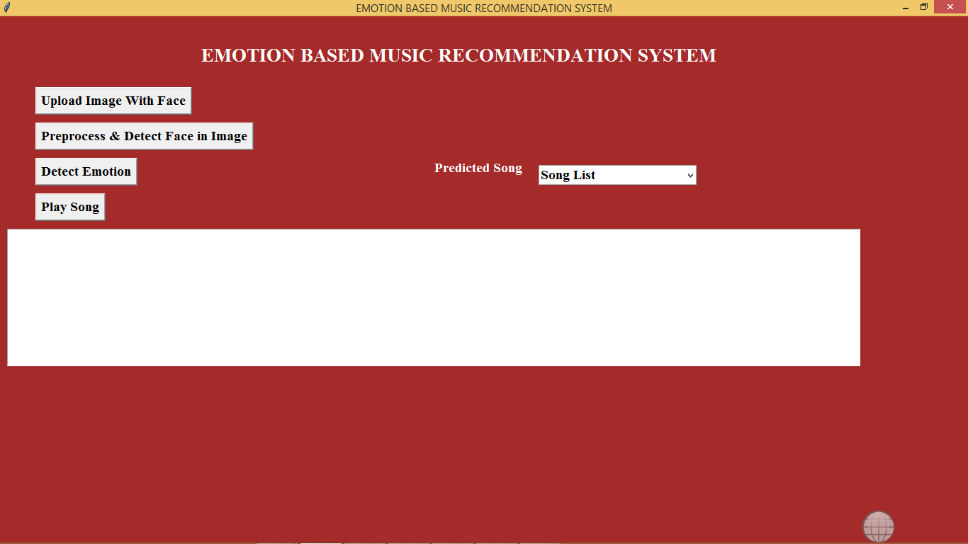

In above screen click on ‘Upload Image With Face’ button to upload image

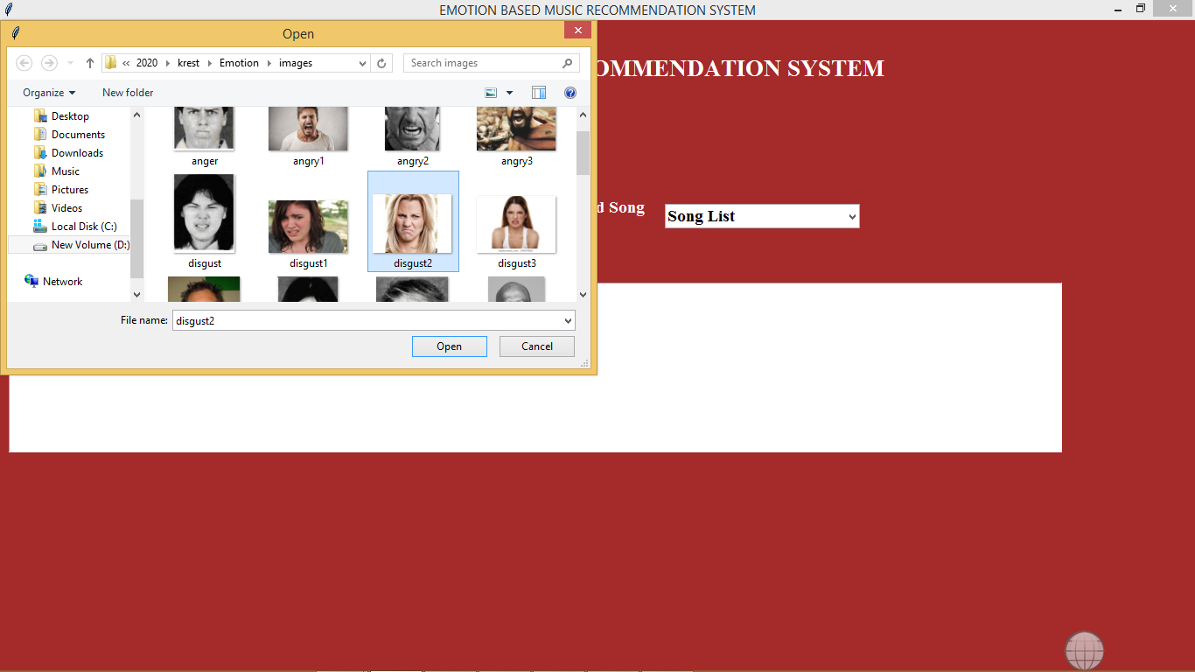

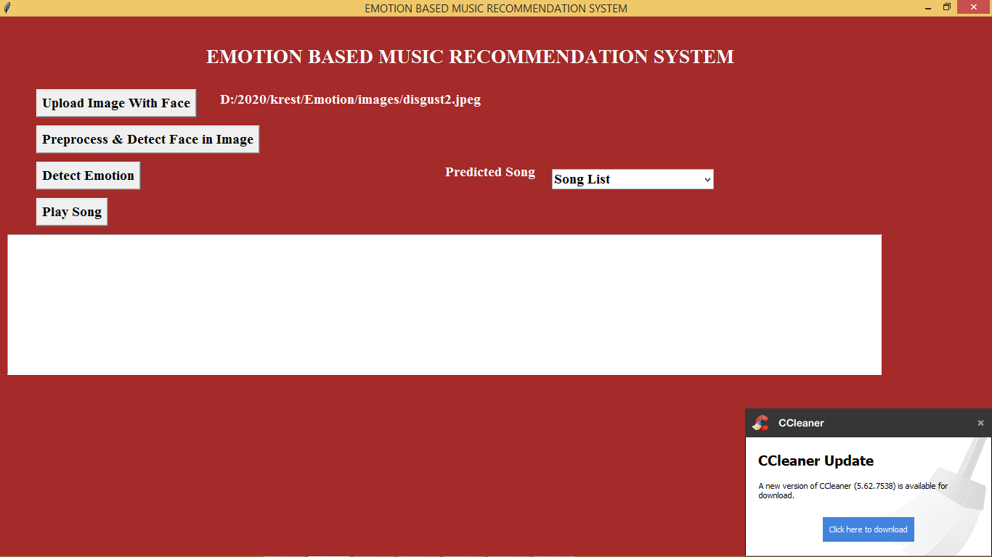

In above screen i am selecting one ‘disgust’ image. Now click on ‘Pre-process & Detect Face In Image’ button to perform pre-processing and to extract face from images

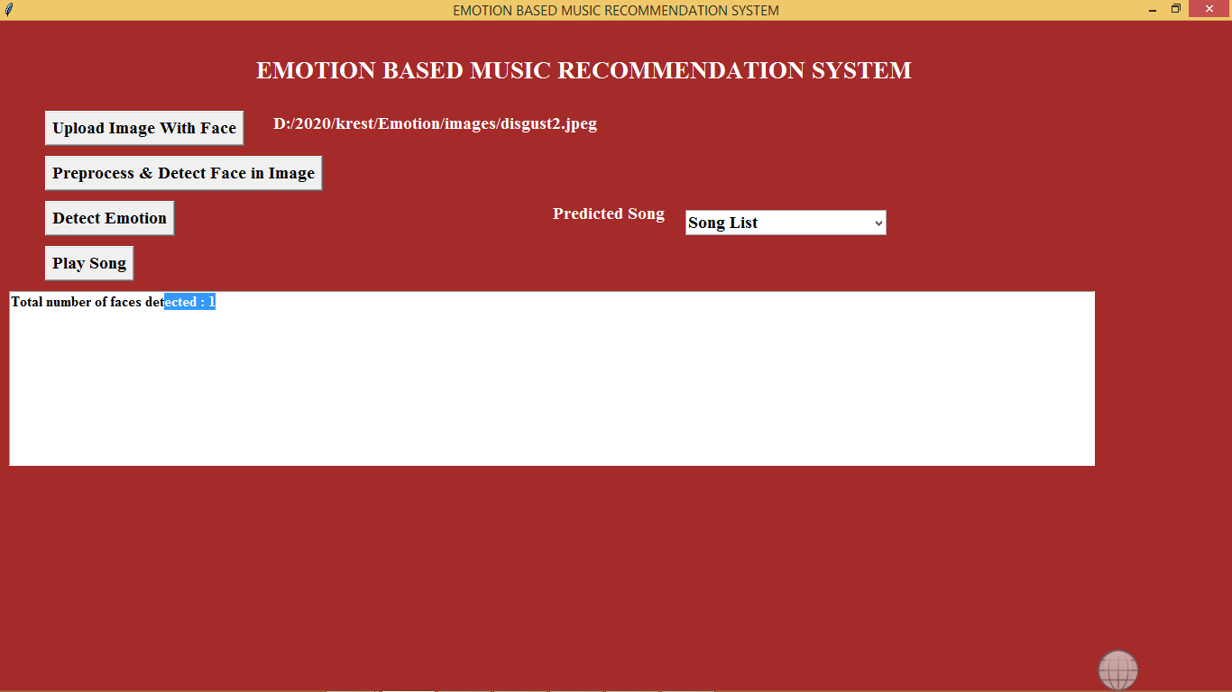

In above screen we can see in uploaded image one face is detected. Now click on Detect Emotion button to detect emotion

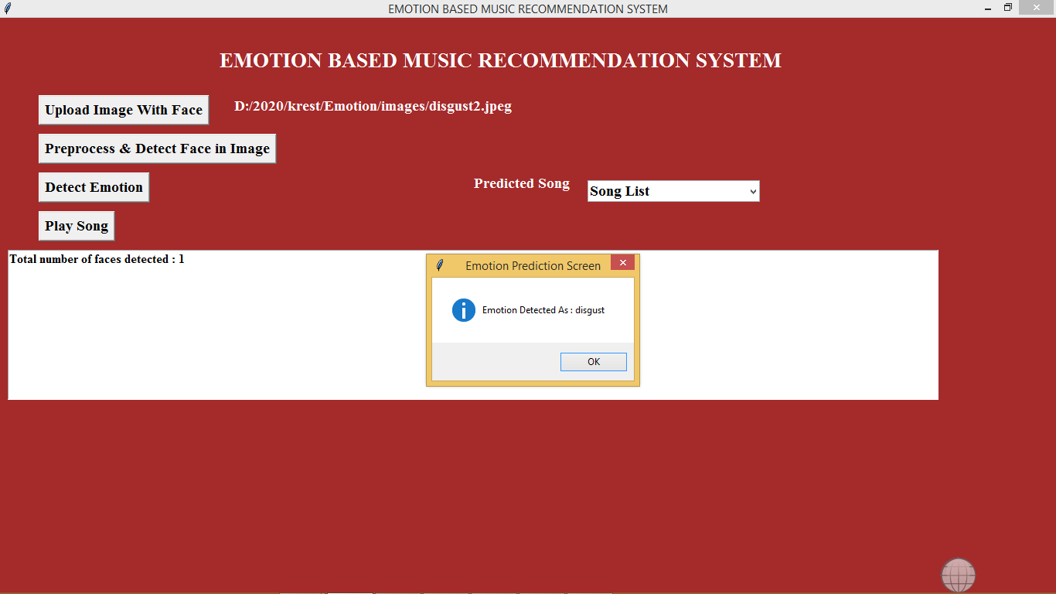

In above screen we can see emotion disgust is detected and now click on drop down arrow link to get all disgust songs list

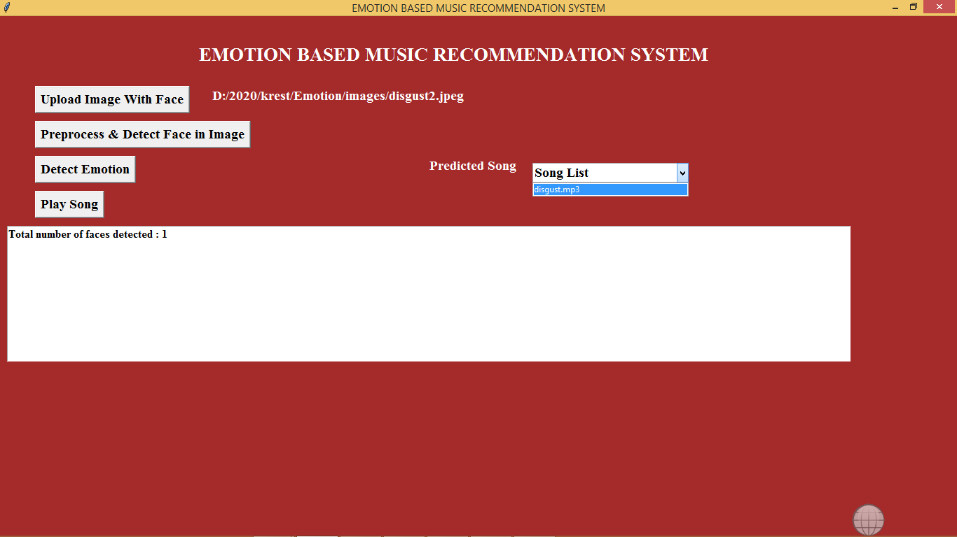

In drop down box we can see ‘disgust.mp3’ songs is showing, select that song and click on ‘Play Song’ button to play song

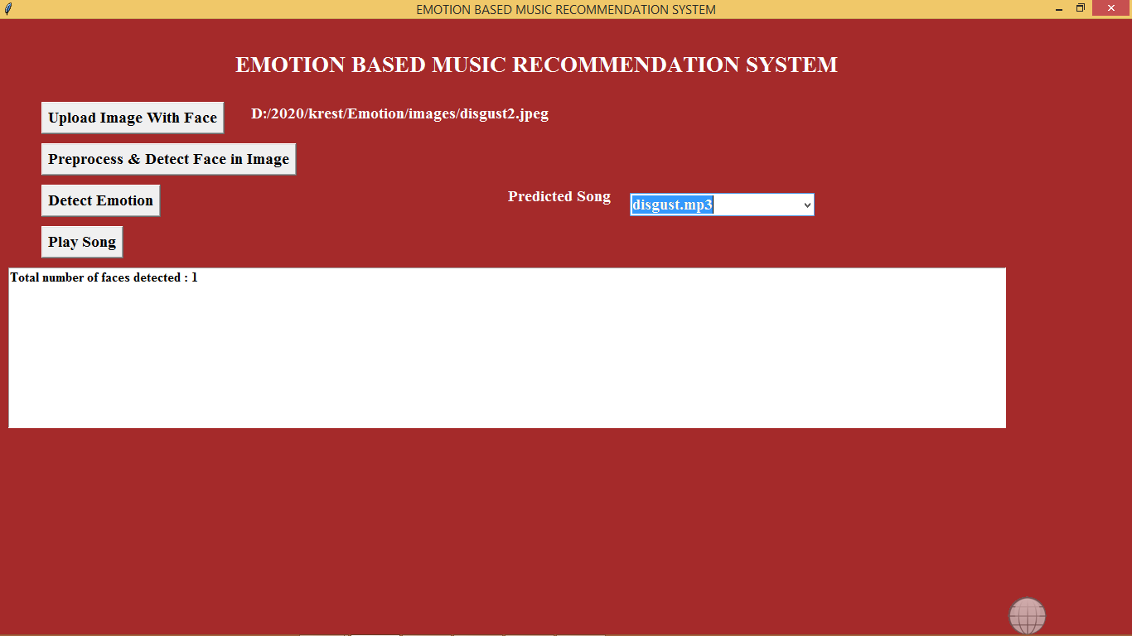

If your system has audio driver then u can hear song.

Note: no technologies can detect 100% emotion from images but this project can detect upto 90%