**Word Count From a Link**

**GitHub Link :** <https://github.com/sravandyapa/WordCount.git>

As per the problem requirements I have created a frontend to take the input and submit to backend and backend computes the request and prints it on frontend. I have created only one php file where front end and backend is written.

**Used:**

* **HTML, CSS** for Frontend
* **PHP** for Backend
* **2 Input Elements**

1. Word Count where we will take number as input and
2. Case-Insensitive checkbox where if it is checked it gives priority to the word not the case of the word but if it is unchecked it checks for words with the same case.

* **Submit button**
* Few Elements to print the result.
* No external lib are used.

**Explanation:**

Firstly, we give a numeric input to word count input element and if required we check the case-insensitive checkbox and enter submit button. After submitting the result is sent to tiny.php file where php code is written. Php code receives the request and computes the request and computation is as follows:

1. Read the content of the link [http://terriblytinytales.com/test.txt](https://www.google.com/url?q=http://terriblytinytales.com/test.txt&sa=D&ust=1596900516378000&usg=AFQjCNHaBoLz5m2QQg1OoClKhoJM6I_53Q) and store it in a var
2. Next I have used associate array to count the words and I have recognized words using spaces and few characters, no external function is used while computing number of words.
3. After counting the words, I have shortlisted the words which match the numeric input and created a dynamic table to print these words and their count.

**Below are few screen shots of webpage:**

* This is how our webpage looks we run tiny.php.

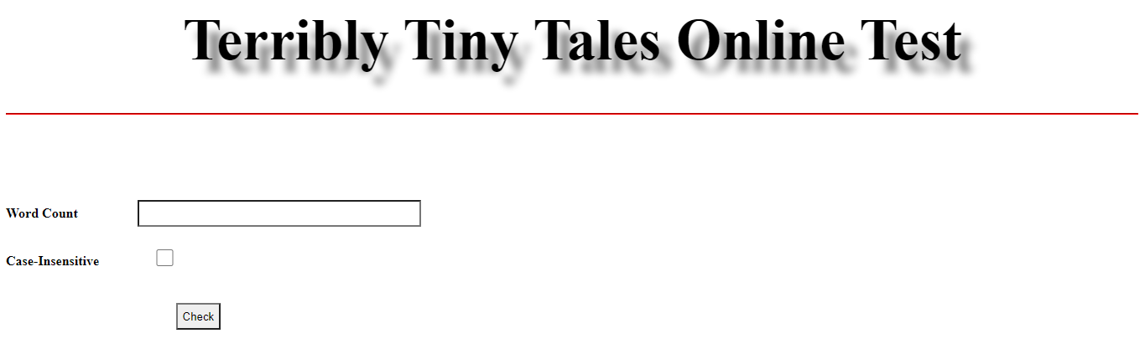

* Lets take 3 as numeric input and unchecked case-insensitive, now words which are similar in txt file and have count=3 will be printed.

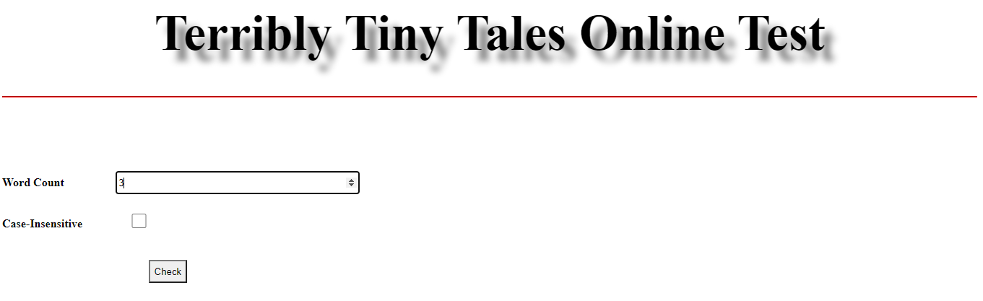

* **Output of** input=3 and unchecked case insensitive, you can see there is no “who” word.

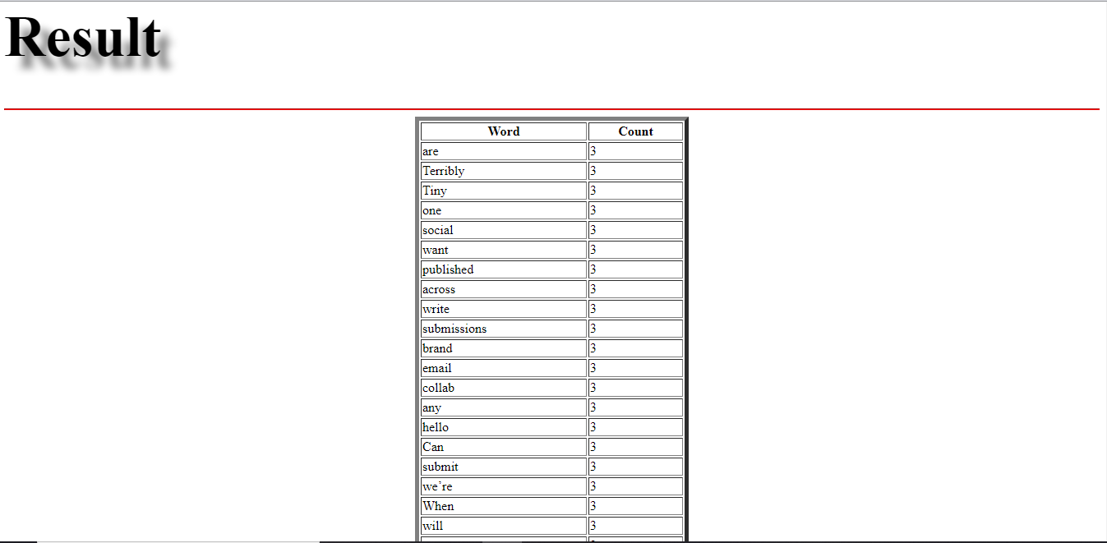

* Now with same 3 as input and case-insensitive is checked, now according to word count regard less of in which case they are written.

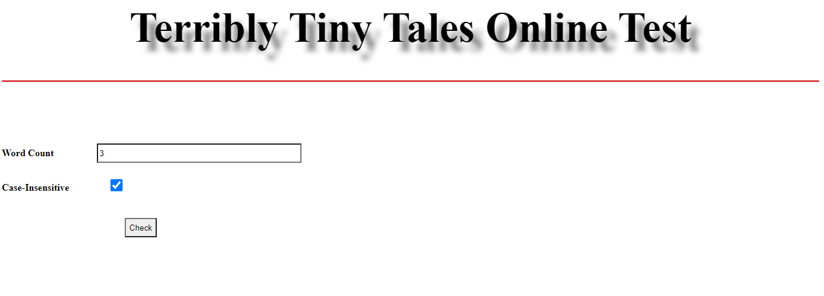

**Output of** input=3 and checked case-insensitive, now you can see there is word “WHO” which says that in the txt file actually there are 3 “WHO” words with different case that’s the reason they were hidden when we unchecked the checkbox.

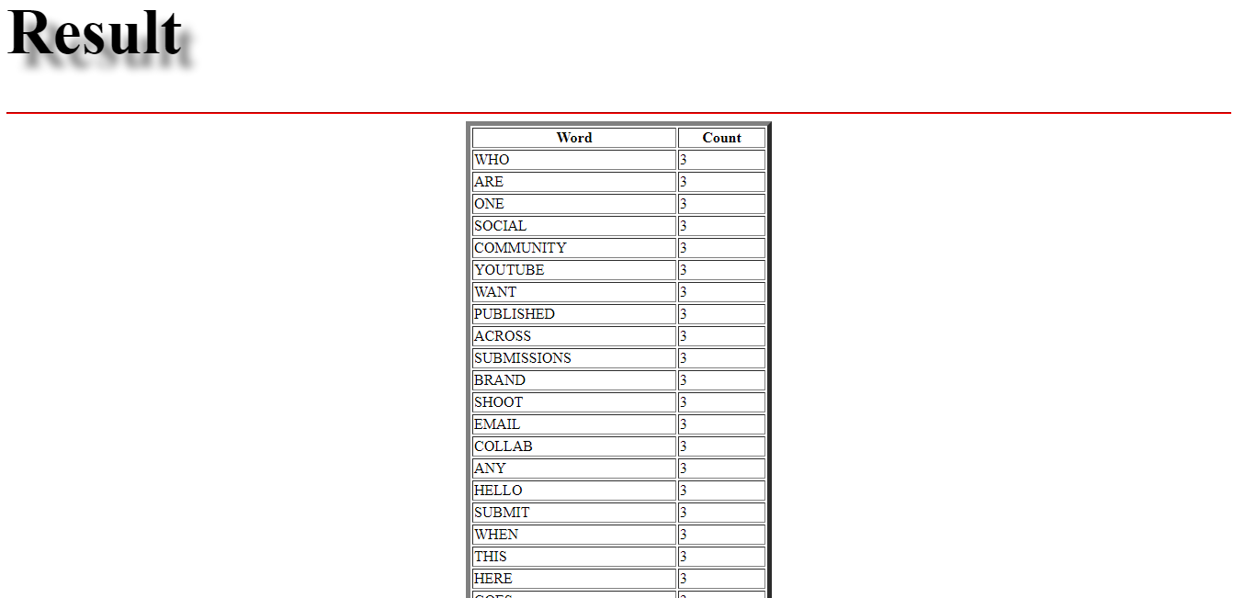

* Now lets give input as 0, because there are no words with 0 count and lets check the output of such a case.

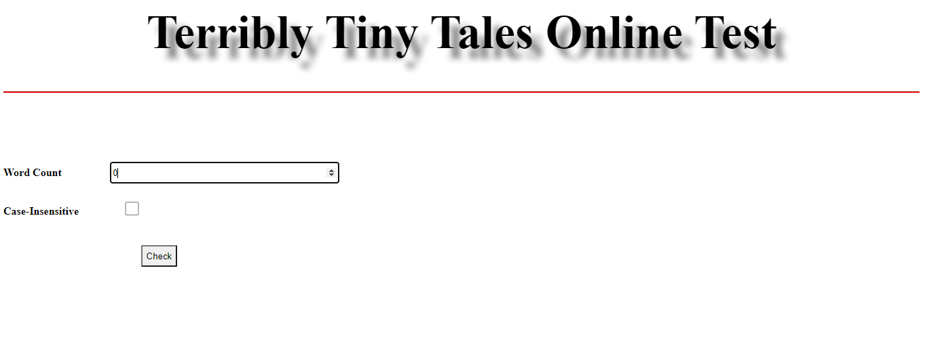

* **Output of** input=0, as you can see it returned “No Words With 0 Count” in result.

