Software Requirements Specification
for
Annotate ME
Version 1.0
Prepared by GROUP 2
12th Feb 2016

Table of Contents
Table of Contents ii
Revision History iii
1. Introduction 1
1.1 Purpose 1
1.2 Document Conventions 1
1.3 Intended Audience and Reading Suggestions 1
1.4 Product Scope 1
1.5 Glossary ………………………………………………………………………………………..2

2. Overall Description 2
2.1 Product Perspective 2
2.2 Product Functions 3
2.3 User Classes and Characteristics 3
2.4 Operating Environment 3
2.5 Design and Implementation Constraints 3
2.6 User Documentation 4
2.7 Assumptions and Dependencies 4

3. External Interface Requirements 4
3.1 User Interfaces 4
3.2 Hardware Interfaces 6
3.3 Software Interfaces 6
3.4 Communications Interfaces 7

4. Domain Model 7

5. Other Nonfunctional Requirements 7
5.1 Performance Requirements 7
5.2 Safety And Security Requirements 8
5.3 Software Quality Attributes 8
5.4 Licences Used --------------------------------------------------------------------------------------8

Introduction

Purpose

The purpose of the document is to collect and analyze all assorted ideas that have come up to define the system, its requirements with respect to consumers. Also, we shall predict and sort out how we hope this product will be used in order to gain a better understanding of the project, outline concepts that may be developed later, and document ideas that are being considered, but may be discarded as the product develops.

In short, the purpose of this SRS document is to provide a detailed overview of our software product, its parameters and goals. This document describes the project's target audience and its user interface, hardware and software requirements. It defines how our client, team and audience see the product and its functionality. Nonetheless, it helps any designer and developer to assist in software delivery lifecycle (SDLC) processes.

Document Conventions
The format of this SRS is simple and clean. Bold face and indentation is used on general topics and or specific points of interest. Topics are numbered in sequential manner. The remainder of the document will be written using the standard font, New Times Roman. Font size of 11pt is used for the text. Important topics and sub-topics come under the standard heading template.

Intended Audience and Reading Suggestions
This SRS gives information to the developer about the features of the product that is to be created . It plays a vital role in creating a legitimate contract between the client and the company. The requirements of the client is mentioned in detail in this SRS. Besides this it also puts a time bound on the work that is to be done. Design aspects of the project is also clarified in this documentation. Readers are advised to go in sequential manner in order to get the maximum information from the document.

Product Scope
The scope of the project is to build a extension for Chrome and Firefox browser that would enable the user to annotate the text in given web page while surfing the webpage. The main aim of the project is to accelerate the machine learning procedure by giving several test cases which the user annotates . With the help of the input that are provided to the machine we can enable it to self annotate the words that appear on a web page. With the success of the product in chrome and Firefox we can extend to Safari and if needed to Internet explorer. The target audience will be naturally all those who are on internet and specially the learning teenagers for whom it can be a fun activity.

On the part of the user it helps in stimulating the learning procedure as he may feel the need to search the words in the annotation process. The frequency of the words annotated under different category also helps us to create a survey that can be used for statistical data analysis. The database used, has been set up and given the necessary permissions. It can be used in field of medicines. Any medicine that is new in the market can be annotated and it can be sent to doctors so that they can be updated to latest content. The project is expected to be completed by the end of April,2016.

Glossary

Term | Definition
Active Text | The document that is tracked by the system; it is a narrative that is planned to be labeled.
Author | Person who is annotating the text.
Database | Collection of all the information monitored by this system.
Field | A cell within a form.
User Database | The existing membership database.
Member | A member listed in the User database.
Reader | Anyone visiting the site to read Annotations.
Software Requirements Specification | A document that completely describes all of the functions of a proposed system and the constraints under which it must operate. For example, this document.
Stakeholder | Any person with an interest in the project who is not a developer.

Overall Description

Product Perspective

The extension we built will be using Chrome API's and Mozilla Firefox API's. It is a new self contained project .The product is supposed to be an open source under the GNU general public license.it is a web based system implementing client -server model. It allows the user to create account in our system. Till date numbers of users that the software can support is limited to 500 but later can be improved for better maintenance.

Product Functions
All the Brief Functions of product can be viewed under section 4 but in this section we provide Bullet points of our functions
=> Main functions are storing the annotated word in a database
=>Giving the data of Annotated words of user (himself or herself)
=>Giving the data of Annotated words of a particular category
=>Searching for a particular word in our databse to know what category
many people have annotated it.

User Classes and Characteristics
User Classes: It is done for a client. The main target class of this project is class of medical doctors, for using it in machine learning .Not only them people who really have enthusiasm in learning new type of words can also use it because we are giving user the information regarding a particular word.
Every class can use it.it is not restricted for any specific class of people.

User Characteristics:
The user id expected to be an internet literate and should know how to know use the search engine.

Operating Environment
It is designed to use only in two browsers Google Chrome version 4.0.249 and the reference about the version can be seen in this link https://en.wikipedia.org/wiki/Google_Chrome_release_history and Mozilla
Firefox till date. No other specific applications are required to use it. As it is an extension it does not have anything to do with the Operating System of the device user use.

Design and Implementation Constraints
The database used in this project can have only list of 500 lines of data. As in an extension we cannot have a specific user(don't know who the user is, it means that people who use our extension can't be identified
because there is no registration system for our extension).we obtain the ip address of the user from insert.php file while inserting the Annotated word we also insert the ip address of the user so that he can be caught if he does things that are against the rules.

The design we develop uses the chrome API's and Mozilla Firefox API's.

User Documentation
We have a manifest.json file which is core of our extension developed in Google Chrome Browser. Along with it we have background.js file which forms the backbone of manifest.json file.In popup.html file we give the user to annotate a word and place it in a database .insert.php file helps in inserting the annotated word and its category in putting it in a database. The website folder which consists of files that maintain a
database of a user for logging and logout.

Assumptions and Dependencies
The Software highly depends on browsers. Especially it needs Google Chrome Browser and Mozilla Firefox Browser. Those browsers also need to be of above some specific version mentioned in the Operating System .

External Interface Requirements

User Interfaces
Whenever user opens a webpage containing some texts and if the user highlights the text the extension is storing that text using the DOM of that webpage inside the text area of the form which is present in popup.html and then user is asked to choose the present categories from the bulleted list or he can add other category in respective text area and then click submit.We are storing the text and its category in our database.popup.html always fills the text area with the highlighted text whether user annotate it or not.To annotate a text after selecting it click on the extension icon present on the top right corner of the browser and user can fill up the required field and submit the form.
Select a text =>

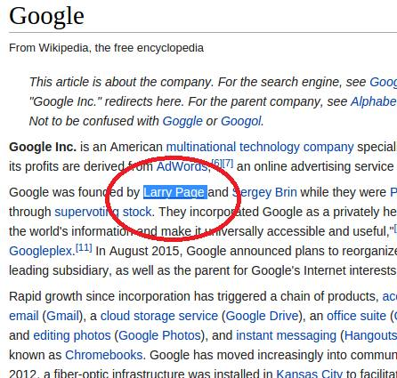

Click on the extension icon =>

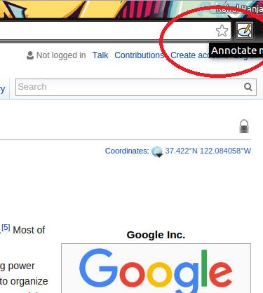

Fill up the category/select from the bulleted list* =>Press Submit Button =>

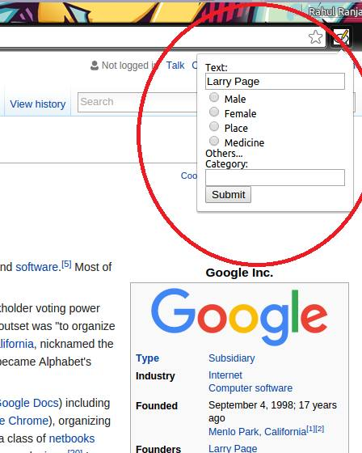

Successfully Annotated/Error Message =>

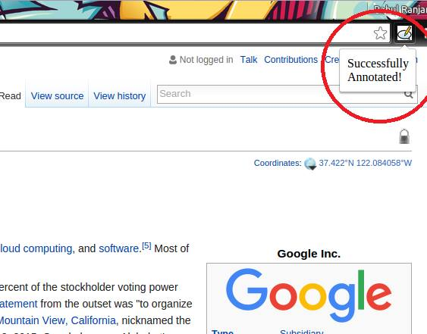

Hardware Interfaces
Supported by every hardware having Google Chrome Web Browser installed on it or Firefox browser installed in it.

Software Interfaces
It is storing data and its category in a MySQL database on XAMPP 7.0.2 server.
XAMPP 7.0.2 contains ::Apache 2.4.18, MariaDB 10.1.10, PHP 7.0.2 + SQLite 2.8.17/3.7.17 + multibyte (mbstring) support, Perl 5.16.3, ProFTPD 1.3.4c, phpMyAdmin 4.5.2, OpenSSL 1.0.2f, GD 2.0.35, Freetype2 2.4.8, libpng 1.5.26, gdbm 1.8.3, zlib 1.2.8, expat 2.0.1, Sablotron 1.0.3, libxml 2.0.1, Ming 0.4.5, Webalizer 2.23-05, pdf class 0.11.7, ncurses 5.9, pdf class 0.11.7, mod_perl 2.0.8-dev, FreeTDS 0.91, gettext 0.18.1.1, IMAP C-Client 2007e, OpenLDAP (client) 2.4.21, mcrypt 2.5.8, mhash 0.9.9.9, cUrl 7.45.0, libxslt 1.1.28, libapreq 2.12, FPDF 1.7, ICU4C Library 4.8.1, APR 1.5.2, APR-utils 1.5.4.
PHP is used to as a server side language to accept the requests send from popup.html file.
Phpmyadmin is used to handle the administration of MySQL over the WWW.

Communications Interfaces
HTTP is used under AJAX as XMLHttpRequest Object to transfer form data from client side to server side.

Domain Model

Database
Author

Text Selection
Suggestion

Annotate
Database

Other Nonfunctional Requirements

Performance Requirements
* Google Chrome Web Browser
* Chromium Web Browser
* Firefox Web Browser
* PHP - A server scripting language used by Drupal
* MySQL - The database that will be used for this project
* Apache - A web service
Plugin/extension can run properly on any version of corresponding web browser. A user/author must be connected to server for full functionality of Plugin/extension(to authenticate and read/write in database which is stored on server).

Safety and Security Requirements
The Plugin / extension should be as hack proof as possible, protecting from injection attacks, bots, and other threats. This includes protecting user-enterable forms from clients.
The code will be clear and well commented to allow modification if necessary. All commonly changed settings should provide an administrator interface to apply the changes. The code should be modular in nature and incremental so that changes and tweaks are easy.
The Plugin / extension we work on should provide good error output on forms the clients will complete. Warning messages should appear when something is incomplete, and Error messages will appear in the unlikely event that something doesn't work as intended, as well as information on how to resolve the issue relevant to the user.

Software Quality Attributes

Availability
If the internet service gets disrupted while sending information to the server, the information can be send again for verification.

Reliability
As the system provide the right tools for annotating, machine learning can be made much easier using this technique. Further frequency of the particular type of annotated words helps in distinguishing between the correct and incorrect tool.

Usability
As the system is easy to handle and navigates in the most expected way with no delays. It has a very user friendly interface.
    - Licence: We are agreeing to all terms and conditions to use Google Chrome API.
friendly interface.

