ADVANCED ENCRYPTION FOR QUANTUM SAFE VIDEO TRANSMISSION


A Technical seminar report submitted in partial fulfillment of the requirement for the award of the
degree of
BACHELOR OF TECHNOLOGY
IN
COMPUTER SCIENCE AND ENGINEERING

Under the esteemed guidance of

D. Venkateshwarlu
Assistant Professor
By

M. SRAVANI (23R15A0509)

Department of Computer Science and Engineering

Geethanjali College of Engineering and Technology (Autonomous)
Accredited by NAAC with A+ Grade: B.Tech. CSE, EEE, ECE accredited by NBA Sy. No: 33 & 34,

Cheeryal (V), Keesara (M), Medchal District, Telangana – 501301

March – 2026

Geethanjali College of Engineering and Technology (Autonomous)
Accredited by NAAC with A⁺ Grade : B.Tech. CSE, EEE, ECE accredited by NBA
Sy. No: 33 & 34, Cheeryal (V), Keesara (M), Medchal District, Telangana – 501301

Department of Computer Science and Engineering


CERTIFICATE

This is to certify that the B.Tech Major Project report entitled “Advanced Encryption For Quantum Safe video Transmission” is a Bonafide work done by M.Sravani (23R15A0509), in partial fulfillment of the requirement of the award for the degree of Bachelor of Technology in “Computer Science and Engineering” from Jawaharlal Nehru Technological University, Hyderabad during the year 2025-2026.

Name of Guide HoD -CSE

D.Venkateshwarlu Dr. E. Ravindra
Assistant Professor Professor

Coordinator Examiner(s)

DECLARATION OF STUDENT

I, Mohitha Vinnakota (21WJ1A1263), hereby declare that the major project titled “Advanced Encryption for Quantum-Safe Video Transmission” has been carried out by me as part of the requirements for the award of the Degree of Bachelor in the Department of Information Technology at Guru Nanak Institutions Technical Campus.
I confirm the following:

- The project was undertaken by me under the supervision of my guide, CH. Gopi, from the selection of the topic to the completion of the final report.
- I have ensured that the results presented in the report are accurate and based on my original work.
- To the best of my knowledge, the content of this report is free from plagiarism and adheres to ethical standards.
- I have contributed significantly and appropriately to the project work.
- The project report has been prepared with diligence, ensuring clarity, accuracy, and adherence to academic standards.
I further declare that this report has not been submitted, in part or full, to any other institution or university for the award of any degree or diploma.

Mohitha Vinnakota Signature

21WJ1A1263

DECLARATION OF GUIDE

I, CH. Gopi, hereby declare that I have guided the major project titled “Advanced Encryption for Quantum-Safe Video Transmission” undertaken by, Mohitha Vinnakota(21WJ1A1263). This project was carried out towards the fulfilment of the requirements for the award of the Degree of Bachelor of Technology in Information Technology at Guru Nanak Institutions Technical Campus.
As the guide, I confirm the following:

- I have overseen the entire project process, from the selection of the project title to the submission of the final report.
- I have reviewed and certified the accuracy and relevance of the results presented in the report.
- The contributions of the student have been appropriately recognized and assessed.
- The project report has been prepared under my supervision, ensuring adherence to high standards of quality, clarity, and structure.
I further certify that this project report has not been previously submitted in part or full for the award of any degree or diploma by any institution or university.

CH. Gopi Signature of the Guide

Date:

Place:

Dr. M.I. Thariq Hussan Signature of the HOD Department of Information Technology

ACKNOWLEDGEMENT

It is with profound gratitude and sincere appreciation that I extend my heartfelt thanks to all those who have played a significant role in the successful completion of this technical seminar.

First and foremost, I express my deep sense of respect and gratitude to our Honorable Chairman, Mr. G. R. Ravinder Reddy, for his constant encouragement and for nurturing a culture of academic excellence and innovation within the institution.

I would also like to express my sincere thanks to Dr. S. Udaya Kumar, Director, for his visionary leadership and continued support, which have provided the ideal environment and motivation for academic pursuits such as this project.

My heartfelt appreciation goes to Dr. K. Sagar, Principal, for his steadfast guidance, infrastructural support, and encouragement that have helped bring this project to successful fruition.

I am deeply grateful to Dr. E. Ravindra, Professor, Head of the Department- CSE, for his academic leadership, valuable feedback, and continuous support throughout the duration of this project.

I extend my sincere thanks to the Major Project Coordinators, Ms.G. Niveditha and Ms.V. Sravanthi , for their meticulous planning, timely evaluations, and constructive feedback which contributed immensely to the smooth and effective completion of the seminar.

A special note of appreciation is reserved for my seminar guide, D.Venkateshwarlu for her valuable insights, scholarly advice, and unwavering mentorship throughout the research and presentation phases of this seminar.

Lastly, I am very grateful to our Parents and Family for their unconditional love, encouragement, and moral support. Their faith in me has been my greatest strength throughout this journey.

With genuine appreciation, I acknowledge every individual who has, in one way or another, contributed to the successful completion of this technical seminar.

With warm regards,
M.Sravani (23R15A0509)
Department of Computer Science and Engineering
Geethanjali College of Engineering and Technology

TABLE OF CONTENTS

CHAPTER NO. | TITLE | PAGE NO.
 | ABSTRACT  LIST OF FIGURES LIST OF SYMBOLS | i ii  iii-v
1. | CHAPTER 1: INTRODUCTION  - GENERAL  - SCOPE OF THE PROJECT  - OBJECTIVE  - EXISTING SYSTEM  - EXISTINGSYSTEM DISADVANTAGES  - LITERATURE SURVEY  - PROPOSED SYSTEM  - PROPOSED SYSTEM ADVANTAGES | 1-10  1  2  3  4  4  5-9  10  10
2. | CHAPTER 2: PROJECT DESCRIPTION  - GENERAL  - METHODOLOGIES  - MODULES NAME  - MODULES EXPLANATION  - TECHNIQUE OR ALGORITHM | 11-16  11  12  12  13-14  15-16
3. | CHAPTER 3: REQUIREMENTS  - GENERAL  - HARDWARE REQUIREMENTS  - SOFTWARE REQUIREMENTS  - FUNCTIONAL REQUIREMENTS  - NON-FUNCTIONAL REQUIREMENTS | 17-20  17  17  18  19  20

4. | CHAPTER 4: SYSTEM DESIGN  - GENERAL  - UML DIAGRAMS  - USE CASE DIAGRAM  - CLASS DIAGRAM  - OBJECT DIAGRAM  - STATE DIAGRAM  - ACTIVITY DIAGRAM  - SEQUENCE DIAGRAM  - COLLABORATION DIAGRAM  - COMPONENT DIAGRAM  - DATA FLOW DIAGRAM  - DEPLOYMENT DIAGRAM  - SYSTEM ARCHITECTURE | 21-33  21  22-33  22  23  24  25  26  27  28  29  30-31  32  33
5. | CHAPTER 5: DEVELOPMENT TOOLS  - GENERAL  - INSTALLATION OF PYCHARM  - SETUP OF PYCHARM  - INSTALLATION OF ANACONDA NAVIGATOR | 34-45  34-35  36-38  39-41  42-45
6. | CHAPTER 6: IMPLEMENTATION  - GENERAL  - IMPLEMENTATION | 46-56  46  47-56
7. | CHAPTER 7: SNAPSHOTS  - GENERAL  - VARIOUS SNAPSHOTS | 57-59  57  58-59
8. | CHAPTER 8: SOFTWARE TESTING  - GENERAL  - DEVELOPING METHODOLOGIES  - TYPES OF TESTING | 60-62  60  60  60-62
9. | CHAPTER 9: FUTURE ENHANCEMENT  - FUTURE ENHANCEMENTS | 63  63

10 | CHAPTER 10:  - CONCLUSION  - REFERENCES | 64-68  64  65-68

ABSTRACT

This project enables secure video processing, encryption, and watermark embedding, focusing on user authentication, video encryption, and decryption capabilities. Users can register, log in, and upload videos along with watermarks for processing. Using the cryptography library, each uploaded video is encrypted, and its encryption key is split using Shamir's Secret Sharing, ensuring secure key distribution and storage. The encrypted frames are stored separately for later retrieval and decryption. Decryption occurs through reassembling key shares, allowing the original video to be reconstructed, with the watermark extracted from the first frame. The application further provides options to download the decrypted video, view split frames, and explore contact and performance information pages. Employing OpenCV for video processing and secure file handling techniques, this system ensures data confidentiality and integrity through a user-friendly interface and robust back-end encryption mechanisms. The application uses secure upload and storage mechanisms for sensitive data, like key shares and encrypted frames, storing them in predefined folders. Key shares are stored separately, further protecting the decryption process from unauthorized access.

LIST OF FIGURES

FIGURE NO | NAME OF THE FIGURE | PAGE NO.
4.1 | Use case Diagram | 22
4.2 | Class diagram | 23
4.3 | Object diagram | 24
4.4 | State Diagram | 25
4.5 | Activity Diagram | 26
4.6 | Sequence diagram | 27
4.7 | Collaboration diagram | 28
4.8 | Component Diagram | 29
4.9 | Data flow diagram | 30-31
4.10 | Deployment Diagram | 32
4.11 | Architecture Diagram | 33

LIST OF SYMBOLS

S.NO | NOTATION NAME | NOTATION |  |  |  |  |  |  | DESCRIPTION
1. | Class |  |  |  |  |  |  |  | Represents a collection of similar entities grouped together.
 |  | + public  -private |  |  | Class Name
 |  |  |  |  | -attribute
 |  |  |  |  | -attribute
2. | Association |  |  |  |  |  |  |  | Associations represents static relationships between classes. Roles represents the way the two classes see each other.
 |  |  | Class A | NAME |  | Class B
 |  |  | Class A |  |  | Class B
3. | Actor |  |  |  |  |  |  |  | It aggregates several classes into a single classes.
4. | Aggregation | Class A Class A  Class B Class B |  |  |  |  |  |  | Interaction between the system and external environment

5. | Relation (uses) | uses | Used for additional process communication.
6. | Relation (extends) | extends | Extends relationship is used when one use case is similar to another use case  but does a bit more.
7. | Communication |  | Communication between various use cases.
8. | State | State | State of the processes.
9. | Initial State |  | Initial state of the object
10. | Final state |  | Final state of the object
11. | Control flow |  | Represents various control flow between the states.
12. | Decision box |  | Represents decision making process from a constraint
13. | Use case | Uses case | Interact ion between the system and external environment.

14. | Component |  |  |  |  |  | Represents physical modules which are a collection of components.
15. | Node |  |  |  |  |  | Represents physical modules which are a collection of components.
16. | Data  Process/State |  |  |  |  |  | A circle in DFD represents a state or process which has been triggered due to some event or action.
17. | External entity |  |  |  |  |  | Represents external entities such as keyboard, sensors, etc.
18. | Transition |  |  |  |  |  | Represents communication that occurs between processes.
19. | Object Lifeline |  |  |  |  |  | Represents the vertical dimensions that the object communications.
20. | Message | Message |  |  |  |  | Represents the message exchanged.

CHAPTER 1
INTRODUCTION
This project is designed to provide a comprehensive solution for secure video processing, encryption, and watermark embedding, emphasizing user authentication and robust video encryption and decryption capabilities. At its core, the application allows users to register and log in, enabling them to upload videos along with their desired watermarks for processing. Once a video is uploaded, it is subjected to encryption using the cryptography library, ensuring that the video data remains confidential and secure. The encryption key itself is further fortified through Shamir's Secret Sharing scheme, which divides the key into multiple shares, thereby enhancing key distribution and storage security. This innovative approach ensures that even if one or more shares are compromised, the original key cannot be reconstructed without the minimum threshold of shares required.
In the system, the encrypted video frames are stored separately to facilitate later retrieval and decryption. During the decryption process, the application intelligently reassembles the key shares, allowing the original video to be reconstructed seamlessly. Additionally, the watermark embedded within the video is extracted from the first frame, ensuring that users can maintain their identity or brand in the content. The application also provides users with various options, including the ability to download the decrypted video, view split frames, and access contact and performance information pages.
.

SCOPE OF THE PROJECT
The scope of this project encompasses a comprehensive suite of functionalities designed to enhance secure video processing and encryption. It begins with user authentication and management, enabling secure registration and login to ensure that only authorized users can access the application. Users can upload videos along with specified watermarks for embedding, with support for various video formats to meet diverse needs. The application employs the cryptography library for video encryption, ensuring confidentiality, while the encryption keys are securely managed through Shamir's Secret Sharing scheme, which divides keys into shares for enhanced security. The project includes watermark embedding features that allow users to personalize their videos and ensures that the watermark can be extracted from the first frame upon decryption.
Additionally, a robust file handling system is implemented to securely store encrypted video frames and key shares in predefined directories, minimizing unauthorized access risks. The decryption process is designed to efficiently reassemble key shares, enabling users to retrieve the original video content seamlessly. The user interface is crafted to be user-friendly, facilitating video uploads, processing, and decryption tasks while providing clear navigation options for downloading decrypted videos and accessing performance information. Furthermore, secure data handling protocols are established to protect sensitive information during transmission, ensuring compliance with data protection regulations. The project architecture is designed for scalability, allowing support for larger video files and more simultaneous users, with a vision for future enhancements such as advanced video analytics and additional encryption algorithms. Overall, this project aims to meet the growing demand for secure video communication and management, laying a solid foundation for the development of secure video technologies.
.

OBJECTIVE
The objective of this project is to develop a secure video processing system that integrates robust encryption and watermark embedding functionalities while prioritizing user authentication and data integrity. The primary goal is to enable users to upload videos seamlessly, embed personalized watermarks, and ensure the confidentiality of video content through advanced encryption techniques. By leveraging the cryptography library for video encryption and implementing Shamir's Secret Sharing scheme for secure key management, the project aims to provide a reliable solution for protecting sensitive video data from unauthorized access and tampering. Additionally, the system will facilitate the extraction of watermarks from encrypted videos and support a user-friendly interface that simplifies the processes of uploading, processing, and retrieving videos. Through these objectives, the project seeks to address the increasing need for secure video communication in various applications, ensuring that users can confidently manage their video assets while maintaining high standards of security and privacy.

EXISTING SYSTEM:
The existing system for video transmission primarily relies on traditional encryption techniques, such as symmetric and asymmetric algorithms (e.g., AES, RSA), to secure video data. While these methods effectively ensure confidentiality, integrity, and authenticity, they face significant challenges due to advancing computing capabilities that make them more vulnerable to brute-force and cryptographic attacks. Additionally, the increasing demand for security in digital communication necessitates stronger encryption methods. Many systems currently utilize SSL (Secure Sockets Layer) for secure transmission over the internet, adding a layer of protection; however, this approach may not be sufficient against sophisticated threats. Consequently, the limitations of existing methods highlight the urgent need for more advanced solutions, such as the proposed Hybrid Quantum Video Encryption Framework, to enhance the security of video transmission effectively.
With the rise of more powerful computing technologies, traditional encryption methods face vulnerabilities, as they can be subjected to brute-force attacks and other cryptographic attacks.

EXISTING SYSTEM DISADVANTAGES:
      - Vulnerability to Attacks: Traditional encryption methods are increasingly susceptible to brute-force and cryptographic attacks due to advancing computational power.
      - Quantum Computing Threat: The rise of quantum computing poses a significant risk to the security of conventional encryption algorithms.
      - Inadequate Security Measures: SSL/TLS, while providing a layer of security, may not fully protect against sophisticated cyber threats.
      - Performance Limitations: Traditional encryption algorithms can experience performance bottlenecks when handling large volumes of video data.

LITERATURE SURVEY
Title: Quantum-Safe Cryptography: A Survey

Author: K. A. C. K. Perera, A. J. S. A. Lee, and A. A. M. Shafique

Year: 2021

Description: This survey provides a comprehensive overview of quantum-safe cryptographic methods as the field of quantum computing progresses, posing significant threats to traditional cryptographic algorithms. The authors analyze the vulnerabilities of widely-used encryption methods, such as RSA and ECC, in light of quantum algorithms like Shor’s algorithm, which can efficiently factor large integers and solve discrete logarithm problems. The paper explores various quantum-safe alternatives, including lattice-based cryptography, code-based cryptography, and multivariate polynomial cryptography, emphasizing their potential applicability in securing data transmissions, including video content. Furthermore, the authors discuss the challenges of integrating these quantum-safe algorithms into existing systems and propose guidelines for developing hybrid approaches that leverage both classical and quantum- safe methods. This work serves as a vital resource for researchers and practitioners aiming to enhance the security of video transmission in an era of quantum threats.

Title: Secure Video Transmission Using Quantum Cryptography

Author: R. B. Patel and M. K. Jha

Year: 2022

Description: This paper presents an innovative framework for securing video transmission by employing quantum cryptographic techniques. The authors explore the concept of quantum key distribution (QKD), which allows two parties to share a secure key over a potentially insecure channel without the risk of eavesdropping. They detail the mathematical principles underpinning QKD and its implementation within a video transmission system. By integrating QKD with traditional encryption algorithms, such as AES, the proposed method enhances the security of video data during transmission over public networks. The authors conduct a series of simulations to evaluate the performance and security of their approach, demonstrating that it effectively mitigates risks associated with eavesdropping and unauthorized access. Additionally, they discuss practical challenges in implementing quantum cryptography in real- world applications and suggest directions for future research to improve its feasibility for large- scale video transmission scenarios.

Title: A Review of Quantum-Safe Encryption Algorithms for Video Streaming

Author: P. Smith, J. R. Doe, and E. W. Brown

Year: 2023

Description: In this extensive review, the authors critically assess various quantum-safe encryption algorithms that are specifically tailored for video streaming applications. The paper begins by discussing the implications of quantum computing on current encryption standards, emphasizing the urgency for transitioning to quantum-safe alternatives. The authors categorize existing algorithms based on their mathematical foundations, such as lattice-based, hash-based, and code-based systems, and evaluate their security levels, performance metrics, and implementation challenges. They also highlight how these algorithms can be integrated into existing video streaming protocols to enhance security without significantly impacting user experience. Through comparative analyses and case studies, the authors provide insights into the effectiveness of each approach, offering valuable guidance for developers and researchers looking to secure video content against potential quantum threats. The review concludes with recommendations for future research, particularly in optimizing the performance of quantum- safe algorithms in real-time streaming environments.

Title: Post-Quantum Cryptography for Secure Video Communications Author: M. T. Alahakoon, A. K. B. Thennakoon, and J. R. W. Ananda Year: 2023
Description: This paper investigates the implications of quantum computing advancements on video communication security, focusing on the need for post-quantum cryptographic solutions. The authors analyze various post-quantum algorithms and their suitability for securing video data during transmission. They emphasize the vulnerabilities of traditional encryption methods to quantum attacks and propose a framework for implementing post-quantum cryptographic protocols in video communication systems. Through detailed simulations and real-world scenarios, the study evaluates the performance, security levels, and overhead of different post- quantum algorithms in video transmission contexts. The authors highlight the importance of transitioning to quantum-safe solutions and provide practical recommendations for integrating these protocols into existing video streaming infrastructures.

Title: Enhancing Video Security through Quantum-Safe Algorithms: A Performance Evaluation
Author: H. G. Lin, P. M. Lim, and Q. Z. Shen

Year: 2023

Description: This paper presents a performance evaluation of various quantum-safe encryption algorithms specifically designed for securing video data. The authors begin by discussing the vulnerabilities of current video encryption techniques to quantum attacks and the necessity for quantum-safe alternatives. They evaluate several post-quantum cryptographic algorithms, including lattice-based and hash-based schemes, comparing their performance in terms of encryption and decryption speed, computational overhead, and resilience against quantum attacks. Through experimental results, the authors illustrate how these algorithms can be effectively applied to video security without significantly impacting the user experience. Additionally, the paper discusses the implications of using quantum-safe algorithms in real- world video streaming scenarios, offering insights and recommendations for implementing these techniques in practice.

PROPOSED SYSTEM
The proposed system is a Flask-based web application designed to deliver secure video processing, encryption, and watermark embedding, with a strong focus on user authentication and data confidentiality. This platform allows users to register, log in, and upload video files, along with watermark images, to enhance security and content integrity. Video files are encrypted, and the encryption key is split using Shamir's Secret Sharing technique, ensuring both secure distribution and controlled access to the decryption key. This process of splitting and securing the encryption key guarantees that only authorized users with the required number of key shares can successfully decrypt and reconstruct the video.
Once uploaded, each video undergoes watermark embedding using OpenCV, where the watermark is integrated into each frame. Following this, the watermarked frames are encrypted frame by frame, allowing for individual frame retrieval and flexible management of video data. The encrypted frames are stored separately, making the data accessible only through the reconstruction and decryption processes. This frame-by-frame encryption further ensures that no single frame is exposed in the absence of the full decryption key, enhancing the overall security of the system. The decryption process is managed through a secure key-sharing mechanism, where users can submit multiple key shares to reconstruct the encryption key. Upon providing enough key shares, the system reassembles the key, decrypts the video, and allows for the extraction of the original watermark from the first frame. This feature is critical for maintaining the integrity of both the original content and the watermark post-decryption. Furthermore, the system enables users to download the reconstructed video, while an additional route provides access to split encrypted frames, allowing users to verify or inspect individual frames if required.

PROPOSED SYSTEM ADVANTAGES:
      - Comprehensive Library: OpenCV offers a wide range of functions and tools for image and video processing, making it suitable for various computer vision tasks.
      - Real-Time Processing: OpenCV is optimized for real-time applications, enabling fast processing of images and videos, which is crucial for time-sensitive tasks.
      - Ease of Use: With a user-friendly API and extensive documentation, OpenCV simplifies the development of complex computer vision applications.

CHAPTER 2
PROJECT DESCRIPTION

GENERAL:
The project "Advanced Encryption for Quantum-Safe Video Transmission" aims to develop a robust framework for secure video communication in the face of evolving quantum computing threats. This initiative focuses on integrating cutting-edge quantum cryptography techniques with classical encryption methods to enhance the security and integrity of video data during transmission. Utilizing Shamir's Secret Sharing for secure key distribution, the framework enables user authentication, video encryption, and watermark embedding while ensuring data confidentiality. Users can register, log in, and upload videos with embedded watermarks for processing. The cryptography library is employed to encrypt each uploaded video, with key shares stored separately to prevent unauthorized access. Encrypted video frames are stored for later retrieval, and the decryption process involves reassembling key shares to reconstruct the original video while extracting watermarks from the first frame. The project leverages OpenCV for efficient video processing and incorporates secure file handling techniques to protect sensitive data. Ultimately, this project offers a user-friendly interface alongside robust backend encryption mechanisms, aiming to provide a significant advancement in the field of secure video transmission in a post-quantum world.

METHODOLOGIES
    - MODULES NAME:

Modules Name:
      - User Authentication Module
      - Video Upload Module
      - Encryption Module
      - Video Processing Module
      - Decryption Module

MODULES EXPLANATION:

- User Authentication Module

The User Authentication Module serves as the gateway for users to access the application, ensuring that only authorized individuals can upload and manage video content. This module includes a registration system where new users can create accounts by providing essential information, such as username and password, which are securely hashed for protection. Additionally, the login functionality validates user credentials against stored records, allowing for session management that maintains user login status throughout their interaction with the application. By implementing robust authentication mechanisms, this module enhances the security of user accounts and protects sensitive data from unauthorized access.
- Video Upload Module

The Video Upload Module facilitates the seamless process of uploading video files along with optional watermarks. Users can easily select video files from their devices through a user- friendly interface, which includes file type and size validation to ensure compatibility with the system requirements. This module also allows users to input watermark information, which will be embedded into the video during processing. By streamlining the upload process and ensuring data integrity, this module serves as a crucial component in preparing videos for secure encryption and transmission.
- Encryption Module

The Encryption Module is responsible for implementing advanced cryptographic techniques to secure uploaded video files. Utilizing both classical encryption methods and quantum-safe algorithms, this module encrypts videos to protect them from unauthorized access during transmission. A key feature of this module is the incorporation of Shamir's Secret Sharing, which divides the encryption keys into multiple shares for enhanced security and safe distribution. This ensures that no single entity has access to the complete key, significantly mitigating the risk of key compromise. By leveraging robust encryption practices, this module guarantees the confidentiality and integrity of video data.

- Video Processing Module

The Video Processing Module employs OpenCV to perform various tasks related to video frames, enhancing the overall functionality of the application. This module is responsible for extracting individual frames from uploaded videos, manipulating them as needed, and embedding watermarks into the appropriate frames. It also manages video format conversions and compressions to optimize performance and storage. By utilizing advanced image processing techniques, this module ensures that videos are processed efficiently while maintaining high quality, enabling secure handling of video content.
- Decryption Module

The Decryption Module allows users to retrieve their uploaded videos securely by decrypting the previously encrypted files. This module employs a systematic approach to reassemble key shares, utilizing Shamir's Secret Sharing to reconstruct the original encryption key. Once the key is reconstructed, the module facilitates the decryption process, enabling users to access their original videos. Additionally, it extracts watermarks from the decrypted video, ensuring that users can verify their ownership and integrity. By providing a secure and efficient decryption process, this module enhances the overall user experience while maintaining data security.

TECHNIQUE USED OR ALGORITHM USED
    - EXISTING TECHNIQUE: -
      - The existing system for video transmission primarily relies on traditional encryption techniques, such as symmetric and asymmetric algorithms (e.g., AES, RSA), to secure video data. While these methods effectively ensure confidentiality, integrity, and authenticity, they face significant challenges due to advancing computing capabilities that make them more vulnerable to brute-force and cryptographic attacks. Additionally, the increasing demand for security in digital communication necessitates stronger encryption methods. Many systems currently utilize SSL (Secure Sockets Layer) for secure transmission over the internet, adding a layer of protection; however, this approach may not be sufficient against sophisticated threats. Consequently, the limitations of existing methods highlight the urgent need for more advanced solutions, such as the proposed Hybrid Quantum Video Encryption Framework, to enhance the security of video transmission effectively.
      - With the rise of more powerful computing technologies, traditional encryption methods face vulnerabilities, as they can be subjected to brute-force attacks and other cryptographic attacks.

DRAWBACKS: -
- Vulnerability to Attacks: Traditional encryption methods are increasingly susceptible to brute-force and cryptographic attacks due to advancing computational power.
- Quantum Computing Threat: The rise of quantum computing poses a significant risk to the security of conventional encryption algorithms.
- Inadequate Security Measures: SSL/TLS, while providing a layer of security, may not fully protect against sophisticated cyber threats.
Performance Limitations: Traditional encryption algorithms can experience performance bottlenecks when handling large volumes of video data.

PROPOSED TECHNIQUE USED OR ALGORITHM USED:
The proposed system is a Flask-based web application designed to deliver secure video processing, encryption, and watermark embedding, with a strong focus on user authentication and data confidentiality. This platform allows users to register, log in, and upload video files, along with watermark images, to enhance security and content integrity. Video files are encrypted, and the encryption key is split using Shamir's Secret Sharing technique, ensuring both secure distribution and controlled access to the decryption key. This process of splitting and securing the encryption key guarantees that only authorized users with the required number of key shares can successfully decrypt and reconstruct the video.
Once uploaded, each video undergoes watermark embedding using OpenCV, where the watermark is integrated into each frame. Following this, the watermarked frames are encrypted frame by frame, allowing for individual frame retrieval and flexible management of video data. The encrypted frames are stored separately, making the data accessible only through the reconstruction and decryption processes. This frame-by-frame encryption further ensures that no single frame is exposed in the absence of the full decryption key, enhancing the overall security of the system.

ADVANTAGES: -
      - Comprehensive Library: OpenCV offers a wide range of functions and tools for image and video processing, making it suitable for various computer vision tasks.
      - Real-Time Processing: OpenCV is optimized for real-time applications, enabling fast processing of images and videos, which is crucial for time-sensitive tasks.
      - Ease of Use: With a user-friendly API and extensive documentation, OpenCV simplifies the development of complex computer vision applications.
      - Scalable Security: The scheme can easily scale to accommodate any number of participants and shares without compromising security.

.

CHAPTER 3
REQUIREMENTS ENGINEERING

GENERAL
We can see from the results that on each database, the error rates are very low due to the discriminatory power of features and the regression capabilities of classifiers. Comparing the highest accuracies (corresponding to the lowest error rates) to those of previous works, our results are very competitive.

HARDWARE REQUIREMENTS
The hardware requirements may serve as the basis for a contract for the implementation of the system and should therefore be a complete and consistent specification of the whole system. They are used by software engineers as the starting point for the system design. It should what the system do and not how it should be implemented.

    - PROCESSOR : DUAL CORE 2 DUOS.
    - RAM : 4GB DD RAM
    - HARD DISK : 250 GB

SOFTWARE REQUIREMENTS
The software requirements document is the specification of the system. It should include both a definition and a specification of requirements. It is a set of what the system should do rather than how it should do it. The software requirements provide a basis for creating the software requirements specification. It is useful in estimating cost, planning team activities, performing tasks and tracking the teams and tracking the team’s progress throughout the development activity.
    - Operating System : Windows 7/8/10
    - Platform : Spyder3
    - Programming Language : Python
    - Front End : Spyder3

FUNCTIONAL REQUIREMENTS
A functional requirement defines a function of a software-system or its component. A function is described as a set of inputs, the behavior, Firstly, the system is the first that achieves the standard notion of semantic security for data confidentiality in attribute-based deduplication systems by resorting to the hybrid cloud architecture.

NON-FUNCTIONAL REQUIREMENTS
The major non-functional Requirements of the system are as follows
Usability

The system is designed with completely automated process hence there is no or less user intervention.
Reliability

The system is more reliable because of the qualities that are inherited from the chosen platform python. The code built by using python is more reliable.
Performance

This system is developing in the high level languages and using the advanced back-end technologies it will give response to the end user on client system with in very less time.
Supportability

The system is designed to be the cross platform supportable. The system is supported on a wide range of hardware and any software platform, which is built into the system.
Implementation

The system is implemented in web environment using Jupyter notebook software. The server is used as the intelligence server and windows 10 professional is used as the platform. Interface the user interface is based on Jupyter notebook provides server system.

CHAPTER 4 DESIGN ENGINEERING

GENERAL
Design Engineering deals with the various UML [Unified Modelling language] diagrams for the implementation of project. Design is a meaningful engineering representation of a thing that is to be built. Software design is a process through which the requirements are translated into representation of the software. Design is the place where quality is rendered in software engineering.

UML DIAGRAMS
    - USE CASE DIAGRAM

Input video Data and Password


Generate Encrytion Key

Append Image Watermark

Encrypt Video using Shamir Secret Rule
User

Shared frames(binary)

Return Encrypted Video

Decrypting video file by Reconstructing Shared Frames

Result(video embeded by watermark)

EXPLANATION:
The main purpose of a use case diagram is to show what system functions are performed for which actor. Roles of the actors in the system can be depicted. The above diagram consists of user as actor. Each will play a certain role to achieve the concept.

CLASS DIAGRAM

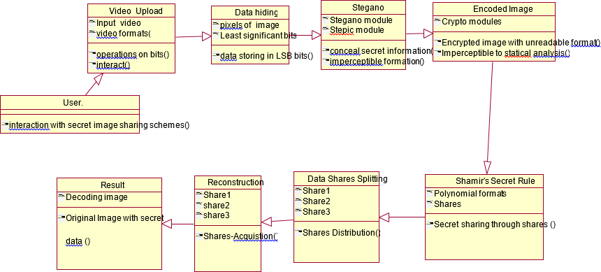

EXPLANATION:
In this class diagram represents how the classes with attributes and methods are linked together to perform the verification with security. From the above diagram shown the various classes involved in our project.

OBJECT DIAGRAM

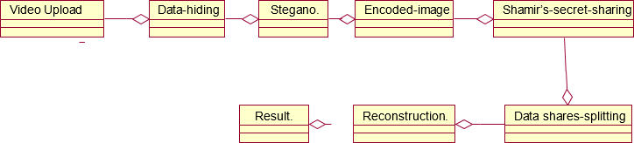

EXPLANATION:
In the above digram tells about the flow of objects between the classes. It is a diagram that shows a complete or partial view of the structure of a modeled system. In this object diagram represents how the classes with attributes and methods are linked together to perform the verification with security.

STATE DIAGRAM

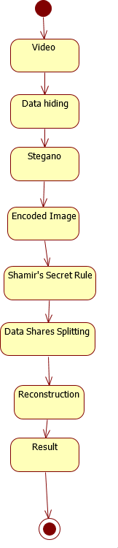

EXPLANATION:
State diagram are a loosely defined diagram to show workflows of stepwise activities and actions, with support for choice, iteration and concurrency. State diagrams require that the system described is composed of a finite number of states; sometimes, this is indeed the case, while at other times this is a reasonable abstraction. Many forms of state diagrams exist, which differ slightly and have different semantics.

ACTIVITY DIAGRAM
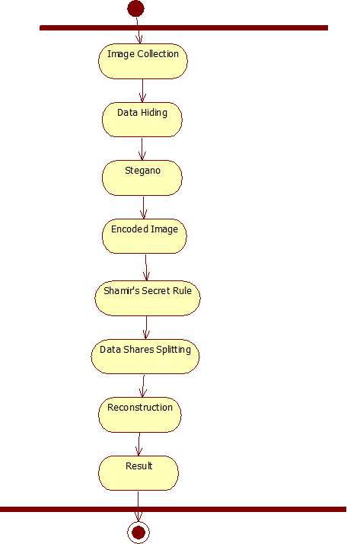

EXPLANATION:
Activity diagrams are graphical representations of workflows of stepwise activities and actions with support for choice, iteration and concurrency. In the Unified Modeling Language, activity diagrams can be used to describe the business and operational step-by-step workflows of components in a system. An activity diagram shows the overall flow of control.

SEQUENCE DIAGRAM

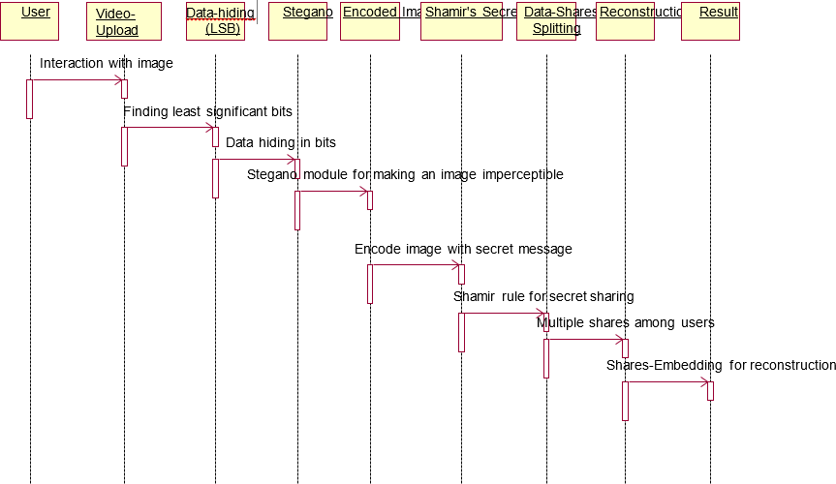

EXPLANATION:
A sequence diagram in Unified Modeling Language (UML) is a kind of interaction diagram that shows how processes operate with one another and in what order. It is a construct of a Message Sequence Chart. A sequence diagram shows object interactions arranged in time sequence. It depicts the objects and classes involved in the scenario and the sequence of messages exchanged between the objects needed to carry out the functionality of the scenario.

COLLABORATION DIAGRAM

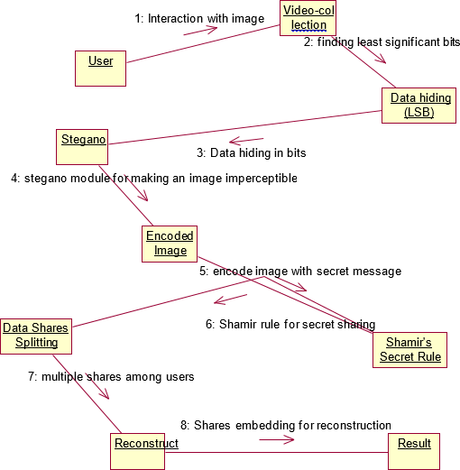

EXPLANATION:
A collaboration diagram, also called a communication diagram or interaction diagram, is an illustration of the relationships and interactions among software objects in the Unified Modeling Language (UML). The concept is more than a decade old although it has been refined as modeling paradigms have evolved.

COMPONENT DIAGRAM

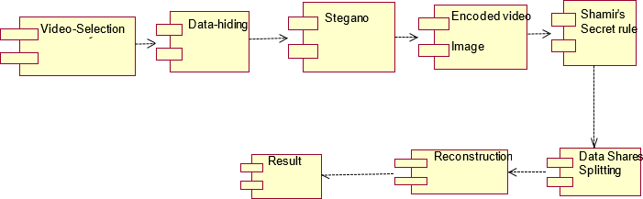

EXPLANATION:
In the Unified Modeling Language, a component diagram depicts how components are wired together to form larger components and or software systems. They are used to illustrate the structure of arbitrarily complex systems. User gives main query and it converted into sub queries and sends through data dissemination to data aggregators. Results are to be showed to user by data aggregators. All boxes are components and arrow indicates dependencies.

DATA FLOW DIAGRAM
Level 0

Video Upload
User
Add Image
Watermark
Shamir Secret Rule

Level 1

Splitting into Frames
Shared Frames
Reconstruction
Result
Video Encrypted by Adding Image watermark

EXPLANATION:
A data flow diagram (DFD) is a graphical representation of the "flow" of data through an information system, modeling its process aspects. Often they are a preliminary step used to create an overview of the system which can later be elaborated. DFDs can also be used for the visualization of data processing (structured design).
A DFD shows what kinds of data will be input to and output from the system, where the data will come from and go to, and where the data will be stored. It does not show information about the timing of processes, or information about whether processes will operate in sequence or in parallel.

DEPLOYMENT DIAGRAM

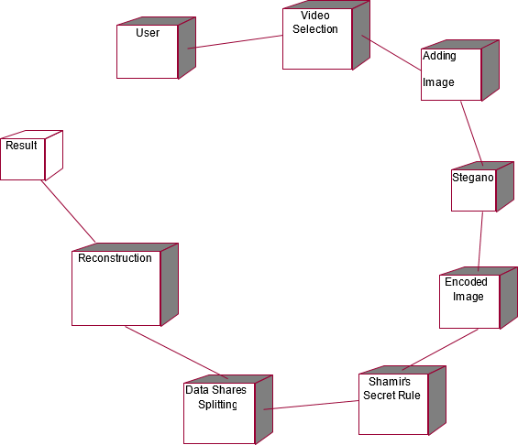

EXPLANATION:
Deployment Diagram is a type of diagram that specifies the physical hardware on which the software system will execute. It also determines how the software is deployed on the underlying hardware. It maps software pieces of a system to the device that are going to execute it.

-

SYSTEM ARCHITECTURE:

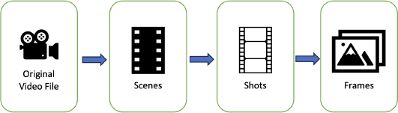



Fig 4.11: System Architecture



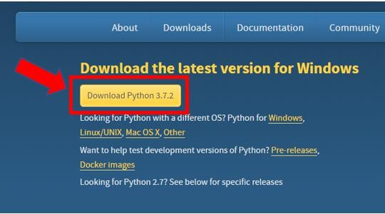
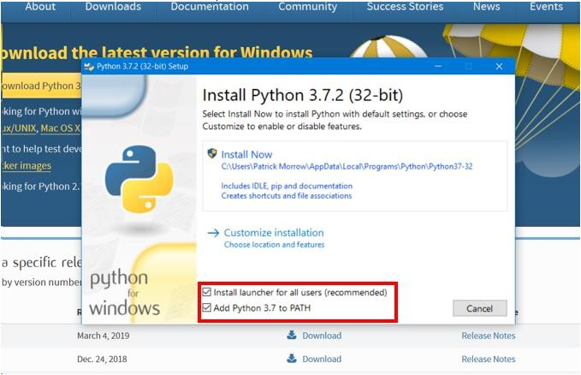

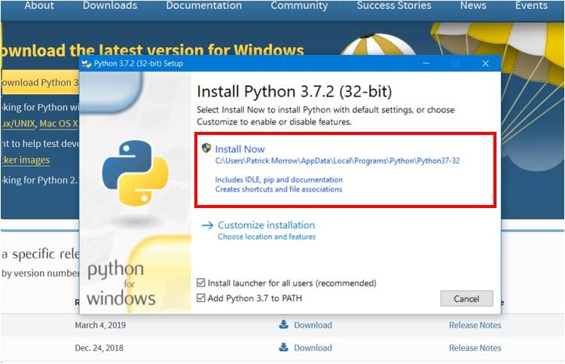

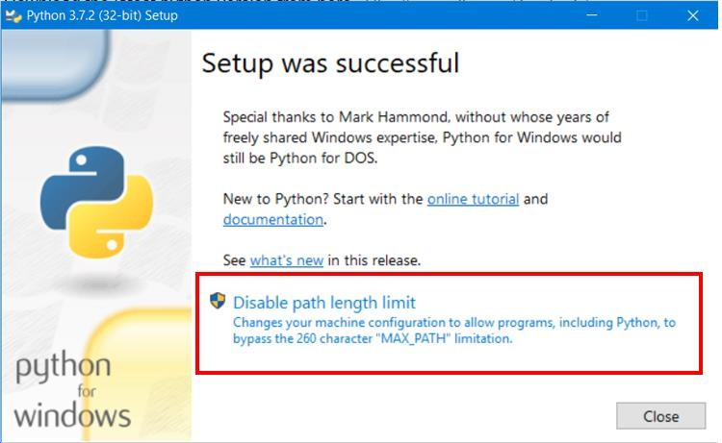

Download Install PyCharm

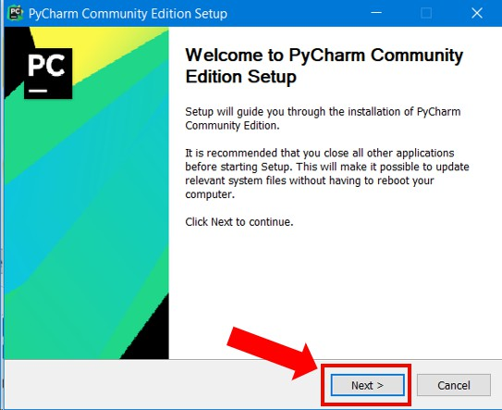

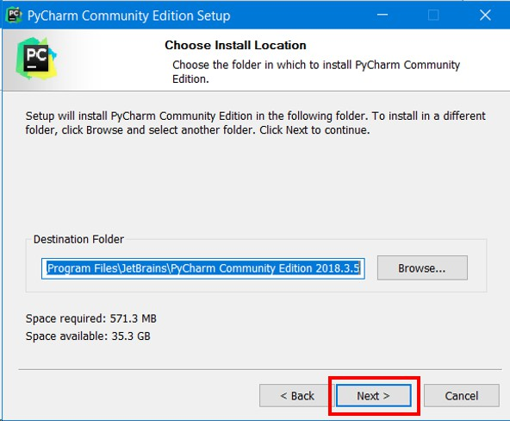

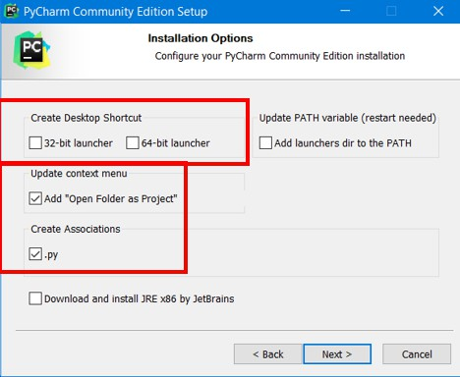

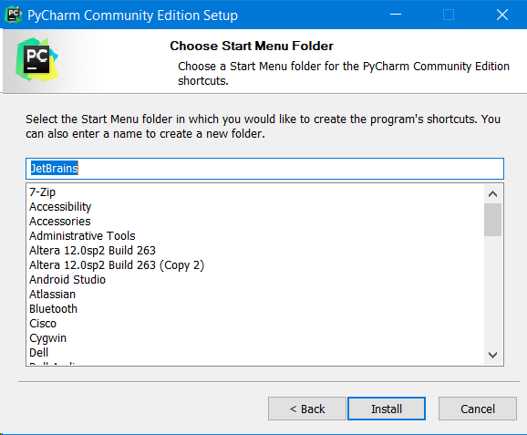



PyCharm--Setup



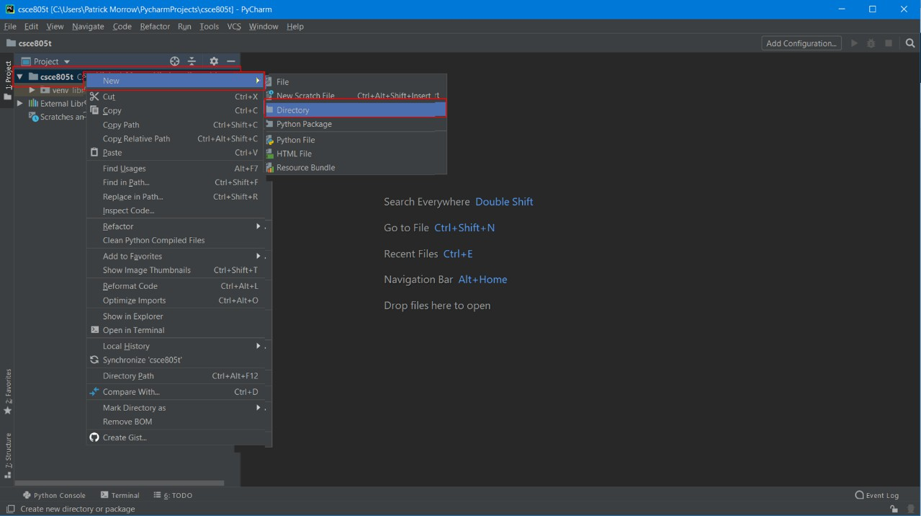

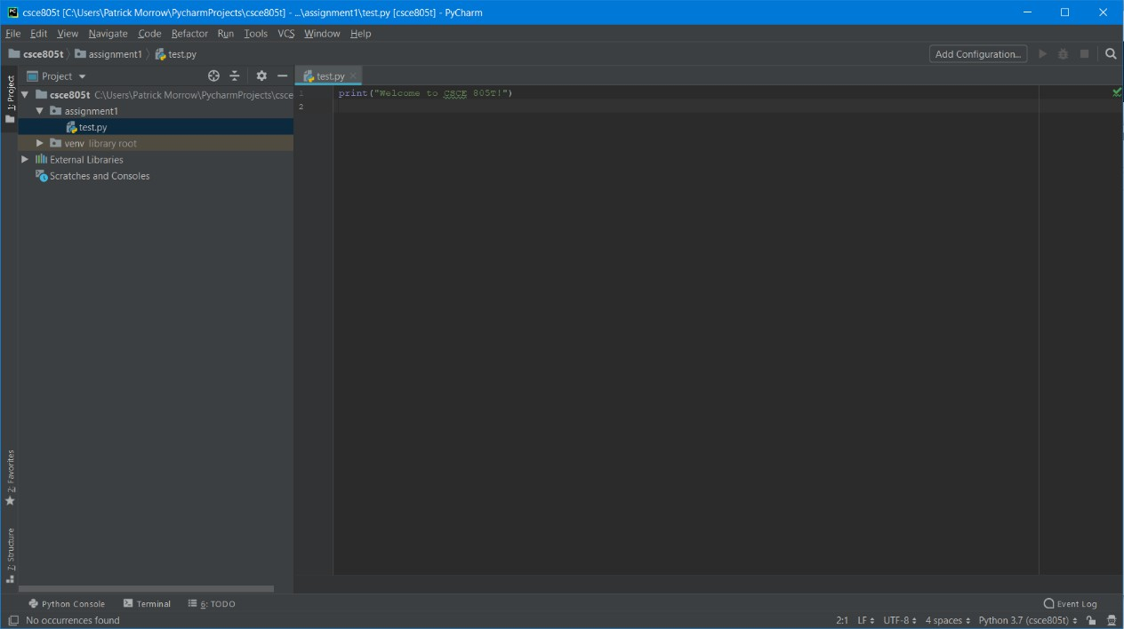



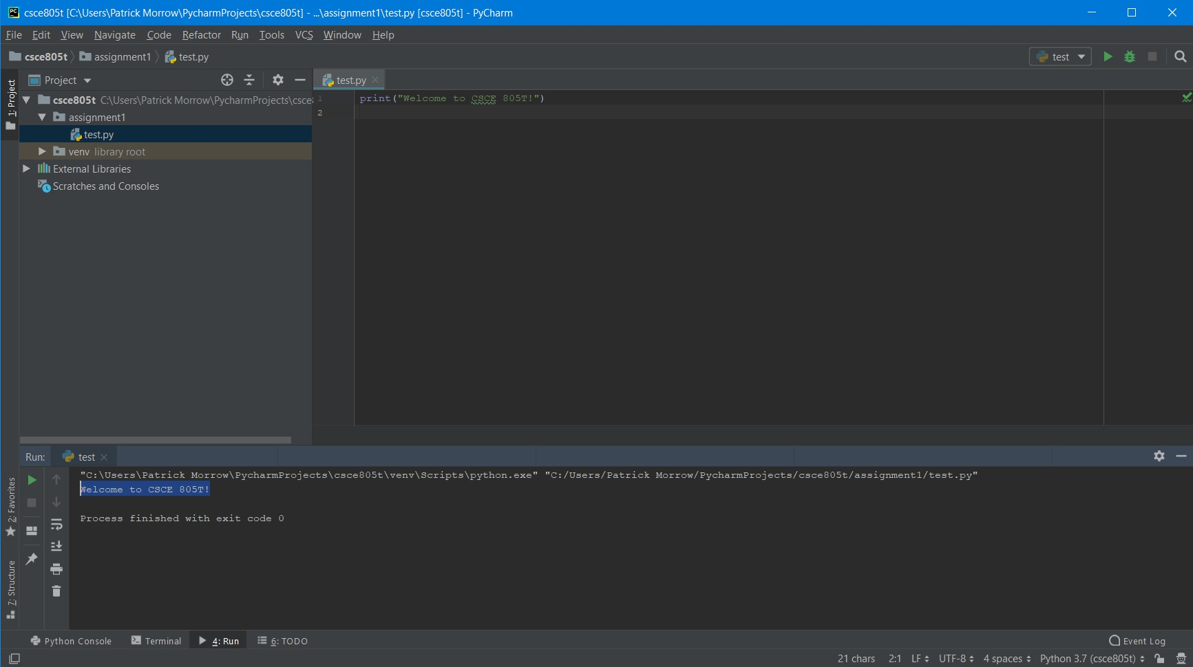

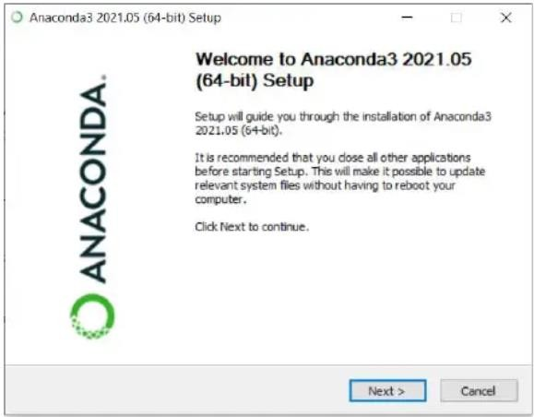
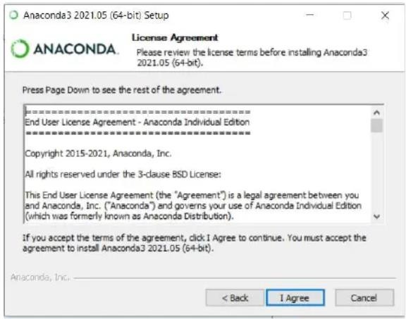

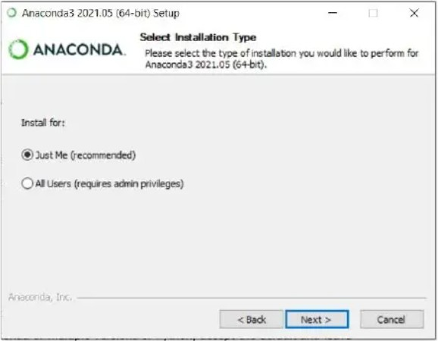

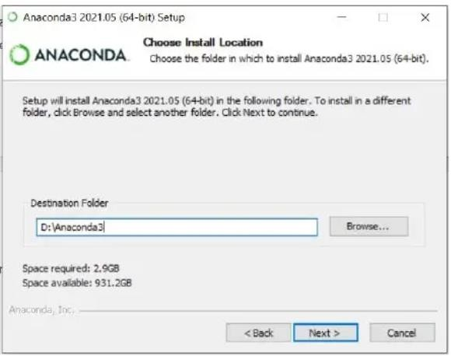

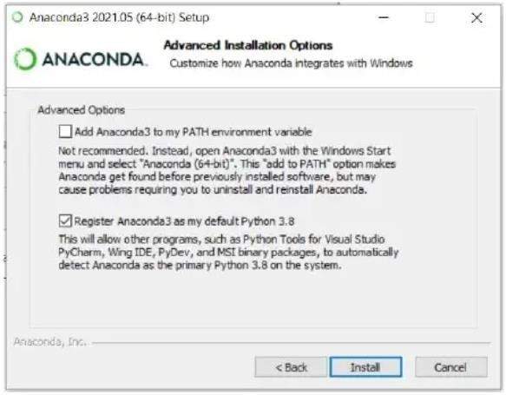

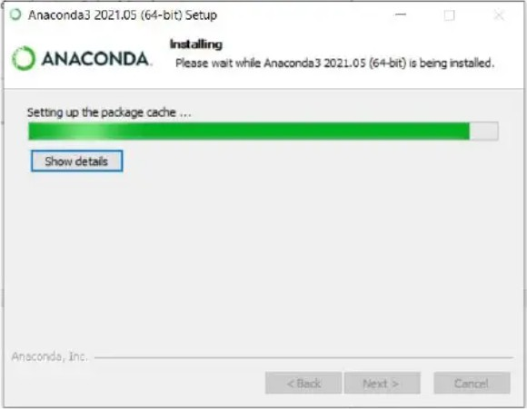

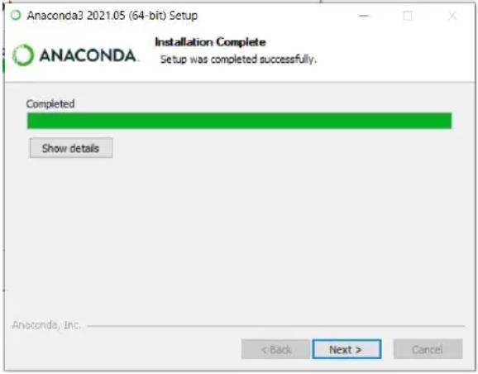

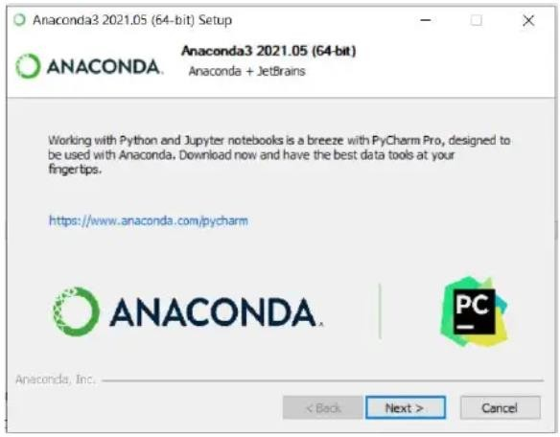

6.1 GENERAL

Coding:

CHAPTER 6
IMPLEMENTATION

from flask import Flask, render_template, request, redirect, send_file import os
import cv2

from cryptography.fernet import Fernet from werkzeug.utils import secure_filename import numpy as np
from secretsharing import SecretSharer import secrets
import pickle # For saving dimensions

from flask_login import LoginManager, UserMixin, login_user, login_required, logout_user, current_user

from werkzeug.security import generate_password_hash, check_password_hash from flask import Flask, render_template, redirect, url_for, request, session, flash app = Flask( name )

app.secret_key = secrets.token_hex(16) # For session and flash messages app.config['UPLOAD_FOLDER'] = 'uploads'

app.config['SHARES_FOLDER'] = 'shares' app.config['DECRYPTED_FOLDER'] = 'decrypted' # Ensure necessary folders exist
os.makedirs(app.config['UPLOAD_FOLDER'], exist_ok=True) os.makedirs(app.config['SHARES_FOLDER'], exist_ok=True) os.makedirs(app.config['DECRYPTED_FOLDER'], exist_ok=True) # Encryption key generation (this is the secret we will split)
key = Fernet.generate_key() cipher_suite = Fernet(key) users = {}
@app.route('/') def home():
return render_template('home.html') @app.route('/register', methods=['GET', 'POST']) def register():
if request.method == 'POST':

username = request.form['username'] password = request.form['password'] if username in users:
flash('Username already exists')

return redirect(url_for('register'))

users[username] = generate_password_hash(password) flash('Registration successful! Please log in.')
return redirect(url_for('login')) return render_template('register.html')
@app.route('/login', methods=['GET', 'POST']) def login():
if request.method == 'POST':

username = request.form['username'] password = request.form['password'] user_hash = users.get(username)
if user_hash and check_password_hash(user_hash, password): session['username'] = username
flash('Login successful!') return redirect(url_for('index'))

flash('Invalid username or password') return render_template('login.html')
@app.route('/index') def index():

return render_template('index.html') @app.route('/upload', methods=['POST']) def upload_video():
if 'video' not in request.files or 'watermark' not in request.files: return redirect('/')
video_file = request.files['video'] watermark_file = request.files['watermark']
if video_file.filename == '' or watermark_file.filename == '': return redirect('/')
video_filename = secure_filename(video_file.filename) watermark_filename = secure_filename(watermark_file.filename)
video_filepath = os.path.join(app.config['UPLOAD_FOLDER'], video_filename) watermark_filepath = os.path.join(app.config['UPLOAD_FOLDER'], watermark_filename) video_file.save(video_filepath)
watermark_file.save(watermark_filepath)

# Encrypt video and embed watermark, then save key shares process_video(video_filepath, watermark_filepath)
# Redirect to reconstruction with the video filename as a parameter return redirect(f'/reconstruct?video_filename={video_filename}')

@app.route('/reconstruct', methods=['GET', 'POST']) def reconstruct_video():
"""Reconstruct the video from key shares and decrypt.""" if request.method == 'POST':
# Reconstruct the encryption key from shares key_shares = []
for i in range(1, 6):

share_filename = f"key_share_{i}.txt"

share_filepath = os.path.join(app.config['SHARES_FOLDER'], share_filename) if not os.path.exists(share_filepath):
break

with open(share_filepath, 'r') as f: key_shares.append(f.read())

if len(key_shares) < 3:

return "Error: Not enough shares to reconstruct the key", 400 reconstructed_key_hex = SecretSharer.recover_secret(key_shares) reconstructed_key = bytes.fromhex(reconstructed_key_hex) cipher_suite_reconstructed = Fernet(reconstructed_key)
# Decrypt the video frames

video_filename = request.form['video_filename'] # Get the original video filename

decrypted_frames, frame_shape = decrypt_frames(video_filename, cipher_suite_reconstructed)

# Save reconstructed video

decrypted_video_path = os.path.join(app.config['DECRYPTED_FOLDER'], f"decrypted_{video_filename}")

save_video(decrypted_frames, decrypted_video_path, frame_shape) # Extract watermark from the first decrypted frame
extracted_watermark_path = os.path.join(app.config['DECRYPTED_FOLDER'], "extracted_watermark.png")

cv2.imwrite(extracted_watermark_path, decrypted_frames[0]) # Save the first frame as the extracted watermark

return redirect(f'/download/{os.path.basename(decrypted_video_path)}')

# Handle GET request: Get video filename from query parameters video_filename = request.args.get('video_filename')
return render_template('reconstruct.html', video_filename=video_filename) @app.route('/download/<filename>')
def download_file(filename):

decrypted_path = os.path.join(app.config['DECRYPTED_FOLDER'], filename) if os.path.exists(decrypted_path):
return send_file(decrypted_path, as_attachment=True)

else:

return "Error: File not found", 404 @app.route('/split_frames/<video_filename>') def split_frames(video_filename):
"""Display split frames for the given video filename.""" base_filename = os.path.splitext(video_filename)[0] frame_files = []
i = 1

while True:

frame_filename = f"{base_filename}_frame_{i}.bin"

frame_filepath = os.path.join(app.config['UPLOAD_FOLDER'], frame_filename) if not os.path.exists(frame_filepath):
break frame_files.append(frame_filepath) i += 1
return render_template('split_frames.html', frame_files=frame_files) def process_video(video_path, watermark_path):
"""Embed watermark, encrypt, and save encrypted video.""" # Read video and watermark
vidcap = cv2.VideoCapture(video_path)

watermark = cv2.imread(watermark_path) # Resize watermark to fit the video frame ret, first_frame = vidcap.read()
h, w, _ = first_frame.shape

watermark_resized = cv2.resize(watermark, (w, h)) frames = []
while ret:

# Embed watermark into the frame

watermarked_frame = cv2.addWeighted(first_frame, 1, watermark_resized, 0.3, 0) encrypted_frame = cipher_suite.encrypt(watermarked_frame.tobytes()) frames.append(encrypted_frame)
ret, first_frame = vidcap.read() # Save the frame shape frame_shape = (h, w)
with open(os.path.join(app.config['SHARES_FOLDER'], 'frame_shape.pkl'), 'wb') as f: pickle.dump(frame_shape, f)
# Split the encryption key into shares using Shamir's Secret Sharing key_hex = key.hex()
key_shares = SecretSharer.split_secret(key_hex, 3, 5) # Save key shares

save_key_shares(key_shares) # Save encrypted video frames
save_encrypted_frames(frames, os.path.basename(video_path)) def save_key_shares(key_shares):
"""Save key shares in the SHARES_FOLDER.""" for i, share in enumerate(key_shares):
share_filename = f"key_share_{i+1}.txt"

with open(os.path.join(app.config['SHARES_FOLDER'], share_filename), 'w') as f: f.write(share)

def save_encrypted_frames(frames, video_filename): """Save encrypted frames in the UPLOAD_FOLDER.""" base_filename = os.path.splitext(video_filename)[0]
for i, encrypted_frame in enumerate(frames): frame_filename = f"{base_filename}_frame_{i+1}.bin"
with open(os.path.join(app.config['UPLOAD_FOLDER'], frame_filename), 'wb') as f: f.write(encrypted_frame)
def decrypt_frames(video_filename, cipher_suite): """Decrypt video frames."""
frames = []

base_filename = os.path.splitext(video_filename)[0] i = 1
while True:

frame_filename = f"{base_filename}_frame_{i}.bin"

frame_filepath = os.path.join(app.config['UPLOAD_FOLDER'], frame_filename) if not os.path.exists(frame_filepath):
break

with open(frame_filepath, 'rb') as f: encrypted_frame = f.read()
decrypted_frame = cipher_suite.decrypt(encrypted_frame) # Load frame shape from the saved file
with open(os.path.join(app.config['SHARES_FOLDER'], 'frame_shape.pkl'), 'rb') as f: frame_shape = pickle.load(f)
np_frame = np.frombuffer(decrypted_frame, dtype=np.uint8).reshape(frame_shape[0], frame_shape[1], 3)

frames.append(np_frame) i += 1
return frames, frame_shape

def save_video(frames, video_path, frame_shape): """Save frames as a video."""
height, width = frame_shape

fourcc = cv2.VideoWriter_fourcc(*'XVID')

out = cv2.VideoWriter(video_path, fourcc, 30.0, (width, height)) for frame in frames:
out.write(frame) out.release()

@app.route('/contact') def contact():
return render_template('contact.html') @app.route('/performance')
def performance():

return render_template('performance.html') if name == ' main ':
app.run(debug=True)

CHAPTER 7 SNAPSHOTS


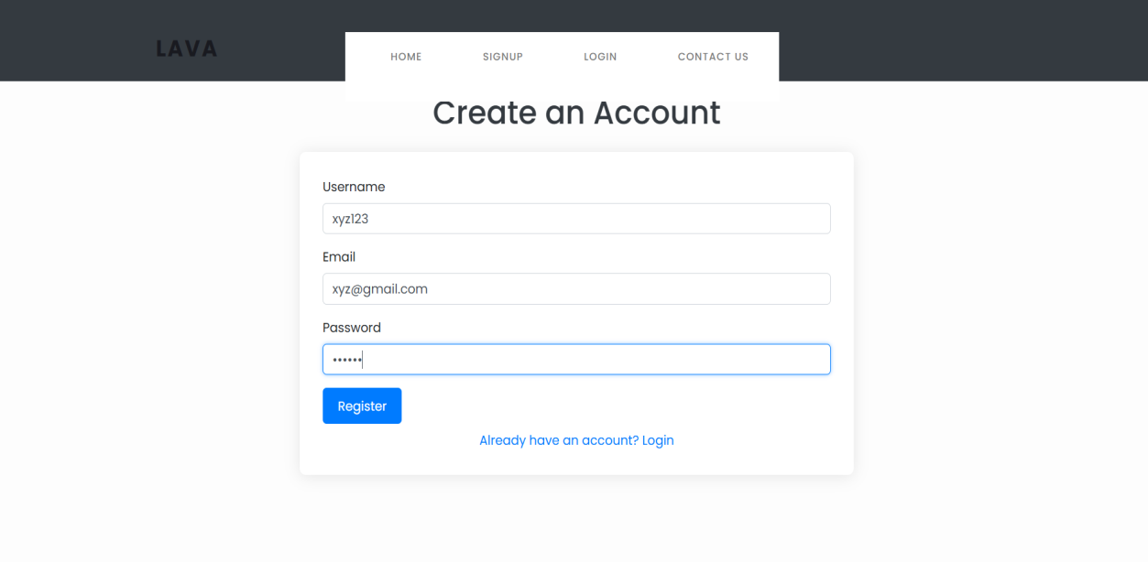

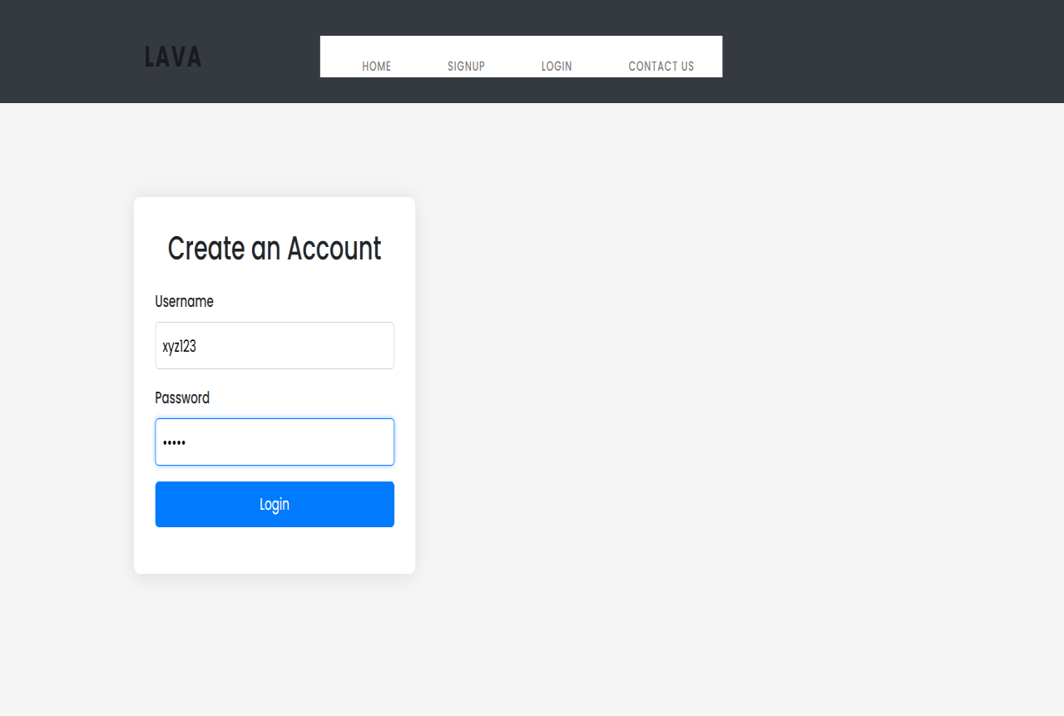

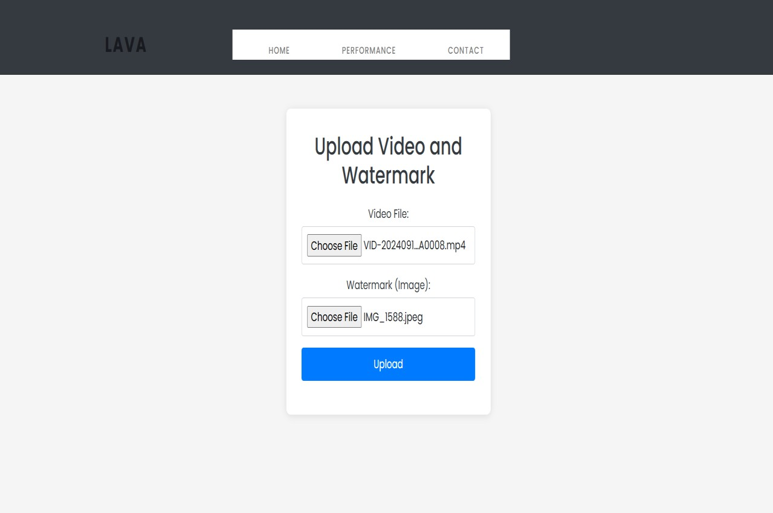

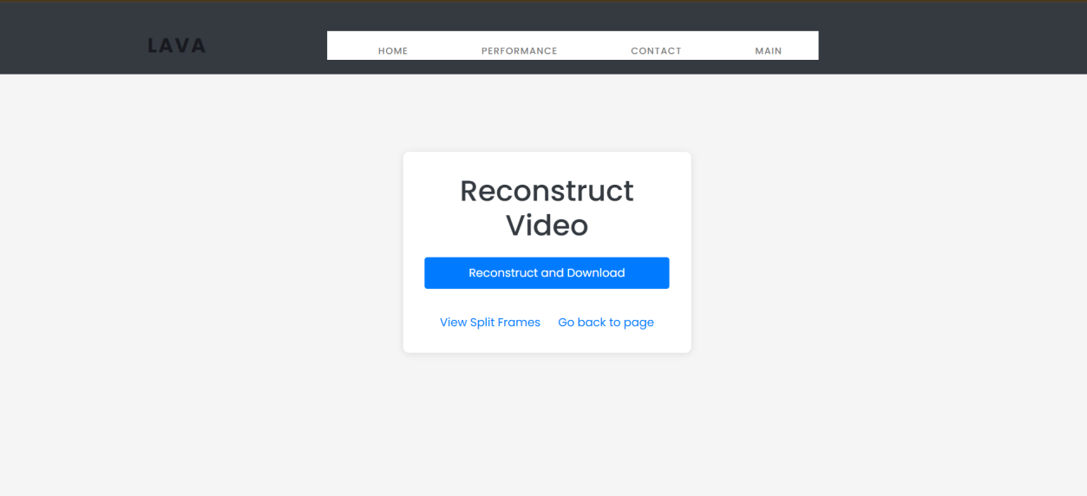
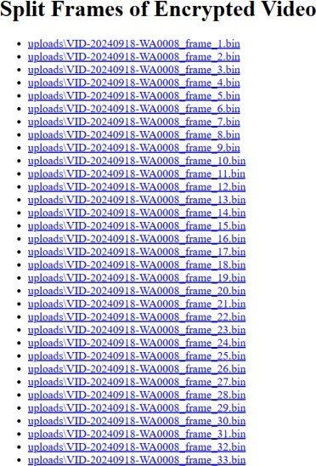
Output:


CHAPTER 8
SOFTWARE TESTING

GENERAL
The purpose of testing is to discover errors. Testing is the process of trying to discover every conceivable fault or weakness in a work product. It provides a way to check the functionality of components, sub-assemblies, assemblies and/or a finished product It is the process of exercising software with the intent of ensuring that the Software system meets its requirements and user expectations and does not fail in an unacceptable manner. There are various types of test. Each test type addresses a specific testing requirement.

DEVELOPING METHODOLOGIES
The test process is initiated by developing a comprehensive plan to test the general functionality and special features on a variety of platform combinations. Strict quality control procedures are used. The process verifies that the application meets the requirements specified in the system requirements document and is bug free. The following are the considerations used to develop the framework from developing the testing methodologies.

  - Types of Tests

    - Unit testing
Unit testing involves the design of test cases that validate that the internal program logic is functioning properly, and that program input produce valid outputs. All decision branches and internal code flow should be validated. It is the testing of individual software units of the application .it is done after the completion of an individual unit before integration. This is a structural testing, that relies on knowledge of its construction and is invasive. Unit tests perform basic tests at component level and test a specific business process, application, and/or system configuration. Unit tests ensure that each unique path of a business process performs accurately to the documented specifications and contains clearly defined inputs and expected results.

    - Functional test
Functional tests provide systematic demonstrations that functions tested are available as specified by the business and technical requirements, system documentation, and user manuals.
Functional testing is centered on the following items:
Valid Input : identified classes of valid input must be accepted. Invalid Input : identified classes of invalid input must be rejected. Functions : identified functions must be exercised.
Output : identified classes of application outputs must be exercised. Systems/Procedures: interfacing systems or procedures must be invoked.

    - System Test
System testing ensures that the entire integrated software system meets requirements. It tests a configuration to ensure known and predictable results. An example of system testing is the configuration oriented system integration test. System testing is based on process descriptions and flows, emphasizing pre-driven process links and integration points.

    - Performance Test
The Performance test ensures that the output be produced within the time limits, and the time taken by the system for compiling, giving response to the users and request being send to the system for to retrieve the results.

    - Integration Testing
Software integration testing is the incremental integration testing of two or more integrated software components on a single platform to produce failures caused by interface defects.
The task of the integration test is to check that components or software applications,
e.g. components in a software system or – one step up – software applications at the company level – interact without error.

    - Acceptance Testing
User Acceptance Testing is a critical phase of any project and requires significant participation by the end user. It also ensures that the system meets the functional requirements.

Acceptance testing for Data Synchronization:
      - The Acknowledgements will be received by the Sender Node after the Packets are received by the Destination Node
      - The Route add operation is done only when there is a Route request in need
      - The Status of Nodes information is done automatically in the Cache Updation process

8.2.7 Build the test plan

Any project can be divided into units that can be further performed for detailed processing. Then a testing strategy for each of this unit is carried out. Unit testing helps to identity the possible bugs in the individual component, so the component that has bugs can be identified and can be rectified from errors.

CHAPTER 9
FUTURE ENHANCEMENT

FUTURE ENHANCEMENTS:
Future enhancements for the "Advanced Encryption for Quantum-Safe Video Transmission" project could include several key improvements to further bolster its functionality and security. Integrating machine learning algorithms could enable the system to monitor video uploads and transmissions for anomalous behavior, enhancing threat detection capabilities. Additionally, incorporating block chain technology would provide tamper-proof storage for encrypted videos and key shares, increasing user trust and data integrity. Implementing real-time encryption and decryption could expand the project's applicability to live video streaming and conferencing. Enhancing user role management would allow for specific access permissions based on roles, while supporting a wider range of video formats and codes would cater to diverse user needs. Continuous improvements to the user interface would enhance user experience, and integrating advanced watermarking techniques would provide robust ownership verification. Optimization for performance and scalability would ensure the application can handle larger volumes of data efficiently. Incorporating multi-factor authentication would significantly strengthen user security, while cloud integration would offer scalable storage solutions for convenient data retrieval. Finally, enhancing cross-platform compatibility would allow users to engage with the application across various devices, and providing comprehensive training materials would empower users to maximize their utilization of the system. Collectively, these enhancements would position the project to effectively address the evolving challenges in secure video transmission.

CHAPTER 10
CONCLUSIONAND REFERENCES

CONCLUSION
In conclusion, the "Advanced Encryption for Quantum-Safe Video Transmission" project represents a significant advancement in the realm of secure video processing and transmission. By leveraging a hybrid approach that combines classical encryption techniques with innovative quantum-safe methodologies, the project effectively addresses the growing need for robust security measures in the digital communication landscape. The modular design of the application enhances its functionality, allowing for seamless user authentication, video upload, encryption, and processing, while ensuring data confidentiality and integrity. Future enhancements, such as the integration of machine learning for anomaly detection, for tamper- proof storage, and real-time encryption capabilities, promise to further strengthen the system's security and usability. As digital communication continues to evolve, this project not only meets current security demands but also positions itself as a forward-thinking solution capable of adapting to future challenges in video transmission. Ultimately, by providing users with a secure and user-friendly platform for video encryption, this project contributes to safeguarding sensitive visual data and promoting trust in digital communication systems.

REFERENCES
- Thabit, Fursan, Ozgu Can, Asia Othman Aljahdali, Ghaleb H. Al- Gaphari, and Hoda A. Alkhzaimi. ”A Comprehensive Literature Survey of Cryptography Algorithms for Improving the IoT Security.” Internet of Things (2023): 100759.

- Hariprasad, Yashas, K. J. Latesh Kumar, L. Suraj, and S. S. Iyengar. ”Boundary-Based Fake Face Anomaly Detection in Videos Using Recurrent Neural Networks.” In Proceedings of SAI Intelligent Systems
Conference, pp. 155-169. Cham: Springer International Publishing, 2022.

- Mohseni, Masoud, Peter Read, Hartmut Neven, Sergio Boixo, Vasil Denchev, Ryan Babbush, Austin Fowler, Vadim Smelyanskiy, and John Martinis. ”Commercialize quantum technologies in five years.” Nature 543, no. 7644 (2017): 171-174.

- Thejas, G. S., Yashas Hariprasad, S. S. Iyengar, N. R. Sunitha, Prajwal Badrinath, and Shasank Chennupati. ”An extension of Synthetic Minority Oversampling Technique based on Kalman filter for imbalanced datasets.” Machine Learning with Applications 8 (2022): 100267.

- Zhu, Dexin, Jun Zheng, Hu Zhou, Jianan Wu, Nianfeng Li, and Lijun Song. ”A hybrid encryption scheme for quantum secure video conferencing combined with blockchain.” Mathematics 10, no. 17 (2022): 3037.

- Gisin, Nicolas, Gr´egoire Ribordy, Wolfgang Tittel, and Hugo Zbinden. ”Quantum cryptography.” Reviews of modern physics 74, no. 1 (2002): 145.

- Wootters, William K., and Wojciech H. Zurek. ”The no-cloning theorem.” Physics Today 62, no. 2 (2009): 76-77.
- Scarani, Valerio, Helle Bechmann-Pasquinucci, Nicolas J. Cerf, Miloslav Duˇsek, Norbert L¨utkenhaus, and Momtchil Peev. ”The security of practical

quantum key distribution.” Reviews of modern physics 81, no. 3 (2009): 1301.

- Yang, Yu-Guang, Juan Xia, Xin Jia, and Hua Zhang. ”Novel image encryption/decryption based on quantum Fourier transform and double phase encoding.” Quantum information processing 12 (2013): 3477-3493.

- Tan, Ru-Chao, Tong Lei, Qing-Min Zhao, Li-Hua Gong, and Zhi-Hong Zhou. ”Quantum color image encryption algorithm based on a hyperchaotic system and quantum Fourier transform.” International Journal of Theoretical Physics 55 (2016): 5368-5384.

- Sharma, Deepak. ”Robust technique for image encryption and decryption using discrete fractional Fourier transform with random phase masking.” Procedia Technology 10 (2013): 707-714.

- Kordov, Krasimir, and Georgi Dimitrov. ”A new symmetric digital video encryption model.” Cybernetics and Information Technologies 21, no. 1 (2021): 50-61.

- Yan, Fei, Abdullah M. Iliyasu, Salvador E. Venegas-Andraca, and Huamin Yang. ”Video encryption and decryption on quantum computers.” International Journal of Theoretical Physics 54 (2015): 2893-2904.

- Zhou, Nan Run, Tian Xiang Hua, Li Hua Gong, Dong Ju Pei, and Qing Hong Liao. ”Quantum image encryption based on generalized Arnold transform and double random-phase encoding.” Quantum Information Processing 14 (2015): 1193-1213.

- Hu, Wen-Wen, Ri-Gui Zhou, Jia Luo, She-Xiang Jiang, and Gao-Feng Luo. ”Quantum image encryption algorithm based on Arnold scrambling and wavelet transforms.” Quantum Information Processing 19 (2020): 1-29.

- Li, Chunmeng, and Xiaozhong Yang. ”An image encryption algorithm

based on discrete fractional wavelet transform and quantum chaos.” Optik 260 (2022): 169042.

- PSong, Xianhua, Guanglong Chen, and Ahmed A. Abd El-Latif. ”Quantum color image encryption scheme based on geometric transformation
and intensity channel diffusion.” Mathematics 10, no. 17 (2022): 3038.

- Wang, Shen, Xianhua Song, and Xiamu Niu. ”A novel encryption algorithm for quantum images based on quantum wavelet transform and diffusion.” In Intelligent Data analysis and its Applications, Volume II: Proceeding of the First Euro-China Conference on Intelligent Data
Analysis and Applications, June 13-15, 2014, Shenzhen, China, pp. 243-
250. Springer International Publishing, 2014.

- Wang, Han, Jian Wang, Ya-Cong Geng, Yan Song, and Ji-Qiang Liu. ”Quantum image encryption based on iterative framework of frequencyspatial domain transforms.” International Journal of Theoretical Physics
56 (2017): 3029-3049.

- Gong, Li-Hua, Xiang-Tao He, Shan Cheng, Tian-Xiang Hua, and Nan- Run Zhou. ”Quantum image encryption algorithm based on quantum image XOR operations.” International Journal of Theoretical Physics 55 (2016): 3234-3250.

- Wang, Jian, Ya-Cong Geng, Lei Han, and Ji-Qiang Liu. ”Quantum image encryption algorithm based on quantum key image.” International Journal
of Theoretical Physics 58 (2019): 308-322.

- Jose, M. Victor, and V. Seenivasagam. ”An Enhanced Opass With Modified Elliptic Curve Cryptography-Based User Authentication Scheme For
Grid Computing.” Life Science Journal 10, no. 3 (2013).

- Le, Phuc Q., Abdullahi M. Iliyasu, Fangyan Dong, and Kaoru Hirota. ”A flexible representation and invertible transformations for images on

quantum computers.” New Advances in Intelligent Signal Processing (2011): 179-202.

- Jiang, Nan, and Luo Wang. ”Quantum image scaling using nearest neighbor interpolation.” Quantum Information Processing 14 (2015): 1559-1571.

- Sun, Bo, A. Iliyasu, Fei Yan, Fangyan Dong, and Kaoru Hirota. ”An RGB multi-channel representation for images on quantum computers.” J. Adv. Comput. Intell. Intell. Inform 17, no. 3 (2013).

Advanced Encryption For Quantum-Safe Video Transmission
CH.Gopi, Hithaishi Gajulapalli, Mohitha Vinnakota, Geenukunta Manish Kumar Goud 1Assistanat Professor, Department of Information Technology, Guru Nanak Institutions Technical Campus, India.
2,3,4B.Tech Students, Department of Information Technology, Guru Nanak Institutions Technical Campus, India.

ABSTRACT
This project enables secure video processing, encryption, and watermark embedding, focusing on user authentication, video encryption, and decryption capabilities. Users can register, log in, and upload videos along with watermarks for processing. Using the cryptography library, each uploaded video is encrypted, and its encryption key is split using Shamir's Secret Sharing, ensuring secure key distribution and storage. The encrypted frames are stored separately for later retrieval and decryption. Decryption occurs through reassembling key shares, allowing the original video to be reconstructed, with the watermark extracted from the first frame. The application further provides options to download the decrypted video, view split frames, and explore contact and performance information pages. Employing OpenCV for video processing and secure file handling techniques, this system ensures data confidentiality and integrity through a user-friendly interface and robust back-end encryption mechanisms. The application uses secure upload and storage mechanisms for sensitive data, like key shares and encrypted frames, storing them in predefined folders. Key shares are stored separately, further protecting the decryption process from unauthorized access.

  - INTRODUCTION
This project is designed to provide a comprehensive solution for secure video processing, encryption, and watermark embedding, emphasizing user authentication and robust video encryption and decryption capabilities. At its core, the application allows users to register and log in, enabling them to upload videos along with their desired watermarks for processing. Once a video is uploaded, it is subjected to encryption using the cryptography library, ensuring that the video data remains confidential and secure. The encryption key itself is further fortified through Shamir's Secret Sharing scheme, which divides the key into multiple shares, thereby enhancing key distribution and storage security. This innovative approach ensures that even if one or more shares are compromised, the original key cannot be reconstructed without the minimum threshold of shares required.
In the system, the encrypted video frames are stored separately to facilitate later retrieval and decryption. During the decryption process, the application intelligently reassembles the key shares, allowing the original video to be reconstructed seamlessly. Additionally, the watermark embedded within the video is extracted from the first frame, ensuring that users can maintain their identity or brand in the content. The application also provides users with various options, including the ability to download the decrypted video, view split frames, and access contact and performance information pages.

EXISTING SYSTEM:
The existing system for video transmission primarily relies on traditional encryption techniques, such as symmetric and asymmetric algorithms (e.g., AES, RSA), to secure video data. While these methods effectively ensure confidentiality, integrity, and authenticity, they face significant challenges due to advancing computing capabilities that make them more vulnerable to brute-force and cryptographic attacks. Additionally, the increasing demand for security in digital communication necessitates stronger encryption methods. Many systems currently utilize SSL (Secure Sockets Layer) for secure transmission over the internet, adding a layer of protection; however, this approach may not be sufficient against sophisticated threats. Consequently, the limitations of existing methods highlight the urgent need for more advanced solutions, such as the proposed Hybrid Quantum Video Encryption Framework, to enhance the security of video transmission effectively.
With the rise of more powerful computing technologies, traditional encryption methods face vulnerabilities, as they can be subjected to brute- force attacks and other cryptographic attacks.

PROPOSED SYSTEM
The proposed system is a Flask-based web application designed to deliver secure video processing, encryption, and watermark embedding, with a strong focus on user authentication and data confidentiality. This platform allows users to register, log in, and upload video files, along with watermark images, to enhance security and content integrity. Video files are encrypted, and the

encryption key is split using Shamir's Secret Sharing technique, ensuring both secure distribution and controlled access to the decryption key. This process of splitting and securing the encryption key guarantees that only authorized users with the required number of key shares can successfully decrypt and reconstruct the video.

  - LITERATURE SURVEY
Title: Quantum-Safe Cryptography: A Survey Author: K. A. C. K. Perera, A. J. S. A. Lee, and A.
A. M. Shafique Year: 2021
Description: This survey provides a comprehensive overview of quantum-safe cryptographic methods as the field of quantum computing progresses, posing significant threats to traditional cryptographic algorithms. The authors analyze the vulnerabilities of widely-used encryption methods, such as RSA and ECC, in light of quantum algorithms like Shor’s algorithm, which can efficiently factor large integers and solve discrete logarithm problems. The paper explores various quantum-safe alternatives, including lattice-based cryptography, code-based cryptography, and multivariate polynomial cryptography, emphasizing their potential applicability in securing data transmissions, including video content. Furthermore, the authors discuss the challenges of integrating these quantum- safe algorithms into existing systems and propose guidelines for developing hybrid approaches that leverage both classical and quantum-safe methods. This work serves as a vital resource for researchers and practitioners aiming to enhance the security of video transmission in an era of quantum threats.

Title: Secure Video Transmission Using Quantum Cryptography
Author: R. B. Patel and M. K. Jha
Year: 2022
Description: This paper presents an innovative framework for securing video transmission by employing quantum cryptographic techniques. The authors explore the concept of quantum key distribution (QKD), which allows two parties to share a secure key over a potentially insecure channel without the risk of eavesdropping. They detail the mathematical principles underpinning QKD and its implementation within a video transmission system. By integrating QKD with traditional encryption algorithms, such as AES, the proposed method enhances the security of video data during transmission over public networks. The authors conduct a series of simulations to evaluate the performance and security of their approach, demonstrating that it effectively mitigates risks associated with eavesdropping and unauthorized access. Additionally, they discuss practical challenges in implementing quantum cryptography in real-world applications and suggest directions for
future research to improve its feasibility for large- scale video transmission scenarios.

Title: A Review of Quantum-Safe Encryption Algorithms for Video Streaming
Author: P. Smith, J. R. Doe, and E. W. Brown
Year: 2023
Description: In this extensive review, the authors critically assess various quantum-safe encryption algorithms that are specifically tailored for video streaming applications. The paper begins by discussing the implications of quantum computing on current encryption standards, emphasizing the urgency for transitioning to quantum-safe alternatives. The authors categorize existing algorithms based on their mathematical foundations, such as lattice-based, hash-based, and code-based systems, and evaluate their security levels, performance metrics, and implementation challenges. They also highlight how these algorithms can be integrated into existing video streaming protocols to enhance security without significantly impacting user experience. Through comparative analyses and case studies, the authors provide insights into the effectiveness of each approach, offering valuable guidance for developers and researchers looking to secure video content against potential quantum threats. The review concludes with recommendations for future research, particularly in optimizing the performance of quantum-safe algorithms in real-time streaming environments.

Title: Post-Quantum Cryptography for Secure Video Communications
Author: M. T. Alahakoon, A. K. B. Thennakoon, and J. R. W. Ananda
Year: 2023
Description: This paper investigates the implications of quantum computing advancements on video communication security, focusing on the need for post-quantum cryptographic solutions. The authors analyze various post-quantum algorithms and their suitability for securing video data during transmission. They emphasize the vulnerabilities of traditional encryption methods to quantum attacks and propose a framework for implementing post- quantum cryptographic protocols in video communication systems. Through detailed simulations and real-world scenarios, the study evaluates the performance, security levels, and overhead of different post-quantum algorithms in video transmission contexts. The authors highlight the importance of transitioning to quantum-safe solutions and provide practical recommendations for integrating these protocols into existing video streaming infrastructures.

Title: Enhancing Video Security through Quantum- Safe Algorithms: A Performance Evaluation

Author: H. G. Lin, P. M. Lim, and Q. Z. Shen
Year: 2023
Description: This paper presents a performance evaluation of various quantum-safe encryption algorithms specifically designed for securing video data. The authors begin by discussing the vulnerabilities of current video encryption techniques to quantum attacks and the necessity for quantum-safe alternatives. They evaluate several post-quantum cryptographic algorithms, including lattice-based and hash-based schemes, comparing their performance in terms of encryption and decryption speed, computational overhead, and resilience against quantum attacks. Through experimental results, the authors illustrate how these algorithms can be effectively applied to video security without significantly impacting the user experience. Additionally, the paper discusses the implications of using quantum-safe algorithms in real-world video streaming scenarios, offering insights and recommendations for implementing these techniques in practice.

  - PROJECT DESCRIPTION
The project "Advanced Encryption for Quantum- Safe Video Transmission" aims to develop a robust framework for secure video communication in the face of evolving quantum computing threats. This initiative focuses on integrating cutting-edge quantum cryptography techniques with classical encryption methods to enhance the security and integrity of video data during transmission. Utilizing Shamir's Secret Sharing for secure key distribution, the framework enables user authentication, video encryption, and watermark embedding while ensuring data confidentiality. Users can register, log in, and upload videos with embedded watermarks for processing. The cryptography library is employed to encrypt each uploaded video, with key shares stored separately to prevent unauthorized access. Encrypted video frames are stored for later retrieval, and the decryption process involves reassembling key shares to reconstruct the original video while extracting watermarks from the first frame. The project leverages OpenCV for efficient video processing and incorporates secure file handling techniques to protect sensitive data. Ultimately, this project offers a user-friendly interface alongside robust backend encryption mechanisms, aiming to provide a significant advancement in the field of secure video transmission in a post-quantum world.
METHODOLOGIES
- User Authentication Module SYSTEM ARCHITECTURE:
The User Authentication Module serves as the gateway for users to access the application, ensuring that only authorized individuals can upload and manage video content. This module includes a registration system where new users can create accounts by providing essential information, such as username and password, which are securely hashed for protection. Additionally, the login functionality validates user credentials against stored records, allowing for session management that maintains user login status throughout their interaction with the application. By implementing robust authentication mechanisms, this module enhances the security of user accounts and protects sensitive data from unauthorized access.
- Video Upload Module
The Video Upload Module facilitates the seamless process of uploading video files along with optional watermarks. Users can easily select video files from their devices through a user-friendly interface, which includes file type and size validation to ensure compatibility with the system requirements. This module also allows users to input watermark information, which will be embedded into the video during processing. By streamlining the upload process and ensuring data integrity, this module serves as a crucial component in preparing videos for secure encryption and transmission.
- Encryption Module
The Encryption Module is responsible for implementing advanced cryptographic techniques to secure uploaded video files. Utilizing both classical encryption methods and quantum-safe algorithms, this module encrypts videos to protect them from unauthorized access during transmission. A key feature of this module is the incorporation of Shamir's Secret Sharing, which divides the encryption keys into multiple shares for enhanced security and safe distribution. This ensures that no single entity has access to the complete key, significantly mitigating the risk of key compromise. By leveraging robust encryption practices, this module guarantees the confidentiality and integrity of video data.

  - DESIGN ENGINEERING
Design Engineering deals with the various UML [Unified Modelling language] diagrams for the implementation of project. Design is a meaningful engineering representation of a thing that is to be built. Software design is a process through which the requirements are translated into representation of the software. Design is the place where quality is rendered in software engineering.

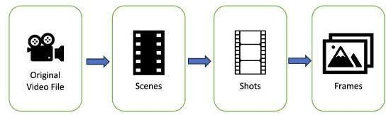

Fig 4.11: System Architecture

  - DEVELOPMENT TOOLS
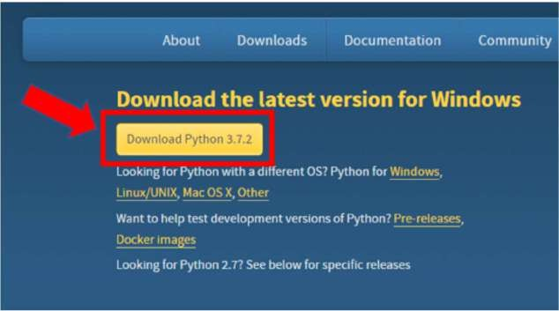
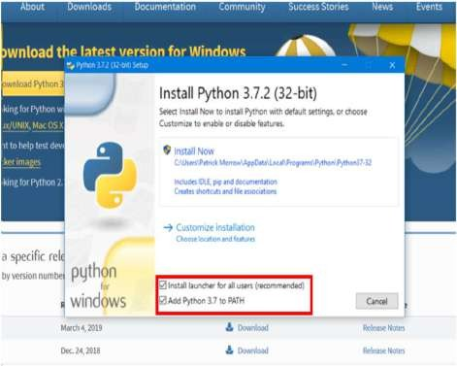

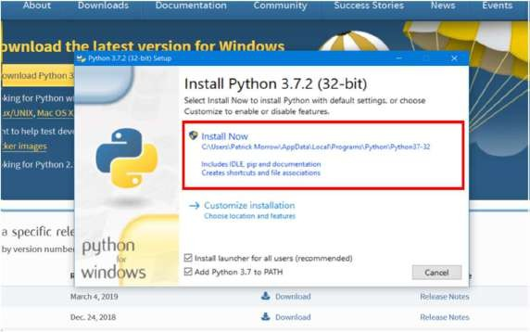
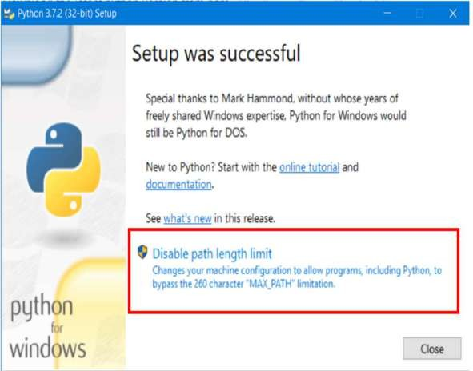

  - SOFTWARE TESTING
The purpose of testing is to discover errors. Testing is the process of trying to discover every conceivable fault or weakness in a work product. It provides a way to check the functionality of components, sub- assemblies, assemblies and/or a finished product It is the process of exercising software with the intent of ensuring that the Software system meets its requirements and user expectations and does not fail in an unacceptable manner. There are various types of test. Each test type addresses a specific testing requirement.
Unit testing
Unit testing involves the design of test cases that validate that the internal program logic is functioning properly, and that program input produce valid outputs. All decision branches and
internal code flow should be validated. It is the testing of individual software units of the application
.it is done after the completion of an individual unit before integration. This is a structural testing, that relies on knowledge of its construction and is invasive. Unit tests perform basic tests at component level and test a specific business process, application, and/or system configuration. Unit tests ensure that each unique path of a business process performs accurately to the documented specifications and contains clearly defined inputs and expected results.
Functional test
Functional tests provide systematic demonstrations that functions tested are available as specified by the business and technical requirements, system documentation, and user manuals.

Functional testing is centered on the following items:
Valid Input : identified classes of valid input must be accepted.
Invalid Input : identified classes of invalid input must be rejected.
Functions : identified functions must be exercised.
Output : identified classes of application outputs must be exercised.
Systems/Procedures: interfacing systems or procedures must be invoked.
System Test
System testing ensures that the entire integrated software system meets requirements. It tests a configuration to ensure known and predictable results. An example of system testing is the configuration oriented system integration test. System testing is based on process descriptions and flows, emphasizing pre-driven process links and integration points.
Integration Testing
Software integration testing is the incremental integration testing of two or more integrated software components on a single platform to produce failures caused by interface defects.
The task of the integration test is to check that components or software applications, e.g. components in a software system or – one step up – software applications at the company level – interact without error.

  - CONCLUSION
In conclusion, the "Advanced Encryption for Quantum-Safe Video Transmission" project represents a significant advancement in the realm of secure video processing and transmission. By leveraging a hybrid approach that combines classical encryption techniques with innovative quantum-safe methodologies, the project effectively addresses the growing need for robust security measures in the digital communication landscape. The modular design of the application enhances its functionality, allowing for seamless user authentication, video upload, encryption, and processing, while ensuring data confidentiality and integrity. Future enhancements, such as the integration of machine learning for anomaly detection, for tamper-proof storage, and real-time encryption capabilities, promise to further strengthen the system's security and usability. As digital communication continues to evolve, this project not only meets current security demands but also positions itself as a forward- thinking solution capable of adapting to future challenges in video transmission. Ultimately, by providing users with a secure and user-friendly platform for video encryption, this project contributes to safeguarding sensitive visual data and promoting trust in digital communication systems.
REFERENCES
- Thabit, Fursan, Ozgu Can, Asia Othman Aljahdali, Ghaleb H. Al- Gaphari, and Hoda A. Alkhzaimi. ”A Comprehensive Literature Survey of Cryptography Algorithms for Improving the IoT Security.” Internet of Things (2023): 100759.
- Hariprasad, Yashas, K. J. Latesh Kumar, L. Suraj, and S. S. Iyengar. ”Boundary-Based Fake Face Anomaly Detection in Videos Using Recurrent Neural Networks.” In Proceedings of SAI Intelligent Systems Conference, pp. 155-169. Cham: Springer International Publishing, 2022.
- Mohseni, Masoud, Peter Read, Hartmut Neven, Sergio Boixo, Vasil Denchev, Ryan Babbush, Austin Fowler, Vadim Smelyanskiy, and John Martinis. ”Commercialize quantum technologies in five years.” Nature 543, no. 7644 (2017): 171-174.
- Thejas, G. S., Yashas Hariprasad, S. S. Iyengar,
N. R. Sunitha, Prajwal Badrinath, and Shasank Chennupati. ”An extension of Synthetic Minority Oversampling Technique based on Kalman filter for imbalanced datasets.” Machine Learning with Applications 8 (2022): 100267.
- Zhu, Dexin, Jun Zheng, Hu Zhou, Jianan Wu, Nianfeng Li, and Lijun Song. ”A hybrid encryption scheme for quantum secure video conferencing combined with blockchain.” Mathematics 10, no. 17 (2022): 3037.
- Gisin, Nicolas, Gr´egoire Ribordy, Wolfgang Tittel, and Hugo Zbinden. ”Quantum cryptography.” Reviews of modern physics 74, no. 1 (2002):145.
- Wootters, William K., and Wojciech H. Zurek. ”The no-cloning theorem.”Physics Today 62, no. 2 (2009): 76-77.
- Scarani, Valerio, Helle Bechmann-Pasquinucci, Nicolas J. Cerf, Miloslav Duˇsek, Norbert L¨utkenhaus, and Momtchil Peev. ”The security of practical quantum key distribution.” Reviews of modern physics 81, no. 3 (2009): 1301.
- Yang, Yu-Guang, Juan Xia, Xin Jia, and Hua Zhang. ”Novel image encryption/decryption based on quantum Fourier transform and double phase encoding.” Quantum information processing 12 (2013): 3477-3493.
- Tan, Ru-Chao, Tong Lei, Qing-Min Zhao, Li- Hua Gong, and Zhi-Hong Zhou. ”Quantum color image encryption algorithm based on a hyperchaotic system and quantum Fourier transform.” International Journal of Theoretical Physics 55 (2016): 5368-5384.
- Sharma, Deepak. ”Robust technique for image encryption and decryption using discrete fractional Fourier transform with random phase masking.”Procedia Technology 10 (2013): 707-714.
- Kordov, Krasimir, and Georgi Dimitrov. ”A new symmetric digital video encryption model.” Cybernetics and Information Technologies 21, no. 1(2021): 50-61.
- Yan, Fei, Abdullah M. Iliyasu, Salvador E. Venegas-Andraca, and Huamin Yang. ”Video

encryption and decryption on quantum computers.” International Journal of Theoretical Physics 54 (2015): 2893-2904.
- Zhou, Nan Run, Tian Xiang Hua, Li Hua Gong, Dong Ju Pei, and Qing Hong Liao. ”Quantum image encryption based on generalized Arnold transform and double random-phase encoding.” Quantum Information Processing 14 (2015): 1193-1213.
- Hu, Wen-Wen, Ri-Gui Zhou, Jia Luo, She- Xiang Jiang, and Gao-Feng Luo. ”Quantum image encryption algorithm based on Arnold scrambling and wavelet transforms.” Quantum Information Processing 19 (2020): 1-29.
- Li, Chunmeng, and Xiaozhong Yang. ”An image encryption algorithm based on discrete fractional wavelet transform and quantum chaos.” Optik 260 (2022): 169042.
- PSong, Xianhua, Guanglong Chen, and Ahmed
A. Abd El-Latif. ”Quantum color image encryption scheme based on geometric transformation and intensity channel diffusion.” Mathematics 10, no. 17 (2022): 3038.
- Wang, Shen, Xianhua Song, and Xiamu Niu. ”A novel encryption algorithm for quantum images based on quantum wavelet transform and diffusion.” In Intelligent Data analysis and its Applications, Volume II: Proceeding of the First Euro-China Conference on Intelligent Data Analysis and Applications, June 13-15, 2014, Shenzhen, China,
pp. 243-250. Springer International Publishing, 2014.
- Wang, Han, Jian Wang, Ya-Cong Geng, Yan Song, and Ji-Qiang Liu.”Quantum image encryption based on iterative framework of frequencyspatial domain transforms.” International Journal of Theoretical Physics 56 (2017): 3029-3049.
- Gong, Li-Hua, Xiang-Tao He, Shan Cheng, Tian-Xiang Hua, and Nan-Run Zhou. ”Quantum image encryption algorithm based on quantum image XOR operations.” International Journal of Theoretical Physics 55 (2016): 3234-3250.
- Wang, Jian, Ya-Cong Geng, Lei Han, and Ji- Qiang Liu. ”Quantum image encryption algorithm based on quantum key image.” International Journal of Theoretical Physics 58 (2019): 308-322.
- Jose, M. Victor, and V. Seenivasagam. ”An Enhanced Opass With Modified Elliptic Curve Cryptography-Based User Authentication Scheme For Grid Computing.” Life Science Journal 10, no. 3 (2013).
- Le, Phuc Q., Abdullahi M. Iliyasu, Fangyan Dong, and Kaoru Hirota.”A flexible representation and invertible transformations for images on quantum computers.” New Advances in Intelligent Signal Processing (2011): 179-202.
- Jiang, Nan, and Luo Wang. ”Quantum image scaling using nearest neighbor interpolation.” Quantum Information Processing 14 (2015):1559-
1571.
- Sun, Bo, A. Iliyasu, Fei Yan, Fangyan Dong, and Kaoru Hirota. ”An RGB multi-channel representation for images on quantum computers.” J.Adv. Comput. Intell. Intell. Inform 17, no. 3 (2013).

