ISM 6404 – Intro to Business Analytics and Big Data
Instructor: Dr. Tres Bishop
Assignment 2
(100 points)
Task: Perform descriptive analytics by creating a Dashboard in Power BI which will help management analyze the Canada Superstore Sales Data.
First create a report containing the following 6 visualizations. Provide individual screen shot of each visualization below and answer the insight question. Then add all the six visualizations from the report onto a single Dashboard and provide a screenshot of the full Dashboard.
1. Order quantity by Province (10 points)
a. Insight question: Which province shows you maximum orders and what is the ‘exact’ number of orders for this province?
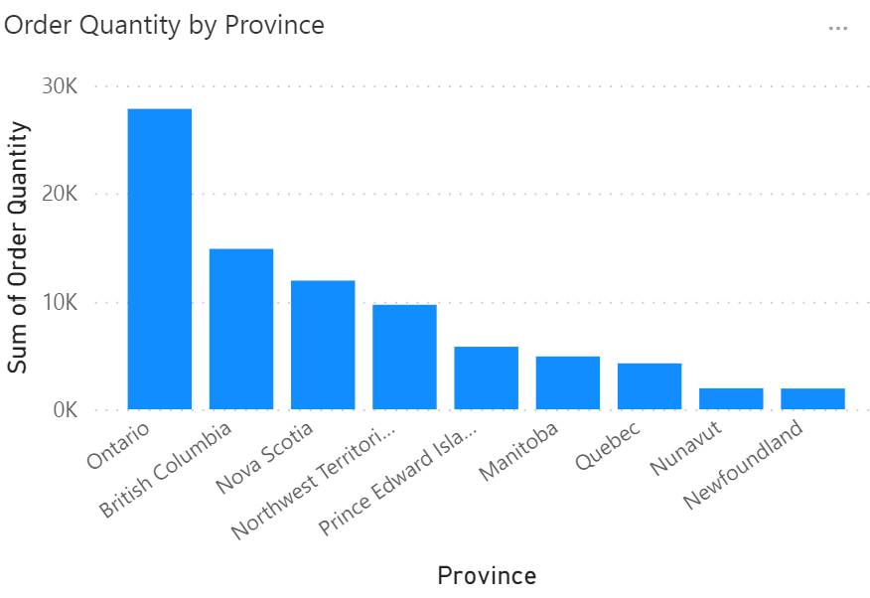
Ontario shows you maximum orders and the 'exact' number is 27840.

2. Total Sales by Customer (10 points)
a. Insight question: Which customer had the maximum sales? Specify Name and exact sales amount?
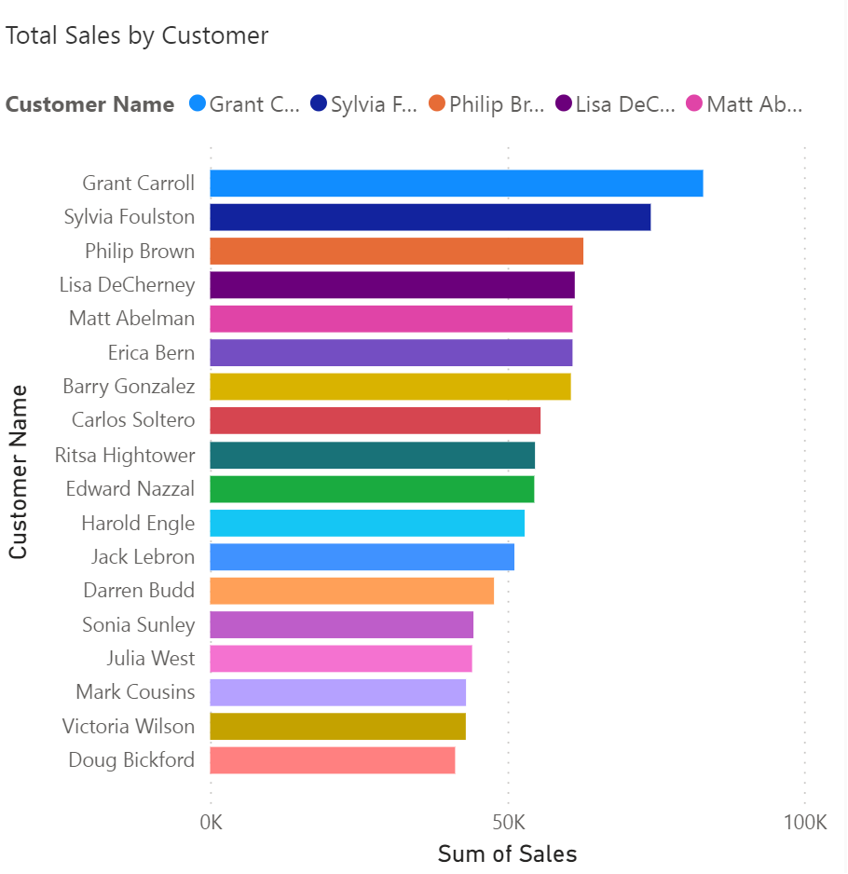
Grant Carroll has the maximum sales and the exact sales amount is 82,990.33

3. Total Sales by Province using ‘Filled map’ (geographical representation) (10 points)
a. Insight question: Which province has the maximum sales and what is the exact amount of the sales?
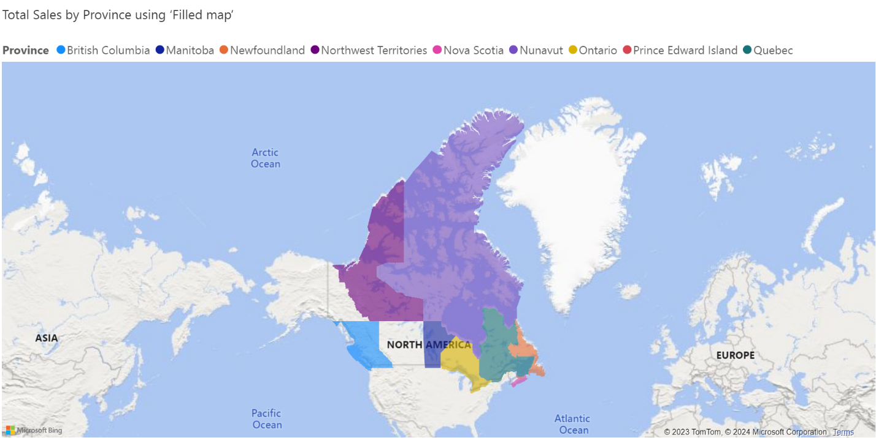
Ontario has the maximum sales and the exact amount of sales is 17,48,758.22

4. Order Quantity Trend using ‘Area map’ (generally used for trends) (10 point)
a. Insight question: Which year had the maximum order quantity and what was the exact number of orders?
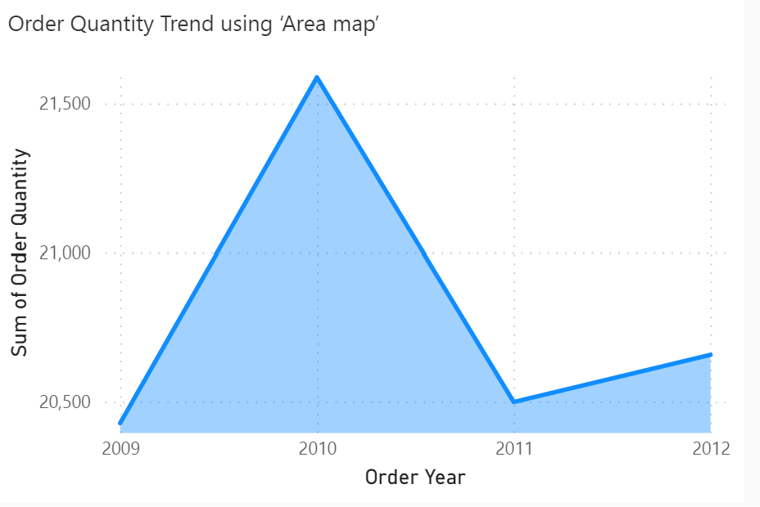
The year 2010 had the maximum order quantity in that particular year was 21588.

5. Your choice of another meaningful visualization and an insight. (10 points)
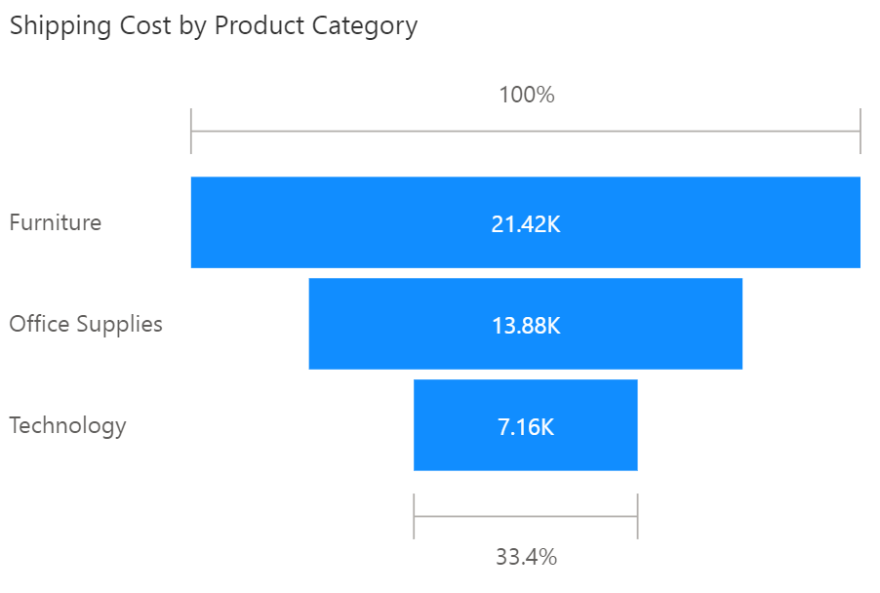
The product category ‘Furniture’ has the maximum shipping cost of 21.42K.
6. Your choice of another meaningful visualization and an insight. (10 points)
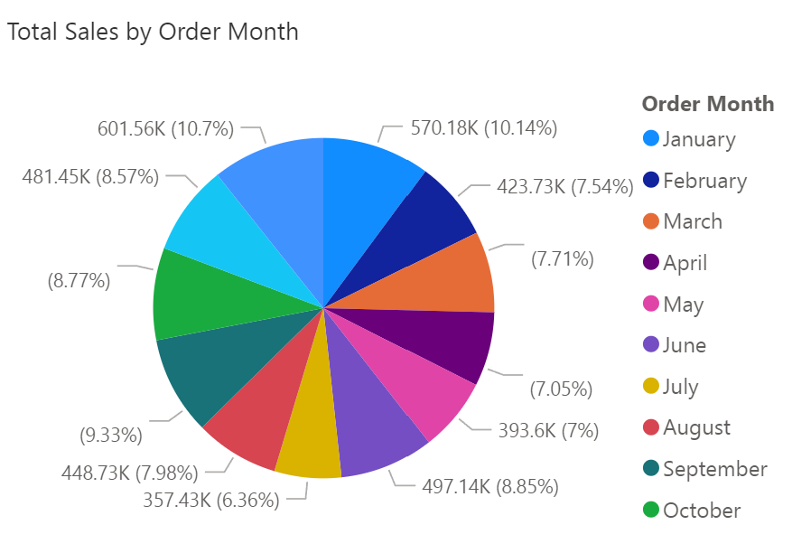
The order month ‘January’ has the greatest sales compared to other months and the total sales is 570.18K.

7. Create Dashboard and paste a screen shot of the full dashboard (you can paste two screenshots if the full Dashboard does not fit in one ...but try to size the visualizations to fit on one screen. You can use this feature located on top menu bar of Dashboard to enter full screen mode and then take a screen shot of full Dashboard). Also try the ‘view insights’ feature (see screenshot under item 23 in tutorial) on Dashboard is very cool! (20 points)
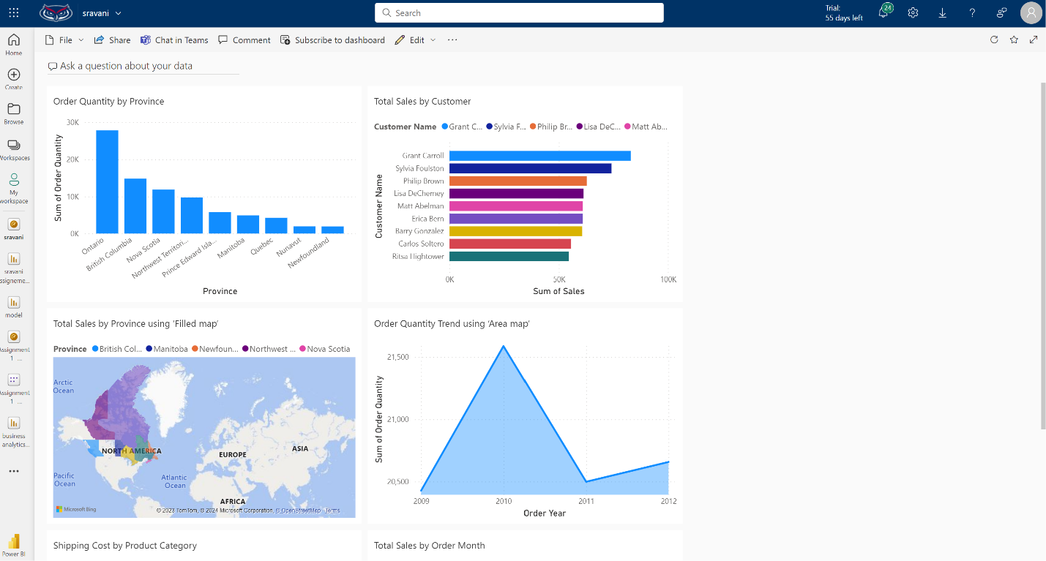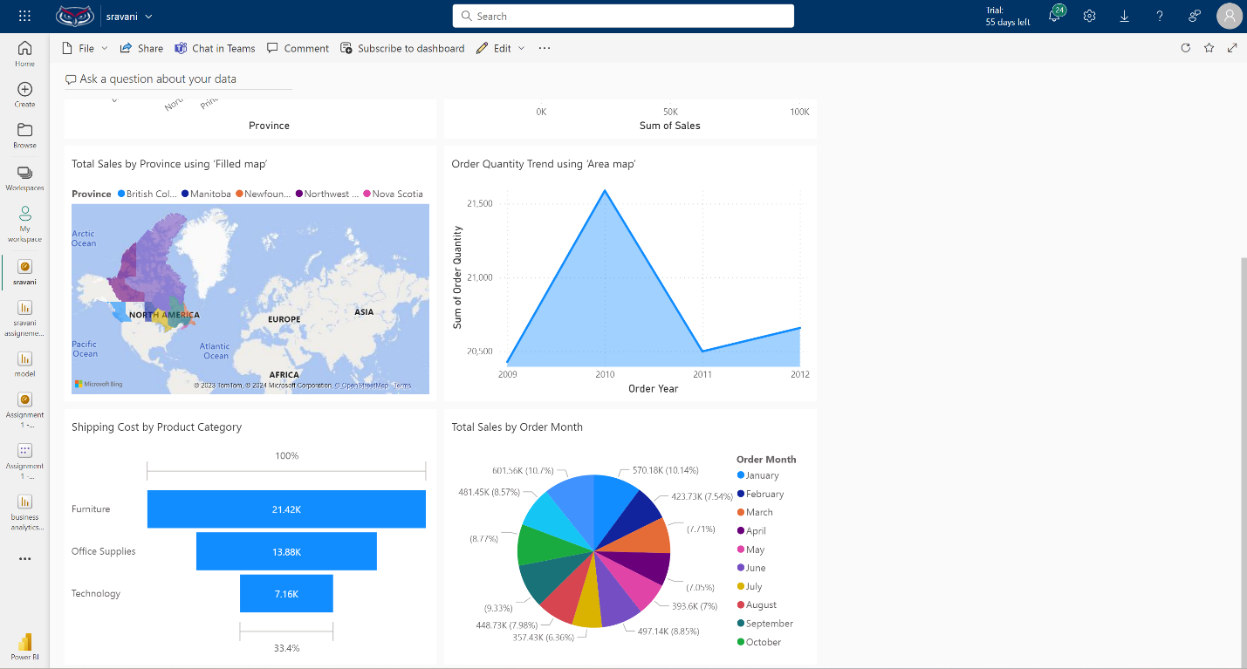
8. Open your dashboard and ‘Ask any question about your data’. Paste screen shots of any 3 questions you asked and their answers (20 points)
Submit the ‘clear’ screenshots and the answers on a Word document on Canvas.
Note: You lose points if your visualizations/plots are not ‘readable’. Please make sure you format the font size etc. 