OJJALA SRAVANI
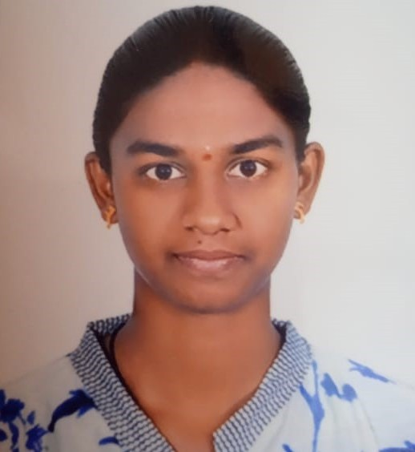
📞 8639963644 | 📧 ojjalasravani@gmail.com
GitHub: https://github.com/sravani0202

Professional Summary
Enthusiastic B.Tech Computer Science student with a strong foundation in Python and web development. Passionate about AI and Machine Learning model types, including supervised learning, neural networks. Seeking an entry-level role to apply Python-based data and AI skills in real-world projects.

Education
B.Tech – Computer Science Engineering
Chaitanya Deemed To Be University (2022 – Present)
Class XII – MPC
Resonance Junior College (2022) – 90%
Class X – SSC
Vignan High School (2020) – GPA: 10/10

Technical Skills
Languages: Python , Java, HTML, CSS, JavaScript.
AI/ML Concepts: Supervised Learning, CNNs, RNNs.
Frameworks: NumPy, Pandas, Scikit-learn , React (UI), Tailwind CSS
Tools: Git, GitHub, VS Code, Google Colab
Soft Skills: Analytical Thinking, Collaboration, Problem Solving

Projects
AI-Powered Recognition System (HRMS Module)
• Developed a module that allows employee recognition with rating and analytics
• Implemented React frontend and MongoDB backend
• Learned real-world data structure handling
• GitHub: https://github.com/sravani0202/hrms-recognition
E-commerce Platform (Python + Web)
• Designed full UI including product filters and responsive layout
• Practiced backend data flow and validations using Python logic
• GitHub: https://github.com/sravani0202/ecommerce-website

Experience
Web Development Intern
Sunstone – May 2024 – Jun 2024
• Built responsive web pages using HTML, CSS, and JavaScript
• Participated in code reviews and team-based UI feature development
• Practiced modular coding and reusable components
Event Organizer
Technovista – Chaitanya University – Sep 2024
• Organized hands-on AI workshops
• Handled logistics and speaker coordination for tech events

Certifications
• Python for Beginners – June 2023
• Introduction to Cybersecurity – Cisco Networking Academy, August 2024

Achievements
• Winner – School Super League
• Participated in coding competitions and Tech fests

Languages
• English
• Telugu

