Identification of Potential Interleukin-2-Inducible T-cell Kinase (ITK) Inhibitors from Natural Products Using Machine Learning and Molecular Docking

Parasurampuram Sravani ^{1,2} , Dr. Sabitha Yadam ^{1,*}
¹Ciencia Labs LLPs, Hyderabad, India
²Kalinga Institute of Industrial Technology, Bhubaneswar, India

ABSTRACT

Interleukin- 2- inducible T-cell kinase (ITK) is an important protein involved in T-cell signaling and immune system regulation. Abnormal activity of ITK has been associated with autoimmune diseases, inflammatory disorders, and certain types of cancer, making it a promising target for drug discovery. The aim of this study was to identify potential ITK inhibitors using a computational approach that combines machine learning and molecular docking.

A dataset containing 929 ITK inhibitors was collected from the ChEMBL database, consisting of 519 active and 410 inactive compounds. Molecular descriptors including Molecular Weight (MolWt), LogP, Hydrogen Bond Donors (HBdonors), Hydrogen Bond Acceptors (HBacceptors), Topological Polar Surface Area (TPSA), Rotatable Bonds, Ring Count, Heavy Atom count, Gastrointestinal (GI) Absorption, and Blood- Brain Barrier (BBB) permeability were used to develop machine learning models. Four classification algorithms, namely Logistic Regression, Support Vector Classifier (SVC), K-Nearest Neighbors (KNN), and XGBoost, were trained and evaluated. Among these, the SVC model showed the best performance with an accuracy of 69.4% and was selected for virtual screening.

For external screening, a pre- filtered natural product dataset derived from the COCONUT (Collection of Open Natural Products) Database was used. The dataset was filtered based molecular descriptors, Lipinski’s Rule of Five, and the remove of compounds containing acrylamide warheads. The screened compounds were further processed by calculating molecular descriptors using RDkit and predicting GI absorption and BBB permeability using SwissADME. The optimized SVC model was then used on their decision scores. The top 50 predicted compounds were selected for molecular docking against ITK crystal structure (PDB ID: 4HCT) using AutoDock Vina and Chimera. Docking results were compared with those of the reference ligand and selected training compounds to evaluate their binding affinities.

The computational workflow identified several compounds with favourable predicted binding affinities towards ITK, suggesting their potential for further investigation. Although additional computational experimental studies are required, this work demonstrates that combining machine learning with molecular docking can serve as an efficient approach for identifying potential ITK inhibitors in the early stages of drug discovery.

Keywords: ITK, ChEMBL, COCONUT database, Machine Learning, Support Vector Classifier (SVC), Molecular Docking, AutoDock Vina, Chimera, Virtual Screening.

Acknowledgement
I would like to express my sincere gratitude to Dr. Sabitha Yadam at Ciencia Labs for providing me with the opportunity to undertake this internship and for guiding me throughout the project. Her valuable suggestions, constant encouragement, and continuous support helped me successfully complete this work. The knowledge and experience I gained during this internship have greatly enhanced my understanding of computational drug discovery and bioinformatics.
I am also thankful to the entire team at Ciencia Labs for providing a supportive learning environment and for their guidance whenever required during the course of my internship.
Finally, I would like to express my heartfelt gratitude to my parents, family, and friends for their constant encouragement, patience, and unwavering support throughout my academic journey and during the completion of this project.
I sincerely thank everyone who directly or indirectly contributed to the successful completion of this work.

INTRODUCTION

  - DRUG DISCOVERY

Drug Discovery is the process of identifying and developing new compounds that can be used to prevent, manage, or treat diseases. It is multidisciplinary field that combines biology, chemistry, pharmacology, and computational science to identify molecules capable of interacting with specific
Biological targets. The traditional drug discovery process involves several stages, including target identification, compound screening, lead optimization, preclinical evaluation, and clinical trials before a drug can be approved for therapeutic use.

Developing a new drug is complex, time consuming, and expensive process that often requires more than a decade of research and significant financial investment. In addition, many drug candidates fail during later stages because of poor efficacy, toxicity or unfavourable pharmacokinetic properties. These challenges have encouraged researchers to adopt computational approach that can identify promising compounds earlier in the drug discovery pipeline, thereby reducing both time and cost.

Recent advances in computational biology and bioinformatics have transformed the early stages of drug discovery. Techniques such as virtual screening, molecular docking, quantitative structure- activity relationship (QSAR) studies, and machine learning researchers to evaluate thousands of compounds efficiently before experimental testing. These approaches help prioritize compounds with desirable biological and physiochemical properties, making the drug discovery process more focused and efficient.

In the present study, computational techniques were employed to identify potential inhibitors of Interleukin-2-inducible T-cell Kinase (ITK). A machine learning model was developed using known ITK inhibitors obtained from the ChEMBL database, and the trained model was later applied to screen compounds from the COCONUT database. The most promising candidates identified through virtual screening were further evaluated using molecular docking to investigate their binding affinity toward the target protein.

  - Computer- Aided Drug Discovery (CADD)

The process of developing new drugs has become increasingly challenging because it requires significant time, financial resources, and experimental effort. To overcome these challenges, researches have widely adopted Computer- Aided Drug Discovery (CADD) as an important tool in modern pharmaceutical research. CADD uses computational methods to identify, analyze, and optimize potential drug candidates before laboratory testing, helping reaserchers make informed decisions during the early stages of drug discovery.

CADD can be broadly classified into structure- based drug designing (SBDD) and ligand- based drug design (LBDD). Structure- based drug design relies on the three- dimensional structure of the target protein to study how small molecules interact with the binding site. Molecular docking is one of the most commonly used techniques in this approach, as it predicts the binding orientation and binding affinity of a ligand with its target protein. In contrast, ligand- based drug design focuses on the properties of known active compounds to identify new molecules with similar biological activity. Machine learning models and Quantitative Structure- Activity Relationship (QSAR) studies are widely used in ligand- based approaches to predict the activity of unknown compounds.

In the present study, both ligand- based and structure-based computational approaches were combined. A machine learning model was first developed using known ITK inhibitors obtained from the ChEMBL database. The trained model was then applied to screen compounds from the COCONUT database to identify potential ITK inhibitors. Finally, molecular docking was performed to evaluate the binding affinity of the selected compounds with the ITK protein structure (PDB ID: 4HCT).

  - Internleukin-2-Inducible T-cell Kinase (ITK)

Protein kinases are enzymes that regulate various cellular activities by transferring a phosphate group from ATP to specific target proteins. This process, known as phosphorylation, plays an essential role in controlling cell growth, differentiation, metabolism, and signal transduction. Among the different families of protein kinases, the Tec family of tyrosine kinases is particularly important in regulating immune cell function. One of the key members of this family is Internleukin-2-Inducible T-cell Kinase (ITK), which is predominantly expressed in T lymphocytes and plays a central role in immune signaling.

ITK is activated following stimulation of the T-cell receptor (TCR). Once activated, it participates in a signaling cascade that regulates T-cell activation, proliferation, differentiation, cytokine production, and calcium mobilization. Through these functions, ITK helps coordinate both innate and adaptive immune responses. Since T cells are responsible for recognizing and eliminating pathogens, proper regulation of ITK is essential for maintaining a balanced immune system.

Abnormal ITK activity has been associated with several immune- related diseases. Excessive or dysregulated ITK signaling has been linked to autoimmune disorders such as rheumatoid arthritis and multiple sclerosis, allergic conditions including asthma, and certain hematological malignancies such as T-cell lymphomas. Because ITK plays an important role in these diseases, inhibiting its activity has emerged as a promising therapeutic strategy. In recent years, several small- molecule ITK inhibitors have been developed, with some progressing to preclinical and clinical evaluation. However, many currently available inhibitors face challenges such as limited selectivity, undesirable off- target effects, or sub-optimal pharmacokinetic properties. These limitations highlight the need to identify new compounds with improved efficacy and safety profiles.

Advances in computational drug discovery have provided efficient approaches for identifying novel ITK inhibitors before experimental validation. Machine learning techniques can rapidly analyze large chemical datasets and predict compounds with potential biological activity, while molecular docking helps evaluate how these compounds interact with the target protein at the molecular level. In the present study, ITK (PDB ID: 4HCT) was selected as the therapeutic target. A machine learning model was developed using known ITK inhibitors obtained from the ChEMBL database and subsequently applied to screen compounds from the COCONUT database. The top- ranked compounds were further evaluated through molecular docking to identify potential ITK inhibitors for future investigation.

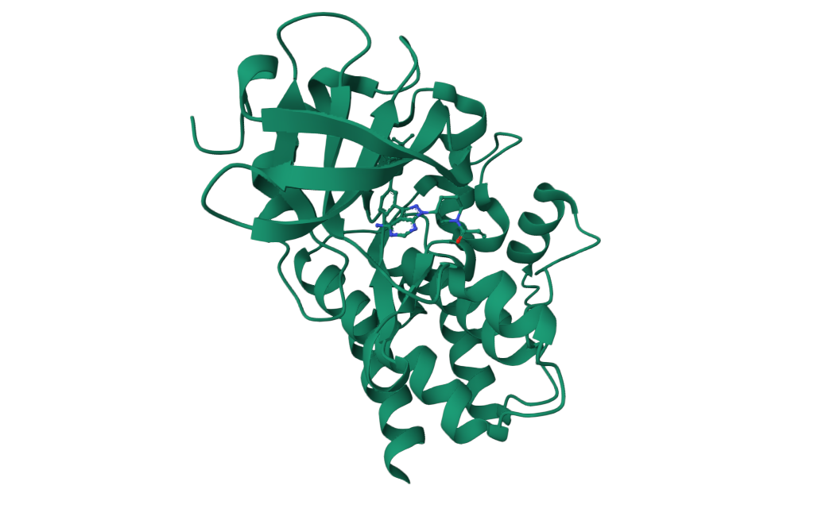
Figure 1. Three-dimensional ribbon representation of the crystal structure of Interleukin-2-Inducible T-cell Kinase (ITK) (PDB ID: 4HCT).

Source: Protein Data Bank (PDB ID: 4HCT).

  - Machine Learning in Drug Discovery

Machine Learning (ML) has emerged as one of the most promising computational approaches in modern drug discovery. It enables computers to learn patterns from existing experimental data and use those patterns to predict the biological activity of new compounds. By analyzing large chemical datasets, machine learning helps researchers identify potential drug candidates more efficiently than traditional screening methods, thereby reducing both the time and cost involved in early-stage drug discovery.

In pharmaceutical research, machine learning has been widely applied for predicting molecular properties, drug- target interactions, toxicity, pharmacokinetic behaviour, and biological activity. These predictive models are developed using molecular descriptors and experimentally validated compounds, allowing the algorithm to distinguish between active and inactive molecules. Once trained, the model can rapidly screen thousands of new compounds and prioritize those with a higher probability of exhibiting the desired biological activity.

Several machine learning algorithms have been successfully applied in bioinformatics, including Logistic Regression, k-Nearest Neighbors (KNN), Random Forest, Support Vector Machine (SVM), Artificial Neutral networks, and Extreme Gradient Boosting (XGBoost). the performance of each algorithm depends on the quality of the dataset, the selected molecular descriptors, and the complexity of the prediction task. Therefore, evaluating multiple algorithms is often necessary to identify the most suitable model for particular study.

In the present work, a supervised machine learning approach was employed to predict potential ITK inhibitors. A classification model was developed using known active and inactive ITK inhibitors obtained from the ChEMBL database. Molecular descriptors representing the physiochemical properties of each compound were used as input features for model training. Multiple classification algorithms were evaluated, and the Support vector machine (SVM) model demonstrated the best overall performance. The optimized model was subsequently applied to screen compounds from the COCONUT database, enabling the identification of potential ITK inhibitors for further molecular docking studies.

  - Molecular Docking

Molecular docking is widely used computational technique in structure- based drug discovery that predicts how a small molecules binds to the active site of a target protein. It estimates both the preferred binding orientation of the ligand and the strength of the interaction, which is generally represented by the binding affinity or docking score. Docking plays an important role in virtual screening by helping researchers identify compounds that are more likely to interact effectively with the target protein before experimental validation,

The docking process involves positioning the ligand within the protein’s binding pocket and evaluating multiple binding conformations using scoring functions. The conformation with the lowest binding energy is considered the most favourable because it represents a more stable protein- ligand complex. Although molecular docking provides valuable insights into binding interactions, the predicted results should be considered preliminary and require further validation through experimental studies.

Several molecular docking software packages are available for virtual screening, among which AutoDock Vina is one of the most widely used due to its balance between computational efficiency and prediction accuracy. AutoDock Vina employs an empirical scoring function and an efficient optimization algorithm to estimate ligand binding affinities while requiring relatively less computational time. These advantages make it suitable for screening multiple compounds against a target protein.

In the present study, molecular docking was performed to validate the compounds predicted by the machine learning model. The crystal structure of Interleukin- 2-inducible T-cell Kinase (ITK) (PDB ID: 4HCT) was obtained from the protein data bank and prepared for docking. The reference ligand, selected training compounds, and the top compounds predicted from the COCONUT database were docked using the UCSF Chimera molecular visualization platform, which integrates the AutoDock Vina docking engine for predicting protein- ligand interactions. The same docking parameters were applied to all compounds to ensure consistency throughout the study. The resulting docking scores were compared to evaluate the binding affinity of the screened compounds and identify promising candidates for further investigation.

  - Aim and Objectives

AIM- To identify potential Interleukin-2- Inducbile T-cell Kinase (ITK) inhibitirs by integrating machine learning- based virtual screening with molecular docking.

OBJECTIVE-
- To collect and prepare a dataset of known active and inactive ITJ inhibitors from the ChEMBL database.
- To collect molecular descriptors and prepare the dataset for machine learning model development.
- To develop and evaluate multiple machine learning classification models for predicting ITK inhibitors activity.
- To identify the best- performing machine learning model for virtual screening.
- To screen compounds from the pre- filtered COCONUT database using the optimized machine learning model.
- To perform molecular docking of the reference ligand, selected training compounds, and the top predicted compounds against ITK protein (PDB ID: 4HCT)
- To compare docking scores and identify compounds with promising binding affinity toward ITK.

2 LITERATURE REVIEW

2.1 ITK Inhibitors and their Therapeutic Potential

Protein kinases have become one of the most important classes of drug targets because of their involvement in numerous cellular signaling pathways. Over the past two decades, significant progress has been made in the development of the kinase inhibitors, leading to the approval of many small- molecule drugs for the treatment of cancer and other diseases. Despite these advances, several kinases remain underexplored, and the development of highly selective inhibitors continues to be an active area of research due to challenges such as off-target effects, drug resistance, and toxicity.

Among the Tec family of tyrosine kinases, interleukin-2-Inducible T-cell Kinase (ITK) has attracted considerable attention as a therapeutic target because of its central role in T- cell receptor signaling and immune regulation. Inhibition of ITK has been shown to suppress abnormal T-cell activation and inflammatory cytokine production, making it a promising strategy for the treatment of autoimmune diseases, allergic disorders, and T-cell malignancies. Recent studies have highlighted ITK as an attractive target for developing immunomodulatory therapies with improved selectivity and reduced adverse effects.

Several classes of small- molecule ITK inhibitors have been reported in recent years. Early inhibitors demonstrated that ITK could be effectively targeted, however, many compounds exhibited limitations such as poor selectivity against closely related kinases, sub-optimal pharmacokinetic properties, or undesirable side effects. These challenges have encouraged researchers to design new inhibitors with improved potency, selectivity, and drug- like characteristics. Current research is focused on optimizing molecular scaffolds, identifying novel binding modes, and improving the therapeutic profile of ITK inhibitors for clinical applications.

Recent advances in computational drug discovery have further accelerated the search for novel ITK inhibitors. Machine learning, virtual screening , and molecular docking are increasingly being integrated into the early stages of drug discovery to prioritize compounds before experimental testing. These computational approaches reduce the number of molecules that require laboratory evaluation and increase the likelihood of identifying promising lead compounds. Such strategies are particularly valuable when screening large libraries of natural products and chemically diverse compounds.

2.2 Computational Approach in Drug Discovery

The integration of computational techniques into drug discovery has significantly improved the efficient of identifying potential therapeutic compounds. Advances in computational power and the availability of large chemical and biological datasets have enabled researchers to predict molecular properties, biological activity, and protein-ligand interactions before experimental testing. As a result, computational approaches have become an essential component of modern drug discovery, helping to reduce both the time and cost associated with lead identification.

Machine learning has emerged as a valuable tool for analyzing complex biological and chemical datasets. Several studies have demonstrated its ability to classify active and inactive compounds, predict biological activity, estimate pharmacokinetic properties, and support virtual screening campaigns. Classification algorithms such as Support Vector Classifier (SVC), random forest, k-Nearest Neighbors (KNN), Logistic Regression, and Extreme Gradient Boosting (XGBoost) have been widely applied in cheminformatics due to their ability to identify meaningful relationships between molecular descriptors and biological activity. The performance and these models depends on factors such as dataset quality, descriptor selection, and appropriate model validation.

Virtual screening has become an effective strategy for prioritizing compounds from large chemicals libraries before experimental evaluation. Instead of testing every molecule in vitro, computational screening enables researchers to rapidly identify compounds with a higher probability of exhibiting the desired biological activity. This approach is particularly useful when working with natural product databases, where thousands of structurally diverse compounds can be evaluated efficiently using predictive models.

Molecular docking is frequently employed after visual screening to evaluate the binding interactions between selected compounds and the target protein. Numerous studies have shown that combining machine learning with molecular docking improves the efficiency of lead identification by reducing the numbers of compounds subjected to docking while maintaining a high probability of identifying promising candidates. This integrated workflow has been successfully applied in the discovery of inhibitors of several therapeutic targets, including protein kinases, enzymes and receptors.

The increasing use of machine learning- guided virtual screening combined with molecular docking demonstrates the growing importance of computational methods in pharmaceutical research. Although these approaches cannot replace experimental validation, they provide a reliable and cost- effective strategy for prioritizing compounds for further biological investigation.

2.3 Research Gap

Despite significant advances in the development of ITK inhibitors, the discovery of highly selective and effective compounds remains a major challenge. Many reported inhibitors have demonstrated promising biological activity, however, limitations such as poor selectivity, unfavourable pharmacokinetic properties, and potential off-target effects continue to restrict their therapeutic applications. These challenges emphasize the need for identifying novel compounds with improved drug- like characteristics.

Recent studies have increasingly adopted computational approaches, including machine learning and molecular docking, to accelerate the early stages of drug discovery. Machine learning has proven effective in predicting the biological activity of chemical compounds, while molecular docking provides valuable insights into protein- ligand interactions. However, many studies rely on a single computational techniques or focus on synthetic chemical libraries, limiting the exploration of structurally diverse natural products.

Natural Products represent a valuable source of chemically diverse molecules with significant therapeutic potential. Integrating machine learning- based virtual screening with molecular docking provides an efficient strategy for prioritizing promising compounds before experimental validation. Such as approach can reduce the number of compounds requiring detailed investigation while improving the efficiency of lead identification.

Based on these observation, they present study integrates machine learning and molecular docking to identify potential Interleukin- 2- Inducible T-cell Kinase (ITK) inhibitors from a pre- filtered natural product dataset. By combining predictive modeling with structure- based validation, this work aims to contribute to the identification of promising lead compounds for future experimental studies.

3 MATERIALS AND METHODOLOGY
3.1 Overall Workflow

The present study employed an integrated computational workflow combining machine learning and molecular docking to identify potential inhibitors of Interleukin- 2-Inducible T-cell Kinase (ITK). Initially, a dataset of known ITK inhibitors was obtained from the ChEMBL database and prepared for model development. Molecular descriptors were calculated using RDKit, and ADME properties were obtained using SwissADME. These data were used to train and evaluate multiple machine learning classification models. The best- performing model was subsequently used to screen compounds from the pre- filtered COCONUT database. The top- ranked compounds predicted to be active were then subjected to molecular docking against ITK protein (PDB ID: 4HCT) using UCSF Chimera with the integrated AutoDock Vina docking engine. Finally, the docking scores of the screened compounds were compared with those of the reference ligand and selected training compounds to identify promising lead candidates.

ChEMBL Database
│
▼
Dataset Preparation
│
▼
Molecular Descriptor Calculation
(RDKit)
│
▼
ADME Property Prediction
(SwissADME)
│
▼
Machine Learning Model Development
(Logistic Regression, KNN, SVM, XGBoost)
│
▼
Best Model Selection (SVM)
│
▼
Screening of COCONUT Database
│
▼
Selection of Top Predicted Compounds
│
▼
Molecular Docking (UCSF Chimera)
(AutoDock Vina Docking Engine)
│
▼
Analysis of Docking Results
│
▼
Identification of Potential ITK Inhibitors

3.2 Dataset collection

The dataset used for machine learning model development was obtained from the ChEMBL database, a manually curated repository of bioactive molecules with experimentally validated biological activity data. Compounds reported against Interleukin-2 -Inducible T-cell Kinase (ITK) were retrieved along with their corresponding IC₅₀ values and SMILES representations.

To develop a binary classification model, the collected compounds were categorized into active and inactive classes based on their IC₅₀ values. Compounds with IC₅₀ values less than 500 nM were considered active, while compounds with IC₅₀ values greater than 1000 nM were considered inactive. Compounds with intermediate IC₅₀ values were excluded from model development to establish a clear distinction between two classes.

After pre-processing and removal of duplicate entries, the final dataset consisted of 929 compound, including 519 active and 410 inactive compounds. The curated dataset was subsequently used for molecular descriptor calculation and machine learning model development.

3.3 Data preprocessing

Before developing the machine learning models, the collected dataset was preprocessed to improve data quality and ensure consistency. Duplicate entries were identified and removed, while compounds with missing or invalid molecular information were excluded from further analysis. The Simplified Molecular Input Line Entry System (SMILES) notation of each compound was verified, as it served as the input for molecular descriptor calculation.

The biological activity data were then categorized into two classes based on their IC₅₀ values. Compounds with IC₅₀ values below 500 nM were labeled as active, whereas compounds with IC₅₀ values above 1000nM were labeled as inactive. Compounds with intermediate IC₅₀ values were excluded to establish a clear distinction between the two classes and improve the reliability of the classification model.

The curated dataset was subsequently used for molecular descriptors calculation and machine learning model development.

3.4 Molecular Descriptor calculation

Molecular descriptors are numerical representations of the physicochemical properties of chemical compounds and play an important role in machine learning- based drug discovery. These descriptors capture structural and chemical characteristics of molecules, enabling machine learning algorithms to identify relationships between molecular properties and biological activity.

In this study, molecular descriptors were calculated from the SMILES representation of each compound using the RDKit cheminformatics library implemented in python. A total of eight physicochemical descriptors were selected for model development: Molecular Weight (MolWt), LogP (MolLogP), Number of hydrogen bond donor (HBdonors), Number of hydrogen bond acceptors (HBacceptors), topological Polar Surface Area (TPSA), Number of Rotatable Bonds,Ring Count, and Heavy Atom Count. These descriptors were selected because they represent important molecular properties associated with drug-likeness and biological activity.

During descriptors calculation, The SMILES notation of each compound was processed individually using RDKit. Compounds that could not be successfully processed due to invalid molecular structures were excluded from further analysis. The calculated descriptors formed the primary feature set used for machine learning model development.

3.5 ADME Property Prediction

In addition to the molecular descriptors calculated using RDKit, Absorption, distribution, metabolism, and Excretion (ADME) properties were predicted using the SwissADME, Gastrointestinal (GI) Absorption, and Blood- Brain barrier (BBB) Permeability were selected for this study. These properties provide important information regarding the absorption and distribution characteristics of compounds and were included as additional features for machine learning model development.

Among the various properties generated by SwissADME, gastrointestinal ( GI Absorption and Blood- Brain barrier (BBB) Permeability were selected for this study. These properties provide important information regarding the absorption and distribution characteristics of compounds and were included as additional features for machine learning model development.

The two ADME properties were combined with the eight RDKit- derived molecular descriptors, resulting in a final dataset consisting of ten molecular descriptors/ properties for each compound. This integrated feature set was subsequently used for training and evaluating the machine learning classification models.

3.6 Machine Learning Model Development

The calculated molecular descriptors and predicted ADME properties were used as input features for developing machine learning classification models. The objective was to classify compounds as active or inactive against ITK based on their molecular characteristics.

Before model training, the dataset was prepared by separating the molecular descriptors and ADME properties as the input features (X), while the activity labels (active and inactive ) were used as the target variables (y). The data were then divided into training and testing sets using an 80:20 ratio to evaluate the predictive performance of the models on unseen data.

Since the selected descriptors had different numerical ranges, features scaling was performed using the StandardScaler method from the Scikit- learn library. Standardization transformed the numerical features to have a mean of zero and a standard deviation of one, thereby improving the performance of distance- based and margin-based machine learning algorithms. The categorical ADME properties (GI absorption and BBB permeability) were encoded into numerical values before model training.

Four supervised machine learning algorithms were implemented and compared in this study:
- Logistic Regression (LR)
- K- Nearest Neighbors (KNN)
- Support Vector Classifier (SVC)
- Extreme Gradient Boosting (XGBoost)

Each model was trained using the same training dataset and evaluated on the testing dataset. Model performance was assessed using accuracy, precision, recall, F1- score, and confusion matrix. These evaluation metrics provided a comprehensive assessment of each classifier’s ability to distinguish between active and inactive compounds.

Among the four algorithms, the Support Vector Classifier (SVC) demonstrated the best overall classification performance and was selected for subsequent virtual screening of the COCONUT database.

Preprocessed Dataset
│
▼
Feature Matrix (X) + Target Labels (y)
│
▼
Train-Test Split (80:20)
│
▼
Feature Scaling (StandardScaler)
│
▼
┌─────────┬─────────
│ │ │ │
▼ ▼ ▼ ▼
Logistic KNN SVM XGBoost
Regression
│ │ │ │
└─────────┴─────────┴─────────┘
│
▼
Model Evaluation
(Accuracy, Precision,
Recall, F1-score,
Confusion Matrix)
│
▼
Best Model Selection (SVM)

Algorithm | Purpose
Logistic Regression | Baseline linear classification model
K-Nearest Neighbors | Distance-based classification
Support Vector Machine | Hyperplane-based classification
XGBoost | Ensemble tree-based classification

3.7 Virtual Screening of the COCONUT Database

After identifying the Support vector Classifier (SVC) model as the best- performing classifier, it was employed for virtual screening of natural compounds obtained from the COCONUT (Collection of Open Natural products) database. The COCONUT database is a comprehensive repository of natural products collected from various biological sources and serves as a valuable resource for the discovery of novel bioactive compounds.

A total of 2,709 compounds from the pre-filtered COCONUT dataset were used for screening. Similar to the training dataset, the SMILES representation of each compound was processed to calculate the selected molecular descriptors using RDKit, while the GI absorption and BBB permeability properties were obtained using Swiss ADME. Together, these ten molecular descriptors and ADME properties constituted the feature set for prediction.

The trained SVC model was then used to predict the activity of each compound against Interleukin-2-Inducible t-cell Kinase (ITK). based on the prediction results, compounds classified as active were shortlisted for further investigation. The predicted active compounds were ranked according to their probability scores, and the top 50 compounds were selected for molecular docking studies.

The machine learning- based virtual screening approach enabled the rapid prioritization of potential ITK inhibitors from a large natural product library, thereby reducing the number of compounds requiring detailed structure- based analysis.

Parameter | Value
Database | COCONUT
Total compounds screened | 2,709
Descriptor calculation | RDKit
ADME prediction | SwissADME
Total features used | 10
Prediction model | Support Vector Classifier (SVC)
Compounds selected for docking | Top 50

COCONUT Database
│
▼
SMILES Extraction
│
▼
RDKit Descriptor Calculation
│
▼
SwissADME Prediction
(GI Absorption & BBB Permeability)
│
▼
Feature Dataset (10 Features)
│
▼
Trained SVM Model
│
▼
Activity Prediction
│
▼
Ranking of Predicted Active Compounds
│
▼
Top 50 Compounds Selected

3.8 Molecular Docking

Molecular Docking was performed to evaluate the binding affinity and interaction of the selected compounds with Interleukin-2-Inducible T-cell Kinase (ITK). The docking study was carried out using UCSF Chimera, which integrates the AutoDock Vina docking engine for predicting the binding orientation and affinity of ligands within the active site of the target protein.

3.8.1 Protein Preparation

The three- dimensional crystal structure of Interleukin-2-Inducible T-cell Kinase (ITK) with PDB ID: 4HCT was obtained from the Protein Data Bank (PDB). Before docking, the protein structure was prepared by removing water molecules and other non- essential hetero-atoms. Hydrogen atoms were added, and appropriate atomic charges were assigned using the Dock Prep tool available in UCSF Chimera. The prepared protein structure was then saved in PDBQT format for molecular docking.

3.8.2 Ligand Preparation

The compound selected for docking included the reference ligand, top- ranked training compounds, and the top 50 compounds predicted by the SVM model from the COCONUT database. Their molecular structures were obtained in three- dimensional format and converted into PDBQT format using Open Babel. During ligand preparation, hydrogen atoms were added, and the molecular geometry was optimized to generate suitable structures for docking.

3.8.3 Docking procedure

The prepared protein and ligand structures were imported into UCSF Chimera for molecular docking. Docking calculations were performed using the integrated AutoDock Vina docking engine. The docking search space was defined by a grid box centered on the active site of the ITK protein.

For each ligand, multiple binding poses were generated, and the pose with the lowest binding energy (kcal/mol) was selected for further analysis. Binding affinity values predicted by AutoDock Vina were used to compare the interaction strength of different compounds with the target protein.

Parameter | Value
Target Protein | ITK (PDB ID: 4HCT)
Docking Software | UCSF Chimera (AutoDock Vina engine)
Center X | 4.42
Center Y | 6.80
Center Z | 19.30
Size X | 35.00
Size Y | 35.00
Size Z | 35.00
Exhaustiveness | 8
Number of Modes | 9
Energy Range | 3

3.8.4 Analysis of Docking results

The docking results were calculated on the predicted binding affinity values generated by AutoDock Vina. Compounds with lower (more negative) binding energies were considered to exhibit stronger binding interactions with the ITK protein. The docking scores of the screened compounds were compared with those of the reference ligand and selected training compounds to identify potential lead molecules

The best docking poses were further visualized in UCSF Chimera to examine the orientation of the ligands within the active site of ITK. These analyses provided structural insights into the binding potential of the predicted compounds and supported the identification of promising ITK inhibitors for further investigation.

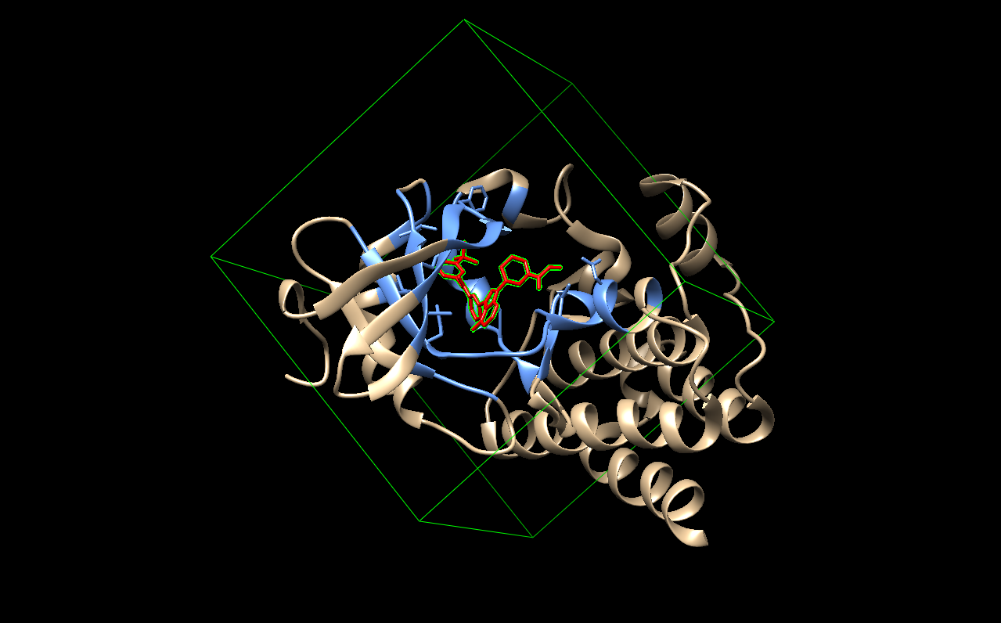

Docking grid box positioned around the active site of ITK in UCSF Chimera

4.1 Dataset preparation and Distribution

The dataset collected from the ChEMBL database was successfully prepared for machine learning model development. After preprocessing, duplicate removal, and activity classification based on IC₅₀ values, the final dataset consisted of 929 compounds. Among these, 519 compounds were classified as active, while 410 compounds were classified as inactive

The distribution of active and inactive compounds was relatively balanced, providing sufficient data for training and evaluating the classification models. A balanced dataset helps minimize prediction bias toward a single class and improves the reliability of the developed machine learning models.

The curated dataset served as the foundation for molecular descriptor calculation, ADME property prediction, and subsequent machine learning analysis.

Activity Class | Number of Compounds
Active | 519
Inactive | 410
Total | 929

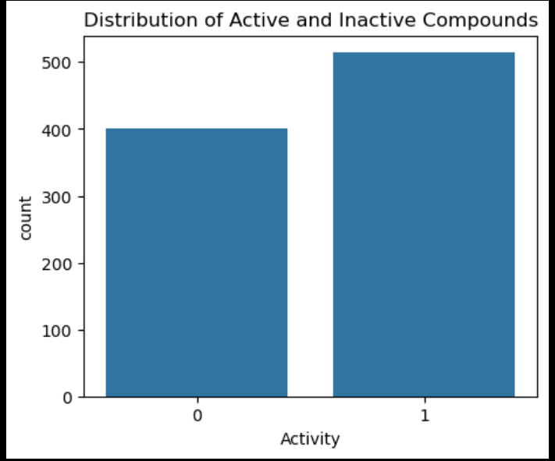

Figure 4.1. Distribution of active and inactive compounds in the curated ChEMBL dataset used for machine learning model development.
4.2 Molecular Descriptor and ADME Analysis

To understand the physicochemical characteristics of the collected compounds, the selected molecular descriptors and ADME properties were analyzed before the machine learning the model development. The analysis helped identify the range and variability of molecular properties within the dataset and ensured that the selected features were suitable for predictive modeling.

The eight molecular descriptors calculated using RDKit, together with the two ADME properties predicted using SwissADME, provided valuable information regarding the structural and pharmacokinetic characteristics of the compounds. The descriptors represented important properties such as molecular size, lipophilicity, hydrogen bonding capacity, molecular flexibility, and molecular complexity, while the ADME properties provided insights into gastrointestinal absorption and blood- brain barrier permeability.

4.2.1 Distribution of Molecular Descriptors

The distribution of the molecular descriptors was examined using histograms and box plots to evaluate the variability of the selected features.most descriptors showed a wide range of values, indicating structural diversity among the compounds present in the ChEMBL dataset. Such diversity is beneficial for machine learning because it allows the algorithms to learn meaningful relationships between molecular properties and biological activity.

Some descriptors exhibited a small number of extreme values, particularly molecular weight and topological polar surface area. These observations are common in drug discovery datasets because bioactive compounds often possess diverse chemical structures. Since the machine learning models feature standardization before training, these variations were appropriately handled during model development.

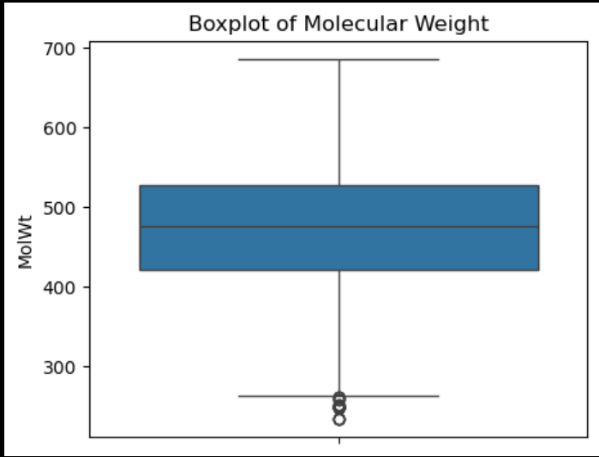

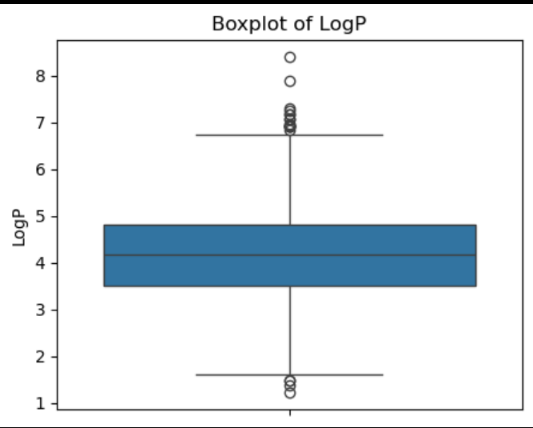

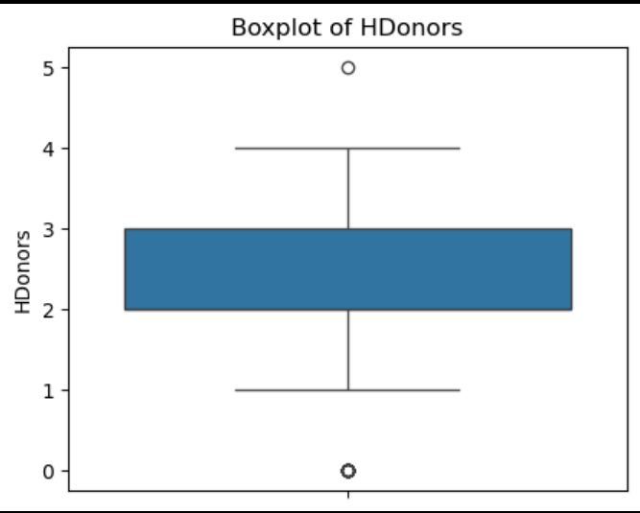

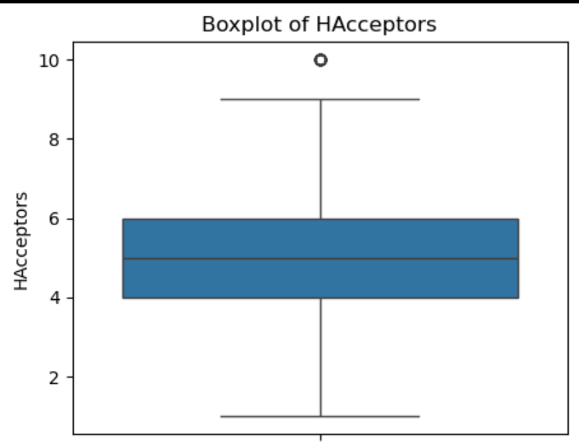

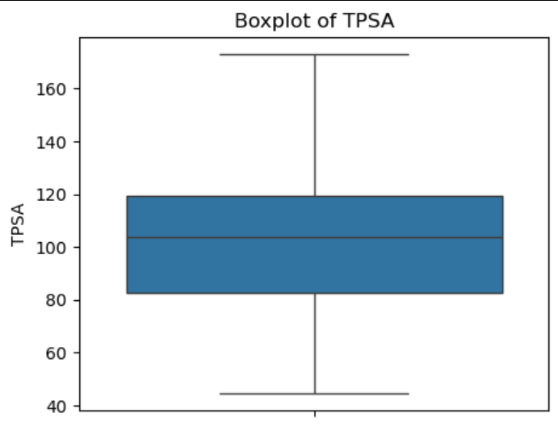

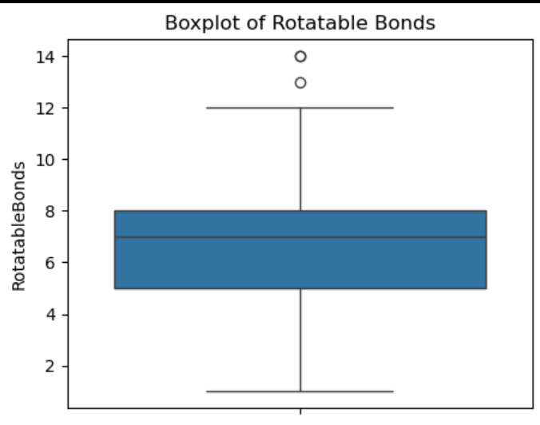

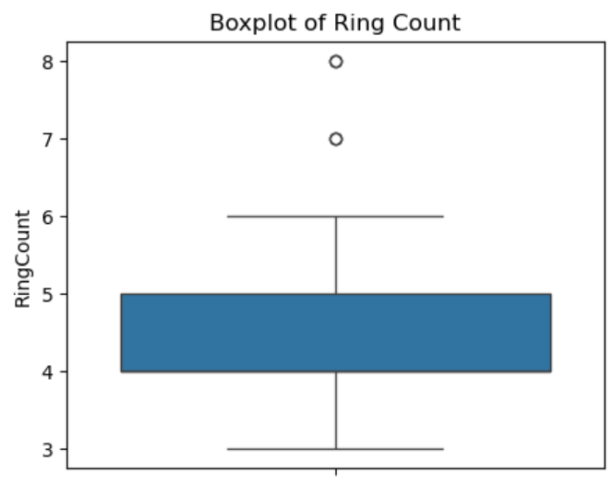

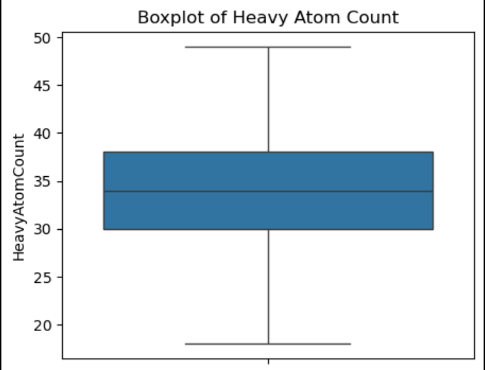

Figure 4.2. Box plots of the molecular descriptors.

4.2.2 Correlation Analysis

A correlation matrix was generated to examine the relationships among the selected molecular descriptors. The heatmap showed that certain descriptors exhibited moderate correlations, reflecting the inherent relationships between molecular properties between molecular properties. For example, molecular weight showed a positive relationship with heavy atom count because larger molecules generally contain a greater number of atoms.

Overall, no severe multicollinearity was observed among the selected features that would adversely affect model development. The selected descriptor set therefore provided complementary information for distinguishing active and inactive compounds.
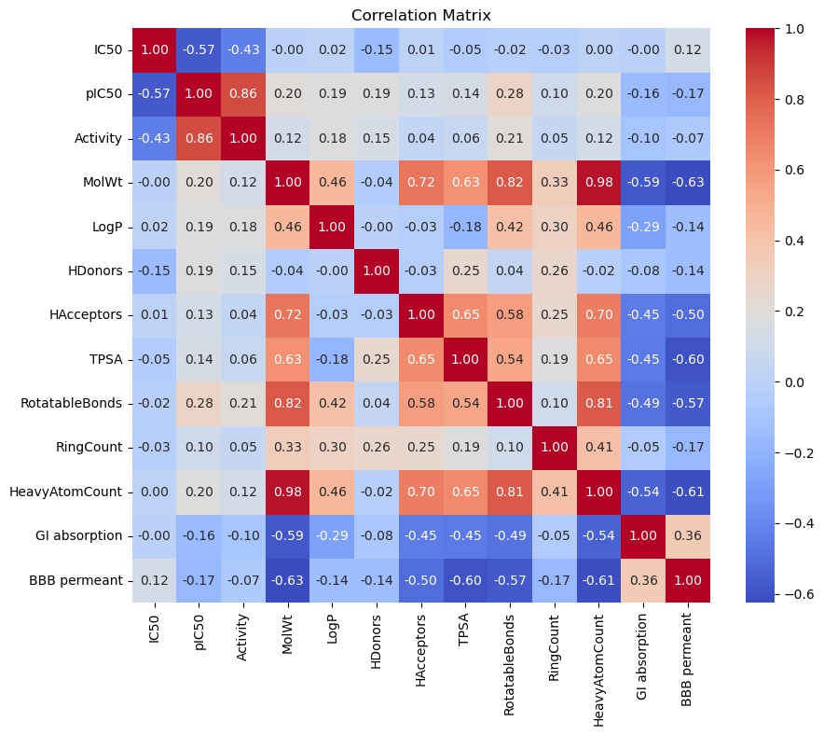
4.3 Machine Learning Model Performance

To identify the most suitable predictive model for virtual screening, four supervised machine learning algorithms were developed and evaluated using the curated ChEMBL dataset. The models included Logistic Regression (LR), k- Nearest Neighbors (KNN), Support Vector Classifier (SVC), and Extreme Gradient Boosting (XGBoost). All models were trained using the same dataset containing ten molecular descriptors and ADME properties, and their performance was evaluated on the testing dataset.

The performance of each model was assessed using accuracy, precision , recall, F1-score, and confusion matrix. These metrics provided a comprehensive evaluation of the models’ ability to correctly classify compounds as active or inactive against Interleukin-2-Inducible T-cell Kinase (ITK).

4.3.1 Performance Comparison of Machine Learning Models

The performance of the four classification models was compared to identify the most effective algorithm for predicting ITK inhibitors. Although all models demonstrated the ability to distinguish between active and inactive compounds, differences were observed in their prediction performance. Among the evaluated models, the Support Vector Classifier (SVC) achieved highest overall accuracy and demonstrated superior classification performance. Consequently, the SVM model was slected for virtual screening of compounds from the COCONUT database.

Model | Accuracy (%)
Logistic Regression | 66
K-Nearest Neighbors | 64
Support Vector Classifier | 69
XGBoost | 62

Table 4.2. Performance comparison of machine learning models.

4.3.2 Performance of the Support vector Classifier (SVC)

Among the evaluated models, the Support Vector Classifier demonstrated the best predictive performance with the accuracy of 69%. The confusion matric showed that the model correctly classified the majority of active compounds while maintaing reasonable performance for inactive compounds.

The classification reprot indicate that the model achieved a precision of 0.67, recall of 0.90, and an F1- score were 0.77 for the active class. For the inactive class, the precision, recall, and F1- score were 0.77, 0.42 and 0.55 respectively. The higher recall for the active class suggests that the model effectively identified compounds with potential inhibitory activity, which is desirable during the early stages of virtual screening where minimizing false negatives is important.

Class | Precision | Recall | F1-score
Inactive | 0.77 | 0.42 | 0.55
Active | 0.67 | 0.90 | 0.77

Overall Accuracy: 69.4%

Table 4.3. Classification report of the Support Vector Classifier

Actual / Predicted | Inactive | Active
Inactive | 34 | 46
Active | 10 | 93

Table 4.4. Confusion matrix of the Support Vector Classifier.

4.4 Virtual screening results

The trained support vector Classifier (SVC) model was employed to perform virtual screening compounds obtained from the COCONUT database. The screening dataset provided for this study had already undergone preliminary filtering, including descriptor- based filtering, Lipinski's Rule of Five, and removal of compounds containing acrylamide warheads, to improve the overall quality of drug- likeness of the compounds.

The pre-filtered dataset initially contained 17.016 compounds. During the present study, duplicate compounds were identified and removed, resulting in 12,840 unique compounds. To ensure consistency with the screening criteria, Lipinski’s Rule of Five was applied again, reducing the dataset to 5,506 compounds, which were used for subsequent activity prediction.

For each of the 5,506 compounds, the SMILES structure were processed to calculate eight molecular descriptors using the RDKit library. In addition, GI Absorption and blood- Brain barrier (BBB) Permeability were predicted using the SwissADME web server. These ten features were combined to generate the input dataset for the trained Support vector Classifier (SVC).

The trained SVC model was then used to predict the biological activity of all 5.506 compounds. Among these, 2717 compounds were predicted as active, while 2,789 compounds were predicted as inactive against ITK.

Since a large number of compounds were predicted as active, the SVC decision scores were calculated for all screened compounds to estimate the confidence of each prediction. The compounds were then ranked in descending order according their decision scores, and the top 50 compounds with the highest confidence were selected for molecular docking studies.

This integrated virtual screening strategy efficiently reduced a large natural product library to a small set of high- confidence candidate compounds for further structure- based evaluation.

Screening Step | Number of Compounds
Pre-filtered COCONUT dataset | 17,016
After duplicate removal | 12,840
After Lipinski's Rule of Five filtering | 5,506
Predicted Active (SVC) | 2,717
Predicted Inactive (SVC) | 2,789
Top compounds selected using SVC decision score | 50

4.5 Molecular Docking Results

Molecular docking was performed to evaluate the binding affinity of the selected compounds towards Interleukin-2- Inducible T-cell kinase (ITK). Docking was carried out using UCSF Chimera with the integrated AutoDock Vina docking engine. The docking scores obtained from the reference ligand, selected training compounds, and the top 50 screened compounds were compared to identify potential lead molecules.

4.5.1 Validation of the Docking Protocol

Before evaluating the screened compounds, the docking protocol was validated by docking the reference ligand into the active site of ITK (PDB ID: 4HCT). the reference ligand exhibited a binding affinity of -11.87 kcal/mol, which served as the benchmark for comparing the docking performance of the screened compounds.

The successful docking of the reference ligand confirmed that the selected docking parameters and binding site were appropriate for evaluating potential ITK inhibitors.

Ligand | Binding Affinity (kcal/mol)
Reference ligand | −11.87

4.5.2 Docking of training compounds

To further evaluate the docking protocol, the top- ranked compounds from the training dataset were docking against the ITK protein. These compounds were selected because they were experimentally reported as active and therefore served as a useful benchmark for comparison with the screened natural products.

The docking scores of the training compounds showed favourable binding affinities, supporting their reported biological activity. These results also provided a reference range for assessing the docking performance of compounds identified through virtual screening.

Smile | Docking score
CCC(CC)(C1=CC2=C(C=C1)C=C(N2)C3=NNC4=C3SC(=C4)C(F)F)O | -8.239
C=CC(=O)NC1=CC(=CC=C1)OC2=NC(=NC3=C2C(=CN3)C4=CC=NC=C4)NC5=CC=C(C=C5)N6CCOCC6 | -9.405
CC(C(C)(C)C)NCC1=CC2=C(C=C1)N(C(=N2)NC(=O)C3=CC=C(S3)C(F)F)CC4CCCN4C(=O)C=C | -9.669
C=CC(=O)N1CCCC(C1)N2C3=CC=CC=C3N=C2NC(=O)C4=CC=C(S4)C5=CNN=C5 | -9.338
CC(C)(CN1C2=C(C=C(C=C2)CNCC3=CC=CC=C3)N=C1NC(=O)C4=CC=C(S4)C5=CNN=C5)O | -9.257
CC1COCC(N1CC2=CC3=C(C=C2)N(C(=N3)NC(=O)C4=CC=C(S4)C5=CNN=C5)CC(C)(C)O)C | -8.098
CC(C)CNCC1=CC2=C(C=C1)N(C(=N2)NC(=O)C3=CC=C(S3)C4=CNN=C4)CC(C)(C)O | -8.174
CC(C)(CN1C2=C(C=C(C=C2)CN(C)CC3=CN=CC=C3)N=C1NC(=O)C4=CC=C(S4)C5=CNN=C5)O | -8.419
CC(C(C)(C)C)N(C)CC1=CC2=C(C=C1)N(C(=N2)NC(=O)C3=CC=C(S3)C4=CNN=C4)CC(C)(C)O | -8.229
CC(C)(CN1C2=C(C=C(C=C2)CNC3CCCCC3)N=C1NC(=O)C4=CC=C(S4)C5=CNN=C5)O | -8.752

Table 4.7. Docking scores of the selected training

4.5.3 Docking of the top 50 Screened Compounds

The top 50 compounds selected based on the SVC decision scores were docked against ITK to evaluate their binding affinity. Each compound generated multiple binding poses, and the pose with the lowest binding energy was selected for analysis.

The docking results demonstrated variation in binding affinity among the screened compounds, indicating differences in their predicted interactions with the ITK active site. Several Compounds exhibited binding energies comparable to those of the training compounds, suggesting their potential as candidate ITK inhibitors.

SMILES | Docking score
Cc1ccc(F)c(NC(=O)Nc2ccc(-c3cccc4[nH]nc(N)c34)cc2)c1 | -11.026
O=C(NCCc1cccc(Nc2ncnc3[nH]ccc23)c1)Nc1ccccc1 | -10.442
COCCOc1ccc(Nc2nn(C)c3nc(Nc4ccc5c(c4)CNCC5)ncc23)c(C)c1 | -10.313
O=C(Nc1ccccc1)Nc1cccc(CCNc2ncnc3[nH]ccc23)c1 | -9.675
C=CC(=O)Nc1cccc(Oc2ncnc(N)c2-c2cnn(Cc3cccc(C(=O)OC)c3)c2)c1 | -9.626
C=CC(=O)Nc1cccc(Nc2nc3c(c(Oc4ccc(OCCOC)cc4)n2)C(=O)NC3)c1 | -9.617
C=CC(=O)Nc1cccc(Nc2nc(Nc3ccc4[nH]ncc4c3)ncc2F)c1 | -9.577
C=CC(=O)Nc1cccc(-n2cnc3cnc(Nc4ccc(OCCCN5CCOCC5)cc4)nc32)c1 | -9.516
C=CC(=O)N1CCC(Nc2nccc(Nc3nc4ccc(Oc5ccccc5)nc4s3)n2)C1 | -9.501
Cc1c(N)cccc1-c1ccc(C(N)=O)c2[nH]c3cc(C(C)(C)O)ccc3c12 | -9.46
Cn1ccc(Nc2ncnc(-c3ccc(CNC(=O)c4noc(C(C)(C)CF)n4)c(C4CC4)c3)n2)n1 | -9.449
CCNC(=O)CNc1ncnc2[nH]cc(C(=O)c3ccc(Oc4ccccc4)cc3Cl)c12 | -9.315
C=CC(=O)Nc1cccc(Oc2nc(Nc3cccc(OC)c3)ncc2C(=O)NC2CC2)c1 | -9.23
C=CC(=O)Nc1cccc(-n2c(=O)c(C)nc3cnc(Nc4ccc(OCCOC)cc4)nc32)c1 | -8.974
C=CC(=O)Nc1ccccc1C1CCNc2c(C(N)=O)c(-c3ccc(OCCOC)cc3)nn21 | -8.914
O=C(O)CNc1ncnc2[nH]cc(C(=O)c3ccc(Oc4ccccc4)cc3Cl)c12 | -8.897
Cc1ccc(COc2cc(F)cc(Oc3ccc(-c4nn(CCO)c5ncnc(N)c45)cc3)c2)cn1 | -8.863
COCCOc1ccc(C(=O)c2c[nH]c3ncnc(NC4CCC(CO)OC4)c23)c(Cl)c1 | -8.845
CN(C)CC=CC(=O)N(C)CCn1nc(-c2ccc(Oc3ccccc3)cc2)c2c(N)n[nH]c(=O)c21 | -8.746
Cn1cncc1COc1cc(F)cc(Oc2ccc(-c3nn(CCO)c4ncnc(N)c34)c(F)c2)c1 | -8.623
Cc1ncc(COc2cc(F)cc(Oc3ccc(-c4nn(CCO)c5ncnc(N)c45)cc3)c2)s1 | -8.575
C=CC(=O)N1CCC(Nc2nccc(Nc3ncc(C(=O)Nc4c(C)cccc4Cl)s3)n2)C1 | -8.559
Nc1ncnc2c1c(-c1ccc(Oc3cccc(OCc4cncs4)c3)cc1)nn2C1CCCNC1 | -8.427
C=CC(=O)N1CCCC(Nc2nc(Nc3cnn(CCN(CC)CC)c3)nc3[nH]ccc23)C1 | -8.342
CN(C)CCn1nc(-c2ccc(Oc3cccc(OCc4cncs4)c3)cc2)c2c(N)ncnc21 | -8.34
CN(C)CC=CC(=O)N(C)CCn1nc(-c2ccc(Oc3ccccc3)cc2)c(C(N)=O)c1N | -7.946
C=CC(=O)N1CCCC(Nc2nc(Nc3cnn(CCN(CC)CC)c3)nc3[nH]ncc23)C1 | -7.829

4.5.4 Comparison of Docking results

The docking scores of reference ligand, training compounds, and screened compounds were compared to evaluate the effectiveness of the virtual screening approach. While the reference ligand exhibited the strongest binding affinity, several screened compounds showed favourable docking scores, indicating their potential to interact with the active site of ITK.

Category | Best Binding Affinity (kcal/mol)
Reference ligand | −11.87
Best training compound | -9.669
Best screened compound | -11.026
The combined machine learning ad molecular docking workflow effectively prioritized compounds with promising binding characteristics. These findings suggest that the selected natural products may serve as potential lead compounds for further experimental validation.

4.6 Overall Discussion

The present study demonstrated the effectiveness of integrating machine learning with molecular docking for identification of potential Interleukin-2-Inducible T-cell Kinase (ITK) inhibitors. A binary classification model was successfully developed using experimentally validated compounds obtained from the ChEMBL database. The model utilized ten features, including eight molecular descriptors calculated using RDKit and two pharmacokinetic properties predicted using SwissADME.

Among the four machine learning algorithms evaluated, the Support Vector Classifier (SVC) achieved the best overall performance with an accuracy of 69%. The model showed a high recall for the active class, indicating its ability to identify compounds with potential ITK inhibitory activity. This is particularly important in virtual screening, where minimizing false negatives increases the likelihood of identifying promising lead compounds.

The trained SVC model was subsequently applied to screen compounds from the COCONUT natural product database. Beginning with 17,016 compounds, successive preprocessing and filtering steps reduced the dataset to 5,506 drug- like compounds suitable for prediction. The model classified 2,717 compounds as active and 2,789 compounds as inactive. By ranking compounds according to their SVC decision scores, the top 50 high- confidence candidates were selected for molecular docking.

Docking studies further evaluated the interaction of the selected compounds with the ITK protein (PDB ID: 4HCT). The reference ligand produced the strongest binding affinity and served as a benchmark for comparison. Several screening compounds also exhibited favourable docking scores, suggesting their potential to interact with the active site of ITK. The combination of machine learning- based prioritization and molecular docking significantly reduced the number of compounds requiring detailed structural analysis while retaining compounds with promising binding potential.

Overall, the integrated computational workflow proved to be an efficient strategy for early- stage drug discovery. By combining ligand- based predication with structure- based validation, the study enabled the rapid identification of potential ITK inhibitors from a large natural product library. Although the identified compounds require further validation through molecular dynamics simulations and experimental studies, the finding demonstrate the usefulness of computational approaches in accelerating the discovery of novel therapeutic candidates.

- Conclusion and Future Scope

  - Conclusion

The present study successfully demonstrated the application of an integrated computational approach for the identification of potential Interleukin-2-Inducible T-cell Kinase (ITK) inhibitors. A machine learning model was developed using experimentally validated compounds obtained from the ChEMBL database. Molecular descriptors calculated using RDKit and ADME properties predicted using SwissADME were utilized as input features for model development.

Among the four machine learning algorithms evaluated, the Support Vector Classifier (SVC) achieved the best predictive performance and was selected for virtual screening of compounds from the COCONUT database. The screening workflow, which included duplicate removal, Lipinski's Rule of Five filtering, and prediction using the trained SVC model, effectively reduced a large natural product dataset to a small number of high- confidence candidate compounds.

The selected compounds were further evaluated through molecular docking against the ITK protein (PDB ID: 4HCT) using UCSF Chimera with the integrated AutoDock Vina docking engine. Several compounds demonstrated favourable binding affinities, indicating their potential as ITK inhibitors.

Overall, the integration of machine learning and molecular docking provided an efficient strategy for prioritizing potential lead compounds while reducing the time and computational effort required for screening large chemical libraries. The findings of this study demonstrate the usefulness of computational approaches in supporting the early stages of computation approaches in supporting the early stages of drug discovery and provide a foundation for further experimental investigation of the identified compounds.
  - Limitations of the Study

Although the computational workflow successfully identified promising candidate compounds, the study has certain limitations. The machine learning models were developed using a limited set of molecular descriptors and ADME properties, and their predictive performance depends on the quality and diversity of the training dataset. Therefore, the developed model may not accurately predict the activity of all chemical scaffolds.

Molecular docking provides an estimate of protein- ligand binding affinity under static conditions and does not account for protein flexibility, solvent effects, or the dynamic nature of molecular interactions. Consequently, docking scores alone cannot confirm the biological activity of the screened compounds.

Furthermore, the findings of this study are based entirely on computational analyses. Experimental validation through in vitro and in vivo studies is necessary to confirm the biological activity, safety, and therapeutic potential of the identified compounds.

  - Future Scope

The present study provides a foundation for the discovery of novel ITK inhibitors and offers several opportunities for further research. The identified lead compounds can be further evaluated using molecular dynamics (MD) simulations to investigate the stability of the protein- ligand complexes and to better understand their binding behaviour over time.

Further studies may also incorporate additional molecular descriptors, larger and more diverse datasets, and advanced machine learning or deep learning techniques to improve prediction accuracy. Experimental validation of the top- ranked compounds through biochemical assays and cell- based studies will be essential to confirm their inhibitory activity against ITK.

In addition, structure- activity relationship (SAR) studies and lead optimization can be performed to improve the potency, selectivity, and pharmacokinetic properties of the identified compounds. Such investigations may contribute to the development of effective therapeutic agents for diseases in which ITK plays a significant role.

