Structure-Based Identification of Phytochemical Inhibitors Targeting PfPGM1 in Plasmodium falciparum Using Molecular Docking and Molecular Dynamics Simulation

VIII Semester Project Report Submitted in Partial Fulfillment for the Degree of
B.Tech & M. Tech in Biotechnology

Submitted By
Sravani P

School of Biotechnology
KIIT Deemed to be University
Bhubaneswar, Odisha, India

Under the Supervision of
Dr. Rajni Kanta Mahapatra

Abstract

Malaria can be treated, prevented and diagnosed but however, there are more than 200million cases of preventable deaths, it being a life-threatening disease mostly found in tropical countries.Plasmodium falciparum being the deadliest malaria parasite (World Health organization,2025). Antimalarial drug resistance being a very challenging problem now a days in treatments. This study investigates Phosphoglycerate Mutase from P.falciparum (PfPGM1), a metabolic enzyme for parasite energy production. The main objective of the study is to identify if it is a potential drug target for phytochemical- based inhibition using structure-based molecular docking and MD simulation.

Given the absence of experimentally determined active site data for 1XQ9, a computational approach was used to identify the best binding pockets. A BLASTp was conducted for sequence homology analysis which identified 4ODI with 75% sequence identity as a structurally informative reference. By integrating structural visualization tools like PyMOL, UCSF Chimera, and Schrodinger SiteMap, seven residues were identified as residues forming the binding cavity: Arg18, His19, Asn25, Thr31, Tyr100, His192 and Asn194. A library of 58 phytochemicals was screened against PGM1 through AutoDock Vina-based molecular docking. The ten highest- scoring candidates were assessed for pharmacokinetic and drug-likeness profiles using SwissADME, and the lead compound underwent a 10ns Molecular Dynamics (MD) simulation in GROMACS to evaluate binding stability over time.

Among all screened compounds, AD53 (tectograndone) had the best binding affinity (-10.68 kcal/mol), and also demonstrated superior overall drug-likeness, with high GI absorption, passes all Lipinski criteria, and a good synthetic accessibility score (3.74). The 10 ns MD simulation confirmed that AD53 maintained a stable binding pose within the active site of PfPGM1 throughout the trajectory, with consistent hydrogen bonding, a stable protein backbone RMSD (~0.12-0.15 nm), and a conserved radius of gyration (~1.84 nm), collectively validating AD53 as a promising lead candidate for further experimental investigation.

Keywords: Malaria, Plasmodium falciparum, PfPGM1, molecular docking, AutoDock Vina, SwissADME, phytochemicals, GROMACS, drug discovery

1. INTRODUCTION

  - The Target Protein: PfPGM1

The selected protein for this study is Phosphoglycerate Mutase (PGM1), an essential enzyme involved in the glycolytic pathway of the malaria parasite Plasmodium Falciparum. This enzyme plays a key role in ATP generation, which is critical for the parasite’s survival and proliferation. Inhibition of this protein can disrupt the parasite’s energy metabolism, ultimately leading to its death.
The three-dimensional structure of PfPGM1 from PDB with PDB ID: 1XQ9 was determined using X-ray crystallography at a resolution of 2.58Å.Structurally, the protein exists as a tetramer, which consists of four identical subunits that function together as a single unit.
PfPGM1 is considered a promising drug target due to its structural differences from the human counterpart. These differences allow the development of selective inhibitors that specifically target the parasite enzyme while reducing potential side effects in humans.

  - Why Phytochemicals?

Phytochemicals are naturally occurring bioactive compounds derived from plants, many of which have or possess antimicrobial and antiparasitic properties (Plants,202;Malaria Journal,2015). Compared to the synthetic drugs, these compounds are often associated with improved biocompatibility and reduced toxicity (Newman & Cragg, 2016). The structural diversity of phytochemicals makes them valuable candidates in drug discovery, providing a rich source of potential lead compounds (Harvey,2008). Furthermore, computational screening of these compounds enables rapid identification of potential inhibitors, significantly reducing the time,cost and effort associated with experimental approaches.

  - Literature review

Malaria caused by Plasmodium falciparum remains a major global health problem, with over 600,000 deaths reported annually. The situation has been made worse by the parasite developing resistance to drugs, making it necessary to identify new drug targets and find better treatment options (ashley et al., 2014; Dondorp et al., 2009)
P.falciparum relies entirely on glycolysis to produce energy during its blood- stage infection, unlike human cells which have alternative energy pathways. This makes glycolytic enzymes attractive drug targets, since blocking them would cut off the parasite’s energy supply without significantly harming the host (Tiwari et al.,2015). Zhang et al. (2018) confirmed through genome- wide studies that glycolytic genes including pfpgm1 are essential for parasite survival, further validating this approach.
PfPGM1 is one such glycolytic enzyme, and its crystal structure reveals a homo- tetrameric assembly. Dzierszinski et al. (2022) showed that disrupting this tetrameric form significantly reduces enzymatic activity, while structural comparisons with the human homologue have revealed differences in the active site that could allow selective inhibition (Blacklow et al., 1995). Joseph et al. (2018) characterised the active site of the closely related protein 4ODI identifying eight conserved catalytic residues that served as the reference for active site mapping in this study.
Plant derived compounds have long been a source of antimalarial drug leads, from quinine to artemisinin (Kaur et al., 2009). Several phytochemical classes including anthraquinones and flavonoids have shown promising activity against blood-stage P.falciparum (Osman et al.,2018). computational screening of phytochemical libraries has been validated as an efficient and cost-effective approach for early- stage drug discovery. Sarangi and Mahapatra (2025a, 2025b) demonstrated this effectively by identifying potent phytochemical leads against PfPI4K and PfPK6 using structure- based virtual screening.
For the computational work, AutoDock Vina was used for molecular docking (Trott and Olson, 2010), SwissADME for pharmacokinetic and drug-likeness evaluation (Daina et al., 2017), and GROMACS with the CHARMM36 force field for molecular dynamics simulation
(Abraham et al., 2015; Huang and MacKerell, 2013). These tools together form a well-validated in silico pipeline for identifying and characterizing potential drug candidates against parasitic targets.

  - Objectives

The primary objectives of this study are as follows:
- To identify the active site residues of PfPGM1 (1XQ9) using a homology- based computational approach.
- To perform virtual screening of selected phytochemicals using AutoDock Vina in order to identify potential inhibitors.
- To assess the top 10 compounds for drug- likeness and pharmacokinetic proerties using SwissADME.
- To conduct a 10 ns MD simulation to evaluate the stability of the most promising protein-ligand complex.

2. Methodology

2.1 Identifying the Active Site of PfPGM1
Step 1: Finding the Target Protein
The 3D structure of PfPGM1 (PDB ID: 1XQ9) was obtained from the RCSB Protein Data Bank (www.rcsb.org). This structure was determined through X-ray crystallography at 2.58 A. The protein is organized as a homotetramer, consisting of four identical subunits.
Step 2: BLASTp Search for a Reference Protein
Since no experimentally validated active site information was available for 1XQ9, a BLASTp search was performed against the NCBI database to identify structurally similar proteins. Among the result, 3KKK showed very high sequence similarity (99% identity, but no literature) and on the other hand 4ODI showed 75% identity, with published active site details (Joseph et al., 2018). Based on the availability of functional data, 4ODi was selected as the reference protein for further analysis.
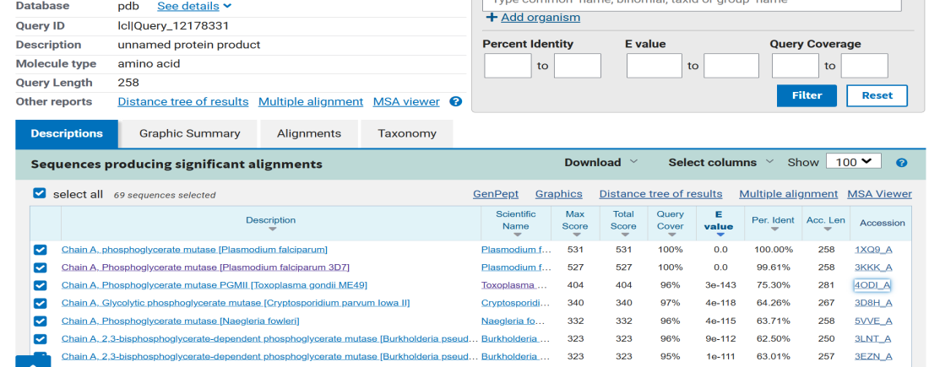

Figure 1: BLASTp results showing sequence homologs of 1XQ9. 4ODI (75% identity) was selected as the reference protein.

Step 3: Protein Preparation in PyMOL
Both 1XQ9 and 4ODI structures were prepared using PyMOL. For 1XQ9, Only Chain A was retained, while Chain B was removed. Similarly for 4ODI, Chains B, C, and D were deleted, leaving Chain A for consistency. All water molecules and non-essential atoms were removed, and hydrogen atoms were added to stabilize the structures for subsequent steps.
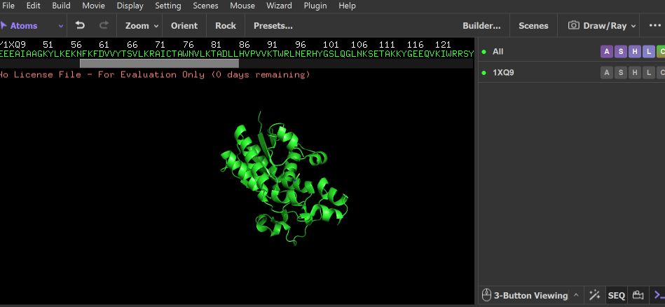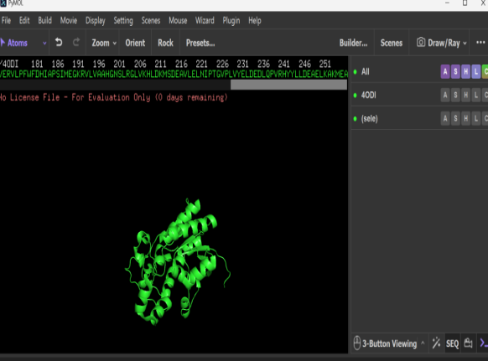
Figure 2: (a) 1XQ9 (Chain A only) loaded and prepared in PyMOL. (b) 4ODI (Chain A only) loaded and prepared in PyMOL.
Step 4: Active Site Prediction using Schrodinger SiteMap
The prepared structure of 1XQ9 was analyzed using the SiteMap tool from the Schrodinger suite to identify potential ligand-binding pockets. Each predicted site was evaluated based on parameters such as Site Score and Druggability Score (Dscore), where values above 1.0 generally indicate favourable binding regions. Among the predicted sites, the pocket labeled sitemap_2_site_1 showed the highest suitability, with a Site Score of 1.07 and a Dscore of 0.902. This pocket was selected for further investigation.

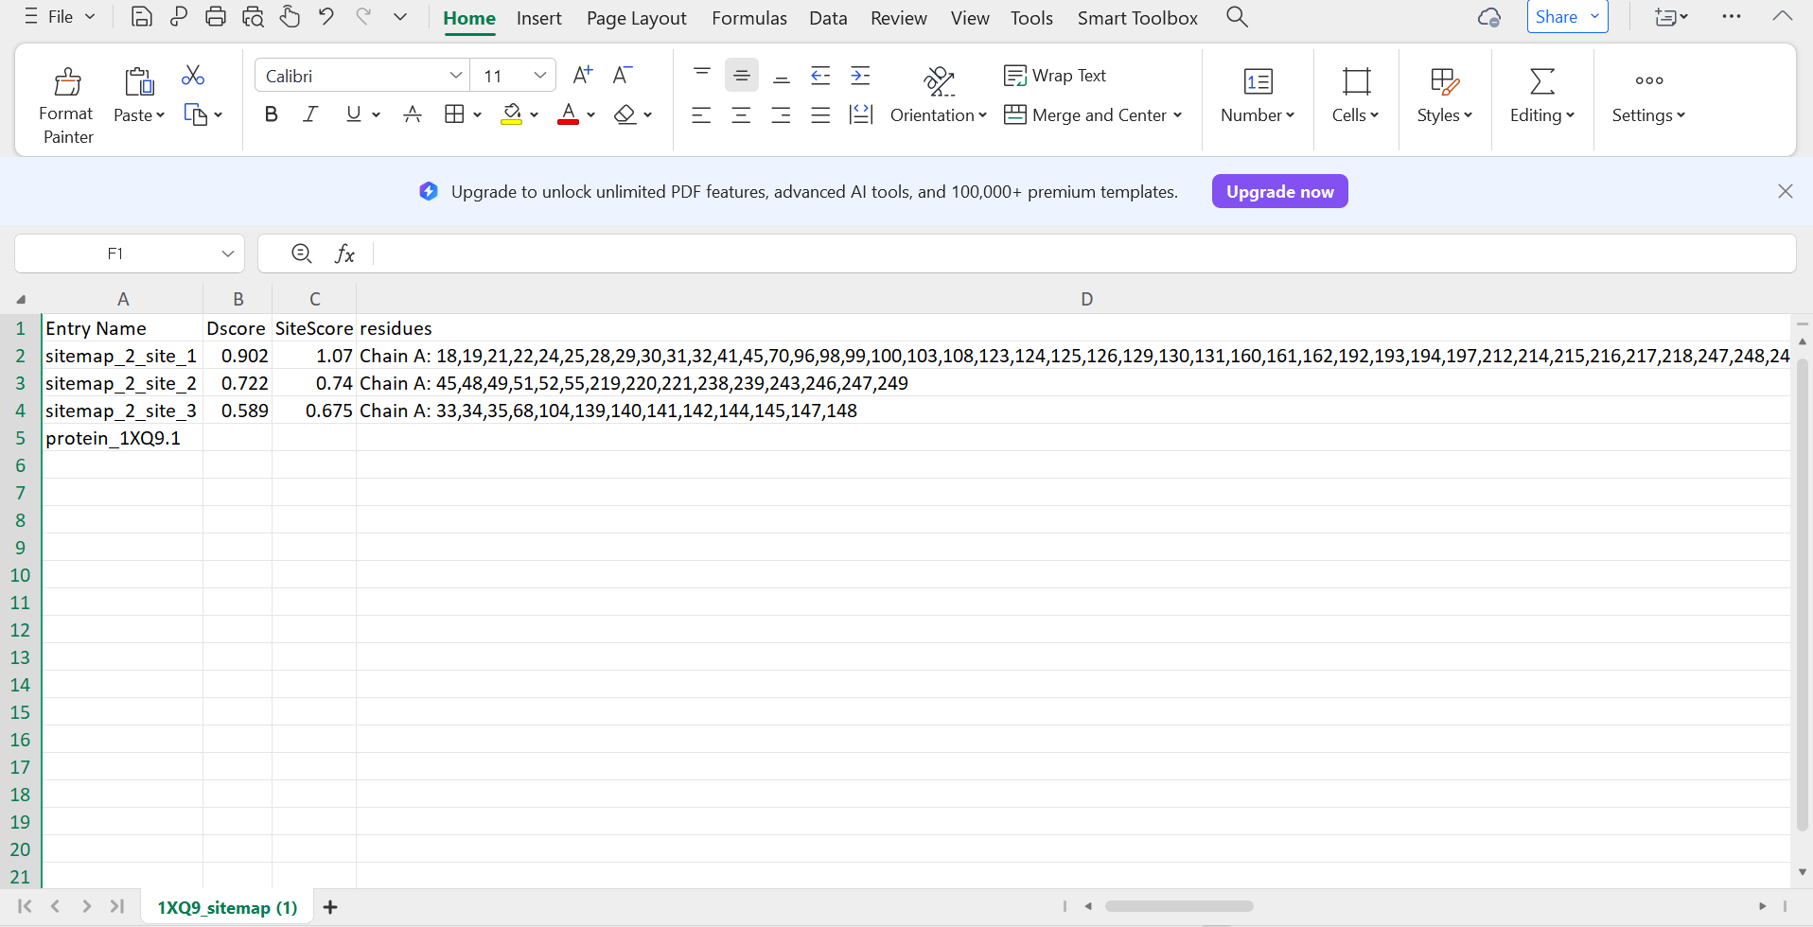
Figure 3: SiteMap results for 1XQ9 showing three predicted pockets. Site 1 (score 1.07) was selected as the best binding site.
Step 5: Structural Alignment using UCSF Chimera
To transfer active site information, structural alignment between 1XQ9 and 4ODI was carried out using the MatchMaker tool in UCSF Chimera. The known active site residues of 4ODI (R25, H26, N32, T38, E104, Y107, H199, N201) were mapped onto the aligned positions in 1XQ9. The corresponding residues identified in 1XQ9 were Arg18, His19, Asn25, Thr31, Glu97, Tyr100, His192, and Asn194.
Further validation using SiteMap revealed that seven out of these eight residues were located within the predicted binding pocket, while Glu97 was not part of the selected site. Based on this combined analysis, the final set of active site residues for 1XQ9 was identified as: Arg18, His19, Asn25, Thr31, Tyr100, His192 and Asn194.
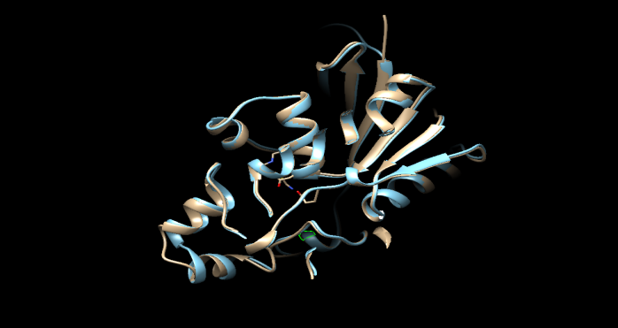
Figure 4: Structural alignment of 1XQ9 (blue) and 4ODI (tan) in UCSF Chimera showing conserved fold.
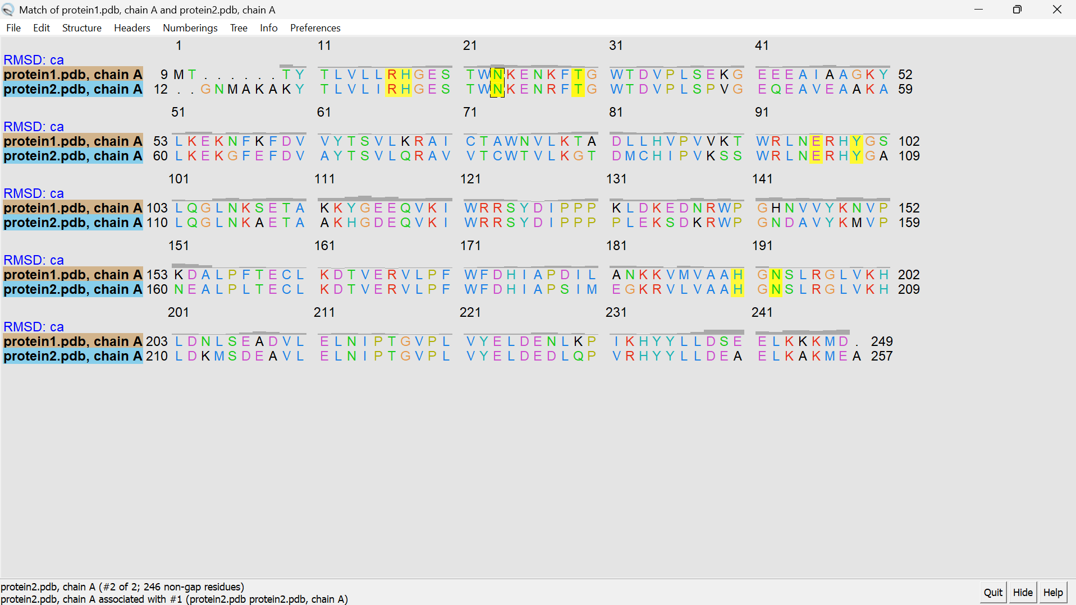
Figure 5: Sequence alignment output from UCSF Chimera showing conserved residues between 1XQ9 and 4ODI.

2.2 Molecular Docking (AutoDock Vina)

Step1: Ligand and Receptor Preparation
A set of 58 phytochemical compounds was collected from a previously published study. The three- dimensional structures of these compounds were converted into PDBQT format using AutoDock Tools. During this process, hydrogen atoms were added, and Gasteiger charges were assigned to ensure docking compatibility.

The protein structure was also prepared in a similar manner. Water molecules were removed, polar hydrogens were added, and the structure was saved in PDBQT format for docking.

Step2: Grid Box and Docking
A docking grid box was defined around the predicted active site residues of the protein to restrict the docking search space. Molecular docking was then carried out using AutoDock Vina with an exhaustiveness value of 8 to ensure adequate sampling.

Each ligand was docked individually, and the resulting complexes were ranked based on their binding affinity values (expressed in kcal/ mol). the top 10 compounds with the most favourable binding scores were selected for further evaluation

The interactions between the protein and ligand, including hydrogen bonds and key residue contacts, were examined and visualized using PyMOL.

2.3 Drug-likeness evaluation (Swiss ADME)

The SMILES representation of the selected top 10 compounds were analyzed using the Swiss ADME web tool. Several pharmacokinetics and Phytochemical properties were assessed, including molecular weight, lipophilicity (LogP), hydrogen bond donors and acceptors, and topological polar surface area (TPSA).

Additional parameters such as gastrointestinal absorption, Lipinski's Rule of Five compliance, synthetic accessibility score, solubility and PAINS alerts were also considered. Based on these criteria, the compounds were compared and ranked accoridng to their suitability as potential drug candidates.

2.4 Molecular Dynamics simulation (GROMACS)

System setup and equilibration
The protein-ligand complex formed between PfPGM1 and the best-performing compounds (AD53) was selected for molecular dynamics simulation. The CHARMM27 force field was applied to the protein, while ligand parameters were generated using Swiss Param server.

The complex was then placed in a cubic simulation cubic box filled with TIP3P water molecules, maintaining a padding distance of 1.0nm from the protein surface. To mimics physiological conditions, the systems was neutralized and supplemented with Na+ and Cl- ions at a concentration of 0.15M.

Energy Minimization was performed using the steepest descent algorithm until the system reached a stable state, with forces reduced below 1000 kJ/mol/nm. Following this, equilibration was carried out in two stages. First, an NVT ensemble was run for 10000ps at 300K using a v-rescale thermostat. This was followed by an NPT conditions. The system coordinates were recorded at intervals of 10ps for further analysis.

Trajectory Analysis
The simulation trajectory was analyzed using various parameters to evaluate the stability and behaviour of the protein- ligand complex:
- Total Energy (gmx energy)- used to monitor the overall stability of the system throughout the simulation.
- RMSD (gmx rms)- Root Mean square Deviation, assessed structural deviations of the protein backbone and ligand over time relative to the initial structure.
- RMSF (gmx rmsf)- Root Mean Square Fluctuation, measured residue- level flexibility to identify dynamic regions within the protein.
- Radius of Gyration (gmx gyrate)- evaluated the compactness and folding stability of the protein structure.
- Hydrogen Bonds (gmx hbond)- tracked the number and persistence of the hydrogen bonds between the protein and ligand during this simulation.
- Visualization of H-bonds: PyMOL was used to compare hydrogen bond interactions at the beginning (0ns) and end (10ns) of the simulation.
- Ligand pose alignment- the ligand conformations at 0ns and 10ns were superimposed to observe any positional or conformational changes during the simulation.

3. Results and Discussion

3.1 Active Site Residues of PfPGM1
Through a homology-based analysis, seven probable active site residues were identified in PfPGM1 (1XQ9): Arg18, His19, Asn25, Thr31, Tyr100, His192, and Asn194. These residues were determined by combining structural alignment with the reference protein 4ODI and SiteMap pocket prediction (Site Score = 1.07, Dscore = 0.902). Although Glu97 was initially mapped from the reference protein, it was not located within the predicted binding pocket and was therefore excluded from the final set. The identified residues collectively form a ell-defined with favorable drug-binding characteristics.This pocket is consistent with the catalytic features typically observed in cofactor- independent Phosphoglycerate mutases, particularly those involving histidine- mediated mechanisms.
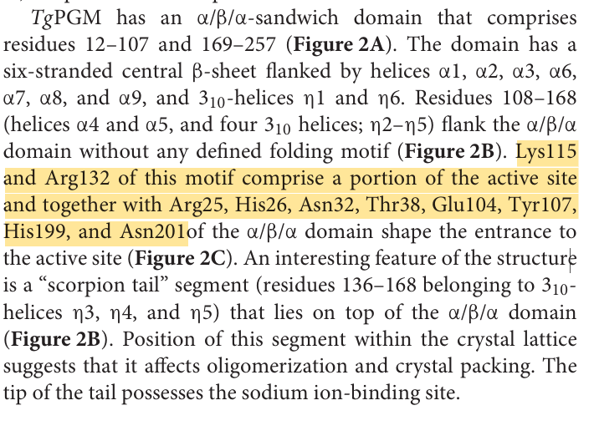
Figure 6: Published active site residues from the reference protein 4ODI (Joseph et al., 2018) used in this study.

3.2 AutoDock Vina- Molecular Docking Results

Following the docking of a phytochemical library with 64 compounds against the predicted active site, the top 10 candidates were selected based on their binding affinity scores.
Compound | Name | Dock Score | PyMOL 3D | Hydrogen Bonding
AD53 | Tectograndone | -10.68 | 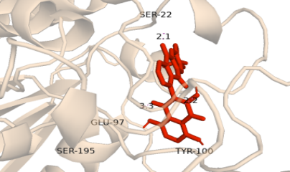 | 22,97,100,195
AD32 | scutianthraquinone D | -10.12 | 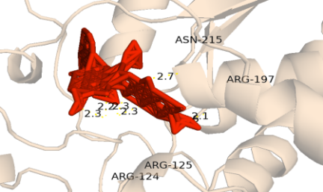 | 124,125,197,215
AD54 | acetyltectograndone | -10.01 | 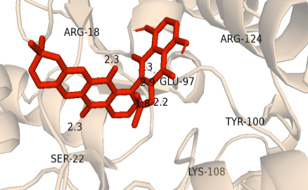 | 18,22,97,100,108,124
AD49 | Microcarpine | -9.542 | 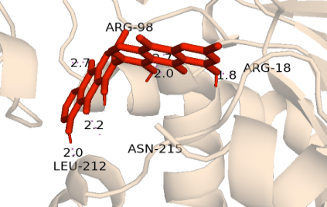 | 18,98,212,215
AD27 | Aloin | -9.371 | 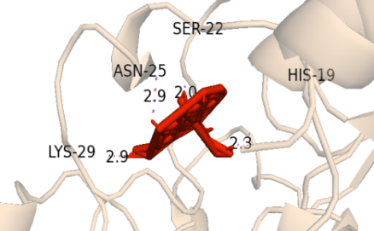 | 19,22,25,29
AD31 | Scutianthraquinone C | -9.277 | 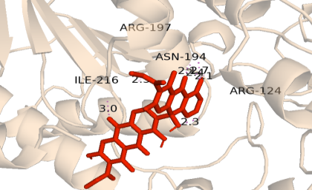 | 124,194,197,216
AD43 | Chryslandicin | -9.137 | 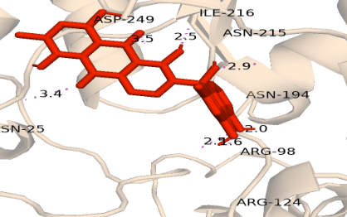 | 25,98,124,194,215,216,249
AD39 | joziknipholones A | -8.924 | 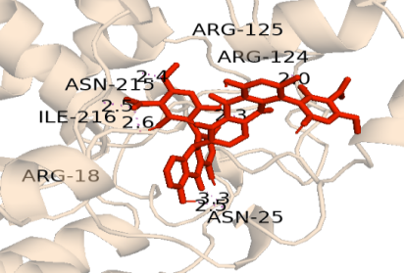 | 18,25,124,125,215,216
AD7 | daunorubicin | -8.763 | 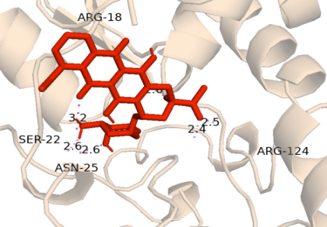 | 18,22,25,124
AD5 | Doxorubicin | -8.629 | 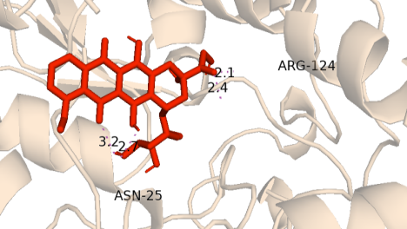 | 25,124

Table 1: Top 10 phytochemicals ranked by AutoDock Vina binding affinity against PfPGM1 (1XQ9).

Among all screened compounds, AD53 (Tectograndone ) showed the strongest binding affinity with PGM1 (1XQ9) with a score of -10.68 kcal/mol. It formed hydrogen bonds interactions with SER-22, GLU-97, TYR-100, SER-195 of which TYR-100 is part of the identified active site. Other compounds such as AD32 and AD54 also exhibited strong binding affinity, with affinities of -10.12 kcal/mol and -10.01kcal/mol, respectively. In addition, AD54 notably formed the highest number of hydrogen bonds among all compounds. AD54, AD49, AD39 and AD7 showed interaction with ARG-18, which is known to play a significant role in catalysis, indicating their potential to interfere with enzyme activity. Overall, compounds with more negative binding affinity values were considered to have a stronger and more favourable interactions with the protein, making them promising candidates for future analysis.

3.3 SwissADME - Drug-Likeness Results

The top 10 docked compounds were submitted to SwissADME for pharmacokinetic and drug-likeness evaluation. The parameters assessed including molecular weight, hydrogen acceptors and donors, TPSA, Gi absorption, Lipinski Rule of Five violations, solubility, PAINS alerts, Brenk alerts, lead-likeness, and synthetic accessibility score. The key findings are summarized below

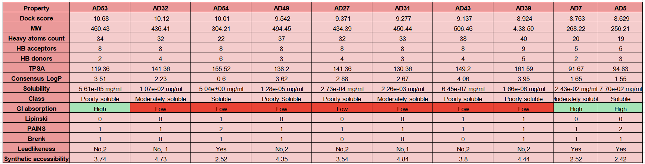
Table 2: SwissADME analysis of the top 10 phytochemicals after docking.

- Molecular Weight: AD5 (256.21 g/mol), AD7 (268.22 g/mol), AD54 (304.21 g/mol), AD27 (434.39 g/mol), AD32(436.41 g/mol), AD39 (438.5 g/mol), AD31 (450.44 g/mol), and AD53 (460.43 g/mol), AD49(494.45 g/mol) all fall within the acceptable limit of 500Da. AD43 (506.46 g/mol) slightly exceeds the threshold.
- HB Donors and Acceptors: Lipinski’s rule requires HB donors ≦5 and HB acceptors ≦10. All compounds satisfy the acceptor limit. AD54 had the highest donor count at 6, which exceeds the limit. AD39 had 5 donors. All the other compounds were within the acceptable ranges.
- TPSA: A TPSA below 140Å² is associated with good oral absorption. AD53, AD49, AD7 and AD5 are within this limit. AD32, AD27, AD43, AD54 and AD39 exceed the limit indicating reduced oral permeability.
- GI absorption- Only AD53, AD7, and AD5 showed High GI absorption which is a critical requirement for oral drug candidates. All remaining compounds showed low GI absorption, limiting their oral bioavailability.
- Lipinski Violations: AD53, AD32, AD49, AD27,AD31, AD7, and AD5 has zero Lipinski violations which fully compliant with oral drug-likeness criteria. AD54, AD43, and AD39 each had one violation, which is generally considered acceptable.
- Solubility: AD5 was the best performer, classified as soluble, followed closely by AD54 and AD7 with moderately soluble. AD53, AD49,AD27, AD43 and AD39 are classified poorly soluble.
- PAINS Alerts: AD54 and AD5 each flagged 2 alerts, which requires careful experimental follow- up as these substructures may interfere with biochemical assays. All other compounds flagged 1 PAINS alert each which is present but not disqualifying.
- Brenk Alerts: AD32, AD31 and AD43 showed 0 brenk alerts, indicating no structurally problematic groups. AD53, AD54, AD49, AD7 and AD5 each had 1 Brenk alert. AD27 and AD39 also flagged alerts, requiring structural scrutiny.
- Lead-Likeness: AD54, AD7 and AD5 were classified as “yes” for lead-likeness, making them the most suitable starting points for further drug optimisation. All other compounds showed 1 or 2 lead-likeness violations.
- Synthetic accessibility: AD5 scored the best at 2.42, followed by AD54 and AD7, indicating they are straightforward to synthesis. AD53 and AD27 have moderate accessibility. AD32, AD49, AD39, AD31 are more complex to synthesis.
- Consensus LogP: All compounds fell within the acceptable range of 0.5. AD54 and AD5 had the lowest LogP values, indicating better water solubility and lower lipophilicity, which is generally favourable for drug development.

Based on a combined evaluation of all parameters, AD53 emerged as the most promising candidate. It demonstrated a well- balanced profile, including zero Lipinski Violation, High GI absorption, a low synthetic accessibility score, suitable molecular weight, favourable TPSA.

3.4 Molecular Dynamics Simulation Results

The MD simulation was run for 10 ns on the AD53-PfPGM1 complex to evaluate how the system behaves over time under conditions that mimic the human body. The results are presented in the following order: RMSD, RMSF, Hydrogen Bonds, Ligand Pose Comparison, Radius of Gyration, and Total Energy.

3.4.1 RMSD (Root Mean Square Deviation)

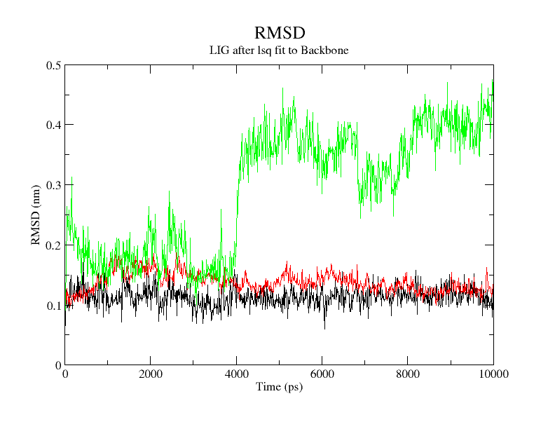
Ligand
Backbone
Complex
Figure 7: RMSD of ligand (black), protein backbone (red), and complex (green) over 10 ns.
The root mean square deviation (RMSD) plot was used to evaluate the structural stability of the complex over a 10ns molecular dynamics simulation. RMSD measures the deviation of atomic positions from the initial structure, providing insight into system equilibration and stability.

The Protein backbone RMSD- remains stable throughout the simulation fluctuating around ~0.12- 0.15 nm.These small and consistent deviations indicate that the protein maintains its structural integrity. N major conformational changes are observed, suggesting that the protein is well equilibrated and structurally stable.

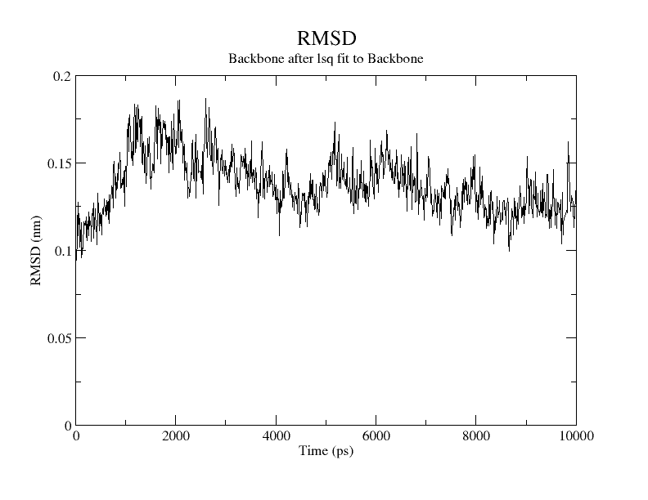
Figure 8: RMSD of protein backbone over 10 ns.

Ligand RMSD- The ligand RMSD remains low (~0.10 -0.13) with minor fluctuation, indicating that the ligand remains consistently bound within the binding pocket. The absence of large spikes suggests that the ligand does not diffuse away or undergo major conformational changes.

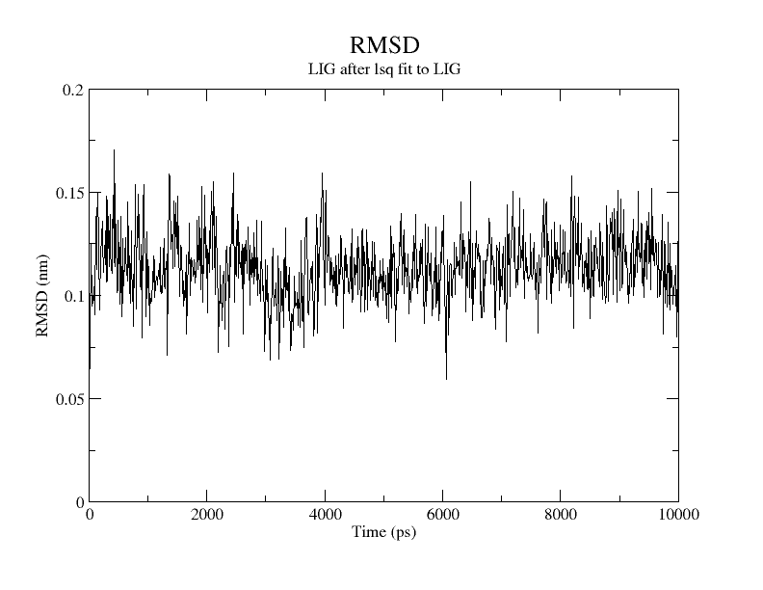
Figure 9: RMSD of ligand over 10 ns.

Complex RMSD- Initially (0-4000 ps), the RMSD is relatively low (~0.15 -0.20nm), indicating early stability. Around ~4000ps, a noticeable increase occurs rising to ~0.35 -0.45nm. After this shift, the RMSD stabilizes again with moderate fluctuations.
The increase suggests a conformational adjustment or rearrangement in the complex. This could be due to Ligand-induced structural adaption and optimization of interactions within the binding pocket. The later stabilization indicates that the system reaches a new equilibrium state.

3.4.2 RMSF (Root Mean Square Fluctuation)

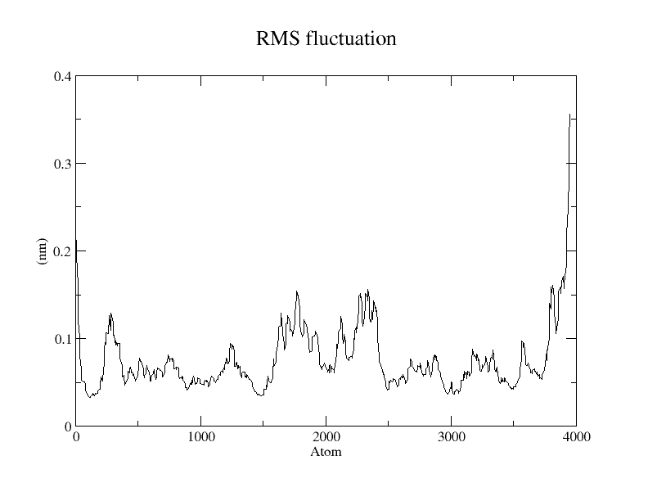
Figure 10: RMSF per atom showing flexibility of different regions of PfPGM1 during the simulation.
Root Mean square Fluctuation (RMSF) measures the flexibility of individual residues (or atoms) in the protein over the course of the simulation. It helps identify stable regions vs flexible regions within the protein structure.
The Low RMSF are the stable regions where a large portions of the protein exhibit RMSF values around ~0.05 -0.08nm, these low fluctuations indicate that the protein core remains stable and well-folded during the simulation. These regions are likely: α- helices and β- sheets
The moderately flexible regions with around ~1500-2300 show RMSF values of ~0.10- 0.15nm. These correspond to loop regions and consists of surface- exposed residues. These flexibility is normal and often important for protein function and ligand interaction.
The High RMSF or the major peaks show high flexible regions where a significant spike is observed near ~3800 -4000 atoms, reaching ~0.30- 0.35nm. They represent the C-terminal regions or highly exposed loop regions. These terminal regions are flexible due to the lack of structural constraints.

3.4.3 Hydrogen Bond Analysis
We tracked hydrogen bonds in two ways: (1) as a plot over the entire 10ns simulation and (2) by visually comparing the H-bond interactions at the very start (0ns) and the very end (10ns) of the simulation using PyMOL.

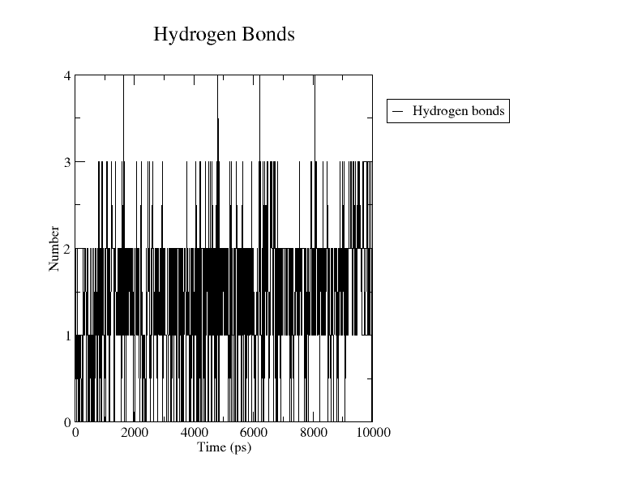

Figure 11: Number of hydrogen bonds between AD53 and PfPGM1 over the full 10 ns simulation.

Hydrogen Bonds are critical for stabilizing protein-ligand interactions. The number of hydrogen bonds formed over time provides insight into the strength and stability of ligand binding during the molecular dynamics simulation.

At 0 ns (Start of Simulation)  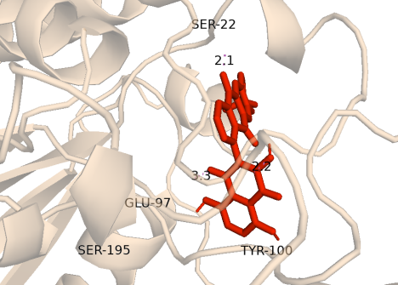  4 bonds- SER-22, GLU-97, TYR-100, SER-195 | At 10 ns (End of Simulation)  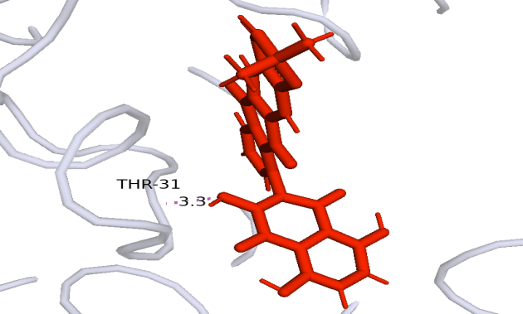  1 bond- THR-31

Figure 12: Visual comparison of AD53 hydrogen bond interactions at 0 ns (left) and 10 ns (right) in PyMOL.
Hydrogen bond analysis at the beginning of the simulation (0ns) shows that the ligand forms four hydrogen bonds with residue SER-22, GLU-97, TYR-100, SER-195 representing the initial docking interaction. However, by the end of the 10ns simulation, the hydrogen bonding interaction shifts to only one residue THR-31.
At 0ns (start of simulation)-
- The ligand forms 4 hydrogen bonds with SER-22, GLU-97, TYR-100 and SER-195
- This represents the initial docking pose
- Interactions are based on docking predictions and are not yet dynamically optimized.

At 10ns (End of simulation)
- The ligand forms 1 hydrogen bond with THR-31
- The ligand has undergone conformational adjustment
- It has found a more energetically favourable interaction site
- THR-31 may provide better geometry, and stronger or more stable interaction

3.4.4 Ligand Pose Comparison (0ns vs 10ns)

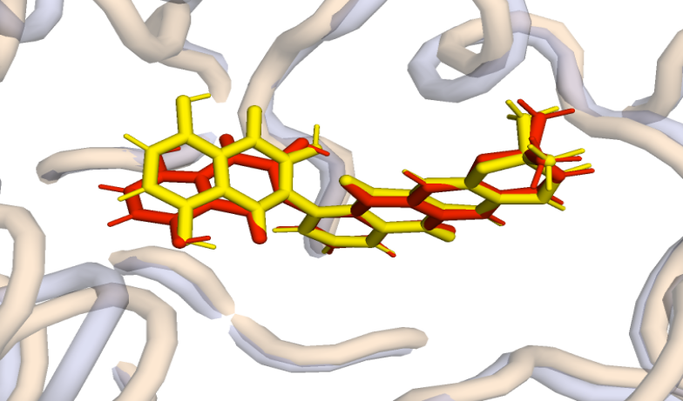
Figure 13: Overlay of AD53 ligand pose at 0 ns (yellow) and 10 ns (red) aligned against protein structures (wheat = 0ns protein, lightblue = 10ns protein).

This image shows the ligand AD53 before and after the 10 ns MD simulation. The yellow pose (0 ns) and red pose (10 ns) overlap almost completely, meaning the ligand stayed in the same position throughout the simulation without drifting away from the binding site. Only a small shift is visible at the terminal end of the ligand, which is due to normal thermal motion and is consistent with the minor change in hydrogen bonding partner from SER-22 to THR-31 discussed above.
The two protein structures also overlap well, confirming that the protein itself remained structurally stable and did not undergo any major conformational change. Overall, this image provides strong visual confirmation that AD53 maintained a stable binding pose inside the active site of PfPGM1 for the entire simulation, supporting its potential as a reliable drug candidate worthy of further experimental investigation.

3.4.5 Radius of Gyration
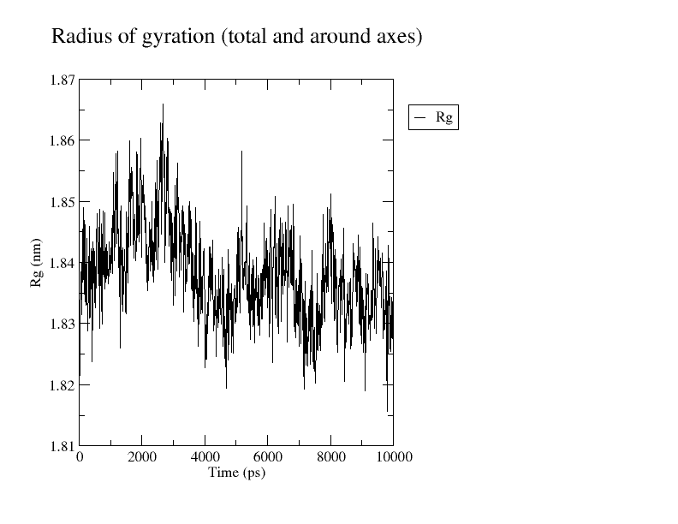
Figure 14: Radius of gyration (Rg) of PfPGM1 over 10 ns, showing stable protein compactness.
The radius of gyration (Rg) was calculated throughout the simulation to assess whether the protein maintained its overall compactness and folded state. As seen in the figure, the Rg values fluctuated within a narrow range of ~1.82 to 1.87nm, with the majority of values centred around 1.84nm for the entire 10000ps trajectory.
No systematic increase or decrease in Rg was observed, meaning the protein neither expanded nor collapsed at any stage of the simulation. This consistent compactness confirms that PfPGM1 retained its native folded structure throughout the simulation and did not undergo any unfolding or large- scale domain movement. The small fluctuations visible in the plot are simply a reflection of normal thermal motion at physiological temperature and do not indicate any structural instability. This result is fully consistent with the backbone RMSD data, together confirming that the protein remained structurally stable from start to finish.

3.4.6 Total System Energy
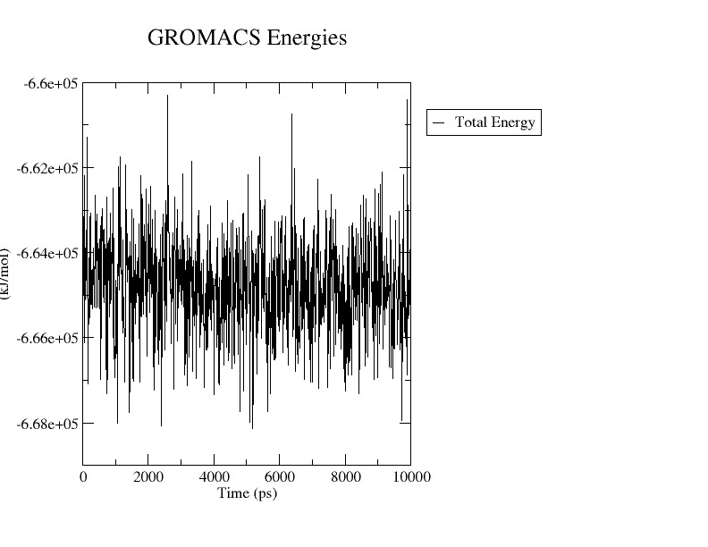
Figure 15: Total energy of the AD53-PfPGM1 simulation system over 10 ns.

The total energy of the system was monitored throughout the 10ns simulation to confirm that the system reached and maintained proper thermodynamic equilibrium. The total energy fluctuated consistently within a range of approximately -6.60 × 10⁵ to -6.68 ×10⁵ kJ/mol across the entire trajectory. No sudden jumps, progressive drift, or instability were observed at any point during the simulation.
The energy values remained evenly distributed around a stable mean throughout all 10000ps, which confirms that the system was well- equilibrated and that the simulation was physically valid. This stable energy profile provides a reliable foundation for all subsequent analyses, as it ensures that the observed structural and dynamic behaviour of the protein- ligand complex reflects genuine molecular interactions rather than simulation artefact.
4. Conclusion

This study presents a comprehensive in silico investigation into the potential of phytochemical compounds as inhibitors of Phosphoglycerate Mutase from Plasmodium falciparum (PfPGM1, PDB: 1XQ9), a key glycolytic enzyme essential for parasite survival. In the absence of experimentally validated active site data for 1XQ9, a homology-based approach combining BLASTp analysis, structural alignment with the reference protein 4ODI (75% sequence identity), and Schrodinger SiteMap pocket prediction was employed to identify seven probable active site residues: Arg18, His19, Asn25, Thr31, Tyr100, His192, and Asn194.
Virtual screening of a library of 58 phytochemical compounds using AutoDock Vina identified AD53 (Tectograndone) as the top-ranked compound with the strongest binding affinity of -10.68 kcal/mol against the predicted active site of PfPGM1. SwissADME-based pharmacokinetic evaluation of the top 10 candidates further supported AD53 as the most drug-like compound, demonstrating high gastrointestinal absorption, zero Lipinski violations, a favourable TPSA of 119 Å², and a synthetic accessibility score of 3.74, all of which are indicative of a strong oral drug candidate profile.
To validate the dynamic binding stability of AD53, a 10 ns molecular dynamics simulation was performed using GROMACS. The simulation confirmed that the AD53-PfPGM1 complex remained stable throughout the entire trajectory. The total system energy remained consistently within -6.60 x 10⁵ to -6.68 x 10⁵ kJ/mol with no drift, confirming proper equilibration. The protein backbone RMSD plateaued at approximately 0.12-0.15 nm, while the radius of gyration was maintained around 1.84 nm, together confirming that the protein retained its native folded structure. The RMSF profile identified a rigid structural core with moderate flexibility at loop regions, which is consistent with a well-folded globular protein. Hydrogen bond analysis revealed that AD53 maintained continuous polar interactions with the protein throughout the simulation, shifting from SER-22, GLU-97, TYR-100, SER-197 at 0 ns to THR-31 at 10 ns, with 1 hydrogen bond present. Critically, the visual superimposition of the ligand pose at 0 ns and 10 ns demonstrated near-perfect overlap, confirming that AD53 did not drift away from or abandon the binding site at any point during the simulation.
Collectively, these findings establish AD53 (Tectograndone) as a highly promising phytochemical lead candidate for the inhibition of PfPGM1. Its combination of strong binding affinity, favourable pharmacokinetic properties, and dynamic binding stability under physiological simulation conditions makes it a compelling starting point for further experimental validation. This study also demonstrates the effectiveness of a fully integrated in silico pipeline — combining active site prediction, molecular docking, ADME profiling, and MD simulation — as a reliable and cost-effective strategy for early-stage antimalarial drug discovery.

5. Outlook/ Future Work

While this study establishes a strong in silico basis for AD53 (Tectograndone) as a candidate PfPGM1 inhibitor, several directions merit further exploration.
First, extending the molecular dynamics simulation beyond 10 ns — ideally to 100–500 ns — would provide a more reliable picture of how stably AD53 binds to the protein over a longer period of time. Additional binding energy calculations could further strengthen confidence in these predictions.
Second, in vitro enzyme inhibition assays using recombinant PfPGM1 are essential to experimentally confirm whether AD53 actually blocks the enzyme, and to determine the concentration at which it does so effectively.
Third, comparative docking and simulation studies against the human phosphoglycerate mutase homologue should be conducted to ensure that AD53 selectively targets the parasite enzyme without affecting its human equivalent.
Furthermore, based on the binding interactions identified in this study, small and targeted chemical modifications to the AD53 structure could be explored to design improved compounds with better potency and drug-like properties.
Finally, if early experimental results are promising, AD53 should be tested in animal malaria models to evaluate its real-world efficacy, safety, and bioavailability before any further preclinical development.

6. References

1. WHO. World Malaria Report 2023. Geneva: World Health Organization; 2023.
2. Ashley EA, et al. Spread of artemisinin resistance in Plasmodium falciparum malaria. N Engl J Med. 2014;371(5):411-423.
3. Dondorp AM, et al. Artemisinin resistance in Plasmodium falciparum malaria. N Engl J Med. 2009;361(5):455-467.
4. Mehta M, et al. Glycolytic flux in Plasmodium falciparum. FEMS Microbiol Lett. 2006.
5. Tiwari MK, et al. Glycolytic enzymes as antimalarial drug targets. Curr Top Med Chem. 2015. PMID: 25580350.
6. Zhang M, et al. Uncovering the essential genome of P. falciparum by saturation mutagenesis. Science. 2018.
7. RCSB Protein Data Bank. PDB ID: 1XQ9. www.rcsb.org/structure/1XQ9. 2024.
8. Dzierszinski F, et al. Tetrameric structure of PfPGM1 is critical for enzymatic activity. J Biol Chem. 2022.
9. Blacklow SC, et al. Structural basis for phosphoglycerate mutase function. Biochemistry. 1995.
10. Joseph S, et al. Active site characterisation of 4ODI phosphoglycerate mutase. 2018.
11. Pettersen EF, et al. UCSF Chimera. J Comput Chem. 2004;25(13):1605-1612.
12. Halgren TA. Identifying and characterising binding sites and assessing druggability. J Chem Inf Model. 2009;49(2):377-389.
13. Kaur K, et al. Antimalarials from nature. Bioorg Med Chem. 2009;17(9):3229-3256.
14. Osman et al. Antiplasmodial anthraquinones from medicinal plants. NPC. 2018.
15. Trott O, Olson AJ. AutoDock Vina. J Comput Chem. 2010;31(2):455-461.
16. Sarangi S, Mahapatra RK. Phytochemical-based discovery targeting PfPI4K. Exp Parasitol. 2025a.
17. Sarangi S, Mahapatra RK. Inhibitors against PfPK6. Exp Parasitol. 2025b.
18. Lipinski CA, et al. Experimental and computational approaches to estimate solubility and permeability in drug discovery. Adv Drug Deliv Rev. 1997;23:3-25.
19. Daina A, et al. SwissADME. Sci Rep. 2017;7:42717.
20. Baell JB, Holloway GA. New substructure filters for removal of pan assay interference compounds. J Med Chem. 2010;53(7):2719-2740.
21. Abraham MJ, et al. GROMACS. SoftwareX. 2015;1-2:19-25.
22. Huang J, MacKerell AD. CHARMM36 all-atom additive protein force field. J Comput Chem. 2013;34(25):2135-2145.
23. Durrant JD, McCammon JA. Molecular dynamics simulations and drug discovery. BMC Biol. 2011;9:71.

