Phylogenetic Analysis of mecA Antibiotic Resistance Gene in Staphylococcus Species
This project focuses on understanding the evolutionary relationship of the mecA antibiotic resistance gene among different Staphylococcus species using bioinformatics and phylogenetic tools. Antibiotic resistance, especially methicillin resistance, is a major concern in both hospital and community settings, making this study highly relevant in the current scenario.

Introduction
Antimicrobial resistance is one of the most pressing challenges faced by modern medicine. Among resistant bacteria, Staphylococcus species, particularly methicillin-resistant strains, pose a serious threat due to their ability to survive standard antibiotic treatments. The mecA gene plays a crucial role in this resistance by producing an altered penicillin-binding protein that reduces antibiotic efficacy.
Studying the evolutionary behavior of resistance genes helps in understanding how resistance emerges, spreads, and persists among bacterial populations. Phylogenetic analysis provides a reliable computational approach to trace evolutionary relationships based on genetic similarity. This project applies phylogenetic methods to analyze the mecA gene across multiple Staphylococcus species.

Aim and Objectives
Aim:
To analyze the evolutionary relationship of the mecA antibiotic resistance gene among different Staphylococcus species.
Objectives:
• To retrieve mecA gene sequences from public databases
• To perform multiple sequence alignment of mecA sequences
• To construct a phylogenetic tree using MEGA software
• To interpret evolutionary conservation and divergence of the mecA gene

Materials and Methods
mecA gene sequences were obtained from the NCBI nucleotide database. Only annotated and verified partial coding sequences with overlapping regions were selected to ensure accurate alignment. The sequences were aligned using ClustalW and MUSCLE algorithms available in MEGA 12 software. Manual trimming was performed to remove non-overlapping regions.
Phylogenetic analysis was carried out using the Neighbor-Joining method with the p-distance model. Bootstrap analysis with 1000 replications was used to test the reliability of the tree, and pairwise deletion was applied to handle gaps and missing data.

Results
The aligned mecA gene sequences showed a high degree of similarity across the analyzed Staphylococcus species. Minor nucleotide variations were observed, indicating species-specific divergence. The Neighbor-Joining tree demonstrated close clustering of mecA sequences, suggesting strong evolutionary conservation. Short branch lengths further confirmed the limited divergence of this resistance gene.
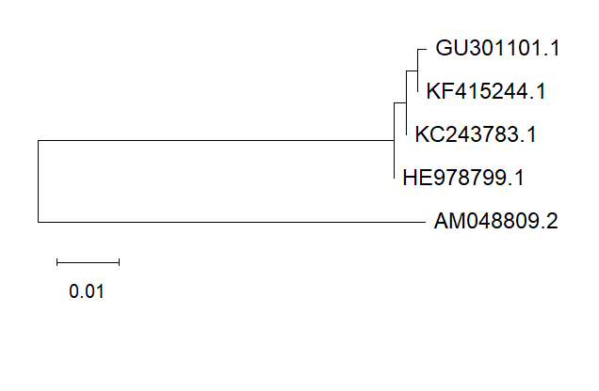

Discussion
The results of this study indicate that the mecA gene is highly conserved among Staphylococcus species. This conservation reflects strong selective pressure to maintain resistance against β-lactam antibiotics. The phylogenetic clustering observed in the tree supports the idea of a common ancestral origin and possible horizontal gene transfer.
Using partial coding sequences with overlapping regions ensured reliable phylogenetic inference and avoided alignment errors. Similar evolutionary patterns have been reported in previous studies on antimicrobial resistance genes.

