**Module 7**

1)

#include<stdio.h>

#include<errno.h>

#include<sys/file.h>

void main()

{

int p;

p=open("filename.txt",O_RDONLY);

if(p==-1)

{

printf("errno = %d\n",errno);

perror("main");

}

p=open("/",O_WRONLY);

if(p==-1)

{

printf("errno = %d\n",errno);

perror("main");

}

p=open("filename.txt",O_RDONLY|O_CREAT);

printf("errno = %d\n",errno);

perror("main");

errno=0;

perror("main");

}

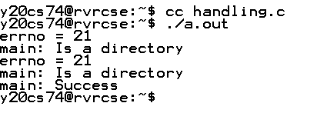

#include<stdio.h>

#include<fcntl.h>

#include<stdlib.h>

int main()

{

int fd1 = open("foo1.txt", O_RDONLY|O_CREAT);

if (fd1==-1)

{

perror("c1");

exit(1);

}

printf("opened the fd = % d\n", fd1);

close(fd1);

}

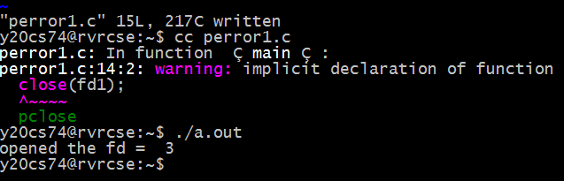

#include<stdio.h>

#include<fcntl.h>

#include<stdlib.h>

int main()

{

int fd1 = open("foo1.txt”);

if (fd1==-1)

{

perror("c1");

exit(1);

}

printf("opened the fd = % d\n", fd1);

close(fd1);

}

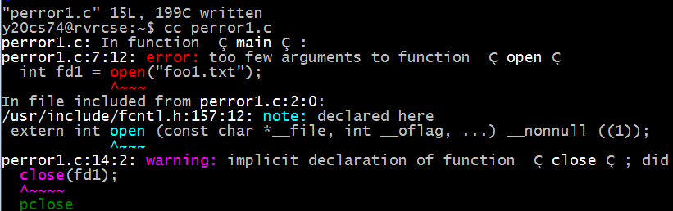

2)

#include<stdio.h>

#include<errno.h>

#include<sys/file.h>

#include<stdlib.h>

void main()

{

int p=open("text.txt",O_WRONLY);

if(p==-1)

{

printf("File doesnot exit");

}

else

{

char s[]="Unix System Programming";

write(p,s,sizeof(s));

}

close(p);

int fd=open("text.txt",O_RDONLY);

if(fd==-1)

{

printf("File doesnot exists");

}

else

{

char *s=(char *)malloc(20*sizeof(char));

read(fd,s,20);

printf("The content in file text.txt is\n%s\n",s);

}

close(fd);

}

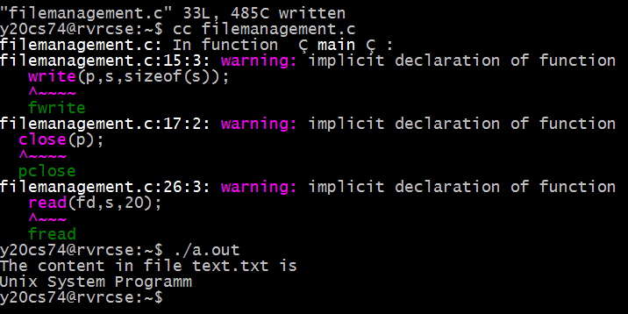

3)

#include<stdio.h>

#include<errno.h>

#include<sys/file.h>

#include<stdlib.h>

void main()

{

int fd1,fd2,fd3;

fd1=open("txt.txt",O_WRONLY|O_CREAT);

if(fd1==-1)

{

printf("File doesn't exists\n");

}

else

{

printf("fd1 = %d\n",fd1);

fd2=dup(fd1);

printf("fd2 = %d\n",fd2);

write(fd2,"linux programming",20);

close(fd2);

fd3=dup(fd1);

printf("fd3 = %d\n",fd3);

write(fd3,"SOC",3);

close(fd3);

dup2(fd1,1);

write(1," unix \n",5);

}

close(fd1);

}



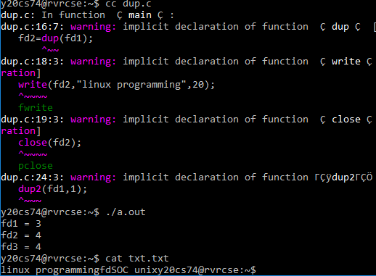

**Module-8**

**1)**

#include<stdio.h>

#include<unistd.h>

void main()

{

int n,sum;

printf("Enter a number\n");

scanf("%d",&n);

if(fork()==0)

{

sum=0;

for(int i=1;i<=n;i++)

{

if(i%2==0)

sum=sum+i;

}

printf("Even sum %d\n",sum);

}

else

{

sum=0;

for(int i=1;i<=n;i++)

{

if(i%2!=0)

sum=sum+i;

╜ }

printf("Odd sum %d\n",sum);

}

}

