#include<stdio.h>

#include<errno.h>

#include<sys/file.h>

void main()

{

int p;

p=open("filename.txt",O_RDONLY);

if(p==-1)

{

printf("errno = %d\n",errno);

perror("main");

}

p=open("/",O_WRONLY);

if(p==-1)

{

printf("errno = %d\n",errno);

perror("main");

}

p=open("filename.txt",O_RDONLY|O_CREAT);

printf("errno = %d\n",errno);

perror("main");

errno=0;

perror("main");

}

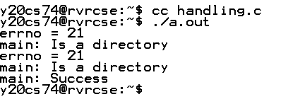

#include<stdio.h>

#include<fcntl.h>

#include<stdlib.h>

int main()

{

int fd1 = open("foo1.txt", O_RDONLY|O_CREAT);

if (fd1==-1)

{

perror("c1");

exit(1);

}

printf("opened the fd = % d\n", fd1);

close(fd1);

}

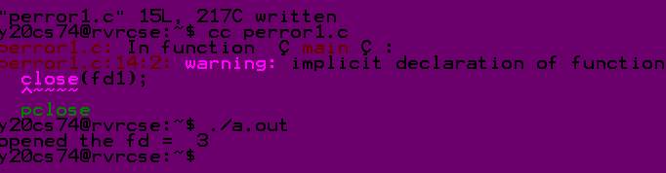

#include<stdio.h>

#include<fcntl.h>

#include<stdlib.h>

int main()

{

int fd1 = open("foo1.txt”);

if (fd1==-1)

{

perror("c1");

exit(1);

}

printf("opened the fd = % d\n", fd1);

close(fd1);

}

