CIS Automation Factory

CDP Neighbor – Cisco Devices
Author: Sagarika Mukesh Jaiswal
Designation: CIS Automation Developer
Date: 03.05.2019
REVISION HISTORY

VERSION | DATE | SUMMARY OF CHANGES | AUTHOR | REVIEWER | REVISION REMARKS (YES/NO)
1.0 | 03.05.2019 | Initial Version | Sagarika Mukesh Jaiswal | Sravani Challa | No

CONTENTS

INTRODUCTION 4
INPUTS 4
LOGIC 5
OUTPUT…………………………………………………………………………………………………………......6
SCOPE 7
PREREQUISITES 7
DEPLOYMENT PROCEDURE 7

Introduction
This Automation Solution extracts bits of information from the ‘show cdp neighbors detail | include Device|Interface|Platform’ command for every device and creates a report for all the distribution switches, with both basic and double authentication login methods.

Inputs
Inputs Parameters required for CDP Neighbor.
Input Files:-
- data.csv :- Device IP, Login ID, Encrypted Password, Encrypted Enable Password

Sample input:
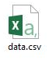

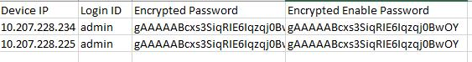

Logic
On the basis of input files configurations the script will connect to the devices (distribution switches), execute the ‘show cdp neighbors detail | include Device|Interface|Platform’ command and create a report for the distribution switches. The script will then connect with the access switches connected to each distribution switch, execute the ‘show cdp neighbors detail | include Device|Interface|Platform’ command and create a report for the access switches.
Flowchart:

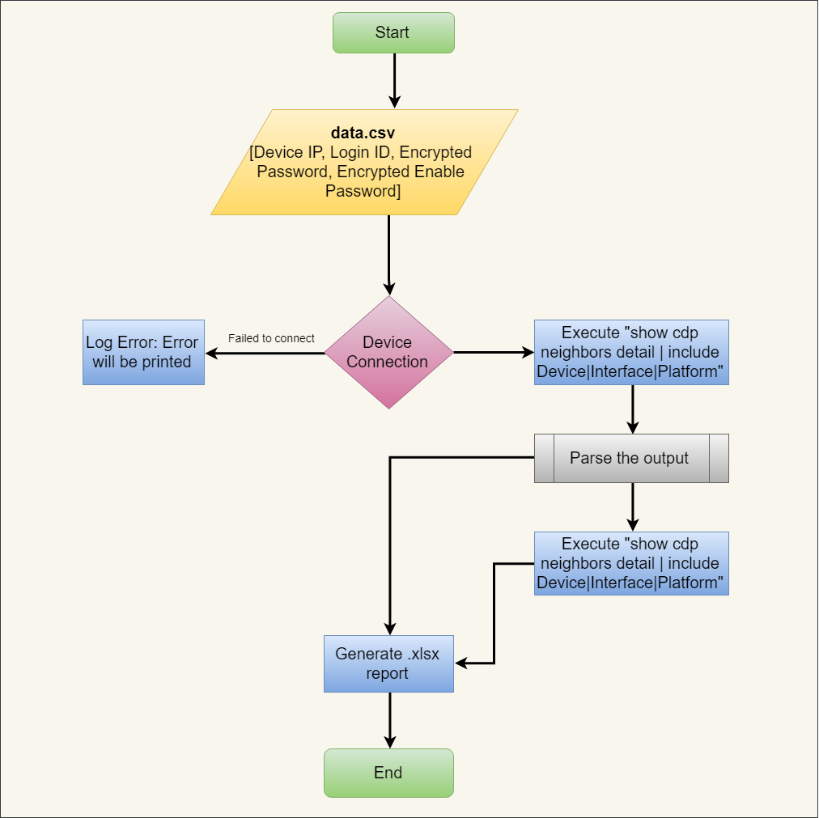

Output
After successful execution of the script, following file will be available in CDPNeighbor\output:
- <Device IP> [Folder]
<timestamp>.xlsx [file]
Sample outputs:
- After successful execution of script, below file or files will be created based on input.
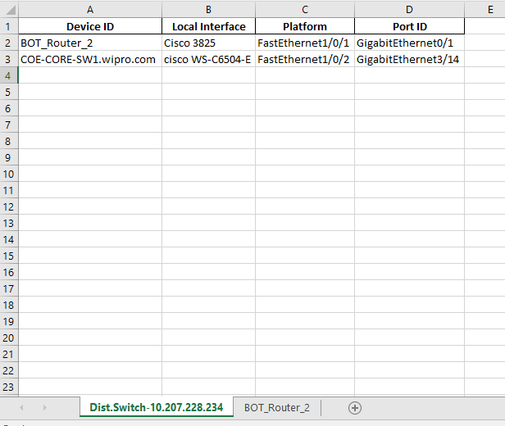

Scope
- Cisco Devices.

Prerequisites
- Windows 2008 or later OS.
- Python Version v3.6 or later.
- Domain / Equivalent Admin privilege on the target devices.

Deployment Procedure
- Unzip CDPNeighbor.zip in the system.
- Open the CDPNeighbor folder and find the conf folder.
- Inside the conf folder, find the data.csv file. Fill the sheet with input device ip, login id and encrypted passwords under the column headers. (Encrypt the passwords using encryption tool provided)
- Open CMD.
- cd to the folder where CDPNeighbor folder is placed.
- cd to bin folder. Inside the bin folder, find the cdp_neighbor.py script.
- Execute the script using the command: python cdp_neighbor.py
- Output will be in excel format in the output folder.

