

Wipro Service Delivery

Standard of Procedure
for
CDP Neighbors

  - Network-Data/19-Dec -18/Process

Table of contents

1. Purpose 3
2. Business as Usual (BAU) Change 3
2.1 CDP Neighbor 3
3. Roles & Responsibility 3
4. Environment 3
5. Definitions & Acronyms 3
6. References 3
7. Implementation Steps 3
8. Amendment History 5

Purpose

The Purpose of this Steps of Procedure (SOP) is to:
- Identify the steps for implementation of BAU Changes.

Business as Usual (BAU) Change

2.1 CDP Neighbors
This activity is useful to identify the devices connected to a switch using Cisco Discover Protocol (CDP).
The following steps provide a high-level overview that outlines CDP Neighbor request to completion.
CDP Neighbor:
- A service request is opened with the YYZ Service Desk for identifying the connected Cisco switches and Routers to update the inventory database accordingly.
- Request assigned to Network team to identify the access switch connectivity through Distribution Switch.
- Team will execute command sh cdp neighbor and determine the switches and routers connected until we reach the access switch with no further connectivity to the other access switches.

- Update the CDP Neighbor Report with the Distribution to Access, Access to Access1 and Access1 to Access2 respectively.
- Service request is updated with status and closed.

Roles & Responsibility

Network Team – Implementing the changes in network

Environment

GTAA environment is comprised of Cisco equipment’s.

Definitions & Acronyms

References

NA

Implementation Steps

- Login to Wipro Jump box 10.251.208.11/10.251.208.10
- Login to Network Jump box via mstsc to 192.168.3.142/192.168.3.24
- Login to the given switch (mentioned in the ticket) for which the port needs to be reset.

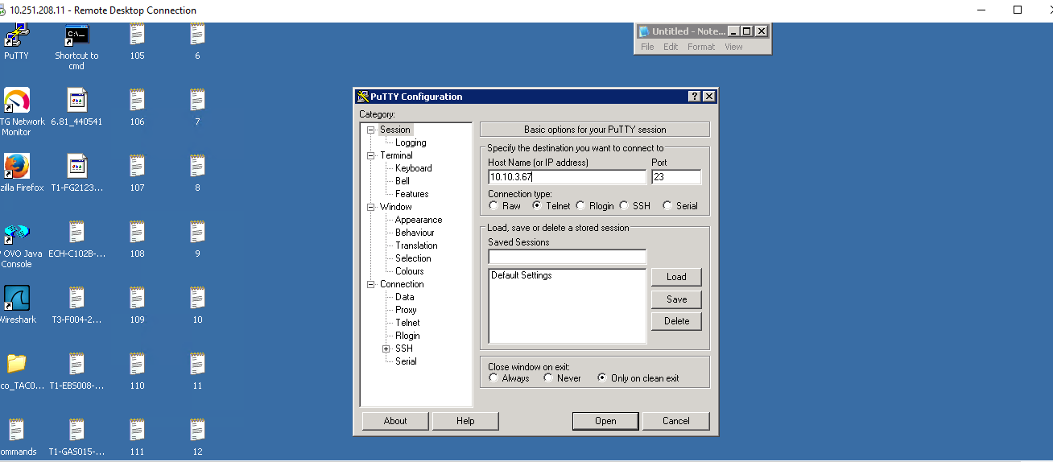

- Execute command:
- Enable
- Enter password
- show cdp neighbors and update the Report accordingly.

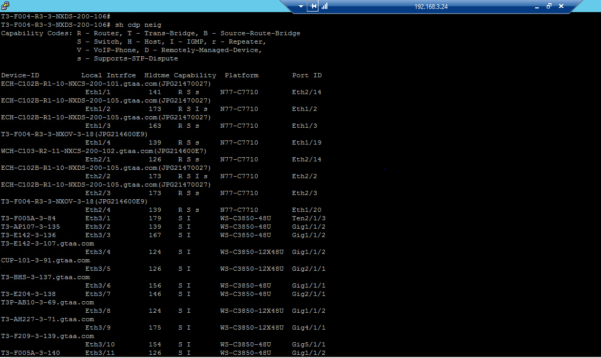

- Based on the output login to the Switches in the output of sh cdp neig in Distribution Switches Execute the same in the access switch for the other access switches connected to that.

For Example: For the below Device is another access switch connected.
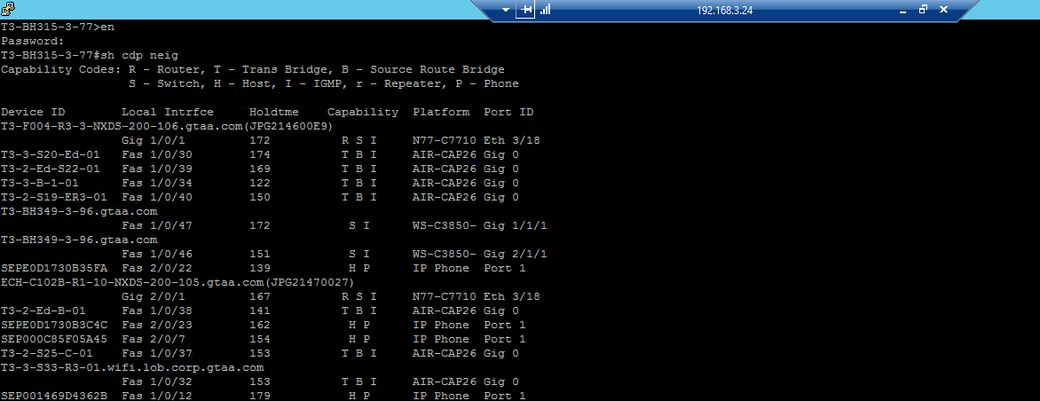

- Update the Report with the switch details.

Amendment History

Version | Author(s) | Approved By | Nature of Change
1.0 | Divya Kumari |  | Creation
1.0 | Yogesh Rajguru |  | Reviewed & approved

Thank You

