CIS Automation Factory

Compliance
Author: Sagarika Mukesh Jaiswal
Designation: CIS Automation Developer
Date: 29.04.2019
REVISION HISTORY

VERSION | DATE | SUMMARY OF CHANGES | AUTHOR | REVIEWER | REVISION REMARKS (YES/NO)
1.0 | 29.04.2019 | Initial Version | Sagarika Mukesh Jaiswal | Sravani Challa | No

CONTENTS

INTRODUCTION 4
INPUTS 4
LOGIC 5
OUTPUT…………………………………………………………………………………………………………......6
SCOPE 7
PREREQUISITES 7
DEPLOYMENT PROCEDURE 7

Introduction
This Automation Solution checks for device’s compliance against standard rules/configurations and produces a report with the compliance status and the missing configurations.

Inputs
Inputs Parameters required for Compliance.
Input Files:-
- soe.csv
- configuration file (one or many)

Sample input:
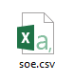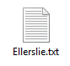
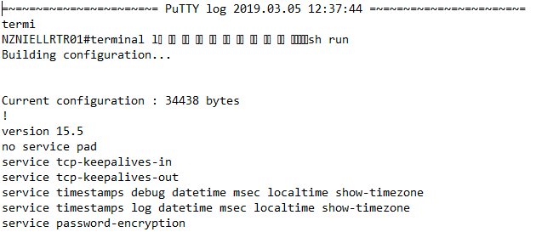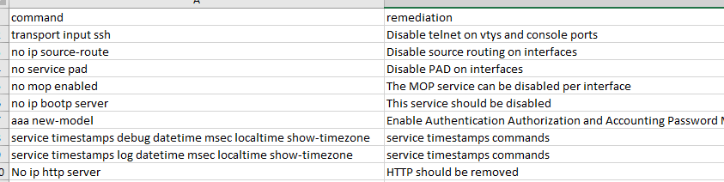

Logic
On the basis of input files the script will compare the soe file with the configuration files and check for the compliance status of each configuration file and generate the report.
Flowchart:

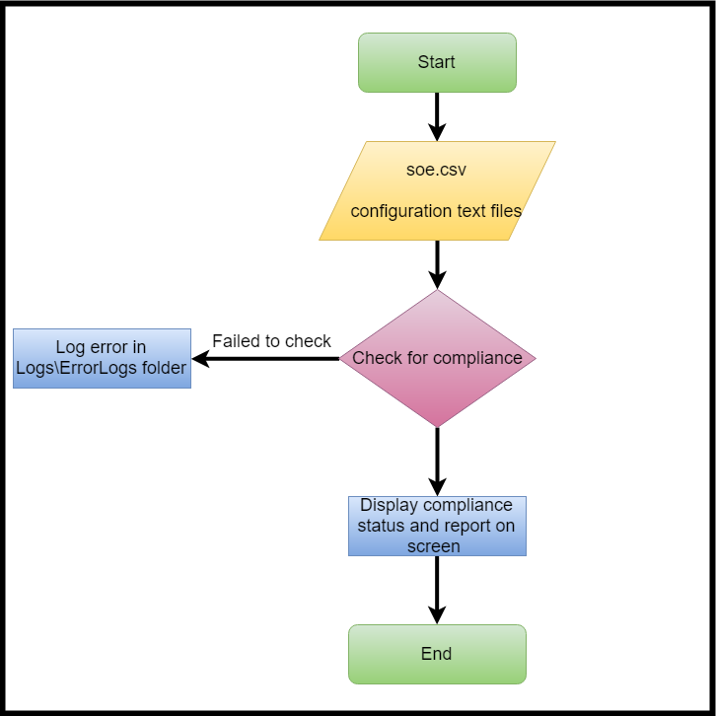
Output
After successful execution of the script, following output will be displayed on the screen:
Sample outputs:
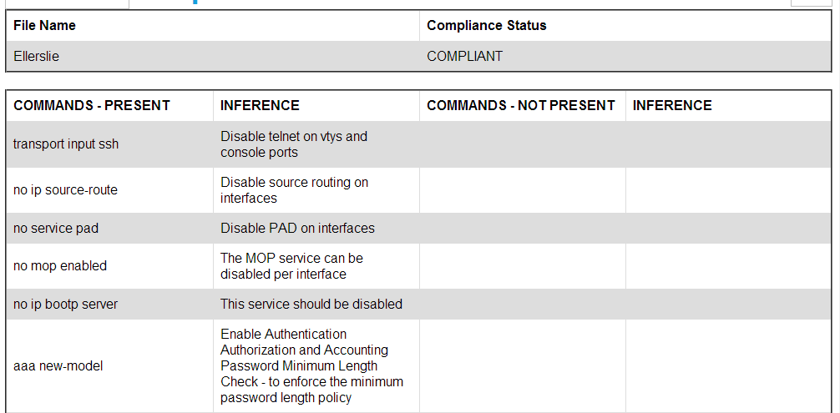

Scope
- Network Devices.

Prerequisites
- Windows 2008 or later OS.
- IIS Manager for hosting the application.
- Enable IIS feature in ‘Turn Windows Feature On or Off’.
- Python Version v3.6 or later.
- Domain / Equivalent Admin privilege on the target devices.

Deployment Procedure
- Unzip Compliance.zip in the system.
- Host it as a site on IIS.

