CIS Automation Factory

Interface Down – Cisco Devices

Author: Ghazala Khanam

Designation: CIS Automation Developer

Date: 30.06.2019

REVISION HISTORY

|  |  |  |  |  |  |
| --- | --- | --- | --- | --- | --- |
| **VERSION** | **DATE** | **SUMMARY OF CHANGES** | **AUTHOR** | **REVIEWER** | **REVISION REMARKS (YES/NO)** |
| 1.0 | 30.06.2019 | Initial Version | Ghazala Khanam | Sravani Challa |  |
|  |  |  |  |  |  |

CONTENTS

INTRODUCTION 4

INPUTS 4

LOGIC 5

FLOWCHART 6

OUTPUT…………………………………………………………………………………………………………...…7

SCOPE 8

PREREQUISITES 8

DEPLOYMENT PROCEDURE 8

Introduction

An alert will generated in RSA Service now tool for interface down issue. This Automation Solution is to for monitoring port up/down status. Need to check interface of the device and analyze the output i.e. Interface Status, Line protocol status, Speed and Duplex setting.

Inputs

Inputs Parameters required for Interface Down.

Input Files:-

* Input from Service now Tool: - interface.
* config_file.txt : Switch_IP, USER, PASSWORD

Sample input:

**Config_file :**

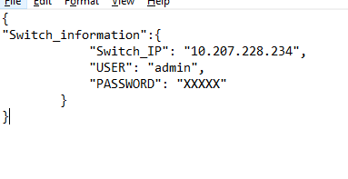

Logic

* Receive an alert in service now tool for interface down issue.
* Once alert is received, check for interface status on the device.
* Login to the device through SSH/ Telnet using the IP address and credential (Script server).
* Check the interface status on the device using commands given below.

BOT_Switch_2# show interface description | include Fa1/0/24

Fa1/0/24 up up

BOT_Switch_2#show interfaces Fa1/0/24

FastEthernet1/0/24 is up, line protocol is up (connected)

Hardware is Fast Ethernet, address is 0019.0681.749a (bia 0019.0681.749a)

MTU 1500 bytes, BW 100000 Kbit, DLY 100 usec,

reliability 255/255, txload 1/255, rxload 1/255

Encapsulation ARPA, loopback not set

Keepalive set (10 sec)

Full-duplex, 100Mb/s, media type is 10/100BaseTX

Interface can be in any of the below states:

• Case1: Interface up, line protocol is up (connected)

* Interface is working fine

• Case2: Interface is down; line protocol is down (not connect)

* Verify the physical connectivity of the port and the connected device with help of local site contact.

• Case3: Interface is up; line protocol is down (not connect)

* Verify whether speed & duplex is same on both end
* This can be due to a faulty cable connected

Flowchart:

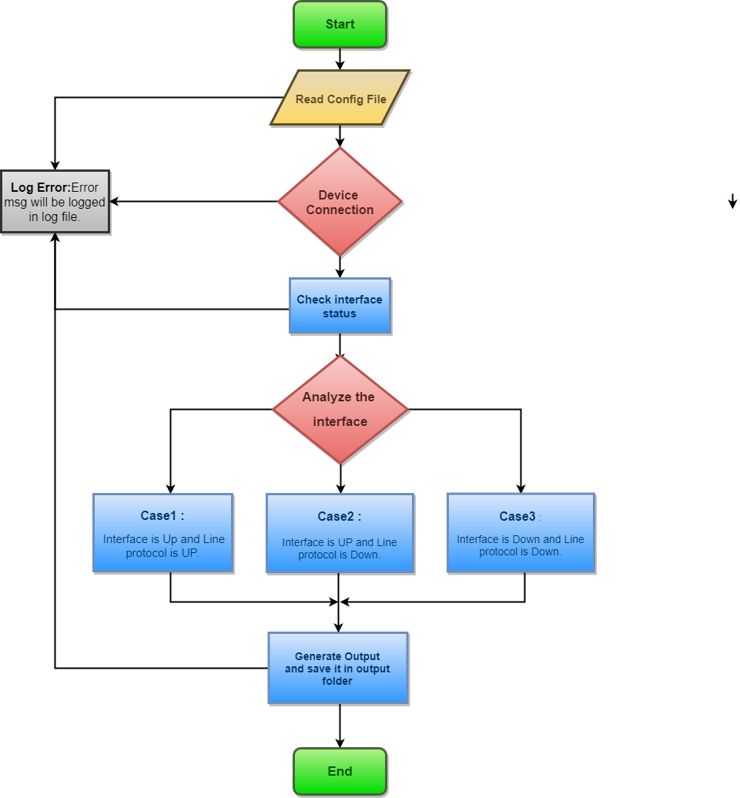

Output

After successful execution of the script, following file will be available in interface utilization folder:

1. ..\Interface-Down\output [Folder]  
   Output_Status-<timestamp> [File]

Sample outputs:

After successful execution of script, below output file will be created based on input.

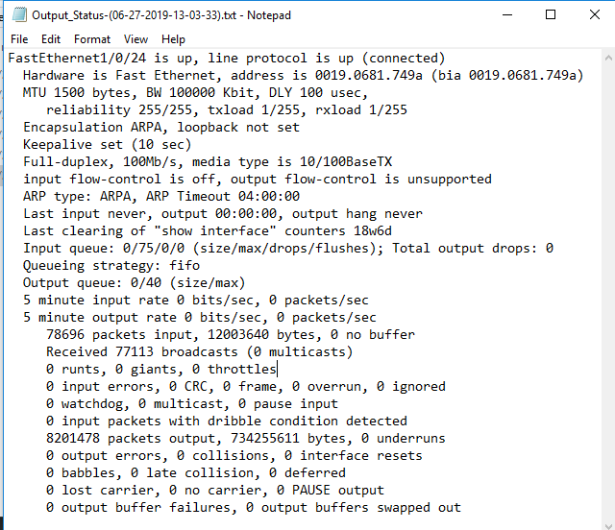

Scope

* Cisco Devices.

Prerequisites

* Windows 2008 or later OS.
* Python Version v3.6 or later.
* Domain / Equivalent Admin privilege on the target devices.

Deployment Procedure

* Unzip Interface-Down.zip in the system.
* Open the Interface-Down folder and find the config folder.
* Inside the config folder, find the config_file file. Fill the file with input device ip, login id and encrypted password under the column headers. (Encrypt the passwords using encryption tool provided)
* cd to the folder where Interface-Down folder is placed.
* cd to scripts folder. Inside the scripts folder, find the Interface-Down.py file.
* Execute the script using the command: python Interface-Down.py
* Output will be in text format in the output folder.