Log Analysis.
Author: Akshata Jadhav
Designation: Project Engineer
Date: 20th july 2019
REVISION HISTORY
VERSION | DATE | Summary Of Changes | AUTHOR | REVIEWED BY | RIVISION REMARKS (YES / NO)
0.1 | 20st June, 2019 | Initial Draft | Akshata Jadhav
0.2 | 20th July 2019 | Modifications in script | Akshata Jadhav
0.3

Contents
Introduction 4
Flow Chart 4
Process 5
Execution Steps 5
Input Parameter: 5
Output 5
Scope 5
Prerequisites 5
Deployment Steps / Procedure 6

Introduction
The script will Login to core Switch, EOR Switch and TOR switch. Triggers commands and get output in text file.

Flow Chart

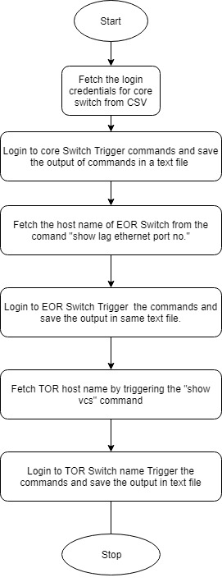

Process
When the script is triggered it will Login to core Switch and trigger a set of commands to get hostname of EOR switch. Then the Script logins to EOR switch and triggers a set of commands to get hostname of TOR switch. Then the script logins to TOR switch Triggers commands. Output of all commands is saved in text file.

Execution Steps
- Script login to Core Switch and triggers following commands:
- Show arp <server ip>: Get mac address from output of this command
- Show mac address <mac address>: Get slot/interface from output of this command
- Show lag ethernet <slot/interface>: Get EOR hostname from output of this command
- Script Login to EOR Switch and triggers following commands:
- Show mac-address-table add <mac address>:Fetch the Rbridge ID from output of this command
- Show vcs : Fetch the host name TOR switch with Rbridge id from output of this command
- Script login to 1st TOR Switch triggers the following commands
  - Show interface Te slot/rbridge/port
  - Show logging raslog | slot/rbridge/port
- Checks the host name of TOR switch if the 1st switch host name includes TOR_A then the 2nd switch hostname to be login and run the same set of commands will have TOR_Z.

Input Parameter:

CSV file with the Core switch credentials encrypted

Output

Output for all the commands will be saved in a text file with a file name Log_Analysis< time stamp.>.txt

Scope
This script will work on python 3.4 and above version.

Prerequisites
•Python 3.4 and above version

Deployment Steps / Procedure

- Edit the input file with device credentials.
- Run the script and the output text file gets generated.

