CIS Automation Factory

Port Provisioning – Cisco Devices
Author: Ghazala Khanam
Designation: CIS Automation Developer
Date: 01:08.2
CONTENTS

REQUIREMENT 4
INPUTS 4
LOGIC 5
OUTPUT…………………………………………………………………………………………………………......6
SCOPE 7
PREREQUISITES 7
DEPLOYMENT PROCEDURE 7

Requirement
This use case is to develop a script that can perform switch port provisioning.
Automation Type: Standalone Script
Environment: Python

Inputs
A service request will be opened with the YYZ Service Desk for Port Provisioning.
Gather data provided in the ticket like Switch, port, Vlan details, either given by the user directly, or by vendor B&M/Service etc which needs to be provisioned.
Input parameters would be provided in csv format, as Ms. excel is not supported in client environment.
Input Files:-
- input.csv:
Parameter | Remark
VLAN_Type | Type of vlan
Interface | Port that need to be provisioned
VLAN_Name | Name of Vlan
Access_VLAN_Number | Access Vlan ID
Voice_VLAN_Number | Voice vlan id
SpeedCable_ID_System/Tenant_Name_SR_Number | Description

- config_file.csv: Device information like IP and credential will be placed in this file in csv format.

Parameter | Remark
Switch_IP | Device IP
USER | login name
PASSWORD | Encrypted login password

Logic
On the basis of input files and configuration file, the script will, generate command based on the filters given in input file, connect to the devices, take a backup of the device and execute the generated commands for provisioning, Verify the provisioning and fetch the output and store results in output folder as log files.

Implementaion Steps:
- Login to the provided switch (provided in the config file) on which the port needs to be provisioned via Putty.
- Take a backup of the device.
- Follow execution with respect to scenarios applicable as below.

- Check if the vlan is present on that switch.

#Show vlan id <vlan number> and

- Check if the Vlan is allowed on the uplink trunk port of the access switch

- If Yes:
Look for vlan type and perform the provisioning accordingly.
- If No:
Update the same on log file and report.

- Verify the Provisioning: Post provisioning verify the provisioning by executing below commands on device.

#Show interface <Number> status
#Show mac address-table interface (number)

Flowchart:
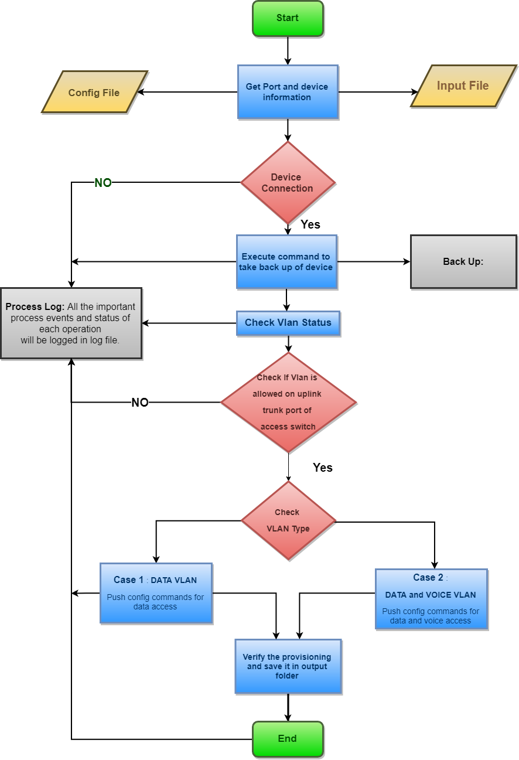

Output:

After successful execution of the script, there would be following output:
- Process log file: Log files provide information about important process events, such as changes in state, warnings, or errors and status of each operation.
- Back up file: Back up of device would be taken before provisioning.
- Verify Provisioning: Port provisioning Script would verify the completion of provisioning, and will save the output in txt file.

Scope:
- Cisco Devices.

Prerequisites:
- Windows 2008 or later OS.
- Python Version v3.6 or later.
- Python modules like paramiko, netmiko.
- Domain / Equivalent Admin privilege on the target devices.

