CIS Automation Factory

Port Availability – Cisco Devices
Author: Sagarika Mukesh Jaiswal
Designation: CIS Automation Developer
Date: 02.05.2019
REVISION HISTORY

VERSION | DATE | SUMMARY OF CHANGES | AUTHOR | REVIEWER | REVISION REMARKS (YES/NO)
1.0 | 02.05.2019 | Initial Version | Sagarika Mukesh Jaiswal | Sravani Challa | No

CONTENTS

INTRODUCTION 4
INPUTS 4
LOGIC 5
OUTPUT…………………………………………………………………………………………………………......6
SCOPE 7
PREREQUISITES 7
DEPLOYMENT PROCEDURE 7

Introduction
This Automation Solution fetches interfaces status for network devices with both basic authentication and double authentication and creates csv report of the ports.

Inputs
Inputs Parameters required for Port Availability.
Input Files:-
- data.csv :- Device IP, Login ID, Encrypted Password, Encrypted Enable Password

Sample input:
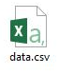

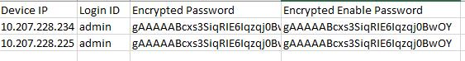

Logic
On the basis of input files configurations the script will connect to the devices, execute commands configured in “commands.txt”, fetch the output and store results in output folder as log files.
Flowchart:

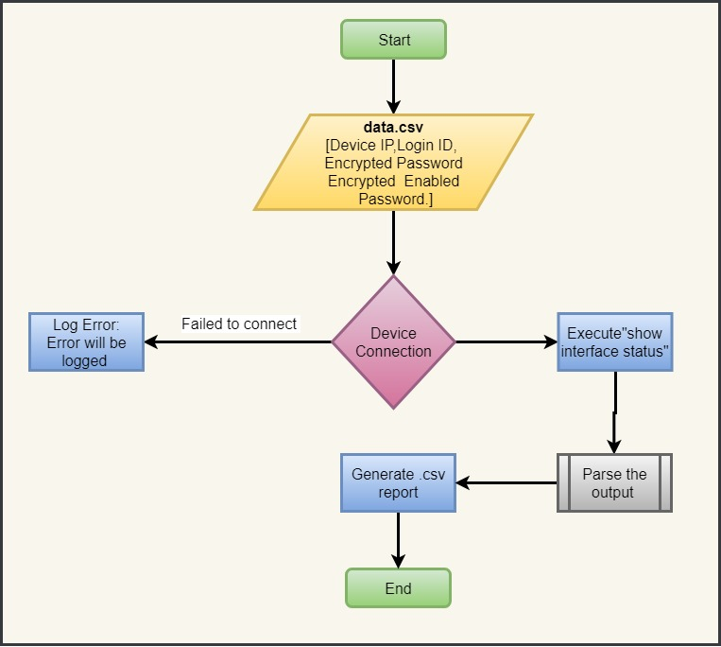

Output
After successful execution of the script, following file will be available in PortAvailability\report:
- <Device IP> [Folder]
<timestamp>_output.csv file
Sample outputs:
- After successful execution of script, below file or files will be created based on input.

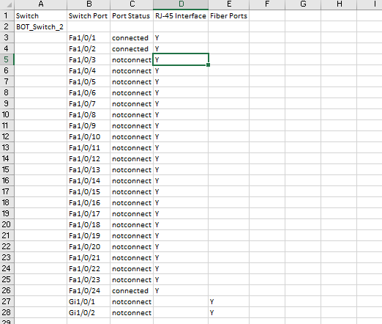

Scope
- Cisco Devices.

Prerequisites
- Windows 2008 or later OS.
- Python Version v3.6 or later.
- Domain / Equivalent Admin privilege on the target devices.

Deployment Procedure
- Unzip PortAvailability.zip in the system.
- Open the PortAvailability folder and find the conf folder.
- Inside the conf folder, find the data.csv file. Fill the sheet with input device ip, login id and encrypted password under the column headers. (Encrypt the passwords using encryption tool provided)
- Open CMD.
- cd to the folder where PortAvailability folder is placed.
- cd to bin folder. Inside the bin folder, find the port_availability.py file.
- Execute the script using the command: python port_availability.py
- Output will be in text format in the output folder and report will be in csv format in the report folder.

