

Wipro Service Delivery

Standard of Procedure
for
Switch Port Availability



  - Network-Data/25-Jul-18/Process

Table of contents

1. Purpose 3
2. Business as Usual (BAU) Change 3
2.1 Switch Port Availability 3
3. Roles & Responsibility 3
4. Environment 3
5. Definitions & Acronyms 3
6. References 3
7. Implementation Steps 4
8. Amendment History 5

Purpose

The Purpose of this Steps of Procedure (SOP) is to:
- Identify the steps for implementation of BAU Changes.

Business as Usual (BAU) Change

2.1 Switch Port Availability

This activity is useful to have the count of available interfaces on the switch.
The following steps provide a high-level overview that outlines Switch Port Availability request to completion.
Switch Port Availability:
- A service request is opened with the YYZ Service Desk for Switch Port Availability.
- Request assigned to Service Provisioning to provide the switch(s) details of the TC room number(s)/area(s) to provide the count of switch ports available on the switch by network team,
- if switch details already available in the ticket description it will be assigned to Network-Data team.
- Once the network switch details available, request will be assigned to Network team to find out total switch ports in the room(s)/area(s)
- Network Team will identify the total switch port capacity and review to ensure they match the requested requirements. (See below for port reset steps)
- Service request is updated with status and closed.

Roles & Responsibility

Network Team – Implementing the changes in network

Environment

Cisco equipment’s.

Definitions & Acronyms

TC | Tele Communication

References

NA

Implementation Steps

- Find the switch details in the ticket provided either by user or SP team.
- If the above information is not present in the ticket, reassign the ticket to provide those details for the respective TC room numbers.
- Login to Wipro Jump box via mstsc to XX.XX.XX.XX/XX.XX.XX.XX
- Login to Network Jump box via mstsc to XX.XX.XX.XX/XX.XX.XX.XX
- Login to the given switch (mentioned in the ticket) for which the capacity of switch ports to be find out through SecureCRT or Putty by using telnet or SSH as connection type.

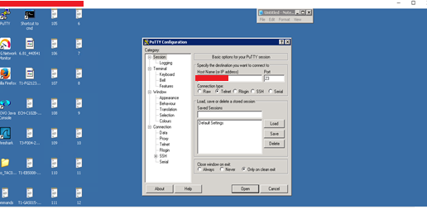

- Execute following command and gather the output:

For the list of connected interfaces need to use:
AccessSwitch#show interface status | I connected

For the list of not connected interfaces need to use:
AccessSwitch#show interface status | I notconnect

For the list of disabled interfaces need to use:
AccessSwitch#show interface status | I disable

- Above command on a switch will show the output of all the ports on switch with status connected/notconnect/disabled state.
- Note down all the interfaces except the SFP ports as those are for uplink switch connectivity.
- Amend the notified interface along with their status in the excel sheet.

Amendment History

Version | Author(s) | Approved By | Nature of Change
1.0 | Yogesh Rajguru |  | Reviewed & approved

Thank You

