CIS Automation Factory

Port Reset
Author: Simrandeep Singh
Designation: CIS Automation Developer
Date: 08.05.2019
REVISION HISTORY

VERSION | DATE | SUMMARY OF CHANGES | AUTHOR | REVIEWER | REVISION REMARKS (YES/NO)
1.0 | 08.05.2019 | Initial Version | Simrandeep Singh | Sravani Challa | No

CONTENTS

INTRODUCTION 4
INPUTS 4
LOGIC 5
OUTPUT…………………………………………………………………………………………………………......6
SCOPE 7
PREREQUISITES 7
DEPLOYMENT PROCEDURE 7

Introduction
This document describes about the pre-requisites, dependencies and deployment process for doing Port reset. In this particular use case, we connect to the cisco switch via Paramiko Module and search for the status of some particular port and identify whether its IP is connected or not. If not connected, script will reset that port using some set of commands. The script automates the entire process.

Inputs
Inputs Parameters required for Performance Testing.
Input Files:-
- data.csv :- Switch name, Switch IP, Login ID, Encrypted Password, Encrypted Enable Password, Port

Sample input:
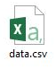

Logic
On the basis of input files configurations the script will connect to the devices, execute commands on the target device’s port and create log files. After checking port’s status, if not connected, script will execute some sets of command to reset the port to make it connected.

Flowchart:

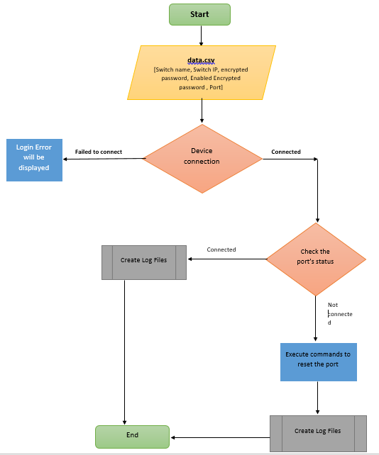
Output
After successful execution of the script, following file will be available in PortReset\output:

< Output/IP> [Folder] <Switch ip><timestamp>.txt [file]
Sample outputs:
- After successful execution of script, below file or files will be created based on input.
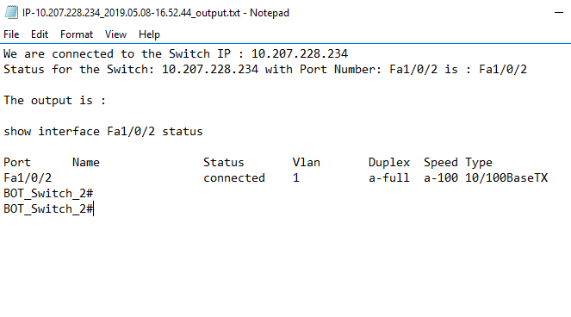

Scope
- Network devices.

Prerequisites
- Windows 2008 or later OS.
- Python Version v3.6 or later.
- Domain / Equivalent Admin privilege on the target devices.

Deployment Procedure
- Unzip PortReset.zip in the system.
- Open the PortReset folder and find the data.csv file.
- Fill the sheet with input device ip, login id and encrypted password under the column headers. (Encrypt the passwords using encryption tool provided)
- Open CMD
- cd to the folder where PortReset folder is placed.
- Execute the script using the command: python PortReset.py
- Output will be in text format in the output folder
- Find the output file in the output folder present inside the PortReset folder

