

Wipro Service Delivery

Standard of Procedure
for
Port Reset



  - Network-Data/20-June-18/Process

Table of contents

1. Purpose 3
2. Business as Usual (BAU) Change 3
2.1 Port Reset 3
3. Roles & Responsibility 3
4. Environment 3
5. Definitions & Acronyms 3
6. References 3
7. Implementation Steps 3
8. Amendment History 5

Purpose

The Purpose of this Steps of Procedure (SOP) is to:
- Identify the steps for implementation of BAU Changes.

Business as Usual (BAU) Change

2.1 Port Reset
This activity is useful to make the interface active/up if it’s down or in err-disabled mode.
The following steps provide a high-level overview that outlines Port Reset request to completion.
Port Reset:
- A service request is to be opened with the YYZ Service Desk for Port Reset
- Request assigned to Service Provisioning to provide the switch interface(s) details for the cable/Data Jack id of the port to be reset by network team,
- if switch and port details already available in the ticket description it will be assigned to Network-Data team.
- Tam will provide Switch and interface details to Reset the port to Network-Data Team.
- Port Reset configurations implemented and reviewed to ensure they match the requested requirements. (See below for port reset steps)
- Service request is updated with status and closed.

Roles & Responsibility

Network Team – Implementing the changes in network

Environment

Cisco equipment.

References

NA

Implementation Steps

- Find the cable id and data jack id details, switch and switch port details in the ticket.
- If the above information is not present in the ticket, assign the ticket to B&M to provide those details.
- Login to Wipro Jump box XXX.XXX.XXX.XXX
- Login to Network Jump box via mstsc to XXX.XXX.XXX.XXX
- Login to the given switch (mentioned in the ticket) for which the port needs to be reset.

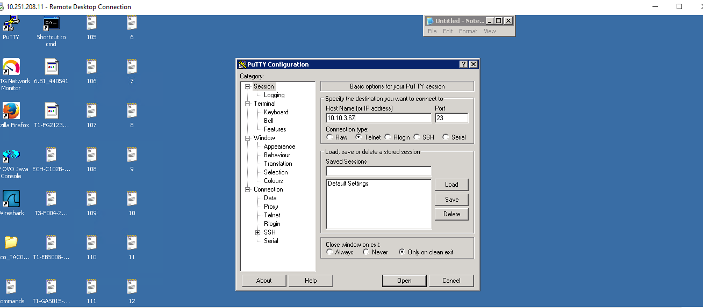

- Execute command:
- Enable
- Enter password
- show interface (Number) status and check the status(connected/notconnect/err-disable)

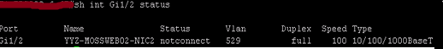

- Execute following commands on Cisco switch/router:

config t
interface <Number>
shut
no shut
exit
exit

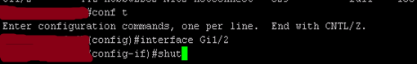
- Update the ticket with the updated interface status.

Amendment History

Version | Author(s) | Approved By | Nature of Change
0.1 | Divya Kumari |  | Creation
1.0 | Yogesh Rajguru |  | Reviewed & approved

Thank You

