**SNMP Changes.**

Author: Akshata Jadhav

Designation: CIS Automation Developer

Date: 9 August 2019

REVISION HISTORY

|  |  |  |  |  |  |
| --- | --- | --- | --- | --- | --- |
| VERSION | DATE | Summary Of Changes | AUTHOR | REVIEWED BY | RIVISION REMARKS (YES / NO) |
| 0.1 | 31st May, 2019 | Initial Draft | Akshata Jadhav |  |  |
|  |  |  |  |  |  |
|  |  |  |  |  |  |

Contents

Introduction 4

Flow Chart 4

Process 5

Execution Steps 5

Input Parameter: 5

Output 5

Scope 5

Prerequisites 5

Deployment Steps / Procedure 6

# Introduction

The script will connect to device and execute commands to add snmp changes and then check the snmp status executing the command “show run | i snmp”.

# Flow Chart

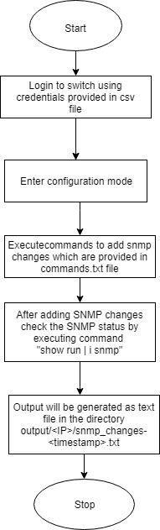

# 

# Process

# Execution Steps

* Script Logins to switch and Adds snmp changes with set of commands from commands.txt file.
* The set of commands triggered are as follows *#Config t*
  + *#* *snmp-server community ICH-Live01 RO 10*
  + *#* snmp-server community 1nP3x RO 5
  + *#* *snmp-serever trap-source Vlan207*
  + *# snmp-server location LNG Onshore*
  + *# snmp-server contact INPEX Service Desk*
  + *# snmp-server enable traps tty*
  + *# snmp-sercfsfver enable traps license*
  + *# snmp-server enable traps config*
  + *# snmp-server enable traps syslog*
  + *# snmp-server enable traps envmon fan shutdown supply temperature status*
  + *# snmp-server host XX.XX.XX.XX version 2c 1CH-Liv301*
  + *# snmp-server host XX.XX.XX.XX 1nP3x*
  + *# snmp-server host XX.XX.XX.XX version 2c ICH-Live01*
  + *# snmp ifmib ifindex persist*
  + *# wr*
  + *# end*
* Get the status of the SNMP changes added using command “show run | i snmp”

# Input Parameter:

# Input required for SNMP_changes

Input Files:-

* data.csv :- Device IP, Login ID, Encrypted Password

Sample input:



# 

# Output

# SNMP status is provided in text file in output folder

# Scope

This script will work on python 3.4 and above version.

# 

# Prerequisites

•Python 3.4 and above version

# Deployment Steps / Procedure

* Edit the input file with device credentials.
* Run the script then the output text file is generated.