The **rat in a maze** problem is a path finding puzzle in which our objective is to find an optimal path from a starting point to an exit point. In this puzzle, there is a rat which is trapped inside a maze represented by a square matrix. The maze contains different cells through which that rat can travel in order to reach the exit of maze.

## Rat in a Maze Problem using Backtracking Approach

Suppose the maze is of size NxN, where cells can either be marked as 1 or 0. A cell marked as 1 indicates a valid path, whereas a cell marked as 0 indicates a wall or blocked cell. Remember, the rat can move in up, down, left, or right directions, but it can only visit each cell once. The source and destination locations are the top-left and bottom-right cells, respectively.

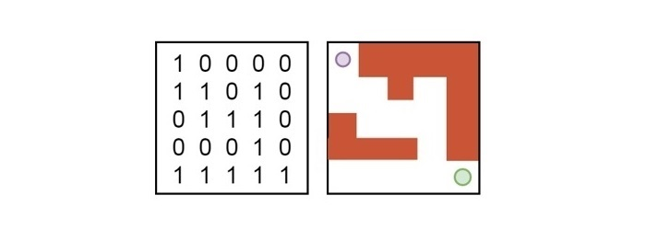

The goal is to find all possible paths for the rat to reach the destination cell (N-1, N-1) from the starting cell (0, 0). The algorithm will display a matrix, from which we can find the path of the rat to reach the destination point. The figure below illustrates the path −

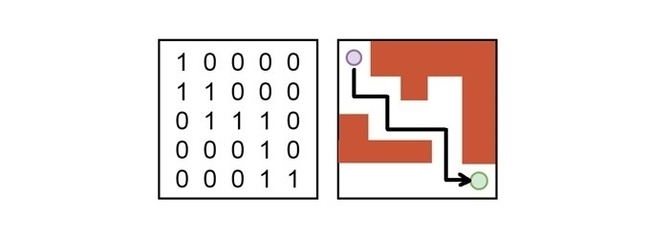

The backtracking process systematically explores all possible paths by marking visited cells and backtracking from dead ends. This approach guarantees to find all possible solutions if they exist for the given problem.

To solve the rat in a maze problem using the backtracking approach, follow the below steps −

* First, mark the starting cell as visited.
* Next, explore all directions to check if a valid cell exists or not.
* If there is a valid and unvisited cell is available, move to that cell and mark it as visited.
* If no valid cell is found, backtrack and check other cells until the exit point is reached.