# **Kruskal’s Minimum Spanning Tree (MST) Algorithm**

A minimum spanning tree(MST) or minimum weight spanning tree for a weighted, connected, undirected graph is a spanning tree with a weight less than or equal to the weight of every other spanning tree. To learn more about Minimum Spanning Tree, refer to [**this article**](https://www.geeksforgeeks.org/what-is-minimum-spanning-tree-mst/).

## **Introduction to Kruskal’s Algorithm:**

Here we will discuss **Kruskal’s algorithm** to find the MST of a given weighted graph.

In Kruskal’s algorithm, sort all edges of the given graph in increasing order. Then it keeps on adding new edges and nodes in the MST if the newly added edge does not form a cycle. It picks the minimum weighted edge at first and the maximum weighted edge at last. Thus we can say that it makes a locally optimal choice in each step in order to find the optimal solution. Hence this is a [**Greedy Algorithm**](https://www.geeksforgeeks.org/introduction-to-greedy-algorithm-data-structures-and-algorithm-tutorials/).

## **How to find MST using Kruskal’s algorithm?**

Below are the steps for finding MST using Kruskal’s algorithm:

1. Sort all the edges in non-decreasing order of their weight.
2. Pick the smallest edge. Check if it forms a cycle with the spanning tree formed so far. If the cycle is not formed, include this edge. Else, discard it.
3. Repeat step#2 until there are (V-1) edges in the spanning tree.

***Step 2*** *uses the* [*Union-Find algorithm*](https://www.geeksforgeeks.org/union-find/) *to detect cycles.*

*So we recommend reading the following post as a prerequisite.*

* [*Union-Find Algorithm | Set 1 (Detect Cycle in a Graph)*](https://www.geeksforgeeks.org/union-find/)
* [*Union-Find Algorithm | Set 2 (Union By Rank and Path Compression)*](https://www.geeksforgeeks.org/union-find-algorithm-set-2-union-by-rank/)

Kruskal’s algorithm to find the minimum cost spanning tree uses the greedy approach. The Greedy Choice is to pick the smallest weight edge that does not cause a cycle in the MST constructed so far. Let us understand it with an example:

### **Illustration:**

Below is the illustration of the above approach:

***Input Graph:***

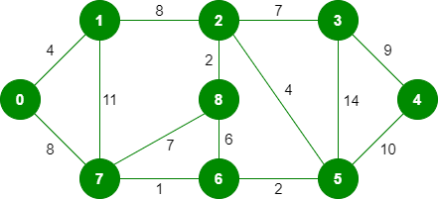

*The graph contains 9 vertices and 14 edges. So, the minimum spanning tree formed will be having (9 – 1) = 8 edges.   
After sorting:*

|  |  |  |
| --- | --- | --- |
| *Weight* | *Source* | *Destination* |
| *1* | *7* | *6* |
| *2* | *8* | *2* |
| *2* | *6* | *5* |
| *4* | *0* | *1* |
| *4* | *2* | *5* |
| *6* | *8* | *6* |
| *7* | *2* | *3* |
| *7* | *7* | *8* |
| *8* | *0* | *7* |
| *8* | *1* | *2* |
| *9* | *3* | *4* |
| *10* | *5* | *4* |
| *11* | *1* | *7* |
| *14* | *3* | *5* |

*Now pick all edges one by one from the sorted list of edges*

***Step 1:*** *Pick edge 7-6. No cycle is formed, include it.*

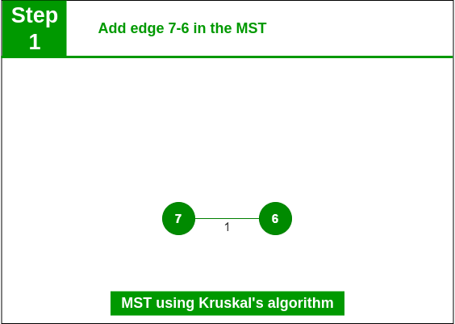

*Add edge 7-6 in the MST*

***Step 2:*** *Pick edge 8-2. No cycle is formed, include it.*

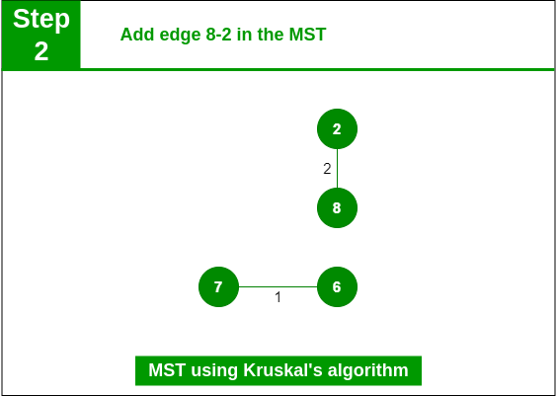

*Add edge 8-2 in the MST*

***Step 3:*** *Pick edge 6-5. No cycle is formed, include it.*

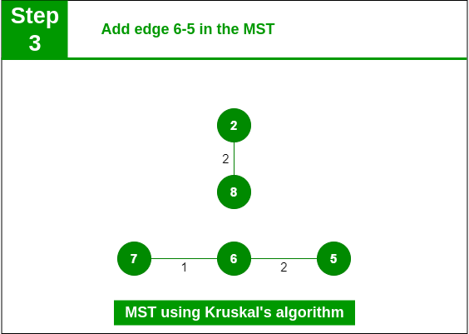

*Add edge 6-5 in the MST*

***Step 4:*** *Pick edge 0-1. No cycle is formed, include it.*

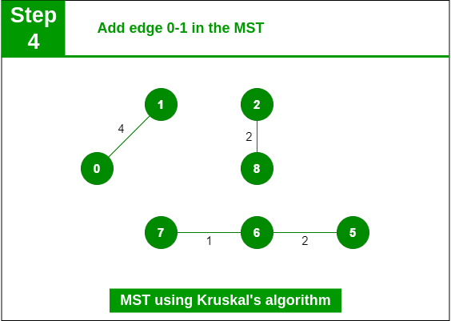

*Add edge 0-1 in the MST*

***Step 5:*** *Pick edge 2-5. No cycle is formed, include it.*

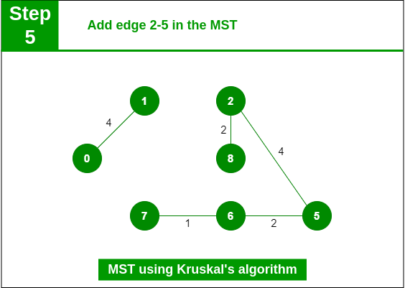

*Add edge 2-5 in the MST*

***Step 6:*** *Pick edge 8-6. Since including this edge results in the cycle, discard it. Pick edge 2-3: No cycle is formed, include it.*

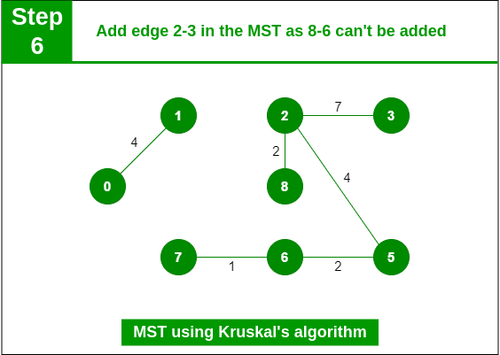

*Add edge 2-3 in the MST*

***Step 7:*** *Pick edge 7-8. Since including this edge results in the cycle, discard it. Pick edge 0-7. No cycle is formed, include it.*

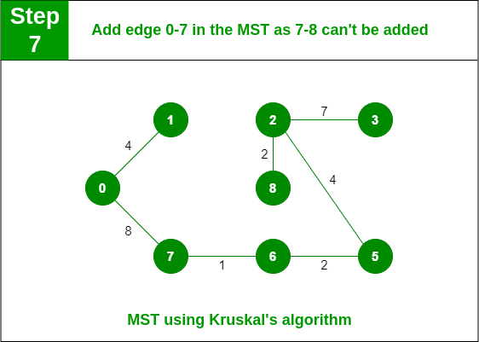

*Add edge 0-7 in MST*

***Step 8:*** *Pick edge 1-2. Since including this edge results in the cycle, discard it. Pick edge 3-4. No cycle is formed, include it.*

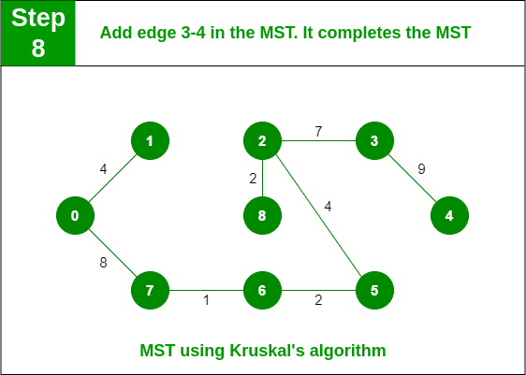

*Add edge 3-4 in the MST*

***Note:*** *Since the number of edges included in the MST equals to (V – 1), so the algorithm stops here*