**Assignment on 29-07-2024**

**Assignment 1:** SDLC Overview - Create a one-page infographic that outlines the SDLC phases (Requirements, Design, Implementation, Testing, Deployment), highlighting the importance of each phase and how they interconnect.

**Software Development Life Cycle (SDLC)**

**SDLC is a process followed for software building within a software organization.**SDLC consists of a precise plan that describes how to develop, maintain, replace, and enhance specific software. The life cycle defines a method for improving the quality of software and the all-around development process.

**Stages of the Software Development Life Cycle**

SDLC specifies the task(s) to be performed at various stages by a software engineer or developer. It ensures that the end product is able to meet the customer’s expectations and fits within the overall budget. Hence, it’s vital for a software developer to have prior knowledge of this software development process.

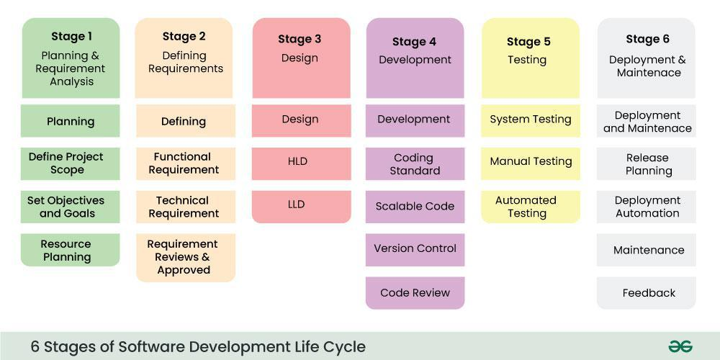

*Stages of the Software Development Life Cycle Model SDLC*

The [**SDLC model**](https://www.geeksforgeeks.org/sdlc-models-types-phases-use)**involves six phases or stages** while developing any software. SDLC is a collection of these six stages, and the stages of SDLC are as follows:

**Stage-1: Requirement Analysis**

Planning is a crucial step in everything, just as in[software development](https://www.geeksforgeeks.org/software-development). In this same stage, [requirement analysis](https://www.geeksforgeeks.org/activities-involved-in-software-requirement-analysis)is also performed by the developers of the organization. This is attained from customer inputs, and sales department/market surveys.

The information from this analysis forms the building blocks of a basic project. The quality of the project is a result of planning. Thus, in this stage, the basic project is designed with all the available information.

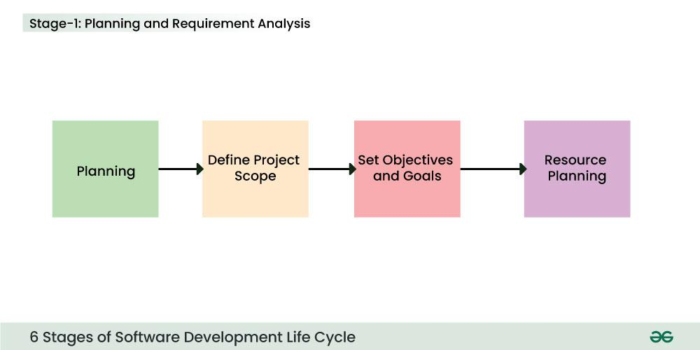

*Stage-1 : Planning and Requirement Analysis*

**Stage-2: Defining Requirements**

In this stage, all the requirements for the target software are specified. These requirements get approval from customers, market analysts, and stakeholders.   
This is fulfilled by utilizing SRS (Software Requirement Specification). This is a sort of document that specifies all those things that need to be defined and created during the entire project cycle.

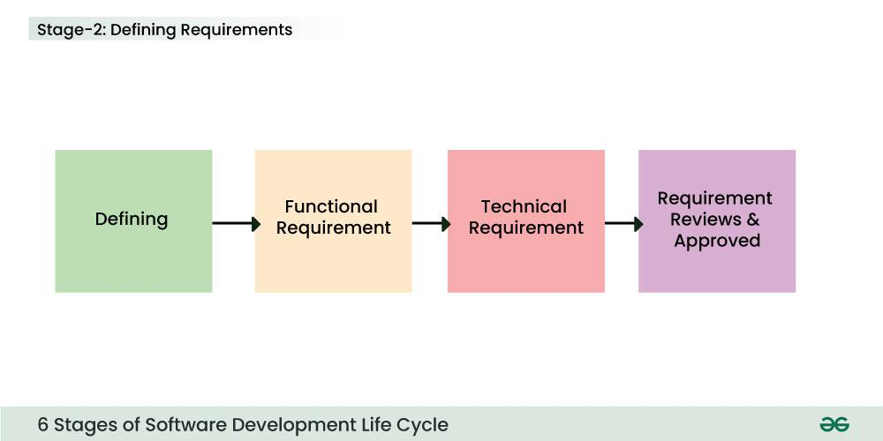

*Stage-2 : Defining Requirements*

**Stage-3: Designing Architecture**

[SRS](https://www.geeksforgeeks.org/software-requirement-specification-srs-format) is a reference for software designers to come up with the best architecture for the software. Hence, with the requirements defined in SRS, multiple designs for the product architecture are present in the Design Document Specification (DDS).

This DDS is assessed by market analysts and stakeholders. After evaluating all the possible factors, the most practical and logical design is chosen for development.

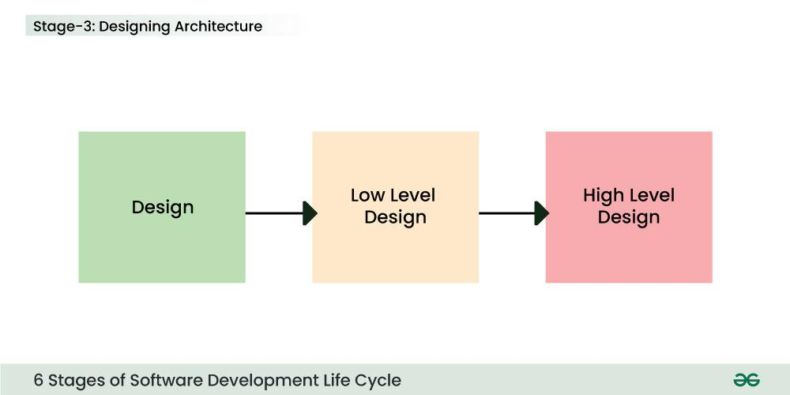

*Stage 3: Design*

**Stage-4: Developing Product**

At this stage, the fundamental development of the product starts. For this, developers use a specific programming code as per the design in the DDS. Hence, it is important for the coders to follow the protocols set by the association. Conventional programming tools like compilers, interpreters, debuggers, etc. are also put into use at this stage. Some popular languages like C/C++, Python, Java, etc. are put into use as per the software regulations.

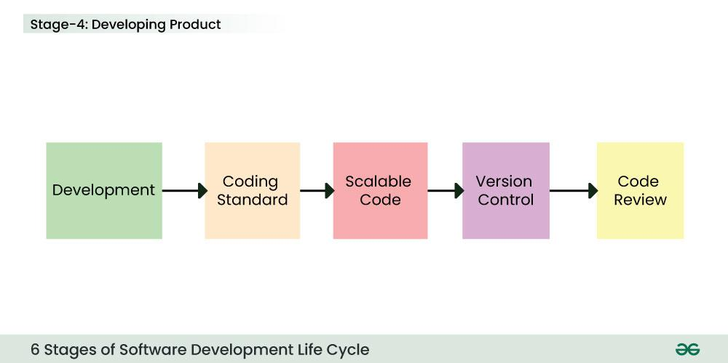

*Stage 4: Development*

**Stage-5: Product Testing and Integration**

After the development of the product, testing of the software is necessary to ensure its smooth execution. Although, minimal testing is conducted at every stage of SDLC. Therefore, at this stage, all the probable flaws are tracked, fixed, and retested. This ensures that the product confronts the quality requirements of SRS.

**Documentation, Training, and Support:**[Software documentation](https://www.geeksforgeeks.org/overview-software-documentation) is an essential part of the software development life cycle. A well-written document acts as a tool and means to information repository necessary to know about software processes, functions, and maintenance. Documentation also provides information about how to use the product. Training in an attempt to improve the current or future employee performance by increasing an employee’s ability to work through learning, usually by changing his attitude and developing his skills and understanding.

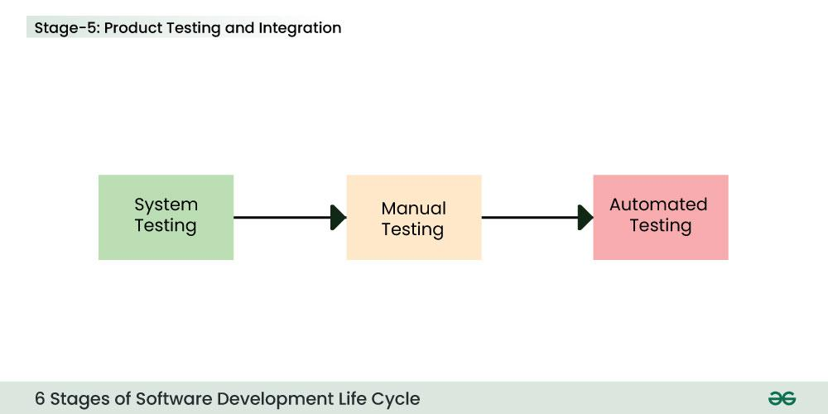

*Stage 5: Testing*

**Stage-6: Deployment and Maintenance of Products**

After detailed testing, the conclusive product is released in phases as per the organization’s strategy. Then it is tested in a real industrial environment. It is important to ensure its smooth performance. If it performs well, the organization sends out the product as a whole. After retrieving beneficial feedback, the company releases it as it is or with auxiliary improvements to make it further helpful for the customers. However, this alone is not enough. Therefore, along with the deployment, the [product’s supervision](https://www.geeksforgeeks.org/product-management).

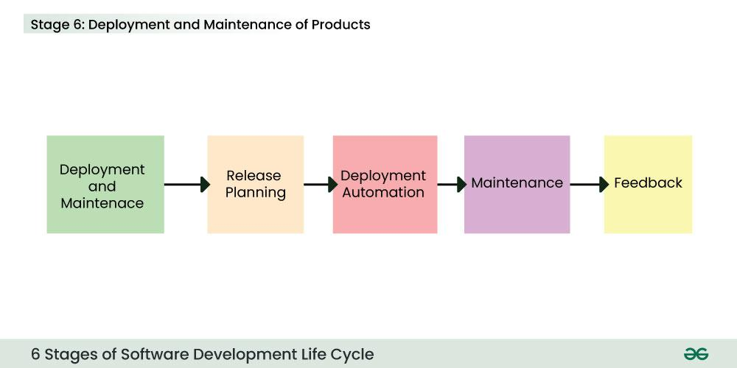

*Stage 6: Deployment and Maintenance*

**Assignment 2:** Develop a case study analyzing the implementation of SDLC phases in a real-world engineering project. Evaluate how Requirement Gathering, Design, Implementation, Testing, Deployment, and Maintenance contribute to project outcomes.

Let's create a case study on the implementation of the SDLC phases in a real-world engineering project, excluding a vehicle navigation system. We'll use a software project for a **smart home automation system** as our focus. This project involves creating an integrated system to manage home appliances, security systems, and environmental controls through a central hub and a mobile application.

**Case Study: Smart Home Automation System**

**Project Overview**

The smart home automation system aims to provide homeowners with a centralized platform to control and monitor various home devices, including lighting, heating, security cameras, and other connected appliances. The system includes a central hub, mobile and web applications, and integration with voice assistants.

**SDLC Phases**

**1. Requirements Gathering**

**Activities**

**Stakeholder Identification**: Key stakeholders include homeowners, product managers, security experts, and UX designers.

**Requirement Collection:** Conducted surveys, interviews, and workshops to gather functional and non-functional requirements.

**Documentation**: Detailed use cases, user stories, and system requirements specification (SRS) document

**Outcome**:

- Clear understanding of user needs, including features like remote access, scheduling, real-time alerts, and user-friendly interfaces.

**2. Design**

**Activities:**

-System Architecture Design: Created a scalable architecture that includes a central hub, cloud services, and client applications.

**User Interface Design:** Developed wireframes and prototypes for the mobile and web interfaces.

**Database Design:** Structured databases for storing user preferences, device status, and security logs.

**Outcome:**

- A comprehensive design document outlining system components, data flow, and user interfaces. The design phase also identified potential integration challenges with third-party devices.

**3. Implementation**

**Activities**

**Development**: Implemented the central hub firmware, mobile apps, and web interface.

**Integration**: Integrated the system with popular voice assistants and third-party smart devices.

**Iteration**: Followed an Agile methodology with iterative sprints, incorporating feedback and making adjustments.

**Outcome:**

- The core functionality was developed and integrated, allowing basic control of home devices. Challenges included ensuring compatibility with various device protocols and handling real-time data.

**4. Testing**

**Activities:**

**Unit Testing:** Verified individual components and modules.

**System Testing**: Ensured all components worked together as intended.

**User Acceptance Testing (UAT**): Involved a group of beta testers to validate the system's usability and performance under real-world conditions.

**Outcome:**

- Detected and resolved numerous bugs and issues, including connectivity problems and interface glitches. UAT provided valuable insights into user experience improvements.

**5. Deployment**

**Activities:**

**Staged** **Rollout**: Initially deployed the system to a limited user group for final testing.

**Full** **Deployment**: Released the system to the general market, along with supporting documentation and customer support.

**Outcome**:

- The system was successfully launched, with users able to control and monitor their home devices seamlessly. A support team was established to handle user inquiries and issues.

**6. Maintenance**

**Activities:**

**Bug Fixes and Updates**: Ongoing monitoring and resolution of reported issues.

**Feature Enhancements:** Regular updates to add new features and improve system performance.

**User Support**: Provided technical support and maintained a helpdesk for user queries.

**Outcome:**

- Continuous improvement of the system based on user feedback. The addition of new features and enhancements helped maintain user engagement and satisfaction.

**Evaluation of SDLC Contribution to Project Outcomes**

**Requirements** **Gathering**: Clearly defined requirements helped align the project with user expectations and avoid scope creep.

**Design**: A well-thought-out design ensured a robust and scalable system architecture, facilitating future enhancements.

**Implementation**: The use of Agile methodology allowed for flexibility and timely incorporation of changes, improving the overall product quality.

**Testing**: Thorough testing at various stages ensured a reliable and user-friendly system, minimizing post-launch issues.

Deployment: A careful deployment strategy minimized risks and allowed for a smooth transition from development to production.

**Maintenance**: Ongoing maintenance and updates helped retain users and extend the system's lifecycle.

Overall, the SDLC phases provided a structured approach to project management, ensuring that each aspect of the project was systematically addressed, leading to a successful product launch and continued user satisfaction.

**Assignment 3:** Research and compare SDLC models suitable for engineering projects. Present findings on Waterfall, Agile, Spiral, and V-Model approaches, emphasizing their advantages, disadvantages, and applicability in different engineering context

Let's explore and compare various Software Development Life Cycle (SDLC) models suitable for engineering projects, focusing on Waterfall, Agile, Spiral, and V-Model approaches. Each model has unique characteristics, advantages, and disadvantages, making them more or less suitable for different types of projects and contexts.

**1. Waterfall Model**

**Overview:**  
The Waterfall model is a linear and sequential approach where each phase must be completed before the next begins. It is one of the earliest SDLC models.

**Phases:**

1. Requirements Analysis
2. System Design
3. Implementation (Coding)
4. Integration and Testing
5. Deployment
6. Maintenance

**Advantages:**

* **Simplicity:** Easy to understand and manage due to its linear structure.
* **Documentation:** Comprehensive documentation is created at each phase.
* **Clear milestones:** Each phase has clear deliverables and review processes.

**Disadvantages:**

* **Inflexibility:** Difficult to accommodate changes once a phase is completed.
* **Late Testing:** Testing occurs only after development is complete, potentially leading to late discovery of issues.
* **Not suitable for complex projects:** Lacks iterative processes, making it unsuitable for projects with high uncertainty or frequent changes.

**Applicability:**  
Best for projects with well-understood requirements and low risk of changes. Suitable for small-scale projects or those with regulatory requirements that necessitate strict documentation and process adherence.

**2. Agile Model**

**Overview:**  
Agile is an iterative and incremental approach that emphasizes flexibility, customer collaboration, and rapid delivery of small, functional pieces of the product.

**Phases (in each iteration):**

1. Planning
2. Design
3. Development
4. Testing
5. Review
6. Retrospective

**Advantages:**

* **Flexibility:** Easily accommodates changes and new requirements.
* **Customer Involvement:** Continuous feedback from customers ensures alignment with their needs.
* **Early and frequent delivery:** Provides working software early and iteratively.

**Disadvantages:**

* **Less predictability:** Constant changes can make it hard to predict final deliverables and timelines.
* **Requires experienced team:** The lack of detailed documentation may require a highly skilled and self-motivated team.
* **Less focus on documentation:** Emphasis on working software can sometimes lead to inadequate documentation.

**Applicability:**  
Ideal for projects with evolving requirements, such as software development, startups, or environments with high uncertainty. Suitable for teams that work closely with customers and can adapt to changes quickly.

**3. Spiral Model**

**Overview:**  
The Spiral model combines elements of both iterative and Waterfall models. It focuses on risk assessment and iterative refinement through multiple spirals (iterations).

**Phases:**

1. Determine Objectives
2. Identify and Resolve Risks
3. Development and Test
4. Plan the Next Iteration

**Advantages:**

* **Risk Management:** Continuous risk assessment and mitigation.
* **Flexibility:** Combines the iterative nature of Agile with the systematic aspects of Waterfall.
* **Customer feedback:** Frequent interaction with stakeholders.

**Disadvantages:**

* **Complexity:** Requires careful planning and expertise, making it more complex to manage.
* **Costly:** Can be more expensive due to multiple iterations and risk management processes.
* **Not suitable for small projects:** The overhead may be too high for small projects.

**Applicability:**  
Suitable for large, complex, and high-risk projects where risk assessment is crucial, such as aerospace, defense, or other critical systems. It's beneficial when requirements are not well-understood at the beginning.

**4. V-Model (Verification and Validation Model)**

**Overview:**  
The V-Model is an extension of the Waterfall model, emphasizing verification and validation at each development stage. It aligns development phases with corresponding testing phases.

**Phases:**

1. Requirements Analysis
2. System Design
3. Architecture Design
4. Module Design
5. Coding
6. Unit Testing
7. Integration Testing
8. System Testing
9. User Acceptance Testing

**Advantages:**

* **High quality:** Emphasizes testing and validation, ensuring high-quality outputs.
* **Clear deliverables:** Each development phase is directly associated with a testing phase.
* **Structured approach:** Well-suited for projects with clear requirements and high-quality standards.

**Disadvantages:**

* **Inflexibility:** Similar to the Waterfall model, changes are difficult to implement once a phase is completed.
* **High cost and time:** The thorough testing process can be costly and time-consuming.
* **Sequential flow:** The lack of iteration can lead to delayed feedback and issue detection.

**Applicability:**  
Best suited for projects with well-defined and stable requirements, such as medical device software, automotive software, or other industries with stringent regulatory requirements. Ideal for projects where high-quality and safety-critical systems are essential.