**Automatic Shopping**

**Day 1:**

**Software:**

Software is a set of instructions, data or programs used to operate computers and execute specific tasks. It is the opposite of hardware, which describes the physical aspects of a computer.

**1.Planning**

The Planning phase in the SDLC is the first and arguably one of the most critical stages. It sets the foundation for the entire project by establishing its goals, scope, and constraints. Proper planning ensures that the project is well-defined, feasible, and aligned with business objectives.

**Feasibility Study for Automatic Shopping System:**

* **Barcode Scanners:** Technically feasible and cost-effective for efficient product identification.
* **Billing System:** Viable with available software solutions for automating transactions and receipts.
* **Payment Method Integration:** Financially feasible with various payment gateways available for secure transactions.
* **Database Management:** Practical with scalable solutions for managing inventory and customer data efficiently.

**Project planning** is a critical phase in the Software Development Life Cycle (SDLC) that lays the groundwork for the entire project. It involves defining the project scope, objectives, resources, timelines, and risk management strategies to ensure the successful execution and completion of the project.

**Project Planning Scope, Aims, and Objectives for Automatic Shopping System**

**Scope:** Develop an automated shopping system for efficient product scanning, billing, payment processing, and inventory management.

**Aims:** To streamline the shopping experience, enhance operational efficiency, and improve inventory accuracy.

**Objectives:** Implement barcode scanning, automate billing and payment, integrate real-time inventory management, and ensure user-friendly operation.

**3.Resource Allocation**

Person 1: Developer/Technical Lead

Tasks: Develop and integrate the system, manage database, and handle testing.

1. Person 2: Business Analyst/Operations Specialist
2. Tasks: Gather requirements, manage inventory for soap, and handle user training.
3. Opening and Closing Times
4. Tasks: Implement automated system functions for handling store operations and data backups.
5. Soap Inventory
6. Tasks: Track stock levels, set up alerts for low inventory, and generate reports.

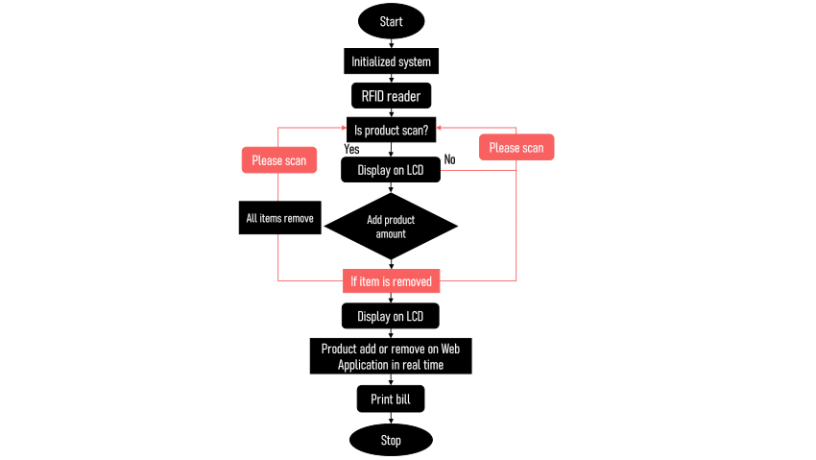

**Payment gateways**

Payment gateways that use card readers for processing transactions typically involve both hardware and software components to handle payments in physical retail environments. Here are some commonly used payment gateways that provide card readers:

1. **Square**

- Card Readers: Offers a range of card readers including magstripe, EMV chip readers, and contactless readers.

- Features: Integrated POS system, no monthly fees, flat-rate transaction fees.

+2. **PayPal Here**

- Card Readers: Provides mobile card readers for magstripe, chip, and contactless payments.

- Features: Seamless integration with PayPal accounts, mobile app for transaction management.

3. **Stripe Terminal**

- Card Readers: Offers a range of card readers including the Verifone P400 and BBPOS Chipper 2X.

- Features: Integrated with Stripe's online payment platform, supports magstripe, chip, and contactless payments.

4. **Shopify Payments**

-Card Readers: Provides card readers through partnerships with third-party hardware providers, such as the Shopify POS hardware.

- Features: Integrated with Shopify’s e-commerce platform, supports various payment methods.

5. **Clover**

- Card Readers: Offers a variety of card readers, including mobile readers and countertop terminals.

- Features: Complete POS solutions with business management tools, customizable hardware options.

6. **Worldpay**

- Card Readers: Provides various card readers, including mobile and countertop devices.

- Features: Supports a range of payment methods, including magstripe, chip, and contactless payments.

7. **SumUp**

- Card Readers: Offers portable card readers for magstripe, chip, and contactless payments.

- Features: Simple pricing model with no monthly fees, integrates with the SumUp app.

8. **Ingenico**

- Card Readers: Provides a range of card readers including countertop and mobile options.

- Features: Reliable hardware with support for various payment methods and advanced security features.

9. **Poynt**

- Card Readers: Offers smart terminals with built-in card readers for magstripe, chip, and contactless payments.

- Features: Integrated POS capabilities, customizable hardware, and software solutions.

10. **Verifone**

- Card Readers: Provides various card readers including countertop and mobile options.

- Features:Robust and secure payment solutions with a range of hardware and software options.

These payment gateways and their associated card readers provide businesses with the tools needed to process card transactions efficiently, securely, and in compliance with payment industry standards. The choice of gateway and card reader depends on factors such as business size, transaction volume, and specific feature requirements.

Payment gateways support a variety of payment options to facilitate secure and convenient transactions for customers. Here are the primary types of payment options typically offered by payment gateways:

**1. Credit and Debit Cards**

* Visa
* MasterCard
* American Express
* Discover

**2. Digital Wallets**

* PayPal
* Apple Pay
* Google Pay
* Samsung Pay
* Amazon Pay
* Microsoft Pay

**3. Bank Transfers**

* ACH (Automated Clearing House) Transfers (primarily in the US)
* SEPA (Single Euro Payments Area) Transfers (primarily in Europe)
* Wire Transfers

**4. Mobile Payments**

* M-Pesa (popular in Africa)
* Alipay (popular in China)
* WeChat Pay (popular in China)

**5. Buy Now, Pay Later (BNPL)**

* Klarna
* Afterpay
* Affirm
* Sezzle

**6. Cryptocurrency Payments**

* Bitcoin
* Ethereum
* Litecoin
* Other Altcoins (depending on the payment gateway)

**7. Prepaid Cards and Gift Cards**

* Store-specific Gift Cards
* Prepaid Visa/MasterCard/American Express Cards

**8. Cash-Based Payment Options**

* Cash on Delivery (COD)
* Cash Payment Vouchers (e.g., PayNearMe)

**9. Loyalty Points and Rewards Programs**

* Using Accumulated Loyalty Points for purchases
* Reward Points Redemption

**10. E-checks and E-wallets**

* E-checks (electronic version of a paper check)
* E-wallets (digital wallets provided by the gateway or third-party services)

**11. Recurring Payments and Subscriptions**

* Automatic Billing for subscription services
* Recurring Direct Debits

**12. Direct Carrier Billing**

* **Mobile Carrier Billing** (charges billed directly to the customer’s mobile phone account)

**Summary**

A comprehensive payment gateway should ideally support a wide range of payment options to cater to different customer preferences and geographic regions. This flexibility can improve the customer experience, increase conversion rates, and broaden the merchant's potential customer base.