**Automatic Shopping**

**Day 1:**

**Software:**

Software is a set of instructions, data or programs used to operate computers and execute specific tasks. It is the opposite of hardware, which describes the physical aspects of a computer.

**1.Planning**

The Planning phase in the SDLC is the first and arguably one of the most critical stages. It sets the foundation for the entire project by establishing its goals, scope, and constraints. Proper planning ensures that the project is well-defined, feasible, and aligned with business objectives.

**Feasibility Study for Automatic Shopping System:**

* **Barcode Scanners:** Technically feasible and cost-effective for efficient product identification.
* **Billing System:** Viable with available software solutions for automating transactions and receipts.
* **Payment Method Integration:** Financially feasible with various payment gateways available for secure transactions.
* **Database Management:** Practical with scalable solutions for managing inventory and customer data efficiently.

**Project planning** is a critical phase in the Software Development Life Cycle (SDLC) that lays the groundwork for the entire project. It involves defining the project scope, objectives, resources, timelines, and risk management strategies to ensure the successful execution and completion of the project.

**Project Planning Scope, Aims, and Objectives for Automatic Shopping System**

**Scope:** Develop an automated shopping system for efficient product scanning, billing, payment processing, and inventory management.

**Aims:** To streamline the shopping experience, enhance operational efficiency, and improve inventory accuracy.

**Objectives:** Implement barcode scanning, automate billing and payment, integrate real-time inventory management, and ensure user-friendly operation.

**3.Resource Allocation**

Person 1: Developer/Technical Lead

Tasks: Develop and integrate the system, manage database, and handle testing.

1. Person 2: Business Analyst/Operations Specialist

2. Tasks: Gather requirements, manage inventory for soap, and handle user training.

3. Opening and Closing Times

4. Tasks: Implement automated system functions for handling store operations and data backups.

5. Soap Inventory

6. Tasks: Track stock levels, set up alerts for low inventory, and generate reports.

**SDLC for Automatic shopping:**

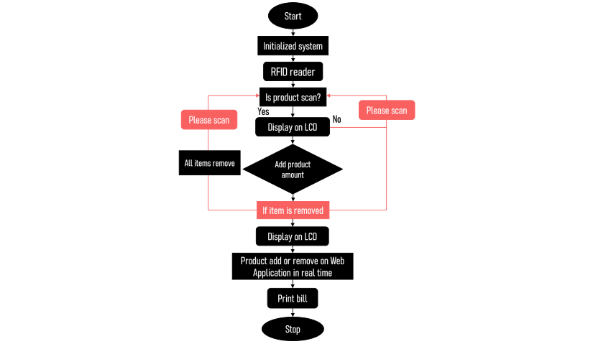

**Payment gateways**

Payment gateways that use card readers for processing transactions typically involve both hardware and software components to handle payments in physical retail environments. Here are some commonly used payment gateways that provide card readers:

**1. **Square\*\***

- Card Readers: Offers a range of card readers including magstripe, EMV chip readers, and contactless readers.

**Transaction Fees:**

* In-Person Payments: 2.6% + 10¢ per transaction
* Online Payments: 2.9% + 30¢ per transaction
* Invoice Payments: 2.9% + 30¢ per transaction

**Features:**

Integrated POS system, no monthly fees, flat-rate transaction fees.

* Free card reader included with sign-up.
* POS systems and hardware solutions for in-store sales.
* Inventory management, customer relationship management (CRM), and reporting tools.

**2. **PayPal Here\*\***

- Card Readers: Provides mobile card readers for magstripe, chip, and contactless payments.

**Transaction Fees:**

* **In-Person Payments:** 2.7% per transaction
* **Online Payments:** 2.9% + 30¢ per transaction

**Features:**

Seamless integration with PayPal accounts, mobile app for transaction management.

* Mobile card readers and POS systems.
* Accepts a variety of payment methods including credit/debit cards and PayPal.
* Easy integration with PayPal's online payment platform.

**3. **Stripe Terminal\*\***

- Card Readers: Offers a range of card readers including the Verifone P400 and BBPOS Chipper 2X.

**Transaction Fees:**

* **In-Person Payments (Stripe Terminal):** 2.7% + 5¢ per transaction
* **Online Payments:** 2.9% + 30¢ per transaction

**Features:**

Integrated with Stripe's online payment platform, supports magstripe, chip, and contactless payments.

* Supports a wide range of payment methods.
* Developer-friendly APIs and SDKs for custom integrations.
* Advanced fraud detection and security features.

**4. **Shopify Payments\*\***

-Card Readers: Provides card readers through partnerships with third-party hardware providers, such as the Shopify POS hardware.

**Transaction Fees:**

* **In-Person Payments:** 2.4% to 2.7% depending on the Shopify plan
* **Online Payments:** 2.4% to 2.9% + 30¢ depending on the Shopify plan

**Features**

Integrated with Shopify’s e-commerce platform, supports various payment methods.

* Integrated POS system with card readers.
* Synchronizes with Shopify online store for unified inventory management.
* Advanced reporting and analytics tools.

**5. **Clover\*\***

- Card Readers: Offers a variety of card readers, including mobile readers and countertop terminals.

**Transaction Fees:**

* Varies by provider, typically around 2.3% + 10¢ per transaction

**Features:**

Complete POS solutions with business management tools, customizable hardware options.

* Comprehensive POS systems with a range of hardware options.
* Inventory management, employee management, and reporting features.
* Customizable POS software and apps through the Clover App Market.

**6. **Worldpay\*\***

- Card Readers: Provides various card readers, including mobile and countertop devices.

**Transaction Fees:**

* Varies by contract, typically around 2.6% + 10¢ per transaction

**Features**

Supports a range of payment methods, including magstripe, chip, and contactless payments.

* Comprehensive POS and card reader solutions.
* Supports a wide range of payment methods.
* Advanced fraud protection and reporting tools.

**7. **SumUp\*\***

- Card Readers: Offers portable card readers for magstripe, chip, and contactless payments.

**Transaction Fees:**

* **In-Person Payments:** 2.75% per transaction

**Features**

Simple pricing model with no monthly fees, integrates with the SumUp app.

* Affordable mobile card readers.
* No monthly fees or contracts.
* Easy-to-use interface and quick setup.

**8. **Ingenico\*\***

- Card Readers: Provides a range of card readers including countertop and mobile options.

#### Transaction Fees

* **Fees:** Ingenico itself does not set the transaction fees; fees are determined by the payment processor you choose to integrate with Ingenico terminals (e.g., Worldpay, First Data).
* **Typical Rates:** Vary based on the processor but generally range from 2.3% to 3% per transaction plus a fixed fee (e.g., 10¢ to 30¢).

**Features**

Reliable hardware with support for various payment methods and advanced security features.

* **Global Reach:** Supports multiple currencies and payment methods worldwide.
* **Versatile Hardware:** Wide range of card readers and POS terminals for in-store, mobile, and unattended payments.
* **Security:** Advanced security features including PCI compliance, point-to-point encryption (P2PE), and EMV chip card acceptance.
* **Customization:** Terminals can be customized with apps to fit specific business needs.
* **Integration:** Seamless integration with various payment processors and software solutions.

**9. **Poynt\*\***

- Card Readers: Offers smart terminals with built-in card readers for magstripe, chip, and contactless payments.

#### Transaction Fees

* **Fees:** Determined by the payment processor used with Poynt terminals (e.g., Elavon, First Data).
* **Typical Rates:** Generally range from 2.3% to 2.9% per transaction plus a fixed fee (e.g., 10¢ to 30¢).

**Features**

Integrated POS capabilities, customizable hardware, and software solutions.

* smart terminals :All-in-one with toSmart Terminals: uchscreen interfaces.
* Flexibility: Supports various payment methods, including EMV, magstripe, NFC/contactless payments, and QR codes.
* Reporting and Analytics: Detailed sales and transaction reporting tools.
* App Marketplace: Access to a range of apps for different business functions.

**10. **Verifone\*\***

- Card Readers: Provides various card readers including countertop and mobile options.

#### Transaction Fees

* **Fees:** Determined by the payment processor integrated with Verifone terminals (e.g., Worldpay, Fiserv).
* **Typical Rates:** Generally range from 2.3% to 3% per transaction plus a fixed fee (e.g., 10¢ to 30¢).

**Features**

Robust and secure payment solutions with a range of hardware and software options.

* **Comprehensive Hardware Range:** Various card readers and POS terminals for different business needs, including countertop, mobile, and unattended solutions.
* **Global Acceptance:** Supports multiple currencies and payment methods.
* **Security:** Offers point-to-point encryption (P2PE), EMV compliance, and advanced fraud prevention tools.
* **Customizable Solutions:** Terminals can be tailored with software applications to meet specific requirements.

These payment gateways and their associated card readers provide businesses with the tools needed to process card transactions efficiently, securely, and in compliance with payment industry standards. The choice of gateway and card reader depends on factors such as business size, transaction volume, and specific feature requirements.

**payment options:**

Payment gateways support a variety of payment options to facilitate secure and convenient transactions for customers. Here are the primary types of payment options typically offered by payment gateways:

**1. Credit and Debit Cards**

* Visa
* MasterCard
* American Express
* Discover

**2. Digital Wallets**

* PayPal
* Apple Pay
* Google Pay
* Samsung Pay
* Amazon Pay
* Microsoft Pay

**3. Bank Transfers**

* ACH (Automated Clearing House) Transfers (primarily in the US)
* SEPA (Single Euro Payments Area) Transfers (primarily in Europe)
* Wire Transfers

**4. Mobile Payments**

* M-Pesa (popular in Africa)
* Alipay (popular in China)
* WeChat Pay (popular in China)

**5. Buy Now, Pay Later (BNPL)**

* Klarna
* Afterpay
* Affirm
* Sezzle

**6. Cryptocurrency Payments**

* Bitcoin
* Ethereum
* Litecoin
* Other Altcoins (depending on the payment gateway)

**7. Prepaid Cards and Gift Cards**

* Store-specific Gift Cards
* Prepaid Visa/MasterCard/American Express Cards

**8. Cash-Based Payment Options**

* Cash on Delivery (COD)
* Cash Payment Vouchers (e.g., PayNearMe)

**9. Loyalty Points and Rewards Programs**

* Using Accumulated Loyalty Points for purchases
* Reward Points Redemption

**10. E-checks and E-wallets**

* E-checks (electronic version of a paper check)
* E-wallets (digital wallets provided by the gateway or third-party services)

**11. Recurring Payments and Subscriptions**

* Automatic Billing for subscription services
* Recurring Direct Debits

**12. Direct Carrier Billing**

* Mobile Carrier Billing (charges billed directly to the customer’s mobile phone account)

**Summary**

A comprehensive payment gateway should ideally support a wide range of payment options to cater to different customer preferences and geographic regions. This flexibility can improve the customer experience, increase conversion rates, and broaden the merchant's potential customer base.

### Handling Card-Only Payments in Payment Gateways

1. **Card Readers and Terminals**
   * Use card readers and POS terminals (e.g., from Square, Stripe Terminal, or Verifone) to accept credit and debit card payments securely and efficiently.
2. **Online Payment Integration**
   * Integrate with online payment gateways (e.g., PayPal, Stripe, or Authorize.Net) that allow customers to pay using their credit or debit cards directly through a secure web interface.
3. **Mobile Payment Solutions**
   * Implement mobile payment solutions that support card payments via digital wallets like Apple Pay, Google Pay, and Samsung Pay, ensuring a seamless and cashless transaction experience.

These solutions ensure secure, efficient, and convenient card-only transactions for customers.

### Handling Card-Only Payments with a Payment Gateway

For handling a large volume of card-only transactions without mobile payments:

1. **Robust Card Readers:**
   * **Use Reliable Terminals:** Deploy multiple secure card readers (e.g., Ingenico, Verifone) to handle high traffic.
   * **Ensure Quick Processing:** Opt for devices that support EMV, contactless payments, and NFC for faster checkouts.
2. **Efficient Queue Management:**
   * **Multiple Checkout Points:** Set up multiple payment stations to reduce wait times.
   * **Dedicated Staff:** Allocate staff to assist with payment processing and manage lines.
3. **Transaction Speed and Reliability:**
   * **High-Speed Internet:** Ensure strong and stable internet connections for quick transaction processing.
   * **Redundancy:** Have backup devices and power sources to avoid downtime.

These measures ensure smooth, fast, and secure card-only transactions, catering to a high volume of members efficiently.