WEEK 2: PL/SQL -Outputs

PL/SQL:

Exercise 1: Control Structures:

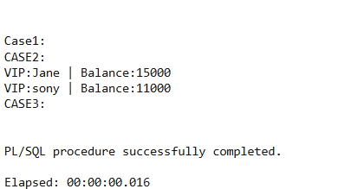

Case1: is empty because there are no people whose age is below 60.

Exercise 3: Stored Procedures:

