Loan Approval Prediction Using Machine Learning
1. Objective
The objective of this project is to build a supervised machine learning model that predicts whether a loan application will be approved or rejected based on applicant information. The project focuses on data preprocessing, handling class imbalance, model comparison, and business interpretation.
2. Dataset Description
The dataset contains information about loan applicants such as gender, marital status, education, income, loan amount, credit history, and property area. The target variable is Loan_Status, which indicates whether the loan was approved or not.
Features:
- Gender
- Married
- Dependents
- Education
- Self_Employed
- ApplicantIncome
- CoapplicantIncome
- LoanAmount
- Loan_Amount_Term
- Credit_History
- Property_Area
- Loan_Status (Target)
3. Data Preprocessing
Several preprocessing steps were performed to prepare the data for modeling:
- Missing values in numerical columns were replaced using median values.
- Missing values in categorical columns were replaced using mode values.
- Categorical variables were converted into numerical format using Label Encoding.
- Feature scaling was applied using StandardScaler.
4. Handling Class Imbalance
The dataset showed an imbalance between approved and rejected loan applications. To address this issue, the Synthetic Minority Oversampling Technique (SMOTE) was applied to the training dataset. SMOTE generates synthetic samples of the minority class and helps improve model performance.
5. Model Development
Two machine learning algorithms were trained and evaluated:
Logistic Regression
A linear classification model used as a baseline.
Random Forest
An ensemble learning model that combines multiple decision trees to improve prediction accuracy and reduce overfitting.
6. Evaluation Metrics
The models were evaluated using the following metrics:
- Precision
- Recall
- F1-Score
- ROC-AUC Score
These metrics provide a comprehensive assessment of model performance.
7. Feature Importance Analysis
Feature importance analysis revealed that the following variables had the greatest impact on loan approval decisions:
- Credit_History
- ApplicantIncome
- LoanAmount
- CoapplicantIncome
- Property_Area
Credit history emerged as the most influential factor in determining loan approval.
8. Business Insights
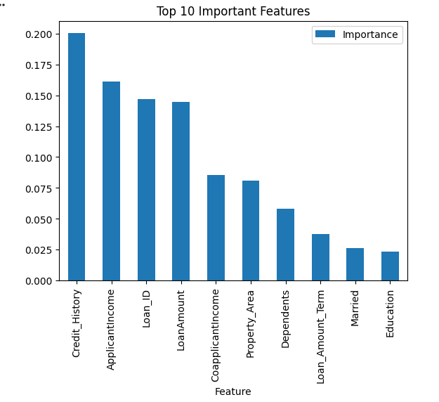
The developed model provides several business benefits:
- Automates loan screening and approval processes.
- Reduces manual effort and processing time.
- Helps identify high-risk applicants early.
- Improves consistency in lending decisions.
- Supports data-driven decision making.
9. Conclusion
A loan approval prediction system was successfully developed using machine learning techniques. Data preprocessing, feature engineering, and class imbalance handling were performed before model training. Logistic Regression and Random Forest models were evaluated using multiple performance metrics. Random Forest achieved superior predictive performance and is recommended for deployment. The model can assist financial institutions in making faster and more accurate loan approval decisions.

