**Procedure:**

**Step1:Install and configure git**

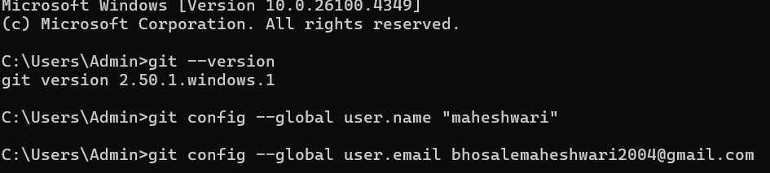

**Step2:Initialize the git repository**

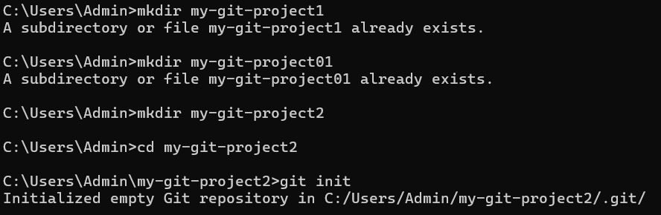

**Step3:Create a sample file and add to repo**

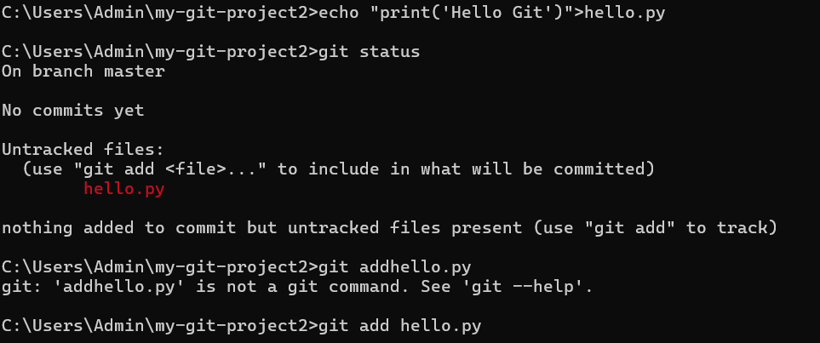

Step4:Commit the file

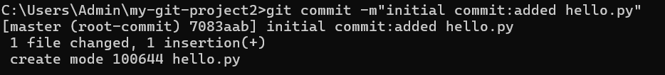

Step5:Check history and status

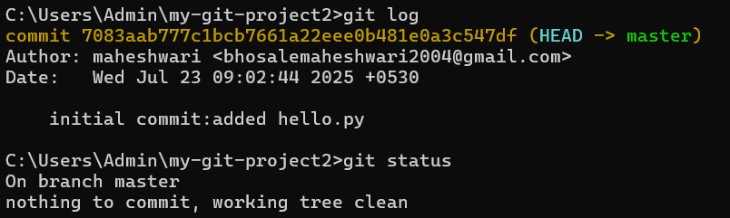

Step6:Modify file and track changes

