**1.**

For the CORA dataset:

Number of nodes = 2708

Number of edges = 10556

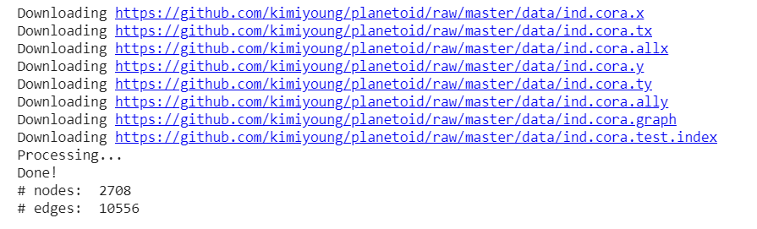

For Enzymes dataset

Number of graphs = 600

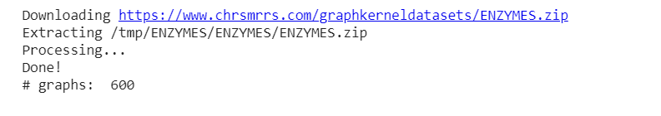

**2.**

**Command :**

!python train.py --dataset=cora --dropout=0.5 --weight_decay=5e-3 --epochs=500

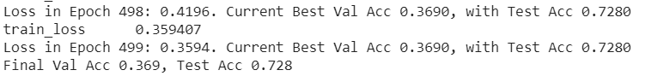

**Command:**

 !python train.py --dataset=enzymes --weight_decay=5e-3 --num_layers=3 --epochs=500

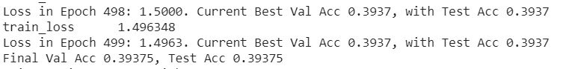

**Command:**

!python train.py --model_type GraphSage --hidden_dim 256 --dropout 0.5 --weight_decay 5e-3 --epochs=500

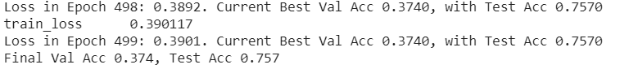

**Command:**

!python train.py --model_type GraphSage --hidden_dim 256 –

dataset enzymes --dropout 0 --weight_decay=5e-3 --num_layers=3 --epochs 500

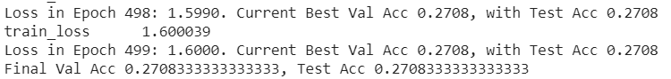

**Command:**

!python train.py --model_type GAT --lr 0.001 --hidden_dim 64 --dropout 0.5 --weight_decay 5e-3 --epochs=500

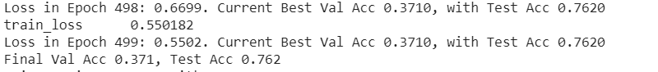

**Command:**

!python train.py --model_type GAT --dataset enzymes --dropout 0 --weight_decay=5e-3 --num_layers=3 --epochs 500

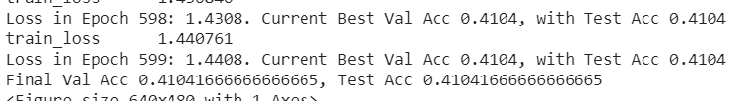

**Performance Discussion:**

The Accuracies for CORA dataset:

GCN = 0.72

GraphSage = 0.75

GAT = 0.76

The Accuracies for ENZYMES dataset:

GCN = 0.39

GraphSage = 0.27

GAT = 0.41

Graph showing validation accuracies for Cora Dataset:

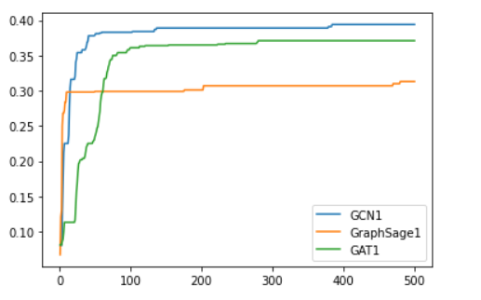

Graph showing validation accuracies for Cora Dataset:

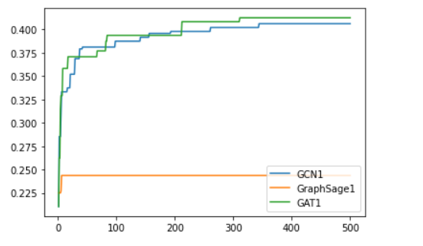

**Discussion:**

**GCN:**

The graph convolutional network is graph neural network because filter parameters are typically shared over all locations in the graph. The goal is to learn a function of signals/features on a graph G=(V,E)

**GraphSage:**

It is a framework for inductive representation learning on large graphs. It is used to generate low-dimensional vector representations for nodes and is especially useful for graphs that have rich node attribute information.

**GAT:**

Graph attention networks are neural network architectures that operate on graph-structured data, leveraging masked self-attentional layers to address the shortcomings of prior methods based on graph convolutions or their approximations

There are fluctuations in validation accuracies. But when we compare the final accuracy we can say that

For Cora dataset: The order of performance will be

GAT > GraphSage > GCN

For Enzymes dataset: The order of performance will be

GAT > GCN > GraphSage