**Outputs**

The training set error percentage = 0.00028

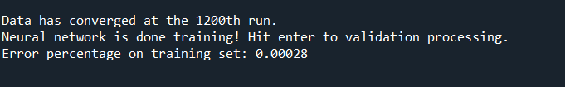

The validation set error percentage = 2e-05

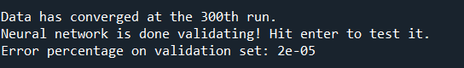

The test dataset error percentage = 0.001771

