**Sravani Konujula**

**16230172**

**ID :- 23**

**Deep Learning**

**LAB Assignment-2**

Introduction

The main aim of this task is to implement text classification using the CNN with different data

Objectives

* To Display the graph in the Tensor Board using tensor flow
* Switch the hyperparameter from one value to other value and note the reports
* Compare the reports and examine the difference

Approaches/Methods

Convolutional Neural Networks are identical to Neural networks which are inclusive of neurons with measurable weight and bias.

This consists of layers

* Convolutional Layer
* Pooling Layer
* Fully-Connected Layer

**Convolutional Layer**

This layer is important building block of CNN which performs computational huge lifting

**Pooling Layer**

* **This layer is fitted between ConvNet architecture.**
* **This layer works very independent on depth of slice with MAX operation.**
* **Works on volume size having W×H×D**

**Fully-Connected Layer**

**This have full of connections with complete activations with prior layers and that is done with matrix multiplications**

Workflow

* Required libraries are to be imported such as Numpy, Pandas, text CNN
* Parameters are considered for Data, Model and Training
* Data to be used for pre-processing
* Load the wanted data and build vocabulary then shuffle randomly
* Splitting is done as the test and train data
* Cross validation must be done after training the data
* Train the procedure
* Note the reports for gradient and sparsity
* Summarize the loss and accuracy
* Note the checkpoints
* Train the loop for every set
* Evaluate parameters
* Epoch number of operations
* Tensor Boards graphs are displayed

Datasets

* Consumer complaints dataset with total number of 11 classes.

Parameters

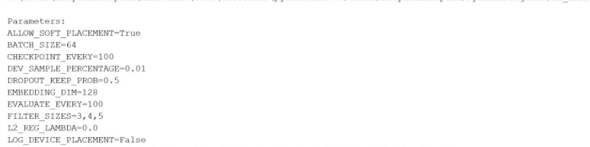

Configuration

Pycharm

Python: 2.7.13

Tensor Flow

Evaluation & Discussion

* Code snippet

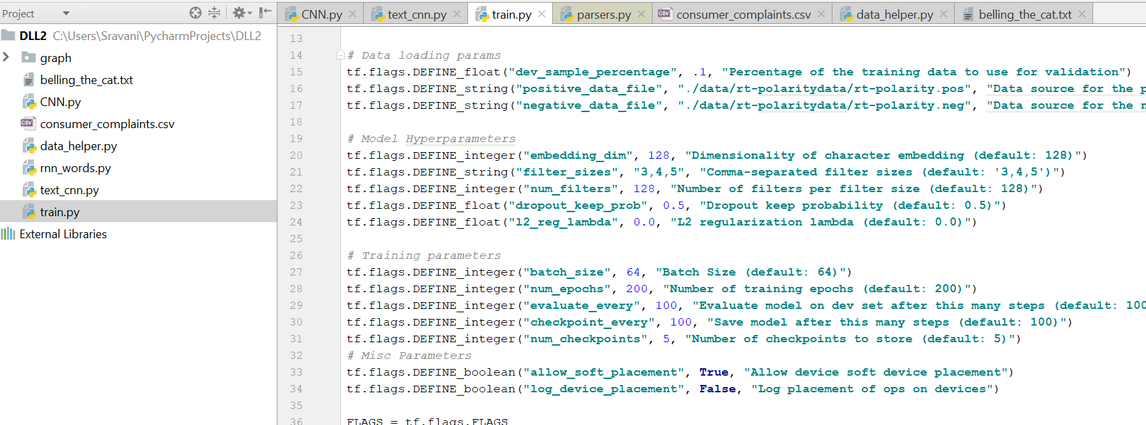

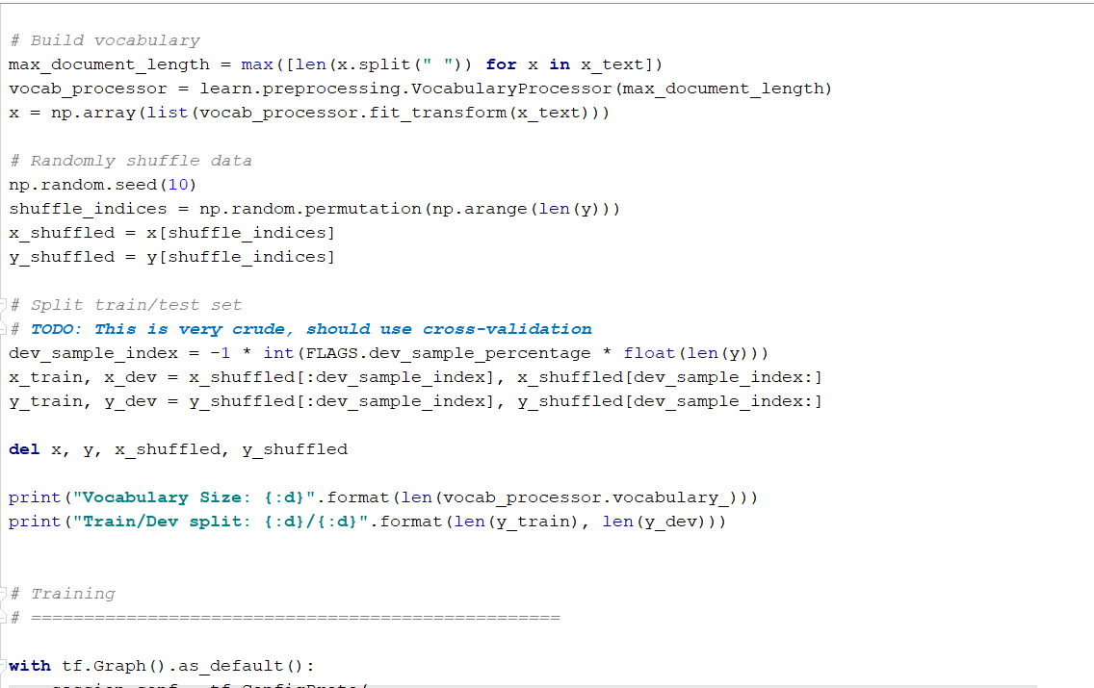

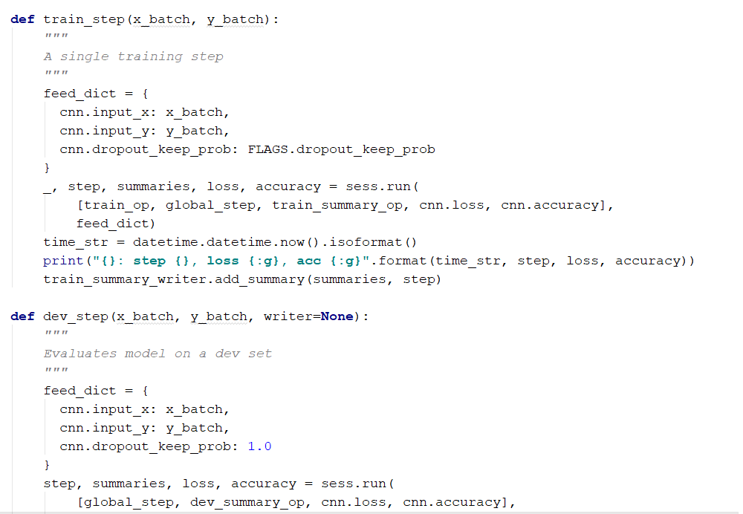

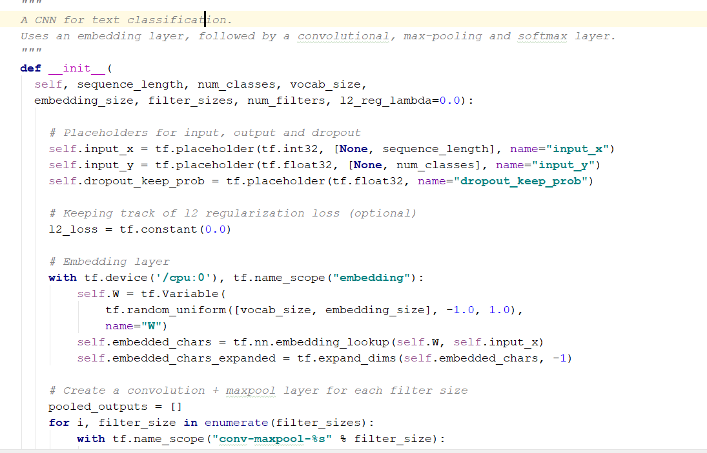

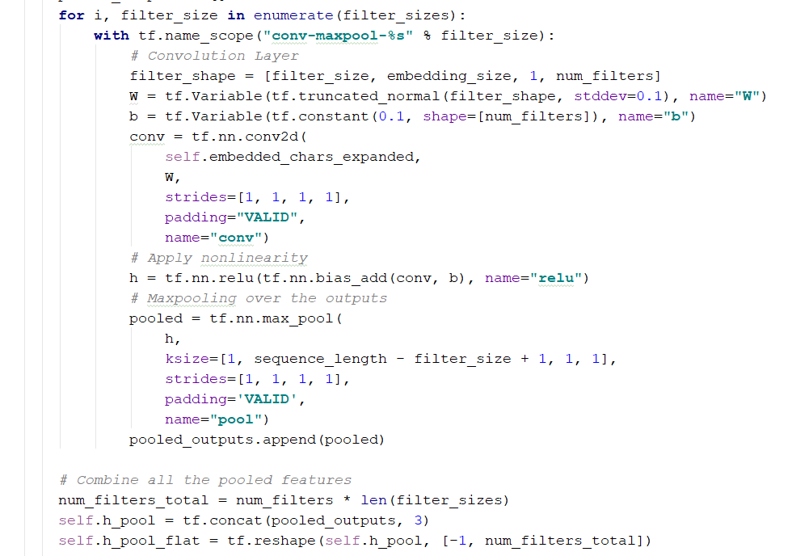

* Output

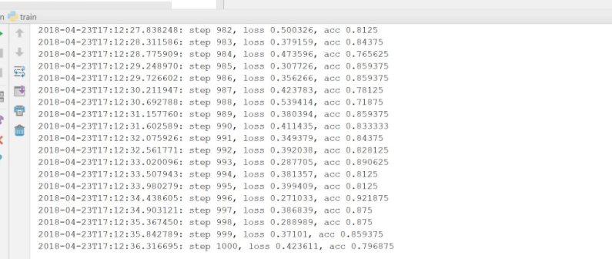

* Tensor flow graph

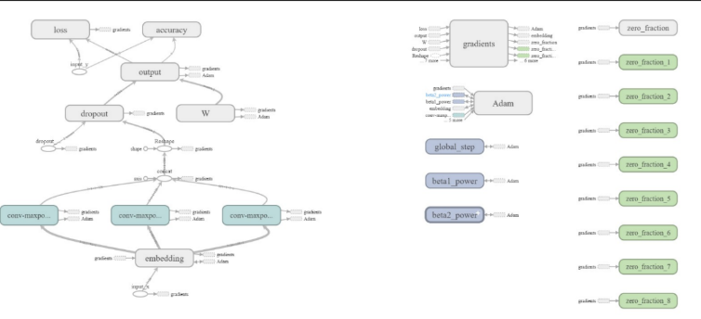

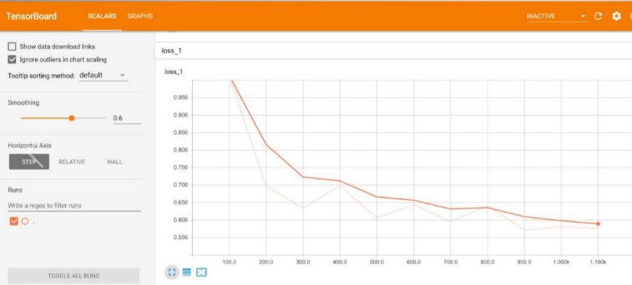

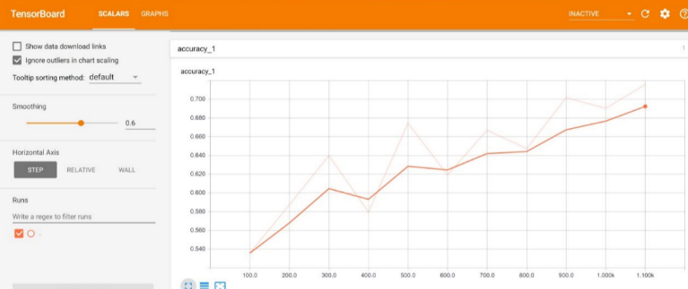

Conclusion

By using tensor flow the code both deploy and debug has done.

By CNN increment of accuracy got satisfied.

There is a chance of increment in both accuracy and complexity if we use RNN’s and LSTM’s

References

http://cs231n.github.io/convolutional-networks/