**Sravani Konujula**

**16230172**

**ID :- 23**

**Deep Learning**

**LAB Assignment-3**

Introduction

The main aim is to implement the text classification using CNN model, RNN model, LSTM model with new data set and compared results obtained.

Objectives

To compare the accuracy results between RNN, CNN, LSTM.

Approaches/Methods

Upload the dataset from the regret and later load it.

Later train it and evaluate it.

By setting the parameters and hiding layers run the code to get wanted results.

Workflow

* Required libraries are to be imported such as Numpy, Pandas, Keras, text CNN, RNN, LSTM
* Parameters are considered for Data, Model and Training
* Data to be used for pre-processing
* Load the wanted data and build vocabulary then shuffle randomly
* Splitting is done as the test and train data
* Cross validation must be done after training the data
* Train the procedure
* Placeholders are created.
* Summarize the loss and accuracy
* Evaluate parameters
* Observe the results

Datasets

The data set considered is regret.txt

Parameters

For CNN

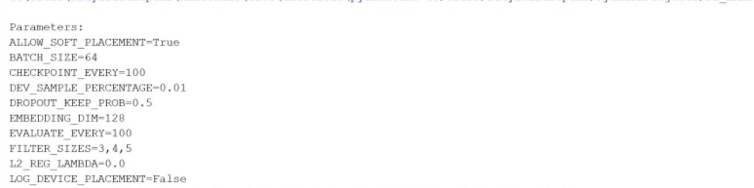

For RNN

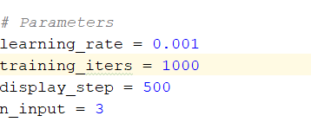

For LSTM

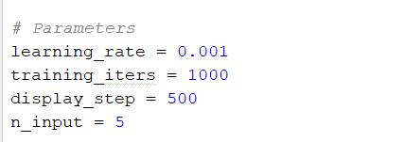

Configuration

Pycharm

Python: 2.7.13

Tensor Flow

Keras

Evaluation & Discussion

Output for LSTM

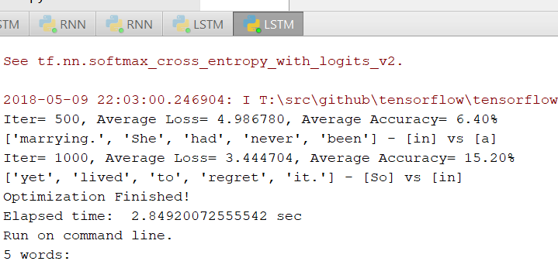

Output for RNN

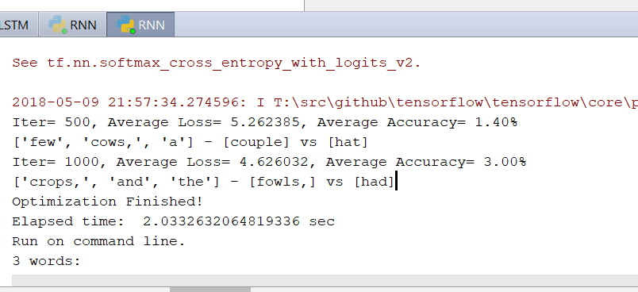

Output for CNN

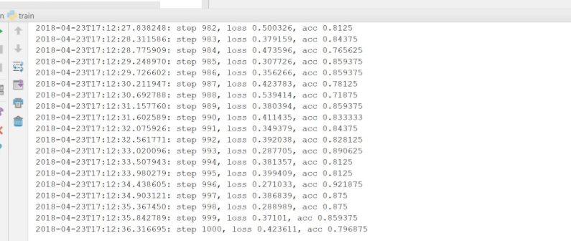

Conclusion

From the above screenshots we can observe that CNN performance is too good compared than the other too. So, CNN is best and Later LSTM compared to RNN. The ranking will be CNN, LSTM, RNN.