**SERVER**

#include <sys/socket.h>

#include <netinet/in.h>

#include <arpa/inet.h>

#include <stdio.h>

#include <stdlib.h>

#include <unistd.h>

#include <errno.h>

#include <string.h>

#include<time.h>

int main()

{

int sock, connected, bytes_recieved , true = 1;

char send_data [1024] , recv_data[1024];

struct sockaddr_in server_addr,client_addr;

int sin_size;

sock = socket(AF_INET, SOCK_STREAM, 0);

server_addr.sin_family = AF_INET;

server_addr.sin_port = htons(7474);

server_addr.sin_addr.s_addr = INADDR_ANY;

bind(sock, (struct sockaddr *)&server_addr, sizeof(struct sockaddr));

listen(sock, 5);

printf("\nTCPServer Waiting for client ");

fflush(stdout);

sin_size = sizeof(struct sockaddr_in);

connected = accept(sock, (struct sockaddr *)&client_addr,&sin_size);

printf("\n I got a connection from (%s , %d)",

inet_ntoa(client_addr.sin_addr),ntohs(client_addr.sin_port));

time_t t; // not a primitive datatype

time(&t);

printf("The time at servet is %s",ctime(&t));

send(connected, ctime(&t),strlen(ctime(&t)), 0);

close(connected);

close(sock);

return 0;

}

**client.c**

#include<stdio.h>

#include<sys/socket.h>

#include<sys/types.h>

#include<netinet/in.h>

#include<string.h>

#include <stdlib.h>

#include <unistd.h>

#include <errno.h>

int main()

{

int sock, bytes_recieved;

char send_data[1024],recv_data[1024];

struct sockaddr_in server_addr;

sock = socket(AF_INET, SOCK_STREAM, 0);

server_addr.sin_family = AF_INET;

server_addr.sin_port = htons(7474);

server_addr.sin_addr.s_addr = htonl(INADDR_ANY);

bzero(&(server_addr.sin_zero),8);

connect(sock, (struct sockaddr *)&server_addr,

sizeof(struct sockaddr));

bytes_recieved=recv(sock,recv_data,1024,0);

recv_data[bytes_recieved] = '\0';

printf("The data recieved is %s",recv_data);

}

**Output:**

**server**

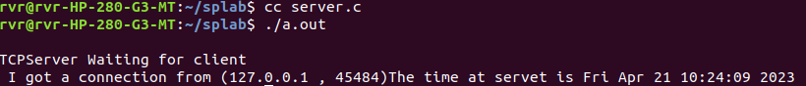

**client**

