PROJECT REPORT
Smart Calendar Booking Assistant
via Telegram
Goal of the Project
Smart Calendar Booking Assistant via Telegram aims to create a chatbot that allows users to check their Google Calendar availability, find suitable free time slots, and schedule meetings directly through Telegram.
Objective
The objective is to develop an AI-powered chatbot that helps users manage meetings through Telegram by checking Google Calendar availability, suggesting suitable time slots, and automatically creating calendar events.
Requirements
- n8n: To build and automate the workflow.
- Telegram Bot: To receive user requests and send responses.
- Google Calendar: To check availability and schedule meetings.
- OpenAI API: To understand user requests using AI.
- Internet Connection: Required for communication between services.
- Laptop/Desktop: Required for development and testing.
Procedure
- User sends a meeting request through Telegram.
- Telegram Bot receives the request.
- AI Agent understands the request.
- AI identifies the date, time, and duration.
- Google Calendar checks availability.
- If unavailable, AI suggests alternative slots.
- User selects and confirms a slot.
- The system creates the meeting in Google Calendar.
- Telegram Bot sends a booking confirmation.
Project Photos
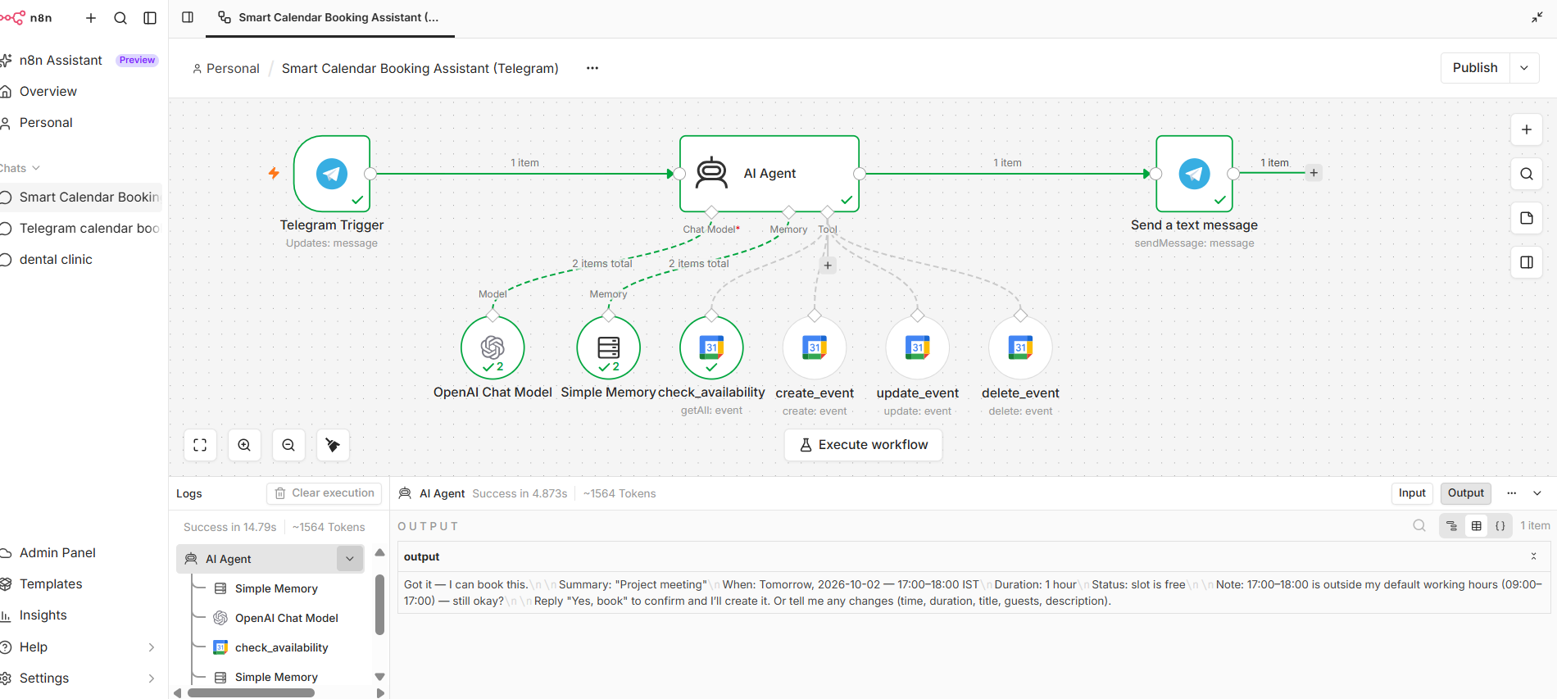
Figure 1: n8n workflow of the booking assistant
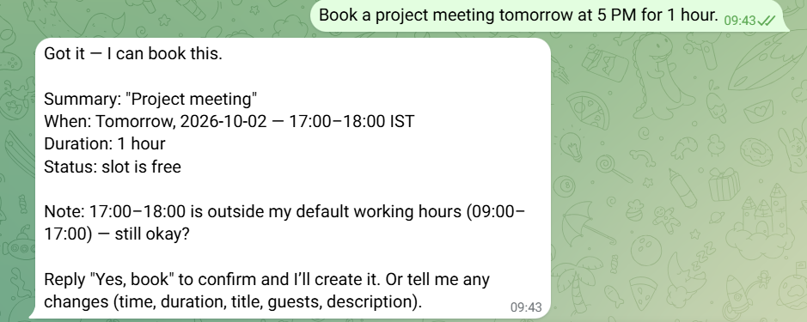
Figure 2: Booking conversation in Telegram
Conclusion
The Smart Calendar Booking Assistant via Telegram simplifies meeting scheduling by using AI, Telegram, n8n, and Google Calendar. It checks availability, suggests suitable slots, and automatically books meetings, saving time and reducing manual work.

Team Members
S. Sravya (Team Leader)
S. Sravani Lakshmi
S. Anusha
T. Bindhu Madhuri
T. Manju Naga Sri

