**Machine Learning – Assignment 1**

**GitHub Link:**

**Video Link:**

1. **Numpy:**
2. Using NumPy create random vector of size 15 having only Integers in the range 1-20.

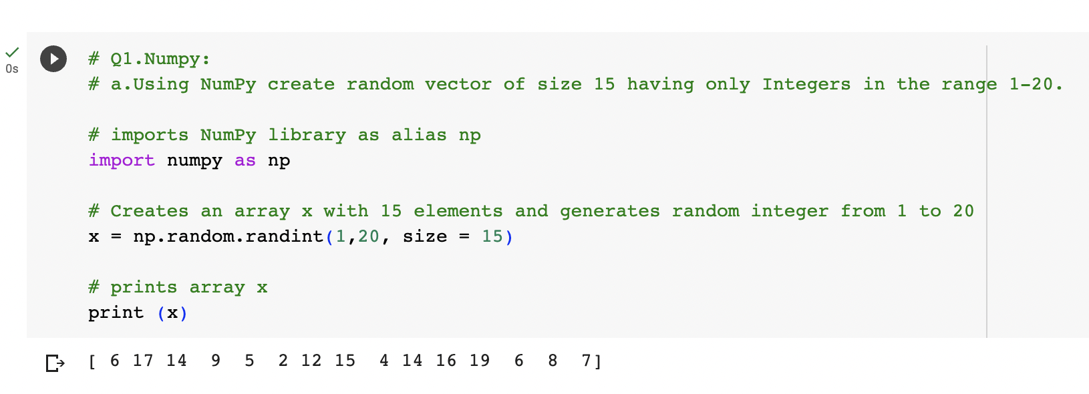

1. Reshape the array to 3 by 5

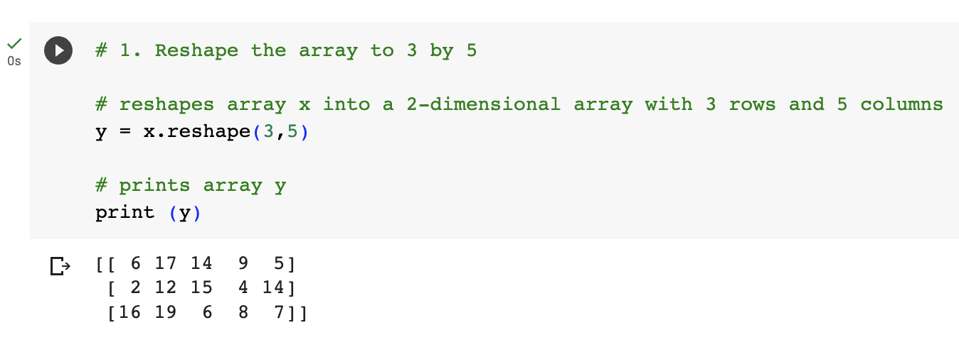

1. Print array shape.

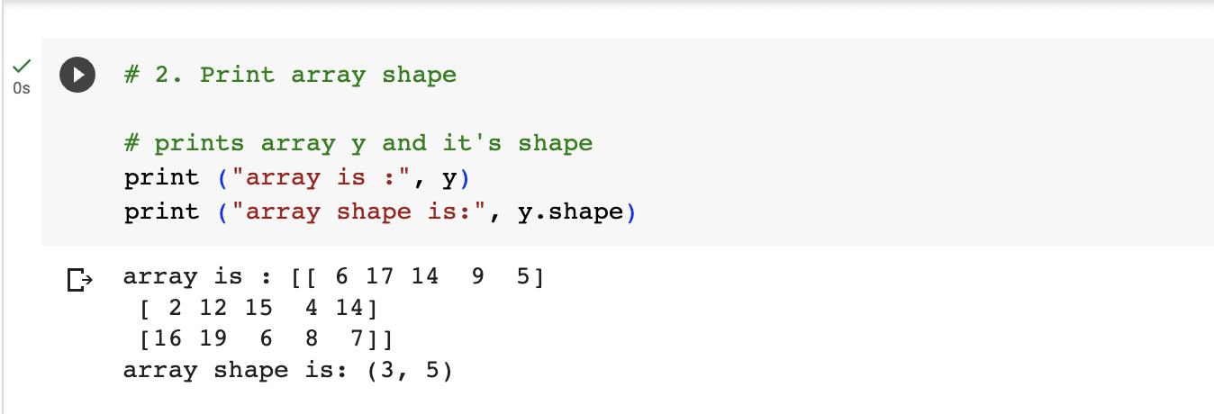

1. Replace the max in each row by 0

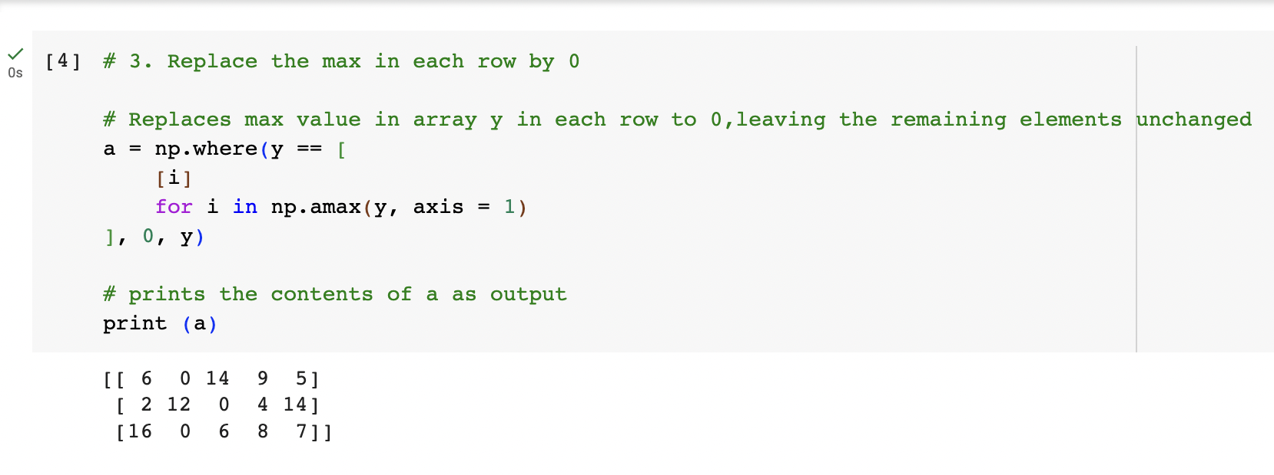

Create a 2-dimensional array of size 4 x 3 (composed of 4-byte integer elements), also print the shape, type and data type of the array.

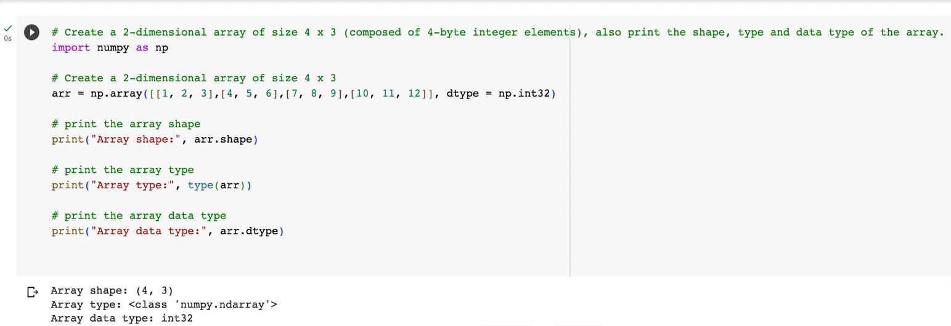

b. Write a program to compute the eigenvalues and right eigenvectors of a given square array given below:

[[ 3 -2]

[ 1 0]]

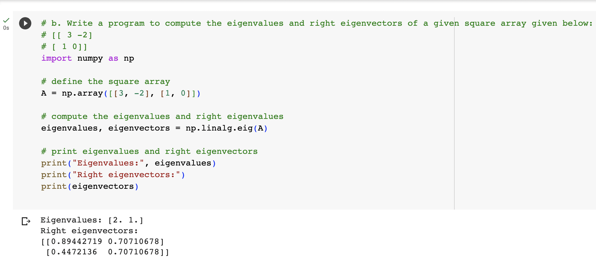

c. Compute the sum of the diagonal element of a given array.

[[0 1 2]

[3 4 5]]

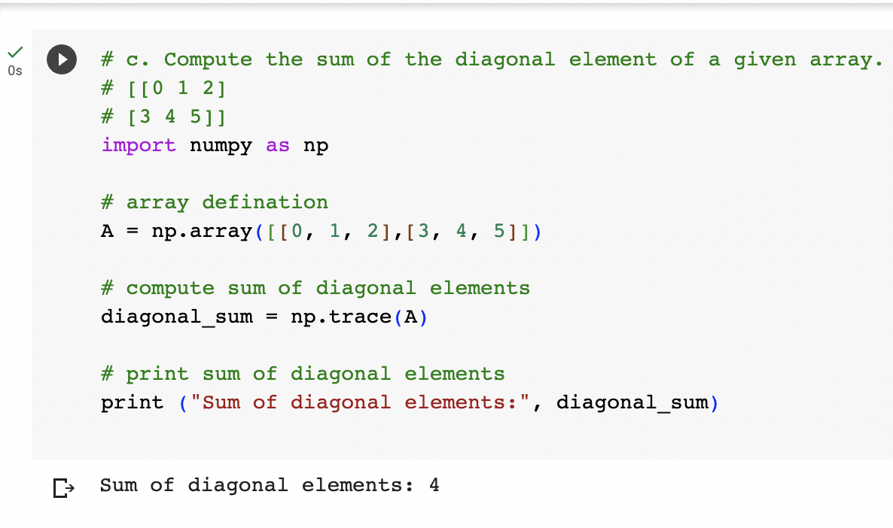

d. Write a NumPy program to create a new shape to an array without changing its data.

Reshape 3x2:

[[1 2]

[3 4]

[5 6]]

Reshape 2x3:

[[1 2 3]

[4 5 6]]

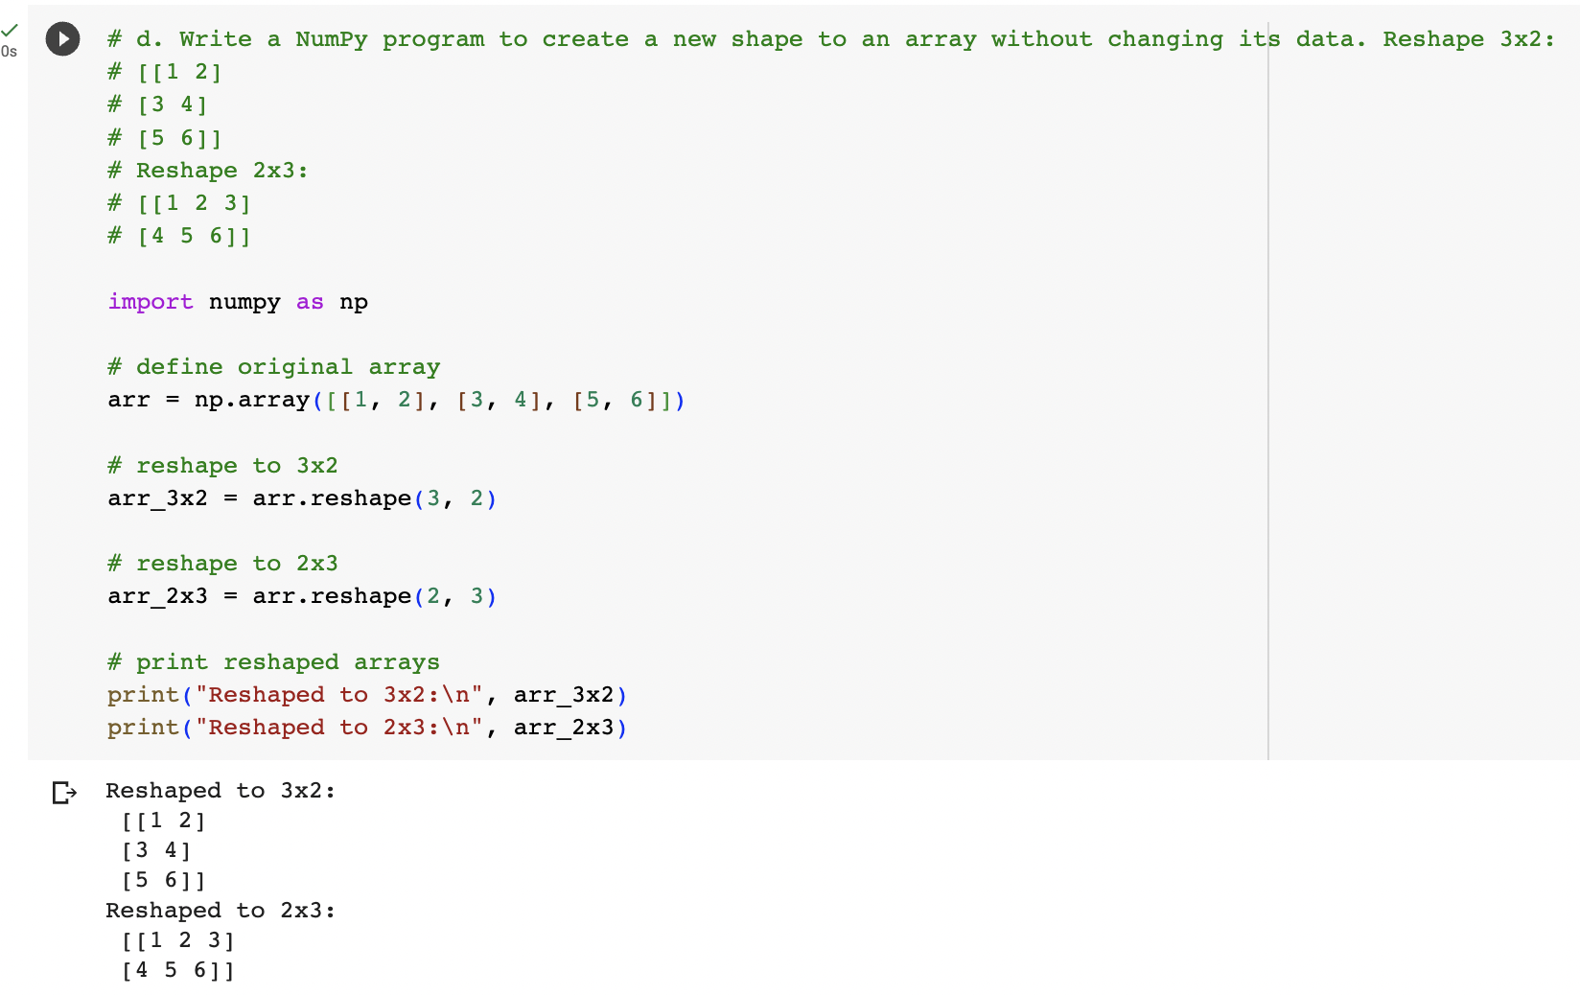

1. **Matplotlib**
2. Write a Python programming to create a below chart of the popularity of programming Languages.
3. Sample data:

Programming languages: Java, Python, PHP, JavaScript, C#, C++

Popularity: 22.2, 17.6, 8.8, 8, 7.7, 6.7

